☐ Listening ☐ Speaking ☐ Reading ☐ Grammar ☐ Writing

Topic: The Rise of Global Media

Instructor:  Soo Yeon Lee | Level:  Pre- intermediate | Students:  4 | Length:  30

Materials:
White board
Board marker
Computer
Youtube video
Worksheet
Reading text

Aims:
To develop intensive reading skill by answering a guiding question to find the main idea and answering multiple choice questions to understand the details
To learn about the rise of global media by reading the text
To learn global media related vocabulary by doing a fill in the blank, listening to the teacher’s explanation

Language Skills:
Reading : fill in the blank worksheet, guiding question, comprehension questions and the text
Speaking : partner discussion to answer the guiding question
Writing : writing about comprehension question
Listening : the teacher’s explanation about new vocabs and partner discussion

Language Systems:
Lexis : (topping, swept, blockbuster, cliched, borders)
Phonology : practicing new vocabulary

Assumptions:
Students have seen many global medias
Students know what global medias
Students know teacher’s style of teaching
Students can speak and write in English

Anticipated Errors and Solutions:
Students may have different pace in reading the text
-teacher reads the text with students and explains the sentences that students do not understand
Some students will have difficulty in doing the comprehension question worksheet
-have students do themselves first and give some help
If students need more time to finish their activity
-be flexible with the time. Give students more time to finish their activity and cut off the time of post activity

References:
https://www.youtube.com/watch?v=PX3k11lAwc8
https://www.youtube.com/watch?v=zS0BA8FnnKc

Lead-In
Materials: Youtube videos

Time | Set Up | Student Activity | Teacher Talk
3 | Whole class | Answer the teacher’s question  Watch the videos  Answer the teacher’s question | Hi~ everyone  How are you?  Ok. Let’s start lesson.  Do you know anything about your favorite movie or Korean drama?  And do you know any global movies?  I’ll show 2 videos.  Let’s watch  What did you see in 2 videos?  What can you think about these videos?  Yes, that’s right  Today we will learn about ‘The rise of Global Media’

Pre-Activity
Materials: computer, powerpoint, board & board marker , worksheet 1

Time | Set Up | Student Activity | Teacher Talk
5  3 | Whole class  I  Individually  Whole class | Learn about 6 key vocabs  Do a activity.  Check the answers | Now, I’ll teach some key vocabularies.  I’ll teach 6 key vocabularies.  (explain 6 key vocabs with using the Powerpoint and write the words on the board)  Instruction  -fill in the blank with proper words about each definitions  Now we will do ‘fill in the blank’ activity.  I’ll give you 2minutes  Let’s do it!  CCQ  How much time do we have?  What should you do?  (distribute the worksheet 1 )  Ok. Let’s check the answers.  Now, let’s start reading our text!  ‘The Rise of Global Media’

Main Activity
Materials: reading text

Time | Set Up | Student Activity | Teacher Talk
4  2  3  3 | Individually  Pairs  Individually  Pairs  Whole class | Skim the reading text  Discuss the question with his/her partner  Check the answer  Do a worksheet  Discuss the number 5 question  Share students’ opinions | Skimming for the Main idea  (teacher writes the guiding question on the board)  What types of media are popular internationally?  Instruction  -Skim the text. Think about this question when you read. I’ll give you 4 minutes.  Work alone.  CCQ  Do you read the text alone?  What should you do?  How much time do you have?  (distribute the reading text)  Now , we will discuss the question on the board with your partner  Ok. Let’s check the answer.  The answer is ‘American blockbuster films, Korean soap operas and Kpop are popular internationally’  Scanning for details  Instruction  Read the worksheet. This time, scan the text and find the anwers to the 1~4 questions I’ll give you 3 minutes. Work alone.  Next we will do pair activity and discuss about number 5 question!  Let’s start!  If you finished, let’s share your opinions!

Post Activity
Materials: paper

Time | Set Up | Student Activity | Teacher Talk
10 | pairs | Do a activity  Volunteer! | Now, we will do group activity.  I’ll give you empty papers to 2 groups  And both have to decide what you want to introduce to other people such as Korean movie, KPOP, Korean drama!  Just choose one thing that you want to introduce other students.  I’ll give you 10minutes  Ok. Let’s volunteer!  Today lesson is done  Did you enjoy today’s lesson?  See you next time!

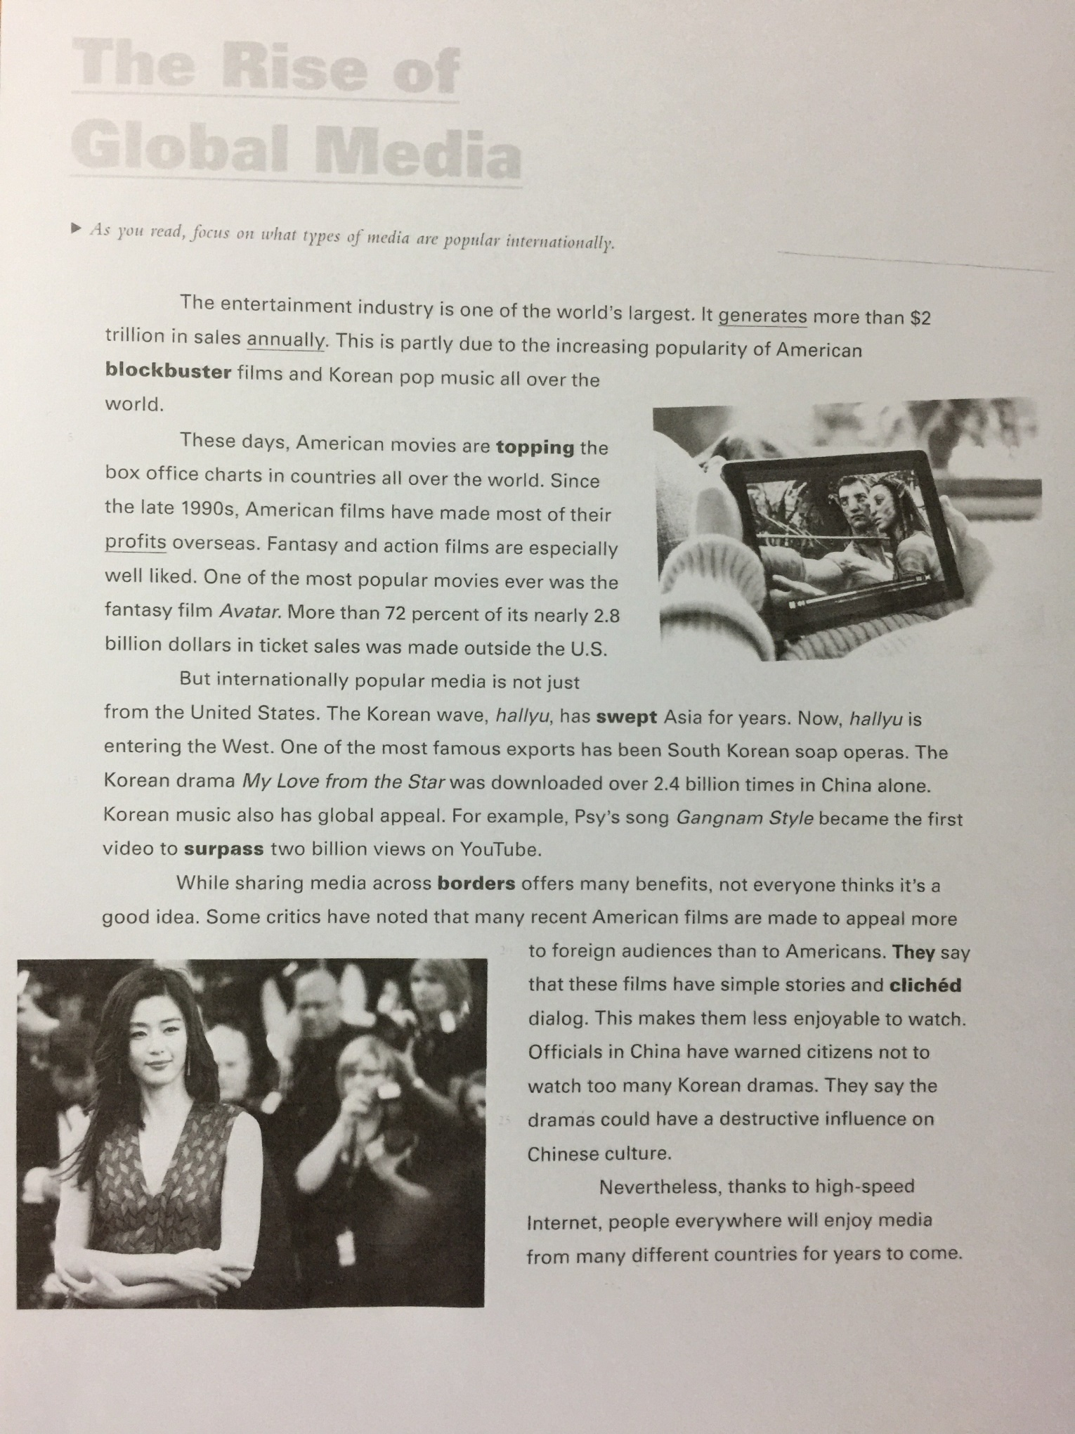
Worksheet 1

- ___________ : to go beyond an amount; to exceed
- ___________ : the line that separates two countries
- ___________ : based on frequently repeated phrases
- ___________ : to move across an area quickly and
easily
- ___________ : a very popular movie made with a big
budget
- ___________ : to be at the highest part or position of
something

Worksheet 2

- What is the passage mainly about?
- The most watched videos on YouTube
- Why the Korean wave is spreading to the West
- Media that many people around the world enjoy
- How globalization makes American movies worse

- What is the first video to surpass 2 billion views on YouTube?
- Baby – Justin Bieber
- Gangnam Style – PSY
- Firework – Katy Perry

- Why are some critics opposed to the globalization of American films?
- Because the movies feature foreign actors
- Because the American films are made to appeal to foreign audiences
- Because the movies will cost too much money to make
- Because the films will no longer be shown in America

- Why is the Chinese government telling people not to watch Korean dramas?

- Why do you think there are bad reasons about Global Media?

