☐ Listening ☐ Speaking ☐ Reading ☐ Grammar ☐ Writing

Topic: Learn about twins

Instructor:  Jean | Level:  False beginner | Students:  8 False beginners  (7-8yrs old ) | Length:  50min

Materials:

-Board and marker
-PPT for the paragraph and vocabulary of ‘We are twins’.
-Vocabulary flash cards
-mp3 file (Vocabulary, Reading paragraph file)
-8 copies of textsheets
-8 copies of worksheet to check comprehension
-youtube

Aims:
-Students can learn vocabulary related to We are twins’ reading
-Figuring out what is twin
-To understand questions from listening and reading.
-To check comprehension with worksheet after listening.
-To practice to choose correct sentence after listening and reading.
-To practice words by worksheet

Language Skills:
Reading : Worksheet
Listening :Listening the video clips and MP3file
Speaking :Discussion
Writing : Word practice

Language Systems:
- Lexis: Vocabulary
- Phonology: mp3 file, teacher’s talking, you tube
- Discourse: Conversation about topic and vocabulary
- Function: Introducing twins and sports.

Assumptions:
Students know they should speak in English only in class.
Students are confident with having a conversation even though not reading well.

Students already know:
-Students just finished phonics and sight words.
-Students know some vocabulary of personality.
-Students can speak and write in English but not very accuracy.
-Students are used to sit on the chairs and learning

Anticipated Errors and Solutions:

If Students are not able to understand what the video clips say
- They will listen to it repeatedly and teacher will explain
If Students might have some difficulties of listening and reading.
- Teacher can help them to explain with drawing in board or use flashcards
If Students don’t know the meaning of vocabulary
-Teacher will explain the meaning with flashcards.
Teacher will give to students more time to work on the worksheet.

References:
https://www.youtube.com/watch?v=tVlcKp3bWH8
https://youtu.be/JxgqJEGC9zE
Korean American Text book 미국교과서 길벗스쿨pg 11-14

Lead-In
Materials: youtube

Time | Set Up | Student Activity | Teacher Talk
3min  4min | Whole class | (Students are sitting on the chairs)  Singing a greeting song  watching the video | “Hello everyone. How are you?  Let say to hello to next you.”  (Sing a hello song with youtube)  “Now I am gonna show to youtube about some story. Let’s watch video and talk about it.”

Pre-Activity
Materials: PPT for vocabulary

Time | Set Up | Student Activity | Teacher Talk
10min | Whole  class | Watching the PPT  See the pictures and guess what they are. | “Now, look at the pictures. There are pictures about health and wellness  The first one, who are they?  Why are same ones there?  What do you see?  Have ever done this before?  And the second one, what does it look like?  Have ever seen this before?  In the fourth one, what are they doing?”  (Show the ppt without letter and one by one like this. Elicit vocabulary used to describe)

Main Activity
Materials: Board, markers, flash cards, mp3 file listening, reading text, comprehension, question work sheet

Time | Set Up | Student Activity | Teacher Talk
10min  1min  10min | Whole  Class | Listening Mp3 files and teacher will ask to students  Pairs  Predicting the theme with the  Images in Flash cards  SS is answering key questions to help broaden background knowledge. | Procedure  - Skimming for the main idea  CCQ:  “Did u understand the story?  “What is the story about?”  “Why do you think?”  (Distribute the reading text)  “Read it for 3min and let’s talk about it”  “Today we are going to learn about twins”  “Look at the picture. How are they alike?”  “How are they different?”  “Why can’t mama sometimes tell who we are?  “What makes us different?”  “Is it eye colors? Or Fingerprints?”  “Have u ever playing ping pong? or tennis?”  “Have u ever done finger prints?

Post Activity
Materials: worksheets, pencils

Time | Set Up | Student Activity | Teacher Talk
10min | individually | Check the blank in the correct sentences | “Now I will give u a worksheet. Read and choose the correct answers.”  CCQ:  “Do you work alone?”  “Do you read the text alone?”

SOS Activity
Materials: work sheets, board and marker

Time | Set Up | Student Activity | Teacher Talk
5min  5min | individually  Whole class | Word practicing  (SS will circle the words and fill out the blank)  Visualization  (SS will compare and contrast) | “I will give you a worksheet which has mixed letters. Please find the words today learn and write down under the matching picture”  Teacher will wrap up in the board and ask  “Which is different between twins?  Which are same between twins?”  Then write the answer after the SS said.
SCRIPT and TEXT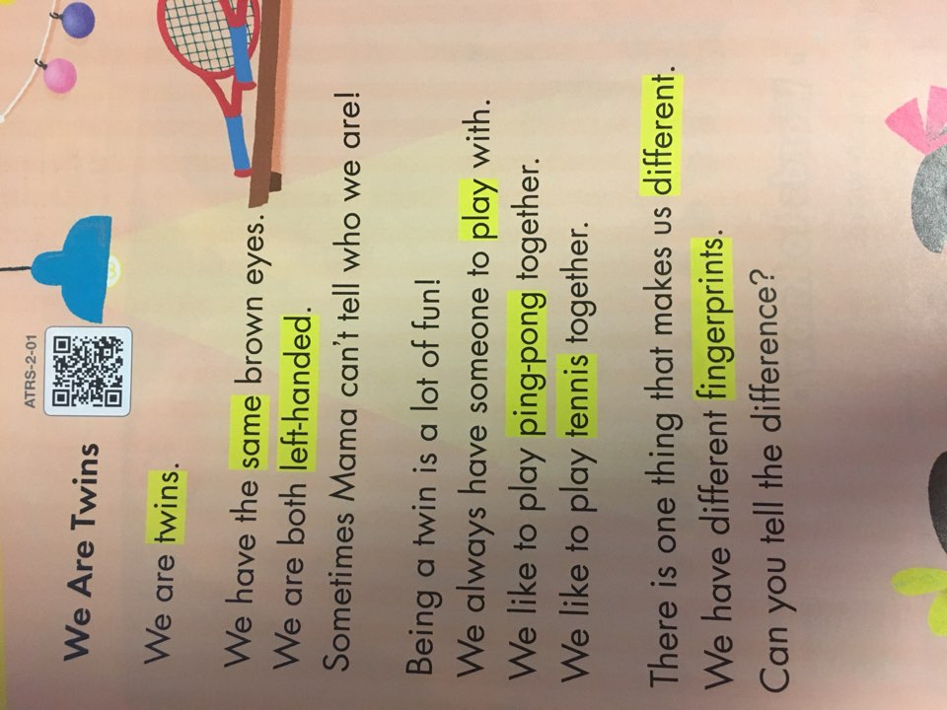
POST WORKSHEET 1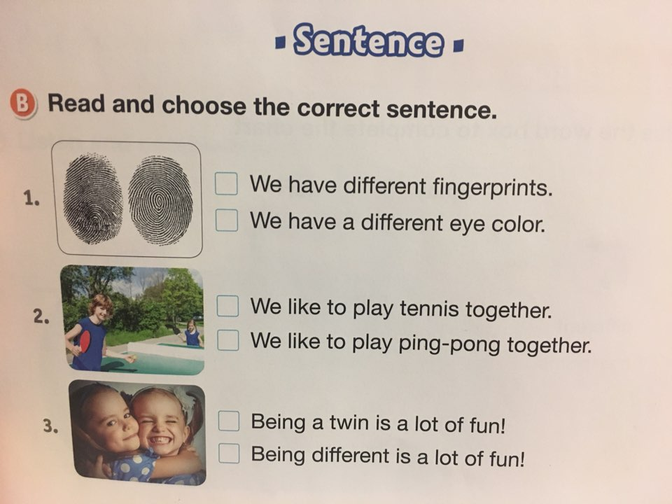
SOS WORKSHEET 1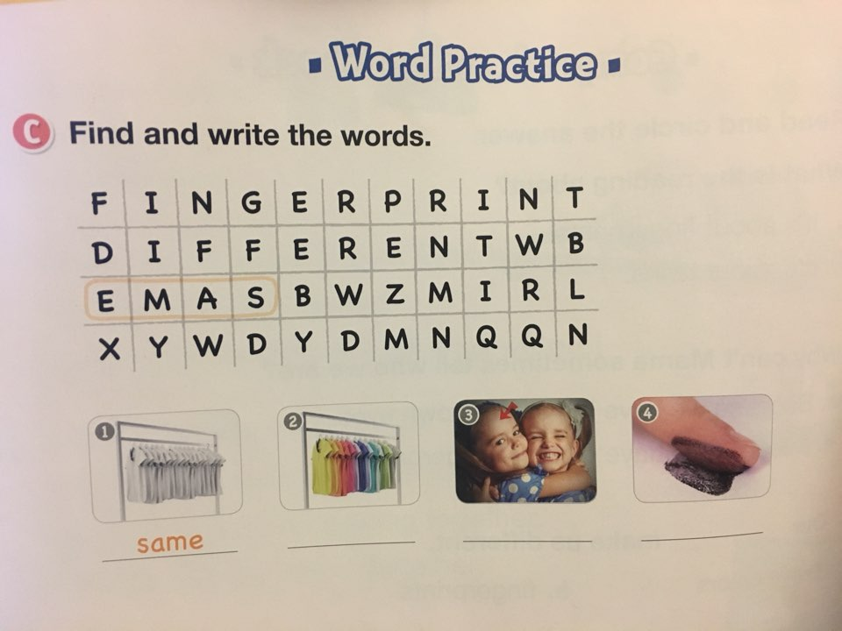 SOS WORKSHEET 2