☐ Listening ☐ Speaking ☐ Reading ☐ Grammar ☐ Writing

Topic:

Instructor:  Kang Jeon Gil (Joseph) | Level:  beginner | Students:  3+ students | Length:  30 min

Materials:
- Youtube video: 30 Places to Add to your Bucket List
- Powerpoint for the lesson
- Computer to play the video on
- Amazing places to visit worksheet
- Travel Bucket List worksheet
- Practice Worksheet
- Grammar worksheets

Aims:
- Get the students to learn about Simple Future Tense
- Students will learn the simple future tense “I will” by the teacher’s instructions, explanation, and classmates ideas.
- Students will practice simple future tense by practicing I will travel to…. and express their ideas freely.
- Students will also practice listening and speaking ability by talking with other students during discussions.

Language Skills:
- Reading: reading the worksheets given to the students in order to solve the problems and answer the discussion questions
- Listening: listening to the teachers instructions, and other student’s discussions
- Speaking: practicing to use simple future tense, and speaking out their own ideas
- Writing: writing on the worksheets, to answer the questions and write down their plans and ideas.

Language Systems
- Phonology: drilling, and practicing the use of simple future tense
- Grammar: learn the function of simple future tense
- Function: describing students idea of where they want to travel

Assumptions:
- Students have traveled at least once in their life, can be domestic or international.
- Students have some interest in traveling to different places in the world
- Students are adults that can travel by themselves
- Students have basic understanding of future tense

Anticipated Errors and Solutions:
- Students may not like traveling and not participate in the activity
-> I will encourage the students to think of a place they may want to visit, and explain to
them that it doesn’t have to be a different country, or a fancy place.
- Students may not understand the grammar right away to use it in the activity
-> I will try to use more examples to explain the grammar function to the student
- Students may be finished too early
-> I will have a SOS activity ready for the students to do additional activity.

References:
https://www.youtube.com/watch?v=vI7cV6jlv-M
https://pixabay.com/ko/%ED%95%AD%EA%B3%B5%EC%82%AC-%EB%B9%84%ED%96%89%EA%B8%B0-b-747-%EB%B9%84%ED%96%89%EA%B8%B0-%ED%95%AD%EA%B3%B5%EA%B8%B0-%EB%82%A0%EA%B0%9C-%EC%9D%B4%EB%AF%B8%EC%A7%80-%ED%88%AC%EB%AA%85%ED%95%9C-2943435/
https://www.flickr.com/photos/mmarchin/40261352

https://www.pinterest.co.kr/pin/459226493223813277/

https://www.flickr.com/photos/mmarchin/40261352

Lead-In/Pre-task
Materials: https://www.youtube.com/watch?v=vI7cV6jlv-M, computer to play video, Travel Bucket List worksheet

Time | Set Up | Student Activity | Teacher Talk
1 min  4 min  3 min | whole class | Students greet teacher  Students briefly talk about if they ever had these kind of moments where they would like to get away from everything.  Students will receive the worksheet and watch the video, as they are seeing the video they will write down on their worksheet. | procedure:  Hello everyone, did you all have a good week? (students greet back)  Lead-In  Do you ever feel tired from your life, and wish you could just get away from it all? Do you ever plan on going on a get away?  I know I always think about traveling, and wish that I had more time and money to do so. Let me show you this video which has a bucket list of many of the places that I would love to visit.  Guided Warmer Activity  While watching the video try to write down some of the interesting places that you saw that you would also want to visit. (hand out the Travel Bucket List worksheet)  CCQ:  What should we do when we watch the video?

Pre-Activity/Present/Task Preparation
Materials: Powerpoint for the lesson,

Time | Set Up | Student Activity | Teacher Talk
5 min  4 min | whole class / in groups | The students will discuss with each other on, which places seemed most interesting. And also talk about which places they would actually like to visit.  Have the students present where they would like to visit the most, and have them talk about why they would like to go there. | Procedure:  - Discuss in group  Did you like the video? Were there some places that you saw that you never knew existed? which countries seemed most interesting to you? I want you to discuss with the classmates on which countries seemed most interesting. Discuss which countries you would visit if you could. Share your Travel bucket list with other students.  II. Discuss with student  So what did you talk about with each other? could each person talk about where you would like to visit the most?  III. Conclude  Great job everyone, we just learned simple future tense. Simple future tense refers to a time later than now. It is a verb tense that is used to talk about things that haven’t happened yet. We will discuss further into simple future tense, and practice using it in a functional sentence.

Main Activity/Practice/Task Realization
Materials: Powerpoint for the lesson, Practice worksheets, Grammar worksheets, amazing places to visit worksheet

Time | Set Up | Student Activity | Teacher Talk
3 min  3 min  4 min | Whole class | Students will receive the practice worksheets and study them as the teacher is speaking.  The students will repeat after the teacher at first  Students will fill in the substitution table on the worksheet using the places they have chosen during discussion.  Then they will speak out their own chosen place using the simple future tense form.  Students will solve the grammar worksheet, then answer the questions when asked to by the teacher. | Procedure:  As I said before simple future tense is simply something that hasn’t happened yet and will happen in the future. So in this case we will talk about where we will travel to in the future. using the sentence  “I will travel to (place/country) in (time).  Then show the students Substitution table on the powerpoint, then continue to write on the board to explain further.  Also explain the simple future form of  Will + verb  and contractions  I will = I’ll  We will = we’ll  you will = you’ll  He will = he’ll  She will = she’ll  they will = they’ll  (Hand out the practice worksheets and amazing places to visit worksheet)  Okay everyone, can you see what the basic patterns are? You can also see them closely on your own worksheets.  Now imagine that you have million dollars, and all the time in the world, I will give you some time please fill in the table with places that you would like to visit, and when you would like to visit.  Could each of you tell the class where you would like to travel to using the substitution table?  Now I am going to give you the grammar worksheet, solve the questions 1 to 10 choose the correct answers individually. I will give you 2 minutes.  (give the students the worksheets)  We will go over the questions together as a class, I will ask one of the students for answer at random.

Post Activity/Production/Post Task
Materials: Practice worksheet bottom part

Time | Set Up | Student Activity | Teacher Talk
3 min | whole class | Students will freely, discuss with other students on what they plan on doing in the future.  Topics can be broad and be about anything! | Free practice  Instruction  Now, let’s use simple future tense in our made up situation, it doesn’t have to be traveling. Let’s talk to each other on what we would like to do in the future, it can be anything. (ex. I will go see you movie tomorrow, I will see a friend next tuesday etc….)  Wrap up  Did you have fun today? I hope you all enjoyed the lesson today, and have understood how to use simple future tense in real life! see you again in our next class.

SOS Activity (in case you finish more quickly than you thought)
Materials: nothing

Time | Set Up | Student Activity | Teacher Talk
 |  | continue to discuss what the students will do in the future, continuing on from the post task. | So is there anything else that you wish to do in the future? let’s continue to discuss with our classmates.

Practice Worksheet

Who | future tense | Verb | place | time
I | will | travel to | Korea | next month

I will _____________________________________

I will _____________________________________
My Travel Bucket List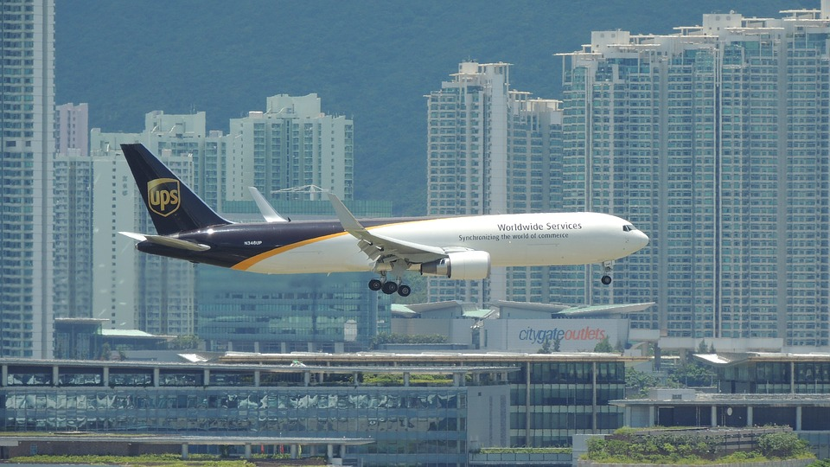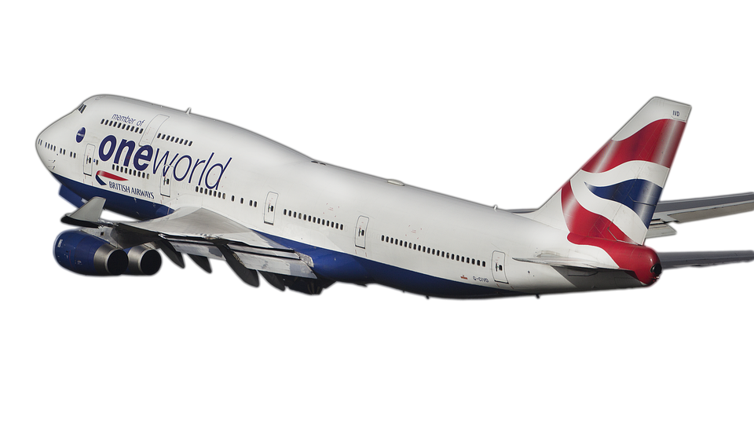
1.
2.
3.
4.
5.
6.
7.
8.
9.
10.
Grammar Worksheet

Correct the following statements into simple future tense.

1. I go see a movie tomorrow with my friends.

_____________________________________________.

2. He ate with my sister next thursday.

_____________________________________________.

3. She will visited the park next monday.

_____________________________________________.

4. They calling me next morning for an appointment.

_____________________________________________.

5. We will going to Canada next year.

_____________________________________________.
Amazing Places to visit

Trolltunga, Norway /The Galapagos Islands / Fingals Cave, Scotland
Tianzi Mountains, China/ The Faroe Islands / Eretat, France
Santorini, Greece / Socotra, Yemen / Antelope Canyon, Arizona
Aogashima Volcano, Japan / The Atltantic Road, Norway
Beachy Head, England / The Blue Hole Skydive Belize
Blue Lagoon, Iceland / Bora Bora vlog / Cathedral Cove, New Zealand
Cinque Terre, Italy / x Dubai skydive / Giants Causeway Ireland
Glass Beach, California / Ha Long, Vietnam
Horsetail Yosemite Park/ Hvitserkur, Iceland/Jacobs Well, Texas
Key West, Florida / Lake Hillier Australia / Lake Myvatn, Iceland
Mamanuca, Fiji / Utah National Park / Iceland Nothern Lights
Palau Islands French Polynesia / Pamukkale Turkey
Panjin China Red Flowers / Patagonia Caves / Machu Picchu Peru Hike
Petra Jordan Hike Wonder / Preikestolen Norway view
Rio de Janeiro travel guide / Split Pinnacle China amazing
Shifen Waterfall / Sea Caves of Malta spain / Saint Lucia beautiful
Stairway to Heaven Iceland / Taj Mahal travelling
The Pyramids cairo travel guide / The Maldives things to do
Tuscany Italy / Venice Italy / Yellowstone National Park
Zion national park USA America

