☐ Listening ☐ Speaking ☐ Reading ☐ Grammar ☐ Writing

Topic: Simple Present Tense - Expressing a habit

Instructor:  John | Level:  Beginner | Students:  3 | Length:  35 min

Materials:
- Presentation slides
- Projector
- Work assignments
- Grammar board game

Aims:

- To improve students’ ability to understand present tense
- Also to show concept of third person
- To show how third person singular conjugation in present tense

Language Skills:

- Listening - students will have to listen to the teacher explaining the present tense
- Reading - students will have to read the text on the slides and assignment
- Writing - student will have to solve the problems on the assignment
- Speaking - student will have to follow along the pronunciation during the lesson

Language Systems:
- Discourse - how words are used in the presentation slides and worksheet assignment
- Function - how to express you routine habits
- Lexis - vocabularies of the verbs we are going to use in the lesson
- Grammar - how the verb changes when being used by third person singular
- Phonology - how the conjugated verbs will sound in a speech

Assumptions:
- students already know
  - pronouns such as subject pronouns of I, you, he. and object pronouns of me, you, him
  - subject-verb-object rule of grammar to form a sentence in English
  - many other verbs

Anticipated Errors and Solutions:
- Student might not have understood the concept of third person
  - teacher will show realia as example
- student might have the knowledge of third person, but has never thought about it
  - going over it in class as a review
- students might be confused about concept of conjugation
  - teacher show example like: I talk, she talks. also shows how and when to conjugate

References:
- https://dkru86weszx9t.cloudfront.net/blog/wp-content/uploads/2016/11/first-second-third-person-grammar-.jpg third person picture
- http://highschool.latimes.com/corona-del-mar-high-school/8-tips-for-waking-up-early-in-the-morning/ waking up picture
- http://moziru.com/explore/Chart%20clipart%20washing%20face/#go_post_4598_chart-clipart-washing-face-4.jpg washing face
- https://cdn3.iconfinder.com/data/icons/kids-flat-colorful/2048/5521_-_Brushing_Hair-512.png brush hair
- https://thumbs.dreamstime.com/b/little-girl-happy-to-eat-breakfast-morning-96206188.jpg eating breakfast
- https://www.eplaneteducation.com/wp-content/uploads/2016/11/For-Facebook-and-Blog-1.png adverb of frequency pyramid
- https://en.islcollective.com/preview/201001/m/board-game-how-often-fun-activities-games_862_1.jpg board game

Lead-In/Pre-task
Materials: n/a

Time | Set Up | Student Activity | Teacher Talk
3min | whole class | - class listen to the teacher and introduce themselves to other classmates (just the name should be fine) | teacher will start the start the class with small introduction allowing all students to introduce themselves, like their names

Pre-Activity/Present/Task Preparation
Materials: n/a

Time | Set Up | Student Activity | Teacher Talk
5min | whole class | - small discussion between teacher and students | Introduction  Teacher then ask students how often they eat out, or other activities. Afterwards ask second student what does the first student like to eat. and ask him/her if he noticed the verb conjugation.  CCQ  Do you guys cook or eat out?  How often do you eat out?  did you listen to him/her?  How often does she…?  Where do you think am I going with this?  Revelation  Tell the class that we just used the simple present tense form in English grammar to answer the question.

Main Activity/Practice/Task Realization
Materials: Projector to show presentation slides,

Time | Set Up | Student Activity | Teacher Talk
5min  5min  5min | whole class  whole class  whole class | - students see the presentation and answers teacher’s questions  - students answer teacher’s questions. | Presentation  show the class in what ways the simple present tense is being used in English grammar. but tell the class be verb is in a class of itself so today we are only going to learn about expressing a habit.  CCQ  do you guys notice the -s in some of the verbs?  why do you think there is -s?  Explanation  explain to the class that -s is the result of conjugation in English grammar, and that it only effects third person singular verbs, then explain the concept of third person.  Conjugation  - Quickly go over the class how to conjugate verbs in third person singular.  - Explains that there are some orders in conjugation.  Frequency  - Go over adverb of frequency.  - explain to the class how often you do certain habits. ranging from never to always.  Example activity  show the class normal morning routine and ask them how often do you do these activity. then do small activity where the teacher ask the some concept checking questions expressing their morning routine and asking students to answer in third person too.  CCQ  How often do you wake up in the morning? like do you ever sleep late until afternoon?  How often do you wash your face in the morning, or how often do you take a shower in the morning?  do you hear what your classmate said? how often does he/ she does ….?  End of Slide  end the presentation and began transitioning to board game  well that is it for the presentation, so how about we enjoy some of this board game?

Post Activity/Production/Post Task
Materials: Board Game

Time | Set Up | Student Activity | Teacher Talk
7 min | whole class | - students play the board game | Introduction  Tell the class the rules for board game  - roll a dice and ask your classmate a question based on a tile you landed on.  - do it untill everyone reaches finish line.  - there is no winner. students should help each other finish the game.  CCQ  how often do you eat pizza?  do you go surfing everyday?  Conclusion  end the class with conclusion asking if everyone enjoyed today’s lesson.

SOS Activity (in case you finish more quickly than you thought)
Materials: Assignment

Time | Set Up | Student Activity | Teacher Talk
5min | whole class | - students solves the assignment problem together as a class | Assignment  tell the class that board game ended faster than expected, so offers to do some quick worksheet assignment as a class
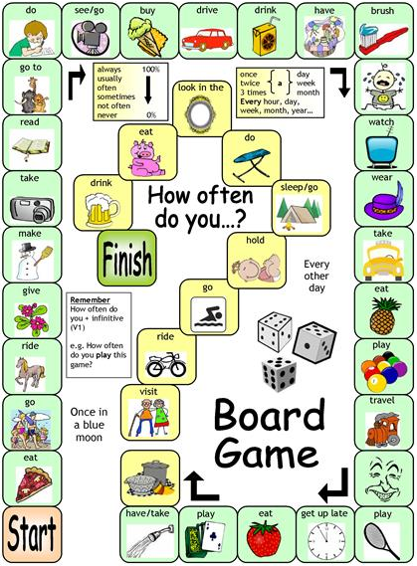
How often worksheet

I | often | Eat Hamburger | Once a week
He | usually
sally |  | Takes shower | Everyday
 |  | Wears scarf
 |  | Go to the movies | On Thursday
They | Never
We | Sometimes
 | Never | Goes fishing
 |  | Drink beer

