☐ Listening ☐ Speaking ☐ Reading ■ Grammar ☐ Writing

Topic: There Is vs. There Are

Instructor:  Heerae, Marsha | Level:  High Beginner | Students:  10 | Length:  40 Minutes

Materials:
● Realia : Several pens and cups
● 10 copies of the practice worksheet #1
● White board and board markers.
● 10 copies of different pictures A & B as worksheet #2
● SOS activity worksheet #3 (10 copies)

Aims:
● Main aim: Students will be able to improve their grammar skills by practicing grammar forms in the worksheets.
● Secondary aim: Students will learn singular, plural and negative forms through drilling.
● Personal aim: I want students to speak when students express singular and plural words, they can express it directly without thinking by repeated learning.

Language Skills:
● Listening: Ss will listen to the partner’s sentences, others’ presentations and follow instructions.
● Speaking: Ss will drill the grammar forms (There is/are and negative phrases) and present their own expressions in the worksheets
● Reading: Ss will read teacher's writing on the board, reading the worksheet's sentences.
● Writing: Ss will take notes their own expressions about there is/are phrases.

Language Systems:
● Grammar: Present tenses. The change of be verb.
● Function: Make sentences Usage of proper sentences according to situations
● Discourse: Descriptions of pictures in the pair working

Assumptions:
Student already know
● What is the usage of singular and plural forms.
● What are the singular and plural words
● Various nouns
● How to make sentences and make negative statements.
● How to distinguish the forms of words.(ex, noun, verb, adjective, ect.)
● Which partner/group they belong to in partner and group discussion time

Anticipated Errors and Solutions:
If the students need to help to find the meaning of new vocabularies more than two time,
- I will allow them to use a dictionary.
If the students have troubles with making their own sentences.
- I will allow them to ask me help.

References:
●English definitions
https://www.google.co.kr/
https://www.grammarly.com/blog/there-is-there-are/
●Worksheet
https://pages-to-print.download/look-and-find-printables/

Lead-In
Materials: None
Time | Set Up | Student Activity | Teacher Talk
1min | Whole  class | Answering teacher’s questions. | Procedure:  -Good morning! How are you today?  -At the last time, we’ve learned “This is and These are phrases, negative forms as well”  -Now you guys know what the meaning of singular, plural and negative forms are, right?

Pre-Activity
Materials: Several pens and cups, a white board and board markers.
Time | Set Up | Student Activity | Teacher Talk
3min  2min  1min | Whole  class  Whole  class  Whole  class | Answering teacher’s questions.  Students are repeating  after teacher reading  Answering teacher’s question. | Procedure:  - Brainstorming  Elicit  -Look there!  (Pun a pen on the desk. And ask the students)  -What is there?  -Yes, Right. There is a pen.  (Put the pen on the desk, again hold a pen on a hand)  -And. What about now?  -Is there a pen on the desk?  -No. There is not a pen on the desk.  -There is a pen on my hand.  -And one more!  (Put the two cups on the desk)  -What are there?  -Yes, right. Cups  -Not only one. These are two.  -Are there cups on the desk?  -Yes! There are two cups on the desk.  (Get those cups away from the desk and ask again)  -What about now? Are those cups on the desk?  -No, there are not cups on the desk.  -Good job!!  Model  (Write the topic “There Is vs. There Are” on the board.”)  -From now! Let’s look at the board!  -We are going to learn “There Is vs. There Are”  -And negative forms too.  (Write the grammar form)  There is a pen On the desk  is not  There are pens On the desk  are not  -Okay, Look at these sentences and repeat after me.  ( read first and make students to follow)  -And we can also change many nouns in a pen or pens positions.  -For example a cup or cups.  -OK. Let me ask you some questions  CCQ  -Is there a bird in this classroom? No  -Are there many books in this classroom? Yes  -There is a chair or there are many chairs?  There are many chairs  Meaning  -Good job everyone.  -We have just learned how to express singular and plural forms and how to use negative forms too.

Main Activity
Materials: Worksheet #1
Time | Set Up | Student Activity | Teacher Talk
1min  3min  2min  1min  6min  1min  6min | Whole Class  Pairs  Whole  class  Whole  class  Whole  class  Whole  class  Whole  class | Answering teacher’s questions.  Students fill in the worksheet with partner  Students are reading answers  Students are listening how to play game.  Students are playing a game.  Students are listening how to play game.  Students are playing a game. | - Controlled practice : Worksheet #1  Instruction  -OK. Now I’ll hand out some worksheets.  (Distribute the worksheet #1)  -Let’s fill in the worksheet #1  Demonstration  -Everyone got the worksheet?  -Look at the example.  -First is a positive sentence.  -Can you read the example sentence in the box?  -OK. Next sentence will be changed to a negative sentence.  -Let’s read the next sentence.  -You may solve these problems with this way. OK?  -And then look at the pictures lower side of the worksheet  -And fill it in the blanks with your partner.  (Arrange students into pairs)  -I’ll give you 3 minutes to finish.  -All right!  ICQ  How much time do you have?  Are you working in pairs?  What should you do with your partner?  Okay, let’s start  Monitoring  (Walk around the classroom. Check whether the students have questions or not)  (Give time warnings: You have 1 minute left)  (Give time warnings: You have 30 seconds left)  Check Answers  -Okay, everyone, the time is up.  -Let’s check the answers and read together.  -Okay good job everyone.  - Less controlled practice : chain drill  Instruction  -Now we’ll start a game together.  -We are going to use there is/are with the items in this classroom.  -But don’t use the items the previous person chose.  Demonstration  -For example, there is a board. Or there are markers.  -And next person will say a different item using there is or there are phrases.  (indicate someone)  -Everyone understand?  ICQ  -What will we do right now?  -Are we working with pairs? No all together  -Can we use the same items?  -Okay, let’s start from 00.  -Start!  Monitoring  (During students speaking if they are wrong for using singular or plural sentences, correct them.)  (Finish the activity)  -All right!  -We will resume  -At this time, We will find there is not something in this classroom or there are not blah blah…. in this classroom.  Demonstration  -For example, there is not a car in this classroom.  -Or there are not cars in this classroom.  -Everyone understand?  -From this time we will change the start point.  -Let’s start from 00.  (indicate someone)  ICQ  -What will we do now?  -Start from whom?  -Let’s start from 00. OK?  -Start!  Monitoring  (During students speaking if they are wrong for using singular or plural sentences, correct them.)  (Finish the activity)  -All right! Everyone good job.

Post Activity
Materials: Worksheet #2 (10 copies)
Time | Set Up | Student Activity | Teacher Talk
1min  4min  2min  1min | Whole class  Pairs  Whole  class  Whole class | Students listen teacher’s instruction  Students in pairs talk about the pictures  Students answer together about the differences of pictures  Students will mention about today’s activity | - Free practice : Worksheet #2  Instruction:  -I’ll give you a picture.  -Hold on. Don’t see your picture yet.  (Hand out 2kinds of pictures to students alternately.)  -There are different kinds of pictures from your partner.  -And you will talk with your partner.  -Don’t show those pictures to each other.  Demonstration  -There are picture A, picture B  -For example, I have a picture A there is a bird.  -Partner holding Picture B checks if there is or there is not a bird.  -Picture A there is a bird, but in the picture B there is not a bird.  -These are differences. Right?  -You should write these sentences on your worksheet.  -How many differences there are between A and B?  -I’ll give you 4 minutes.  ICQ  -How much time do you have?  -Are you work alone?  -What should you do with your partner?  -Do you write the same answer?  -Do you show your picture to your partner?  -OK. Let’s start!  Monitoring  (Monitor discreetly, Answer students questions if they have)  (After 4 minutes)  (Give time warnings: You have 1 minute left)  -Time’s up.  Check Answers  -How many different things did you guys find?  -Let’s talk together!  (Asking students)  - Conclusion  (Conclude today’s lesson by checking the newly learned.)  (Then pick out grammatical and pronunciation errors the students made, and correct them)  -Everyone, you did a great job today, try to keep in mind the grammar “There is and There is not” and “There are and There are not.”.  - Feed back  -How was the class? Was it difficult or did you have fun today?  -I hope you can use this expression in real life.  -Thank you for participating in class and have a good day.

SOS Activity
Materials: Worksheet #3 (10 copies)
Time | Set Up | Student Activity | Teacher Talk
8min | Individually | Students find out hidden pictures | - Hidden pictures  Instruction  Now, we are going to find the things in the drawing.  Work individually please. You will have 8 minutes to do so.  (Hand out the worksheet #3)  ICQ  Are you working in groups?  How much time do you have?  What can you do?

Worksheet #1
♥ Let’s fill in the blank and change the sentences to negative sentences like an example.
Ex) There are two birds in the tress.========There are not(aren’t) two birds in the trees.
1) There _____ seven people in my family. |  | There _____ seven people in my family.
2) There _____ a fridge in your kitchen. |  | There _____ a fridge in your kitchen.
3) There _____ two trees in my yard. |  | There _____ two trees in my yard.
4) There _____ a teacher in this classroom. |  | There _____ a teacher in this classroom.
5) There _____ many people in the station. |  | There _____ many people in the station.

♥ Complete the blank and answer the questions
1. Complete with there is/ there are
_____________ a t-shirt on the bad.
_____________ two books on the floor.
_____________ a scarf on the floor
_____________ four pictures on the wall.
_____________ many books on the shelves.
_____________ a book on the bed.
_____________ a laptop on the floor.
_____________ some papers on the floor
2. Answer Yes, there is/are or No, there isn’t/aren’t
Are there any eggs in the fridge?_____________
Are there any onions in the fridge?___________
Is there any lettuce in the fridge?_____________
Is there any milk in the fridge?_______________
Are there any bananas in the fridge?__________
Is there a cake in the fridge?_________________
Is there any pizza in the fridge?_______________

Worksheet #2

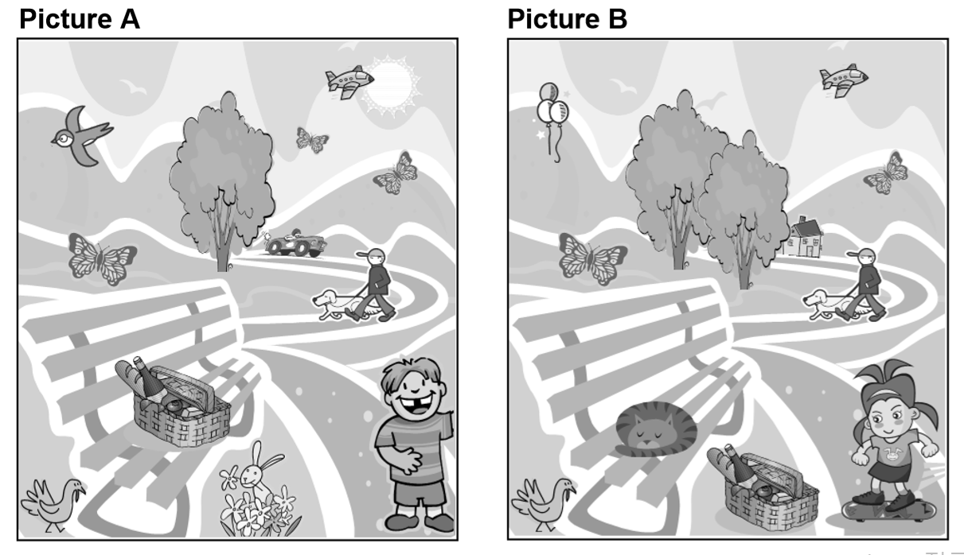

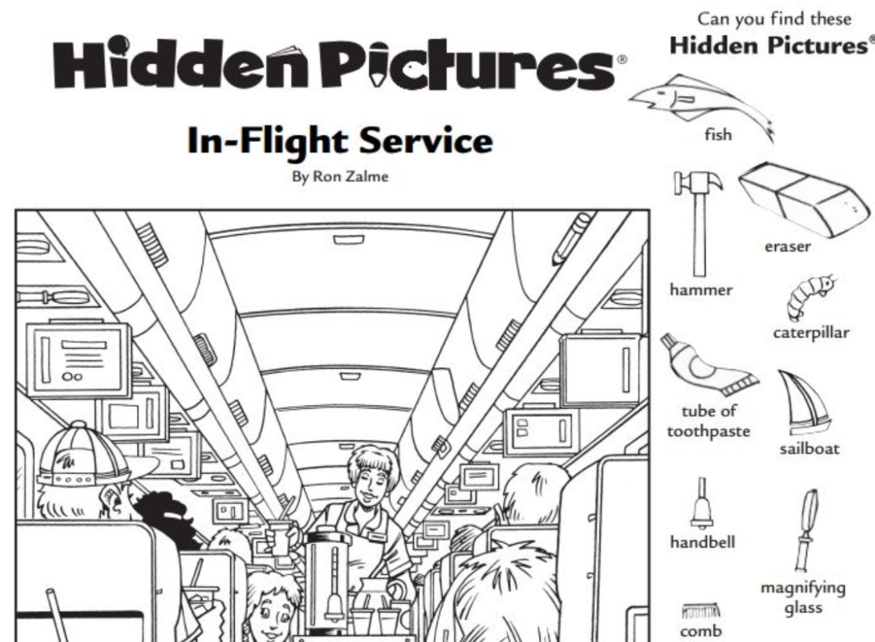
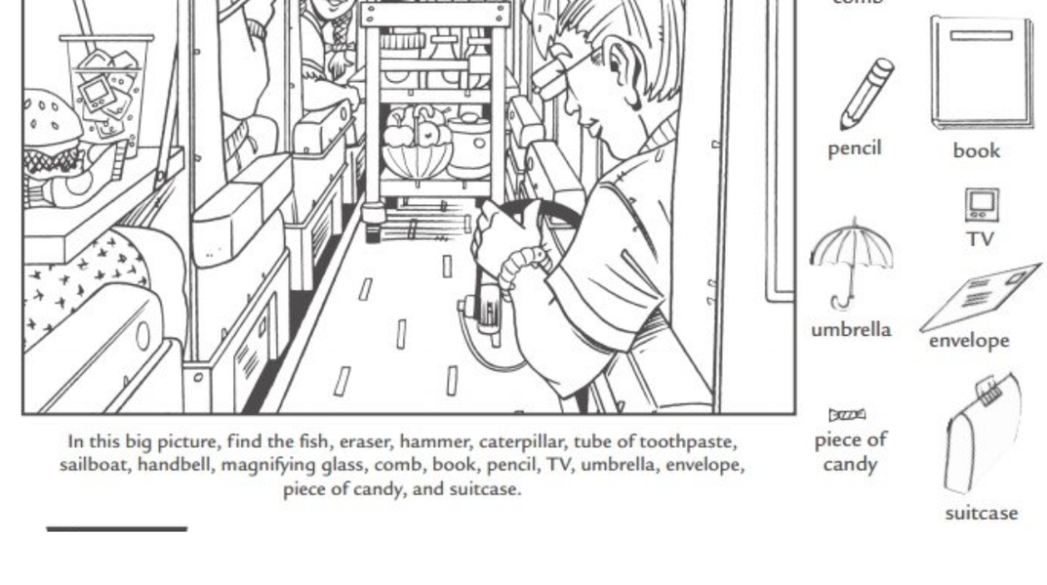
Worksheet #3 : ♡ Find the 16 things that are hiding in this drawing.

Answer sheet
- Worksheet #1
1) There are seven people in my family. |  | There aren’t seven people in my family.
2) There is a fridge in your kitchen. |  | There isn’t a fridge in your kitchen.
3) There are two trees in my yard. |  | There aren’t two trees in my yard.
4) There is a teacher in this classroom. |  | There isn’t a teacher in this classroom.
5) There are many people in the station. |  | There aren’t many people in the station.
1. Complete with there is/ there are
There is a t-shirt on the bad.
There are two books on the floor.
There is a scarf on the floor
There are four pictures on the wall.
There are many books on the shelves.
There is a book on the bed.
There is a laptop on the floor.
There are some papers on the floor
2. Answer Yes, there is/are or No, there isn’t/aren’t
Are there any eggs in the fridge? Yes, there are.
Are there any onions in the fridge? No, there aren’t
Is there any lettuce in the fridge? No, there isn’t
Is there any milk in the fridge? Yes, there is
Are there any bananas in the fridge? Yes, there are.
Is there a cake in the fridge? Yes, there is
Is there any pizza in the fridge? No, there aren’t

