☐ Listening ■ Speaking ☐ Reading ☐ Grammar ☐ Writing

Topic: How to describe animals appearance

Instructor:  Marsha | Level:  Intermediate  (Elementary student) | Students:  12 | Length:  35 Minutes

Materials:
● Realia : Audio file (animal sound)
● Worksheet #2 :6 copies animals appearance description card & animals name
(1 copy for each pair)
● White board and board markers.
● Vocabulary worksheet #1.(12 copies)
● Discussion worksheet #3 (12 copies)
● Cellphone for audio file ( for animals sound )

Aims:
● Main aim: Students will be able to improve their speaking skill by speaking and matching the target language in a game.
● Secondary aim: Students will develop their ability to speak about animal appearances by writing them down and describing it to each other using the new target language.
● Personal aim: Through activities with partners, students can improve their speaking, listening, and social skills, as well as cooperating with others

Language Skills:
●Listening: Ss will drill new vocabulary, follow instructions, and match sounds in a game.
●Speaking: Ss will do a matching game and discussion.
●Reading: Ss will read descriptions about animal appearances description.
●Writing: Ss will take notes on animal appearances and fill out worksheets.

Language Systems:
●Lexis: New vocabularies from the role play card.
(Tail, Flesh, Temper, Stripe, Color-blind, Bark, Look like, Flat, Ox, Spot, Forelimb)
●Grammar: Present Tense, Expression of description.(I have~, I live in~, I can~ .etc)
●Function: Giving descriptions.
●Discourse: Encyclopedia

Assumptions:
Student already know
● How the class is organized and operated (Pair-work)
● Name of animals
● Animals appearance
● Which partner/group they belong to in for partner and group discussion time

Anticipated Errors and Solutions:
If the students need to help finding the meaning of new vocabularies more than two time,
- I will allow them to use dictionary.
If the students have trouble with finding answers
- I will allow them to get help from partner.
If the students find difficulty to matching words on the word search activity,
- I will demonstrate one or two words by circling them.

References:
●English definitions
https://www.google.co.kr/
●Animal description.
https://blog.naver.com/homerunengl/90117471417
https://blog.naver.com/homerunengl/90117365651
●Animal sound
Application of “animal sound”

Lead-In
Materials: None
Time | Set Up | Student Activity | Teacher Talk
1min | Whole  class | Answering teacher’s question. | Procedure:  Good morning! How are you today?  Do you like animals?  What kind of animal do you like?  If you could hear animal sounds, could you guess which animal it is?  How else can animals be explained?

Pre-Activity
Materials: Computer for audio file (About animals sounds ), Worksheet #1, White board and board markers.
Time | Set Up | Student Activity | Teacher Talk
3min  3min  1 min  1min  2min  2min | Whole  class  Pairs  Whole  Class  Whole Class  Pairs  Whole Class | Listing and answering teacher’s question  Students complete Worksheet#1  Student check the answers together  Answering teacher’s question  Students in pairs talk about teacher’s question  Students speak their answer. | Procedure:  - Brainstorming  Elicit  ( play the audio file #1 )  What kind of is this sound? →Animals  ( Play the audio file #2 )  What sound is it? → Chicken  Why do you think it is chicken?  The answer is hen. Okay next.  ( Play the audio file #3 )  What about this sound? → lion  It is puma’s sound.  Why are you saying the wrong answer?  (expected the answer: sound is not enough to get a perfect answer.)  Model  (Write the topic “how to describe animals’ appearance” on the board.”)  We are going to learn “how to describe animals’ appearance”  - Vocabulary : Matching Worksheet #1  Instruction  “We are going to learn the new vocabulary before learning to describe animal appearance. I will give you a worksheet. First, read the definitions of word and then match it with the correct word. I’ll give you 3 minutes to finish, Work together with your partner.”  (Arranged students into pairs)  (Distribute the worksheet #1)  Demonstration  Everyone look at worksheet #1. Let’s solve #1 together. What can be … right….  Now, work with your partner and if you and your partner don’t know the answer, just guess together! I’ll give you 3 minutes to finish.  ICQ  How much time do you have?  Are you working in pairs?  What should you do with your partner?  What to do If you and your partner don’t know the answer? →just guess together  Monitoring  (Walk around the classroom. Check whether the students have questions or not)  (Give time warnings: You have 1 minute left)  Check Answers  “Okay, everyone, the time is up. Let’s check the answers together. See your prediction is right or wrong.”  - Prediction  Introduction  Let’s think about, if you have to explain about an animal, and only in English, how would you do it? What could you do?  For example, if you have to explain a “Hen”  What would you say?  I’ll give you 2 minutes. Work together with your partners.  Demonstration  For example, if you describe ”Deer”  What can we say? How many legs does it have?(four)  I have four legs. How do they run? Fast? Slow?  I can run very fast.  Now, work with your partner. I’ll give you 2 minutes to finish.  ICQ  How much time do you have?  Are you working alone?  What should you do with your partner?  Let’s start  (monitor students)  (after 2 minute)  Check answer  Okay, time is up. Let’s discuss together  Who wants to be the volunteer?  (Example of describe - I have wings, but I cannot fly. I usually live in the farm. I bring forth eggs.  I am a female chicken.)  Today we will learn how to describe animals through a game.

Main Activity
Materials: Worksheet #2 : animals name & appearance descriptions cards 6copies ( 1 copy for each pair.) , worksheet #2-1
Time | Set Up | Student Activity | Teacher Talk
3min  7min  1min  1min | Whole Class  Pairs  Pairs  Whole Class | Students listen to how to play main-activity  Students are answering  Students are playing game with partner  Students check the answer with partner  Students are asking | - Talk about animal names and descriptions  Instruction  Now, we’re going to do a real practice with your partner. Each person gets six animal names and descriptions, and then one person reads a description and the other write down the name of the animal.  One has 1 to 10, the other has 11 to 20  (write on the board “I have~, I live in~, I can~, What am I?”) “You can use this form for descriptions and questions.”  “Listen carefully to your partner and find out what is it. Don’t show each other’s cards while you are playing the game.”  After you read the descriptions, use the question “What am I?”  You guys have 7 minutes. Work with your partner. If you don’t know the vocabulary or animals name, you can search the dictionary on your phone.  (Distribute to each pair of cards with the animals name & appearance descriptions)  Demonstration  Let’s do it together each part one  (read W/S #2 card number 1 # Lion)  Question “What am I?”  ICQ  How much time do you have?  Are you working in pairs?  What should you do with your partners?  Do you write the answer or not?  Everyone understand? Okay... Let’s start  Monitoring  Monitor discreetly, Answer students if they ask questions  (Give time warnings: You have 2 minutes left)  (Give time warnings: You have 1 minute left)  Check answer  Okay, time is up. Check your answers with your partner.  (After 1 minutes)  If you are unsure about the answer, let’s discuss together.  (waiting ask, if there is no question from the student, after 1 minutes do next step)

Post Activity
Materials: Worksheet #3
Time | Set Up | Student Activity | Teacher Talk
4min  4min  1min  1 min | Group  Whole Class  Whole class  Whole class | Students in groups talk about the discussion topic.  Presenters present their conclusion  Students listen and answer to the teachers’ question  Students will mentions about today’s activity | - Discussion  Instruction:  (There are 3 in each group. Write down the topic of the discussion on the board as I introduce it.- What am I living in the sea?)  Each group will discuss  “Let's describe the things that live in the sea.”  Your group should describe one or more. And at least three things write for each one.  Each group needs a reporter to present yours.  I will give you 4 minutes to discuss  ICQ  Are you working in groups?  What do you need to discuss?  Do you need a writer and a reporter to present?  “Let’s start”  Monitoring  Monitor discreetly, Answer students if they ask questions  (After 4 minutes..)  Time’s up  - Sharing  One person of each group presents your group’s conclusion.  Presenter, keep it simple and short. Audience,  show respect to the presenter and pay attention.  - Conclusion  (Conclude today’s lesson by checking the newly learned vocabulary and their understanding of the topic. Then pick out grammatical and pronunciation errors the students made, and correct them)  “Everyone, you did a great job today, try to keep in mind the content and vocabulary we learned today”  - Feed back  “How was the class? What do you feel of the new topic? Can you use the words you learned today to describe something?”  “Thank you for participating in class and have a good day.”

SOS Activity
Materials: Worksheet #3 (12 copies)
Time | Set Up | Student Activity | Teacher Talk
5min | Individually | Students find out hidden animals | - Hidden animals search  Instruction  Now, we are going to find the animals in the drawing.  Work individually please. You will have 5 minutes to do so.  (Hand out the worksheet #3)  ICQ  Are you working in groups?  How much time do you have?  What can you do?

Worksheet #1
♡Match the right meaning and word
1. An animal, bird, or fish is the part extending beyond the end of its body. |  |  | a. spot
2. The way that they are behaving shows that they are feeling angry and impatient. |  |  | b. flesh
3. Typically of the same width throughout its length, differing in color or texture from the surface on either side of it. |  |  | c. stripe
4. The soft part of a person's or animal's body between the bones and the skin. |  |  | d. OX
5. The sharp explosive cry of certain animals, especially a dog, fox, or seal. |  |  | e. tail
6. A small round or roundish mark, differing in color or texture from the surface around it. |  |  | f. color-blind
7. Slower than desired or expected. |  |  | g. forelimb
8. Either of the front limbs of an animal. |  |  | h. temper
9. Unable to distinguish certain colors, or (rarely in humans) any colors at all. |  |  | i. bark
10. A domesticated bovine animal kept for milk or meat; a cow or bull. |  |  | j. look like
11. Having similar qualities or characteristics to another person or thing. |  |  | k. flat
Worksheet #2 | Worksheet #2
Read this description for your partner. | Read this description for your partner.
1. Lion | 11. Kangaroo
I am a large animal.  I have a yellow-colored body.  I usually live in Africa.  I am a king of the animal. | I am an animal.  I have a small head short forelimbs.  There are many of us in Australia.  I protect my young carrying in my belly-bag.
2. Monkey | 12. Pig
I am good at tree-climbing.  I have a long tailed. I like a banana.  Many people pet me. | I have four legs. I usually live in the farm.  My flesh is used as food.  I am meant a person of greed.
3. Bear | 13. Elephant
I have for legs.  My body is very big.  My temper is violent.  I am meant a person of silly. | I have a big body and a long nose.  I have large ears.  My nose works as a hand.  You can see me in the zoo.
4. Zebra | 14. Dog
I have four legs.  I can run very fast.  I have black and white stripes.  I look like a horse. | I live in a small house made of wood.  I am color-blind, but I am good at smelling.  If a stranger comes near the gate, I bark at him.  My duty is to watch your house.
5. Penguin | 15. Gorilla
I live on the ice of the sea.  I have wings, but cannot fly.  Instead I can swim.  My body is white and black. | I look much like a monkey.  I am the largest of apes.  My arms are longer than those of man.  My temper is violent.
6. Cat | 16. Turtle
I am an animal. I have four legs.  I can run very fast.  I can see clearly at night,  So, I catch a mouse very well. | I usually live in water, I am very short an flat.  I live a long life.  I walk very slowly.  My body and back are enwrapped in shells.
7. Goose | 17. Tiger
I am a bird, but I don't fly in the air.  I am good at swimming.  I am larger than a duck.  My flesh is used as food. | I am a large animal.  I look much like a cat.  I have a brown is orange-colored body.  I am a known as an 88 and Pyeongchang Olympics mascot.
8. Duck | 18. Ox
I have wings, but I cannot fly.  I am good at swimming.  I usually live in the farm.  I am in the habit of making a noise. | I am one of the domestic animals.  I am well-known for working hard.  I have brownish hair.  I help farmers by drawing the plow in the farm land.
9. Rabbit | 19. Snake
My food is green grass.  My temper is mild.  People often raise me in their house.  My main feature is long ears. | I am long and flexible. I don't have feet,  but I can go very fast.  I am a poisonous reptilum.  When you meet with me, you will tremble with fear.
10. Horse | 20. Giraffe
I have four legs.  I can run very fast.  I like a carrot. Old days,  I am used instead of car. | I am very tall.  I have four long legs and a long neck.  I am well known for a long neck and a spotted body.  You can see me in the zoo.

Worksheet #2-1 | Worksheet #2-1
Listen to the description  Write the animals name | Listen to the description  Write the animals name
1 | 11
2 | 12
3 | 13
4 | 14
5 | 15
6 | 16
7 | 17
8 | 18
9 | 19
10 | 20

Worksheet #3

♡Find the 14 animals that are hiding in this picture.
: crayfish, beetle, songbird, snail, frog, rabbit, duck, butterfly, snake, fish, turtle, dragonfly, raccoon’s head and a person’s face
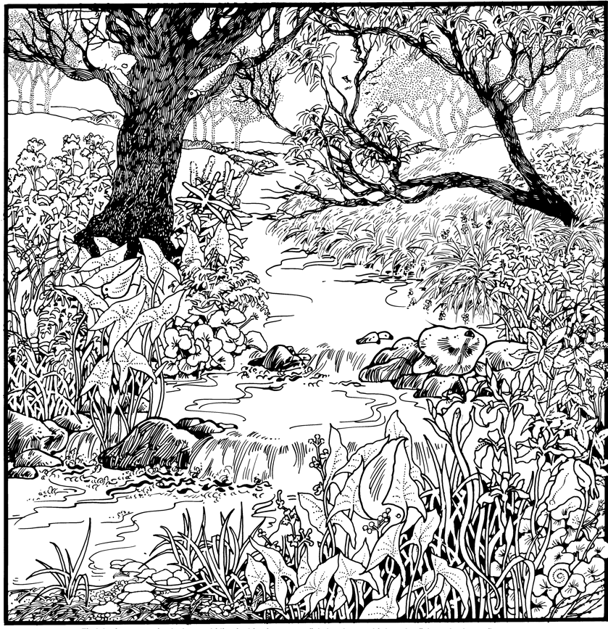
Answer sheet
- Worksheet #1
1-e | 7-k
2-h | 8-g
3-c | 9-f
4-b | 10-d
5-i | 11-j
6-a

- For example –post-activity
Octopus | Squid
I have a soft, egg-shaped body.  I have eight arms.I have no bone.  When something unpleasant approaches me, I let off black water. | I live in the sea. I have a large head and ten arms.  People call my arms feet.  Woman enjoy eating me for their snack.
Fish | Crab
I like playing in the water.  I have neither hands nor feet.  I can swim very well.  My body is covered with scales. | I live in the sea.I have ten legs ;  two legs are comparatively big and the other eight legs are small.  My body is short and a little flat.  I am well-known for walking sideways.

- Worksheet #3

