☐ Listening ☐ Speaking ■ Reading ☐ Grammar☐ Writing
Topic: Dear, Zootopia hotel

Instructor:  Marsha | Level:  Intermediate | Students:  11 | Length:  35 Minutes

Materials:
●White board and board markers
●Vocabulary worksheet #1 (11copies)
●Main activity worksheet #2,#3 (11copies)
●Worksheet #4 for complaint letter form (11copies)
● SOS worksheet (11copies)
●11 copies of a text
●Computer for websites and example of letter

Aims:
●Main aim: Students will be able to improve their reading skill by reading to customer complain letter
●Secondary aim: Students will develop their ability to read about customer complain letter by keeping touch and writing their own complain letter
●Personal aim: I want a student to write a letter themselves regarding the complaint about any situation and develop an ability to express their feeling

Language Skills:
●Listening: Ss will drill new vocabulary, follow instructions, and listen to form other student’s own idea. (complaint letters)
●Speaking: Ss will speak their own complaint letter.
●Reading: Ss will read customer complaint letter on the topic
●Writing: Ss will write own complaint letter about some situation

Language Systems:
●Phonology: [-θ], [-ər]
●Lexis: New vocabularies from the letter
(dissatisfaction, opt, portray, facility, unaware, drag, claiming, property, conserve, shatter )
●Grammar: Present Tense, Present Past
●Function: Keeping in touch
●Discourse : Letter, Email
Assumptions:
Student already know
●Complaint meaning.
●How to write a letter.
●Experience of staying and booking at a hotel.
●Which partner/group they belong to in for partner and group discussion time.

Anticipated Errors and Solutions:
If the students need to help to find the meaning of new vocabularies more than two time,
- After reading the main script, I will allow them to use the dictionary.
If the students need to help writing the letter from their bad experience,
- I will allow them to write a good experience.
If the students find difficulty in matching words on the word search activity,
- I will demonstrate one or two words by circling them.

References:
●English definitions
https://www.google.co.kr/
●Reading script
https://www.template.net/business/letters/sample-customer-complaint-letter/
●Worksheet
https://www.education.com/worksheet-generator/reading/crossword-puzzle/
https://www.pinterest.co.kr/pin/518969557041621018/
●Visual aid
https://www.booking.com
https://kr.hotels.com/
https://secure.accorhotels.com

Lead-In
Materials: None
Time | Set Up | Student Activity | Teacher Talk
1min | Whole  class | Answering teacher’s question. | Good morning! How are you today?  Do you write the letter a lot(include email)?  When do you usually write?

Pre-Activity
Materials: Board, Board makers, Computer, Worksheet #1
Time | Set Up | Student Activity | Teacher Talk
1min  1min  1min  3min  2 min | Whole  class  Whole  class  Whole  class  Pairs  Whole  Class | Answering teacher’s question  Answering teacher’s question  Students are answering teacher’s question  Student complete  Worksheet#1  Student check the answers together | Procedure:  - Brainstorming  Elicit  (Show some websites)  Look at the websites.  When do you use this kind of websites?  I use these websites for booking hotel.  Have you ever booked a hotel by a website?  - Introduce Topic  Introduction  Before booking a hotel, what are some important things to check on the website?  (expected the answer: room condition, price, location, facility, free services, customer’s reviews)  Many things are important but for me, the customer's review is the most important.  How about you guys?  Why do I think it is the most important?  (expected the answer: because it is real customer opinion about the positive or negative feedback)  Have you ever written a dissatisfied review or letter to a hotel?  Okay.  Model  (Write the topic “Dear, Zootopia hotel” on the board.)  Today's topic is " Dear, Zootopia hotel "  - New vocabulary : worksheet #1  Instruction  “We are going to learn the new vocabulary before reading a text. I will give you a worksheet. Read the definition of a word and then match it with the correct word.  (Distribute the worksheet #1)  Demonstration  Everyone look at the worksheet #1.  Let’s solve #1 together.  Could you read it together? What can be no.1?  I’ll give you 3 minutes to finish, Work together with your partner. If you and your partner don’t know the answer, just guess together!  I will give you 3 minutes, okay?  (Arranged students into pairs)  ICQ  How much time do you have?  Are you working in pairs?  What should you do with your partner?  Okay. Let’s start  Monitoring  (quietly walk around the classroom. Check whether the students have questions or not)  (Give time warnings: You have 1minute left)  (Give time warnings: You have 30seconds left)  Time’s up!  Check Answers  Let’s check the answers together.  Please read aloud each sentence slowly and correctly by all students in a rotation.  Okay, what it be.  (Repeat the answer again and continue.)  Everyone okay?  CCQ  If you have good service do you feel dissatisfaction?  If you have bad service do you feel dissatisfaction or satisfaction?  Good job everyone.

Main Activity
Materials: Worksheet #2,#3,#4 (11 copies), Speaker, Computer
Time | Set Up | Student Activity | Teacher Talk
1min  4min  1min  1min  6min  2min  2min  5min  2min | Whole  Class  Pairs  Whole  Class  Whole  Class  Individual  Whole  Class  Whole  Class  Individual  Whole  Class | Students listen to how to work  Students complete worksheet#2  Students check their answers together  Students listen to how to work  Students read to the text again and complete worksheet#3  Students check their answers together  Students listen to how to work  Students write a letter  Students pay attention | - Reading for the main idea : worksheet#2  Instruction  (Distribute worksheet #2)  Please read the questions on the worksheet.  Everyone okay?  This is a letter.  (Distribute the text)  Does everyone have one letter and one worksheet?  We will read a letter from Judy to hotel Zootopia. Do not focus on details, read the whole story and mark the true and false in the question..  We are looking for the main idea in this letter.  Demonstration  Everyone look at the worksheet no1,  After reading the letter and mark on the paper.  Okay? And then write your opinion on the second question  (Arranged students into pairs)  I’ll give you 4 minutes to finish,  Work together with your partner.  We will look over detail later. so do not focus on every detail  ICQ  What do we do now?  Are you working alone?  How much time do you have?  Okay let’s start  Monitoring  (Walk around the classroom. Check whether the students have questions or not)  (Give time warnings: You have 2 minutes left)  (Give time warnings: You have 1 minute left)  Everyone finished? Do you need more time? Okay.  Time’s up!  Check answer  Let’s check the answers together.  Please read aloud each sentence.  Okay, is it true or false?  (Repeat the answer again and continue.)  What does Judy want to say through this letter?  Good job everyone  - Reading for the detail : worksheet #3  Instruction  (Distribute worksheet #3)  Now, we are going to reading more detail to the text. After reading carefully choose the correct answer on worksheet #3.  If you don't understand the meaning of the words, you can use a dictionary on your phone.  But remember it only uses a phone as a dictionary.  I will give you 6 minutes to finish.  Work individually please.  ICQ  Do you choose the answers while you are reading or after reading?  Could you use a phone? Yes, only dictionary.  Are you working in pairs?  How much time do you have?  Okay. Let’s start  Monitoring  (Walk around the classroom. Check whether the students have questions or not)  (Give time warnings: You have 2 minutes left)  (Give time warnings: You have 1 minute left)  Everyone finished reading and choosing the answer, right? Do you need more time? Okay.  Time’s up!  Check Answers  According to the text, is Judy feeling good?  Let’s check the answers together.  Please read aloud each sentence slowly and correctly by all students in a rotation.  Okay, what it be.  (Repeat the answer again and continue.)  Good job everyone.  - Production : worksheet #4  Instruction  Now, we are going to write some letters.  Let's write your own letter based on your unsatisfied experience at the hotel.  If you don’t have any bad experience, you can write thanks letter.  You should have at least 10 sentences and at least 5 lines of main content.  (Distribute the worksheet #4)  Demonstration  (show up the screen)  This is example letter.  Could anyone read it?  Dear, Hilton hotel.  My name is Marsha. I stayed at your hotel when I visited Busan with my family last week. As I know it is a 6-star hotel, but the service was not at all like that.  The room was too loud and the portion of breakfast was not enough. Moreover the food was cold and tasteless. When we complained about the food, you did not take any action. So all my family had to eat cold food.  It was the worst experience and I think other customers need to know this happened too.  We don’t want any compensation and hope to provide better service in the future. Sincerely.  Like this. You should start Dear blah blah and finish as sincerely.  Everyone understand? Okay  After work, 5 volunteers will read their own letter. I will give you 5 minutes to finish.  Work alone please.  ICQ  What do we do now?  Are you working alone?  How much time do you have?  Let’s start  Monitoring  (Walk around the classroom. Check whether the students have questions or not)  (Give time warnings: You have 2 minutes left)  (Give time warnings: You have 1 minute left)  Do you need more time?  Shearing  Please, everyone, show respect to the presenter and pay attention.  Is there any volunteer to read yours?  Thank you, OO.  (continue4times more)

Post Activity
Materials: Audio file, while board, board marker
Time | Set Up | Student Activity | Teacher Talk
2min | Whole class | Students will mentions about today’s activity | - Error correction  (Pick out grammatical and pronunciation errors students made, and correct them)  - Conclusion  (Conclude today’s lesson by checking the newly learned vocabulary and their understanding of the main idea.)  “Class, you did a great job today, try to keep in mind of the vocabulary and how to express your feeling what we learned today”  - Feed back  How was the class?  What do you feel about the new topic?  Thank you for your participation in class and have a good day.

SOS Activity
Materials: Crossword puzzle worksheet (11 copies)
Time | Set Up | Student Activity | Teacher Talk
5min | Individually | Students complete the word puzzle of today’s newly-learned vocabularies | - Word Search  Instruction  (Distribute the worksheet #5)  Now, we are going to complete the word puzzle using the words we learned today. So, see the meaning of vocabularies on the bottom and fill in the puzzle.  Work individually please.  You will have 5 minutes to do so.  ICQ  What do we do now?  Are you working alone?  How much time do you have?  Let’s start

Worksheet #1
♡Match the right meaning and word.

1. Having no knowledge of a situation or fact. |  | ●a. Dissatisfaction
2. A thing or things belonging to someone; possessions collectively. |  | ●b. opt
3. Describe someone or something in a work of art or literature. |  | ●c. portray
4. Lack of satisfaction. |  | ●d. facility
5. Protect something from harm or destruction. |  | ●e. unaware
6. Make a choice from a range of possibilities. |  | ●f. drag
7. It is buildings, pieces of equipment, or services that are provided for a particular purpose. |  | ●g. property
8.If something shatters or is shattered, it breaks into a lot of small pieces. |  | ●h.conserve
9. If someone drags you somewhere you do not want to go, they make you go there. |  | ●i. shatter
April 25, 2017
Dear, Zootopia hotel

My name is Judy Hopps. I am writing this letter following my stay at your hotel, Hotel ZOOTOPIA, last week. This letter is in regard to the poor level of customer service with high customer dissatisfaction.

I opted for your property after checking your website which portrays a completely different picture, as compared to reality. You claim to provide a lot many facilities which are not even available in your best rooms – the super deluxe ones.

Right from the time of check-in, my experience had been the worst ever. I understand that the way to the resort from the main road cannot be your responsibility, but the way from the entrance at the main gate till the reception is much worse than the road outside. The door was so dirty that I did not even want to touch it. Lots of dust were seen all over the lobby. I actually could not understand if that is for the beautification as per you people or is that your lack of maintenance.

There was nobody to welcome at the reception. It took 10 minutes for a room service boy to address us and another 15 minutes to call the receptionist. And to the height of irresponsibility, the receptionist was unaware of the booking details, and the service boy took the baggage to the room without even informing us for the same.

The room service has never attended on any of our calls either for the tea, meals or cleaning up the rooms. The bathrooms and toilets were not cleaned before the check-in and I had to drag the person along with me after calling for the service some 10 times. A problem in power outage in my room at Zootopia hotel, I didn’t even dream of facing electricity cut-off in such a 3 star claiming property. You have got electrical appliances which either wouldn’t work or there would be no electricity to operate. This is how you conserve electricity, I hope.In short, you have totally shattered our vacation leaving us more tired than ever. I have written all these comments on the website. Your property and services are not even worthy to be checked-in for free.

I will definitely take up these issues and will make sure that your property does not even get a single star.

Sincerely,
Judy hoops

Worksheet #2
♥ Read the sentences and decide if they are true or false.

1) Judy felt very comfortable at hote Zootopia, last week. | T / F
2) The Zootopia hotel picture was exactly like the photo on the website. | T / F
3) It was the worst experience of staying for Judy at Zootopia Hotel. | T / F
4) Judy wants to give a single star to this hotel. | T / F
5) I requested room service 10 times. | T / F

♥Write your opinion what do Judy wants to say through this letter.

Worksheet #3
♡Read the text and find the correct answer.

Q1. Where did Judy Hopps go last week?
- Zootopia village
- Zootopia hospital
- Zootopia hotel
Q2. Choose one that is not Judy's complaint?
- There was no one at the reception.
- The main door was not clean.
- The bathroom was not clean.
- Bed sheets were dirty before check-in.
- Judy's room was the blackout.
Q3. What did Judy feel staying at the hotel?
- Curiosity
- Happiness
- Satisfactory
- Uncomfortable
Q4. What kind of letter is it?
- Friendly letter
- Complaint letter
- Gratitude letter

Worksheet #4
♡Let's write your own letter based on your unsatisfied experience at the hotel.
If you don’t have any bad experience, you can write thanks letter.

SOS Activity
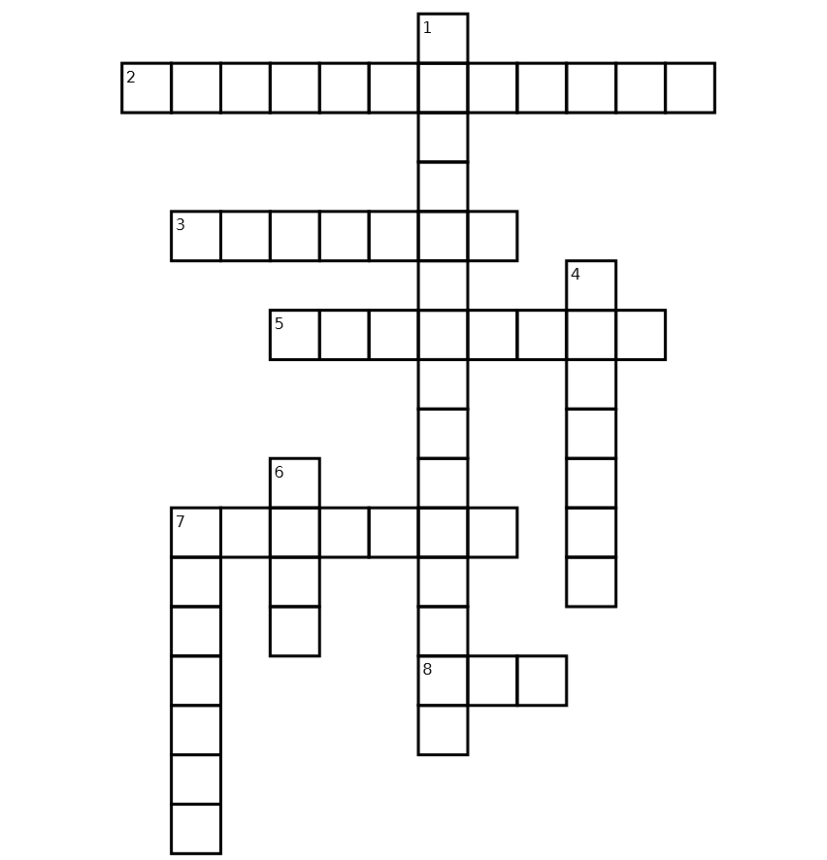

Answer sheet
♥Worksheet #1
1 | e | 6 | b
2 | g | 7 | d
3 | c | 8 | i
4 | a | 9 | f
5 | h | ♡ | ♡
♥Worksheet #2
1) | F | 2) | F | 3) | T | 4) | F | 5) | T
Judy has a complaint about the hotel.
♥Worksheet #3
1 | ③
2 | ④
3 | ④
4 | ②
♥Worksheet #4 -Example
Dear, Hilton hotel.
My name is Marsha. I stayed at your hotel when I visited Busan with my family last week. As I know it is a 6-star hotel, but the service was not at all like that.
The room was too loud and the portion of breakfast was not enough. Moreover the food was cold and tasteless. When we complained about the food, you did not take any action. So all my family had to eat cold food.
It was the worst experience and I think other customers need to know this happened too.
We don’t want any compensation and hope to provide better service in the future.

Sincerely,
Marsha
♥SOS activity

