Listening Speaking Reading Grammar Writing
Topic: Did anybody call?

Instructor:  Eddie Moon | Level:  Intermediate | Students:  12 students | Length:  30 Minutes

Materials:
- Computer, speaker, big screen for image of receptionist, white board, markers
- Worksheet #1 – Present the new words (matching definitions and fill the gaps)
- Worksheet #2 – Practice sheet A (12 copies)
- Worksheet #3 – Practice sheet B (12 copies)
- Worksheet #4 – Worksheet for free production (12 copies)
- SOS Worksheet – Crossword puzzle (12 copies) / Answer sheet (1 copy)

Aims:
- Main aim: Students will practice for talking to the various customers on the phone and take messages.
- Secondary aim: Students will be able to deliver it to their supervisors.
- Personal aim: I want students to challenge as many phone calls as possible and build up confidence in taking calls.

Language Skills:
- Reading: Role cards, worksheets.
- Listening: Vocabulary, background information, instruction, and demonstration.
- Speaking: Asking and answering during practice and giving own presentation.
- Writing: Filling in the information on the worksheet and making own dialogue.

Language Systems:
- Phonology: /ph/, /ô/
- Lexis: Receptionist, secretary, boss, supervisor, colleague, headquarters, caller
- Grammar: Present tense, past tense
- Function: Comprehensive phone conversation and taking messages
- Discourse: Dialogue

Assumptions:
- Students know most of the vocabularies in the worksheets.
- Some students have an experience of taking calls for their boss at work.
- Students have an experience of calling an office and leaving a message.
- Students already know what prepositions are.

Anticipated Errors and Solutions:
- Students may have fear of not understanding what the person says on the phone.
-> Create as many situations as possible and practice them.
- Students may have a problem of taking a message in an appropriate form.
-> Help students to get used to how to jot down the message.

References:
- Image of receptionist
- http://www.jobmail.co.za/blog/10-skills-that-will-help-you-in-receptionist-jobs/
- Worksheet #2 & #3
- https://en.islcollective.com/
- Crossword puzzle
- https://worksheets.theteacherscorner.net/make-your-own/crossword/
- Dictionary
- http://www.dictionary.com/

Lead-In
Materials: None
Time | Set up | Student Activity | Teacher Talk
1min | Whole  class | Answer the teacher’s questions | Good morning, everyone! How are you doing today?  Did you guys do anything fun yesterday?  I had to call the gym to reactivate my gym membership but I couldn’t do it because the manager was out for lunch. So guess what? I had to leave a message for the manager.

Pre-Activity
Materials: Computer, screen, receptionist image file, white board, board markers
Time | Set up | Student Activity | Teacher Talk
4 min  4 min  1 min | Whole class  Pairs  Whole class | Students complete the worksheet #1.  Students check answers. | Procedure:  1. Prediction  Yes, sometimes we call the business company to talk to the owner or the office manager. However, we cannot always reach them directly in most cases.  Then who do you think you will get to talk to first?  Elicit  (Project the image file on the screen.)  Who do you see here in the picture?  (Wait for students to think and answer)  Yes, she is a receptionist.  What is she doing here?  (Wait for answers)  Yes, she is taking phone calls and taking messages.  What will she do with the messages?  (Wait for answers)  Yes, she will have to deliver or give all the messages to her supervisor or boss.  That why we are going to learn how to leave a message as a caller, and how to take a message on the phone and deliver it to your boss as a receptionist.  So, today is topic is “Did anybody call?”  Model  (Write the topic “Did anybody call?”)  CCQ  Does the receptionist take calls?  Does the receptionist keep messages to herself or give it to the boss?  2. Introduce new vocabularies and phrases  Instruction  We are going to check some new vocabularies and phrases. Here is the worksheet #1.  (Hand out worksheet #1)  Now, match the words with the definitions. You work with your partner and I will give you 3 minutes.  ICQ  What do you do now?  Are you working alone?  How much time do you have?  Demonstration  Let’s take a look at #1 and find the answer together.  What is a receptionist?  (Allow students time to think and answer.)  Correct, receptionist means a person employed to receive and assist callers, clients, etc., as in an office.  Great. Let’s start now.  Monitoring  (Monitor discreetly. Answer if any questions arise.)  (Give time warning)  30 seconds left. Time’s up.  Check Answers  Let’s check the answers together.

Main Activity
Materials: Worksheet #2, #3, white board, board markers
Time | Set up | Student Activity | Teacher Talk
3 min  7 min | Individual  Pairs | Students read the introduction on worksheet #2 or #3  Students will have a small conversation to fill out the own worksheet. | Procedure:  1. Overview of the main activity Instruction  Okay, now I’ll give you worksheet #2 for one student and #3 for the other student.  Don’t show your worksheet to your partner.  (Hand out worksheet #2 for one student and #3 for the other student.)  Now, you read the instruction on top of your worksheet for 2 minutes by yourself.  ICQ  What do you do now?  Do you show your worksheet to your partner?  How much time you have?  Good! You can read it now.  Monitoring  (Don’t need time warning and monitor the students.)  Okay, time’s up.  ICQ  According to the worksheet, is your boss at his office?  What do you have to do now as a receptionist?  Yes, you need to take calls and take messages for your boss.  Now, you guys work in pairs and fill in your own worksheet by having a small conversation. I will give you 7 minutes.  ICQ  What do you do now?  Do you work in pairs?  How much time do you have?  Now, let’s begin.  Monitoring  (Monitor discreetly. Answer if any questions arise.)  (Give time warning)  30 seconds left. Time’s up.

Post Activity
Materials: Worksheet #4, white board and board makers
Time | Set up | Student Activity | Teacher Talk
4 min  4 min  2 min | Pairs  Pairs  Whole class | Students create a dialogue using one of the messages on the worksheet.  Students do a role-play the own dialogue to the class.  Students listen. | Procedure:  1. Writing own dialogue  Instruction  Now, work in pairs to write one of your own dialogues based on the messages you took. And add the part delivering it to your boss in the end. You can use some of the expressions on your worksheet. You have 4 minutes.  ICQ  What should you do now?  Do you work in pairs?  How much time do you have?  Now, let’s start.  Monitoring  (Monitor discreetly)  (Give time warning)  30 seconds left. Time’s up.  2. Role-play  Instruction  Okay, now one team at a time, you will do a role-play. One of you become a caller and the other will be a receptionist. And when the call is over, the caller plays the boss and asks the receptionist “Did anybody call?” and the receptionist deliver the message to the boss.  ICQ  What do you do now?  Who becomes the boss?  Great! Who would like to go first? Thank you. Please stand up and present it to the class.  Monitoring  (Monitor discreetly and make sure students use the sentences correctly.)  Excellent! It was very practical dialogue. Good job! Let’s go clockwise.  3. Feedback and conclude the lesson  Error correction if necessary  (Write the grammatical or pronunciation errors on the board and drill.)  Did you guys have a good time today? I enjoyed very well too. You all did a great job and hope you find the opportunities to use it. Thank you again for your participation and have a great day!

SOS Activity
Materials: SOS worksheet, white board, board markers
Time | Set up | Student Activity | Teacher Talk
5 min  2 min | Pairs  Whole class | Students solve the crossword puzzle.  Students check the answers with a teacher. | Procedure:  1. Solving the crossword puzzle  Instruction  Ok, now I will hand out the worksheet #5 and you will solve the crossword puzzle in pairs. I will give you 5 minutes.  (Hand out SOS worksheet)  ICQ  What do you do now?  Are you working in pairs?  How much time do you have?  Okay, lets’ start!  Monitoring  (Monitor discreetly. Answer if any questions arise.)  (Give time warning)  30 seconds left. Time’s up.  Check answers  Now let’s check the answers together. What’s the answer for question #1? (Allow students to answer.) Correct! What’s #2? …

- Image of receptionist

- Worksheet #1

- Match the words to the definitions and fill the blank with proper prepositions.
1. Receptionist |  | - A person employed to receive and assist callers, clients, etc., as in an office
2. secretary |  | - A person who supervises workers or the work done by others; superintendent.
3. boss |  | - A person in charge of a worker or organization.
4. supervisor |  | - A person or thing that calls.
5. colleague |  | - A person with whom one works, especially in a profession or business.
6. headquarters |  | - A person, usually an official, who is in charge of the records, correspondence, minutes of meetings, and related affairs of an organization, company, association, etc.
7. caller |  | - A center of operations, as of the police or a business, from which orders are issued; the chief administrative office of an organization

- Fill in the proper prepositions.

for / for / to / to

leave a message _______ your boss.
send a message _______ your supervisor.
give a message _______ your boss.
be out ______ lunch.

- Worksheet #2

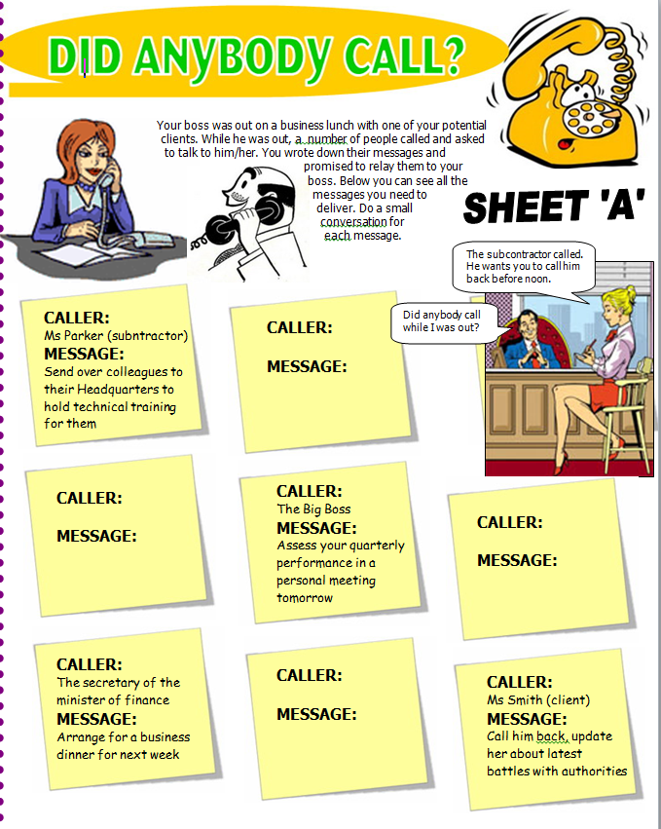

- Worksheet #3

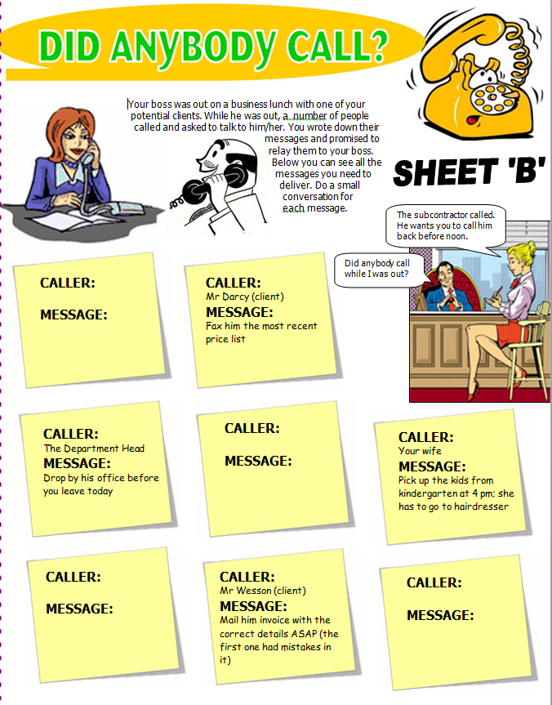

- Worksheet #4
Here are some possible questions and statements to include in your role-play. You don’t have to use them all.
- He is out for lunch.
- She is not available at this moment.
- Can I speak to the manager?
- Would you like to leave a message?
- Can I leave a message?
- I can take a message for you.
- Did anybody call while I was out?
- He wants you to call him back as soon as possible.

1) Choose one message and make your own dialogue with your partner.

2) The caller plays the boss and asks “Did anybody call while I was out?”

- SOS Worksheet
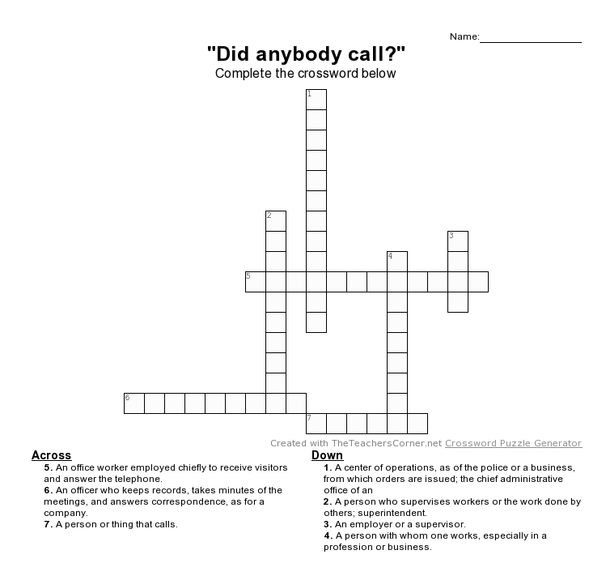

- SOS worksheet answer key
