Listening Speaking Reading Grammar Writing
Topic: Common Interjections

Instructor:  Andy Lee  Eddie Moon | Level:  Intermediate | Students:  12 students | Length:  30 Minutes

Materials:
- Computer, speaker, screen, white board, board markers, picture image (shh!)
- Worksheet #1 – Match the interjections to the meanings (12 copies)
- Worksheet #2 – Fill in the blank (12 copies)
- Worksheet #3 – Make your own two-line dialogue (12 copies)
- SOS worksheet – Crossword puzzle (12 copies)

Aims:
- Main aim: Ss will learn the interjections by expression of their emotions.
- Secondary aim: Ss will learn how to pronounce them correctly by drilling.
- Personal aim: Help Ss get used to the interjection by drilling.

Language Skills:
- Reading: reading worksheets
- Listening: listening to teacher’s instructions, classmates’ comments
- Speaking: drilling, practice the new words and discuss ideas with a partner
- Writing: worksheet answers, write down the dialogue

Language Systems:
- Phonology: /sh/, /ch/, /ph/
- Lexis: Shh, aww, ouch, argh, eww, duh, oops, phew, yikes, yay
- Grammar: interjections
- Function: place the right interjection in the right place within the sentence.
- Discourse: describing the emotion in a dialogue

Assumptions:
- Students have learned and heard of some interjections.
- Students know most of vocabularies in the worksheets.
- Students know what consists of an English sentence in proper form.

Anticipated Errors and Solutions:
- Students may know the sound but don’t know how to spell it.
-> Board the difficult words and drill.
- Students may not pronounce the injections correctly.
-> Have students repeat after the teacher until become comfortable with it.

References:
- Image (Shh!)
https://www.youtube.com/watch?v=qNmnnDNpfYk
- Crossword Puzzle Maker
https://www.education.com

Lead-In
Materials: None
Time | Set up | Student Activity | Teacher Talk
1 min | Whole class | Answering the teacher’s questions | Good morning, everyone! How are you feeling today? Good!

Pre-Activity
Materials: Computer, screen, worksheet #1, white board and marker
Time | Set up | Student Activity | Teacher Talk
2 min  2 min  4 min  3 min | Whole class  Individual  Pairs  Whole class | Students answer to teacher’s questions  Students read definition on worksheet #1  Students complete the worksheet #1  Students check the answers and repeat after teacher | Procedure:  1. Prediction  What would this person say?  (Show the picture on the screen)  Elicit  How would you express your emotion?  (Wait for ss to think and guess and board if ss have the right answers)  That’s right! The words used to express strong feelings or sudden emotions are called “Interjections”.  So, today’s topic is “Common Interjections.”  (Board the topic and definition)  Model  “Common Interjections”  (Hand out worksheet #1)  Okay, now here’s the worksheet #1 and read the definition for 2 minutes alone.  ICQ  What do you do now?  Do you work in pairs?  How much time do you have?  Now, read the definition.  Monitoring  (Don’t give time warning and monitor the students.)  Okay, time’s up.  CCQ  Can interjections convey your feeling?  Do interjections usually come in the beginning of the sentence?  Are interjections used a lot in formal writing?  Great!  Demonstration  Let’s look at #2.  How would you read “shh”?  Excellent! When do you use it?  Repeat after me. shh!  (Use gesture)  When do you use it?  A request for silence. Be quiet.  Now, choose the right interjections to the meanings on your worksheet #1. Work in pairs and you have 4 minutes.  ICQ  What do you do now?  Do you work in pairs?  How much time do you have?  Now, let’s start.  (Board 10 new words for drilling)  Monitor  (Monitor discreetly, answer if any questions arise.)  (Give time warning.)  30 seconds left. Time’s up.  Check answers and drilling  Let’s check the answers together.  What’s the answer for question #1? Right. Everybody say Shh. Shh.  Good. And #2? …  Everyone did a good job!

Main Activity
Materials: Worksheet #2, #3, white board and marker
Time | Set up | Student Activity |  | Teacher Talk
7 min  3 min  3 min  3 min | Pairs  Pairs  Pairs  Pairs | Students complete the worksheet #2  Students present own sentences to the class  Students complete the worksheet #3  Students present own dialogue to the class |  | 1. Using the interjections in the sentence  Instruction  Okay, here’s the worksheet #2 and fill the blanks using interjections.  (Hand out the worksheet #2)  Demonstration  Let’s look at #1 as an example.  “Shh! I’m trying to hear what they’re saying!”  Now, work in pairs and you have 7 minutes.  ICQ  What do you do now?  Do you work in pairs?  How much time do you have?  You can start now.  Monitor  (Monitor discreetly, answer if any questions arise.)  (Give time warning.)  30 seconds left. Time’s up.  Check sentences and present  Let’s check your sentences.  Team A. What is your sentence for the question #2?  That’s great!  (Correct errors if any)  (Ask one question per team)  And team B for the question #3? …  Everyone did a great job!  2. Making two-line dialogue  Instruction  Now, here’s the worksheet #3 and make two-line dialogue.  (Hand out the worksheet #3)  Demonstration  Look at the example together.  (Show the example on worksheet #3)  Now, work with your partner and you can use more than one interjection. You have 3 minutes.  ICQ  What do you do now?  Do you work with your partner?  How many lines do you make?  How much time do you have?  Okay, let’s begin.  Monitor  (Monitor discreetly, answer if any questions arise.)  (Give time warning.)  30 seconds left. Time’s up  Check the dialogues  Let’s hear from the team A.  (Correct errors if any)  Good. And team B? …  You guys are great!
Post Activity
Materials: White board and marker
Time | Set up |  | Student Activity | Teacher Talk
2 min | Whole class |  | Students listen to the teacher | 1. Feedback and conclusion  (Error correction if necessary)  (Write the grammatical or pronunciation errors on the board and drill.)  Feedback  Did you guys have fun today?  You all did a great job today and let’s use interjections more often in speaking. See you next class!

SOS Activity
Materials: SOS worksheet, white board and markers
Time | Set up | Student Activity | Teacher Talk
5 min | Pairs | Students solve the crossword puzzle | 1. Solving the crossword puzzle  Instruction  Ok, now I will hand out another worksheet and you will solve the crossword puzzle in pairs. I will give you 5 minutes.  ICQ  What do you do now?  Are you working in pairs?  How much time do you have?  You can start now.

- Images (Shh!)

- Worksheet #1
  - Definition:
What Are Interjections? Interjections are words used to express strong feeling or sudden emotion. They are included in a sentence (usually at the start) to express a sentiment such as surprise, disgust, joy, excitement, or enthusiasm. An interjection is not grammatically related to any other part of the sentence. Interjections are rarely used in academic or formal writing, but are common in fiction or artistic writing. They are usually, but not always, offset by an exclamation point (which is also used to show emotion).

  - Choose the correct interjections to the meanings
1. Used to make someone be quiet
1) Shh! 2) Aww!
2. How sweet or cute or feeling sorry for someone.
1) Argh! 2) Aww!
3. Fear and alarm or bad surprise.
1) Yikes! 2) Duh!
4. Expressing relief
1) Phew! 2) Duh!
5. Annoyance, anger, frustration
1) Eww! 2) Argh!
6. Expresses annoyance over something stupid or obvious
1) Duh! 2) Yay!
7. Expression of pain.
1) Ouch! 2) Eww!
8. Being surprised at or acknowledging your own mistakes
1) Argh! 2) Oops!
9. All-purpose cheer. Approval, congratulations and triumph
1) Yay! 2) Phew!
10. Disgust, dislike
1) Duh! 2) Eww!
- Worksheet #2
Fill in the blank with your own idea and present it to the class.

  - Shh! I’m trying to hear what they’re saying!_________________________.
  - Aww! ________________________________________________________.
  - Ouch! _______________________________________________________.
  - Argh! ________________________________________________________.
  - Eww! ________________________________________________________.
  - Duh! ________________________________________________________.
  - Oops! ________________________________________________________.
  - Phew! _______________________________________________________.
  - Yikes! _______________________________________________________.
  - Yay! ____________________________________________________________.

- Worksheet #3
Make two-line dialogue using the interjections below.
You can use more than one interjection.

Shh! Aww!
Ouch! Argh!
Eww! Duh!
Oops! Phew!
Yikes!
Yay!

Example:
A: Shh! TWICE is on the TV now and I got to watch them.
B: Oops! I’m sorry. I didn’t know you’re watching TV.

A:

B:

- 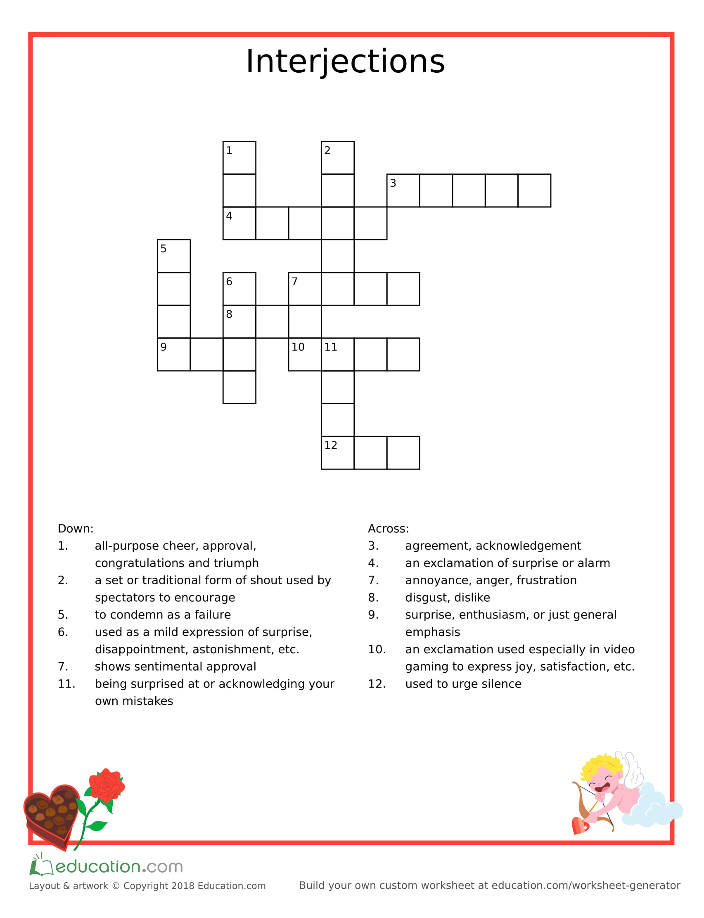SOS Worksheet (Crossword puzzle)
- 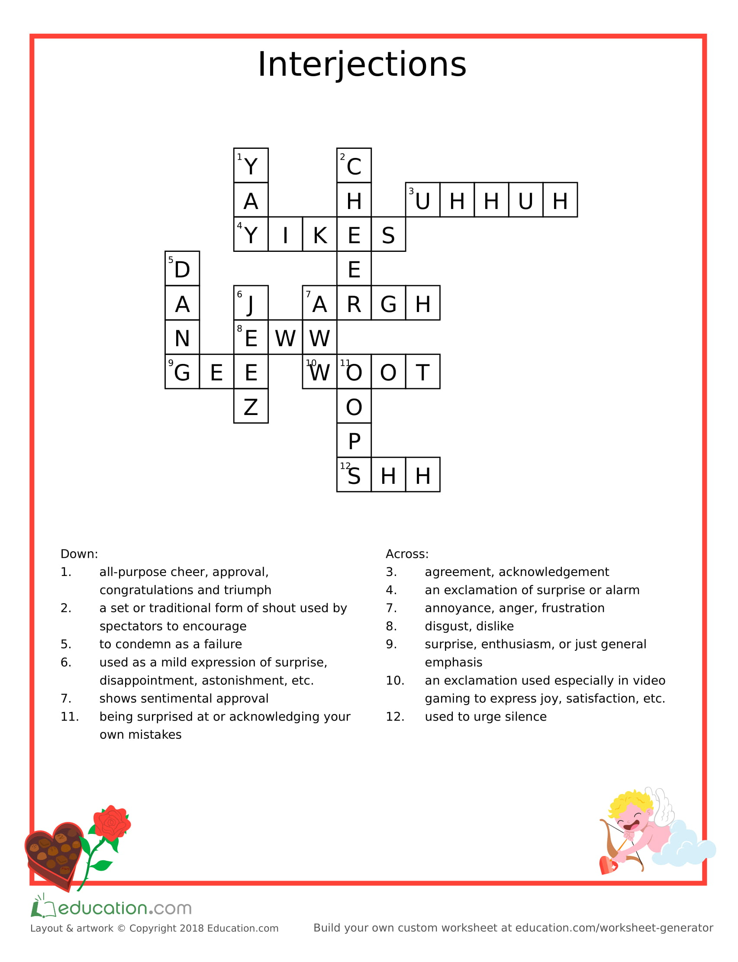SOS Worksheet Answer sheet (Crossword puzzle)

