☐ Listening ☐ Speaking ☐ Reading ■Grammar ☐ Writing
Topic: What is Your Favorite Invention?

Instructor:  Lily  Clara | Level:  Intermediate | Students:  10 students | Length:  40 Minutes

Materials:
- Computer, ppt slides, white board, markers
- Worksheet #1 for controlled practice
- Worksheet #2 for less-controlled practice
- Worksheet #3 for free practice
- SOS activity worksheet

Aims:
- Main aim: Students will understand passive voice by drilling and completing worksheets.
- Secondary aim: Students will be able to talk about their ideas by using passive voice.
- Personal aim:
-I want my students to build up confidence in passive voice.
-I want my students to think about the greatest inventions of all time.
And
Language Skills:
- Reading: reading worksheets to answer questions
- Listening: listening to teacher’s instructions and classmates’ ideas
- Speaking: drilling, presenting their ideas
- Writing: worksheet answers

Language Systems:
- Phonology: drilling
- Lexis: The meaning of the words in SOS activity – crossword puzzle
- Grammar: use of passive form in past tense (was/were p.p.)
- Function: describing their favorite inventions
- Discourse: asking and answering ideas about favorite inventions

Assumptions:
- Students know what active voice is.
- Students already have learned passive voice in present tense (am/are/is p.p.)

Anticipated Errors and Solutions:
- If students need more time to finish their activities
→ Be flexible with the time and give them more time to finish their activity.
- If students do not know information about their favorite inventions.
→ Let them use their smartphones to find the information on the Internet.
- If some students finish their worksheets and task earlier than others
→ Give them SOS activity sheet (If not used in the class, give it to students as homework)
- If students do not know some words
→ Explain the meanings of the words to the students.

References:

https://bogglesworldesl.com/files/Passives.doc

http://www.teachingideas.co.uk/vocabulary/active-voice-and-passive-voice

Lead-In
Materials: None
Time | Set up | Student Activity | Teacher Talk
1 min | Whole  class | Answering the teacher’s questions | Good morning, everyone! How are you today? Very good! Let’s start today’s class.

Pre-Activity
Materials: Computer, PPT slide, board, markers
Time | Set up | Student Activity | Teacher Talk
4 min  3min | Whole class  Whole  class | Answering the teacher’s questions  Drilling the sentences as asked. | Before getting into today’s lesson, let’s review last class. Look at the screen. Is a girl eaten or a cookie is eaten? Good! A cookie is eaten. Who is the cookie eaten by? A cookie is eaten by a girl. Very good!  (Show students how to change an active sentence into a passive sentence and again in past tense by writing the sentences on the board)  Today we’ll talk about the situation happened in the past: your favorite invention. I’ll show you some greatest inventions.  What can you see in this picture?  Right! Telephone. Do you know who invented telephone? Right! Alexander Graham Bell invented telephone. How do we change the sentence to have the same meaning?  (Show students the sentences on PPT)  Look at the next picture!  (keep showing the pictures and elicit student’s answers)  Let’s read these sentences together.  (Ask students to drill the sentences on the PPT slides)
S
Main Activity
Materials: Worksheet #1
Time | Set up | Student Activity | Teacher Talk
3min  1min  3min  1min  8min  10min | Individually  Whole class  Pair work  Whole class  Pair work  Pair work | Doing the worksheet #1  Checking the answers.  Working on the worksheet#2.  Checking the answers.  Working on the worksheet#3.  Presenting their ideas and listening to what other classmates are saying. | <Controlled practice>  Now I’ll give you the first worksheet. You need to fill in the blanks individually. The sentence’s situation happened in the past. I’ll give you 3minutes to finish it.  ICQ  Are you working alone?  How much time do you have?  What will you do?  (Monitoring)  Ok, time’s up! Let’s check the answers together. I’ll read a question and you should answer the question. Let’s read the answers again.  <Less-controlled practice>  I’ll give you second worksheet. You’ll make sentences using passive voice with your partner. I’ll give you 3 minutes for this activity.  (Demonstration)  ICQ  Are you working alone or with your partner?  How many minutes do you have?  (monitor discreetly and give students help if they have difficulty finding the answers)  Are you done?  (If students need more time, give them 30seconds more)  Let’s check the answers together. What’s the answer for number 2?  <Free practice>  Now it’s time to talk about your favorite invention. I’ll hand out third worksheet. First, fill in the blanks and do role-plays with your partner. I’ll show you how to do it.  (Model the activity)  You have 8min.  ICQ  Are you working alone or with your partner?  What are you doing with your partner?  How many minutes do you have?  Have you all finished?  (If some students need more time, give them two more minutes and give SOS activity to those who finished first.)  It’s time to present your ideas. Which pair wants to start first?  (Go through all pairs)  All your ideas are great!

Post Activity
Materials: white board and makers
Time | Set up | Student Activity | Teacher Talk
3min  2min  1min | Whole  Class  Whole  Class  Whole  class | Trying to self-correct their errors.  Answering the teacher’s questions. | <Error Correction>  You did a great job today. Before wrapping up today’s lesson, we’ll review some errors.  (Board sentences with errors and ask students to try to self-correct first, and then let them know the correct sentences)  <Feedback>  Did you have fun today?  What was the most creative idea?  (Share students’ ideas and wrap up the class)  <Wrap-up>  You guys were great today. I’m so proud of you. Please review passive voice in past tense and see you next time. Have a good day!

SOS Activity
Materials: Worksheet #4
Time | Set up | Student Activity | Teacher Talk
3min | Those who finished earlier | Solving the crossword puzzle. | You finished the activity early. While waiting for other pairs to finish it, solve the puzzle. All the words here were used in today’s lesson.  (If not used in the class)  Everyone, this is crossword puzzle. You should finish it at home. The words were used in the lesson today. Read the meanings of the word and review the words we’ve learned today. Thank you!

- Worksheet #1 (Controlled practice)

★ Fill in the blank so that the two sentences have the same meaning.
1.  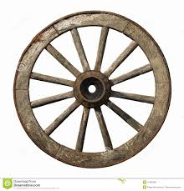 | A Mesopotamian invented a wheel.  → A wheel ______ _________ by A Mesopotamian.
2.  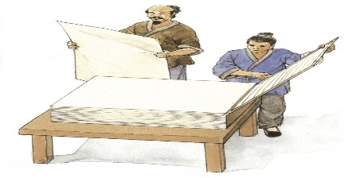 | The Chinese made paper about 2000 years ago.  → Paper ______ _________ by the Chinese about 2000 years ago.
3. | We used a telephone to make a call.  → A telephone _____ __________ to make a call.
4. | People discovered fire a long time ago.  → Fire _____ __________ a long time ago.
5. | Airplanes changed the way of travel.  → The way of travel ______ _______ by airplanes.

- Worksheet #2 (Less-controlled practice)
Passives
- Write the past participle of each verb under the verb: paint, painted.
paint write invent
build design discover

Fill in the blanks using the passive voice:

- Romeo and Juliet _____________________by Shakespeare.

- The Mona Lisa ___________________by Leonardo da Vinci.

- The light bulb ___________________by Edison.

- The Law of Gravity ___________________by Newton.

- The pyramids ___________________to protect the body of the pharaohs.

- The Eiffel Tower ___________________ by Gustave Eiffel in the 19th century.

- Worksheet #3 (Free practice)

- Think about your favorite invention and talk about it with your partner.

A: What is your favorite invention?
B: _____________ is my favorite invention.
A: Cool! Who invented it?
B: It ______________________________.
A: When was it invented?
B: It ______________________________.
A: How is it used? (You can change the last question)
B: It ______________________________.

- Change your role and do a role-play again.

A: What is your favorite invention?
B: _____________ is my favorite invention.
A: Cool! Who invented it?
B: It ______________________________.
A: When was it invented?
B: It ______________________________.
A: How is it used? (You can change the last question)
B: It ______________________________.

- SOS Activity

Vocabulary Review
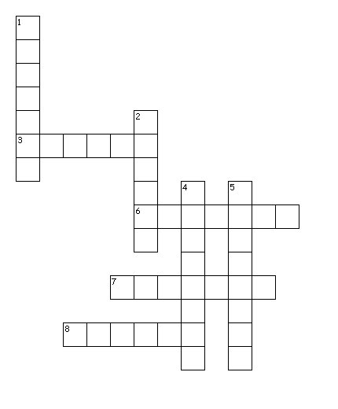
Across
3. Make or become different.
6. The force that attracts a body towards the center of the earth, or towards any other physical body having mass.
7. A ruler in ancient Egypt.
8. Create or design (something that has not existed before); be the originator of.

Down
1. Keep safe from harm or injury.
2. A plan or drawing produced to show the look and function or workings of a building, garment, or other object before it is made.
4. Preferred to all others of the same kind.
5. Find unexpectedly or during a search.

Words
protect, discover, change, design, favorite, invent, pharaoh, gravity

