☐ Listening ☐ Speaking ■ Reading ☐ Grammar ☐ Writing

Topic: What is your favorite a type of cars?

Instructor:  Andy Lee | Level:  Intermediate  (Adult) | Students:  12 | Length:  30 minutes

Materials:
• Computer, TV, white board, markers
• Reading material – Internet article, some images
• Worksheet #1 – for vocabulary
• Worksheet #2 – True/False
• Worksheet #3 – Thought-provoking questions
• Worksheet #4 – Discussion about own ideas
• SOS Worksheet – crossword puzzle (12 copies)

Aims:
• Main aim: Students will practice reading skill by reading the article.
• Secondary aim: Students will learn vocabularies by reading the article.
• Personal aim: I want to help students to get the meaning of new words from context

Language Skills:
• Reading: reading the article, worksheets
• Listening: listening to teacher’s instructions, classmates’ comments
• Speaking: drill new vocabulary words, presenting own opinion to the class
• Writing: worksheet answers, write down own opinion about the topic

Language Systems:

Phonology: /v/, /e/
Lexis: SUV, van, convertible, sedan, coupe, wagon, hatchback, truck
Grammar: present tense, future tense, conditional tense
Function: asking for information; giving information; hypothesizing
Discourse: conversation and discussion with partner

Assumptions:
-Students know some categories in the article
-Students have heard some words from the article

Anticipated Errors and Solutions:
• Students may not have an interest in the given topic.
-> Draw their attention to the information that related to the topic.
• Students may not know the exact meaning of some vocabularies.
-> Give students some information to

References:
- Reading image file from:
- https://www.technobuffalo.com/2016/08/25/amazon-vehicles-cars-new-section
- Reading script edited from:
- http://www.car-brand-names.com/types-of-cars/
- Match-up worksheet from:
- https://worksheets.theteacherscorner.net/make-your-own/match-up/
- SOS activity crossword puzzle generator:
- https://worksheets.theteacherscorner.net/make-your-own/word-search/

Lead-In
Materials: board and markers
Time | Set Up | Student Activity | Teacher Talk
1min | Whole  Class | Answering to the teacher’s questions | - Greeting students  Good morning! How are you today?  Good!

Pre-Activity
Materials: board and markers, worksheet #1
Time | Set Up | Student Activity | Teacher Talk
2min  3min  1min | Whole  class  Groups  Whole  Class | Answering teacher’s questions  Students work on the worksheet #1  Students check answers | - Prediction  What is your dream car?  (elicit students ideas – Ferrari, Porsche, BMW, Mercedes, etc.)  Good. However, if you buy your car, you will choose what model is of the brand.  (Show a picture of categories of cars)  What is called type of the car? Did you hear that?  Yes. Today’s topic is “What is your favorite a type of cars?”  (Hand out worksheet #1)  - Introduction  Ok. Please make group with your partner. Before we get started, let’s solve the worksheet #1. Write the letter of the correct match. Work with your partner and you have 3 minutes.  - ICQ  What do you do now?  Do you work in pairs?  How much time do you have?  - Monitoring  (Monitor discreetly and check if students are working well.)  (Give time warnings)  Now you have 1 min left. Time’s up.  - Check Answers and drill the words  Let’s check the answers together.  What’s the answer for question #1? Right. Everyone says, “Sedan”. Again? Good job.  And #2? …  Everyone did great!
.
Main Activity
Materials: Role cards (12 copies)
Time | Set Up |  | Student Activity | Teacher Talk
5min  1min  1min  3min  1min  4min  3min |  | Individual  Whole Class  Whole class  Groups  Whole class  Pairs  Pairs | Students read the reading material alone  Students work on worksheet #2  Students check the answers  Students work on worksheet #3  Student check the answers  Students work on worksheet #4  Students present their work to the class | - Reading for the main idea  - Instructions  Do you know what is your favorite a type of cars?  (Show a picture and allow students to answer)  This picture can help to understand the article for you. Here’s the article from the internet and read alone for 5 minutes.  - ICQ  Are you working individually?  What are you doing now?  How long time do you have?  Ok. Let’s start.  - Monitor  (Monitor discreetly, answer if any questions arise)  (Give time warning)  30 seconds left. Time’s up.  - CCQ  What do you like a type of cars?  What is different between categories of cars?  - Another instruction  Here’s the worksheet #2 and circle true or false as you read.  (Hand out worksheet #2)  Work with your partner and you have 1 minute.  - CCQ  Are you working individually?  What are you doing now?  How much time do you have?  - Monitor  (Run the task, monitor, and help students as needed, have pairs perform their work in front of the class.)  - Check answers  Let’s check the answers together.  Is #1 true or false? Right.  And #2 ...  - Reading for details  - Instructions  Here is the worksheet #3.  (Hand out worksheet #3)  Work with your partner and you have 3 minutes.  - ICQ  What do you do now?  Are you work alone?  How long time do you have?  Ok. Let’s start.  - Monitor  (Monitor discreetly, answer if any questions arise)  (Give time warning)  30 seconds left. Time’s up  - Check answers  Let’s check the answers together.  What’s the answer for #1? Right.  And #2 ...  - Production  - Instructions  Here’s the worksheet #4.  (Hand out worksheet #4)  Think about what types of cars will be popular in global market and write down one or more reasons and discuss with your partner. And then present to the class after. Work with your partner, you have 4 minutes.  - ICQ  What do you do now?  Do you read alone?  How much time do you have?  Ok. Let’s go.  - Monitor  (Run the task, monitor, and help students as needed, have pairs perform their work in front of the class.)  30 seconds left. Times up.  - Present to the class  Ok. Group A, can you tell us about your idea?  (Students present their ideas to the class)  Ok. Everyone has a great work!

Post Activity
Materials: Board & markers
Time | Set Up | Student Activity | Teacher Talk
5min | Whole Class | Students check the answers and question | - Error correction  (write sentences on the board that students misspoke during discussion. Facilitate peer correction.)  - Feedback  (check the answer with reasonable words for using situation.)  Did you have fun about today’s topic? I also have fun to talk about topic with you. See you tomorrow!

SOS Activity
Materials: Crossword puzzle worksheets (12 copies)

Time | Set Up | Student Activity | Teacher Talk
3min  2min | Individual  Whole class | Student complete the crossword puzzle using the word in the speaking article. | - Crossword puzzle  Instruction:  Now, we are going to complete the crossword puzzle using the word in the speaking script. First, read the definition on the bottom and write down the word on the puzzle. You will work individually. You have 3 minutes to finish it.  ICQ:  Are you working alone or in a group?  How much time do you have?  Monitoring:  (Monitor discreetly to see if the students are working well. Answer to the question.)  Check answers:  Let’s check the answers together.

Worksheet #1
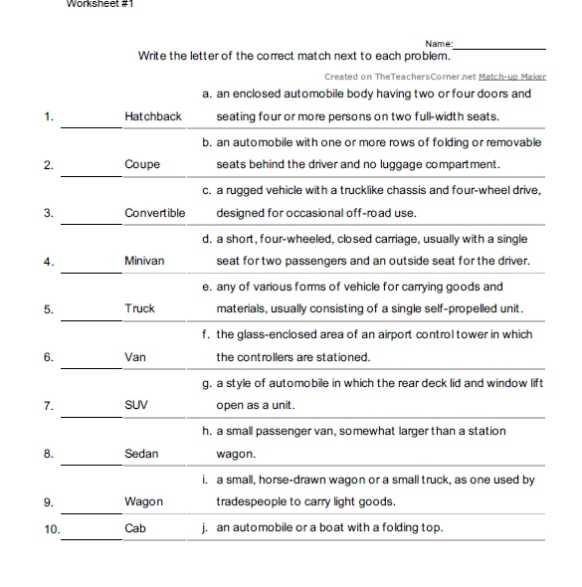

Worksheet #2

- True / False – SUVs have great fuel efficiency.

- True / False – Convertibles have beautiful shape.

- True / False – Sedans have enough cargo space.

- True / False – Wagons have large space behind the second row.

Worksheet #3

Think about some questions:

- Why cars have different shapes?

- If most car makers made only one category of cars, what would be happened?

- If you are a president of car company, what do you want to suggest body types for your customers?

Worksheet #4

Discussing with your partner and present about your idea.

- I think _________, it will be a popular type of cars because ____________________.

- I think _________, it won’t be a popular type of cars because ___________________.

SOS Activity

