■ Listening ☐ Speaking ☐ Reading ☐ Grammar ☐ Writing

Topic: The two sides of sports.

Instructor:  Sunny, Sonia | Level:  Intermediate | Students:  12 students | Length:  30 minutes

Materials:
- Computer and speaker for listening MP3 files, images
- big screen, white board, board marks
- Worksheet #1, worksheet #2, worksheet #3, worksheet #4
- Listening script

Aims:
-Main aim: Students will be able to improve their listening skills by listening to and understanding the topic.
-Secondary aim: Students will be able to talk and share different two aspects of sports.
-Personal aim: I want them to share their opinion to each other.

Language Skills:
•Listening: Students will listen to the article about the two sides of sports.
•Speaking: Students will talk and share about whether “What sports do you think is the •most helpful to people”
•Reading: Students will read scripts of topic
•Writing: Students will take notes on details.

Language Systems: (4- Integrated)

Phonology: /f/, /p/
Lexis: New vocabulary in the article. (cheer, winner, competition, diet, cheat etc)
Grammar: Giving information
Function: present tense
Discourse: News article

Assumptions:

•Students already know how the class is organized and operated,(3 at each table)
•Students know the teacher’s style of teaching.
•Students know they should speak only English in the class
•Students know the two sides of sport (positive, negative)

Anticipated Errors and Solutions:
• If students are not follow the passage easily
-let them listen again until they get the main point of the content.
• If students finish their activity early (SOS Plan)
-give bingo game worksheet to students who finish their activity early.
• If computer will not working
-Teacher will read listening script.

References:

-Visual aid, listening file and script
http://www.onestopenglish.com/

-Dictionary
http://www.dictionary.com/

Lead-In
Materials: None

Time | Set Up | Activity Teacher Talk | Student
1min | Whole  Class | Answering teacher's questions | Good morning! How are you today? Do you like sport? What’s your favorite sport? Why?

Pre-Activity
Materials: White board, Board markers, Worksheet #1, pictures, big screen

Time | Set Up | Student Activity | Teacher Talk
3min  2 min  4 min  2 min  3 min | Whole class  Pairs  Pairs  individually  Whole class | Answering teacher's questions.  Discuss with partner  Students complete  Students start writing down the words.  Student check answers. | Procedure:  1.Brainstorming  Elicit  (Show the students two pictures)  There are two pictures about sports.  Look at the pictures, How do you feel?  What are the differences between two pictures?  Which picture is better?  Model  (Write the topic "Two sides of a sport")  Today's topic is "Two sides of a sports"  CCQ  So does sport help you become healthier?  Discuss with your partner about the positive and negative aspects of sports.  2. New vocabulary  "We are going to learn new vocabulary before listening. First, read the sentences and then fill in the blanks with the correct word from the list below. Now I'll hand out a worksheet. I will give you 5 minutes to finish."  (Hand out worksheet #1)  ICQ  What do you write in the blanks?  Are you working in pairs?  How much time do you have?  Let's start!  Monitoring  (Quietly walk around the classroom. Check to see if the students are on track. Answer to questions.)  Give time warning:  1 minute: 30seconds left.  (Be flexible with time. Give 1more minute if they need it.)  "Time's up"  Check answers  Let's check the answers together.  After checking answer, do complement.

Main Activity
Materials: computer for listening, worksheet #2, worksheet #3
Time | Set Up | Student Activity | Teacher Talk
3 min  2 min  3 min  2 min | Individually  Whole class  Individually  individually | Students listen to the article and fill in the blanks in the worksheet  Students check the answers.  Listening and check true or false.  Students check answers. | 1. Fill in the blank  Instruction  "Now, we are going to listen to the article. You have to fill the blanks with the right words while listening. Work individually please. I will give you another worksheet."  (Hand out the worksheet #2)  ICQ  Do you fill in the gaps while you listening or after listening?  Are you working in group?  (Teacher plays the MP3 files. Let students to fill the blanks while listening.)  "Do you need to listen again?"  If yes, play it one more time.  Check answer  "Check the answers together.  Please read aloud each sentences slowly and correctly by all students in rotation."  2. Listening for main idea.  Instruction  (Hand out the worksheet #3)  We will listen one more time and check true or false by yourself while listening. I will give you 3 minutes to finish."  ICQ  Are you working in pairs?  Do you guess if the sentences are true or false?  Do you share your ideas about all questions?  How much time do you have?  "OK, everybody, the time is up. I think you are doing well. Then let's listen to the article and check the answers. See if your prediction is right or wrong.

Post Activity
Materials: Worksheet #4, white board, board marker

Time | Set Up | Student Activity | Teacher Talk
2 min  3 min | Group  Whole class | Students discuss in groups about the topic.  Students present their opinions | 1. Discussion  Instruction  (There are 3 in each group. Write down the topic of the discussion on the board as I introduce it.)  (Hand out worksheet #4)  The topic of today's discussion is,  "What sports do you think is the most helpful to people?  Your group should talk to each other. You now have 5 minutes to discuss.  ICQ  What is the topic of your discussion?  Are you working in groups?  You may begin now.  Monitoring  (Quietly walk around the classroom. Check to see if the students are on track. Answer to questions.)  (After 4 minutes.)  You now have 1 minutes left.  (After 1 minutes)  Time's up.  2.Sharing  Presenters of each group, please come up to the front. Please present your group's opinions. Presenter, keep it simple and short.  3. Feedback/conclusion  (Conclude the lesson checking the new words and correct grammatical and pronunciation errors.)  You guys did a great job today. Please try to remember the words you learned today try to use it in real life.  Thank you all for your participation and have a great day.

SOS Activity
Materials: 12 sheets of blank paper, color pencil

Time | Set Up | Student activity | Teacher talk
5 min  5 min  3 min | Individually  Whole class  Individually | Drawing pictures about sports  Students will draw a picture about sports.  Presenting pictures what they draw. | 1. Instructions  Now we are going to drawing a picture about your favorite sports.  Demonstrate  (Showing a picture to the student what you draw.)  Now drawing out individually, please. You will have 5 minutes to do so.  (Hand out papers)  ICQ  How much time you will have?  Are you working in a group?  Monitoring  (Quietly walk around the classroom. Check to see if the students are on track. Answer to questions.)  Now, you will present your pictures.

Visual Aid
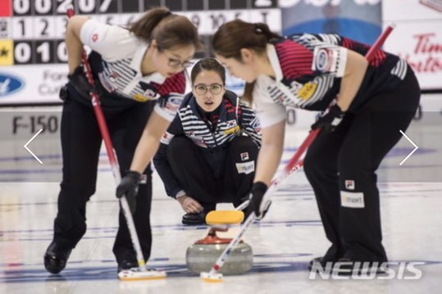
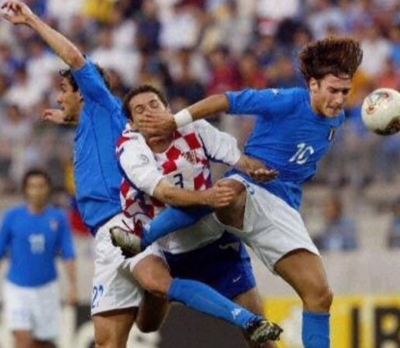
Work sheet #1

Find the definition
: Pharmacology. a chemical substance used in the treatment, cure, prevention, or diagnosis of disease or used to otherwise enhance physical or mental well-being.
: The person who comes first in a race
: to get the better of in a struggle or conflict; conquer; defeat:
: a prevailing custom or style of dress, etiquette, socializing, etc.
: a person trained or grifted in exercises or contests involving physical agility, stamina, or strength
: food and drink considered in terms of its qualities, composition, and its effects on heath
: an occasion on which a winner is selected from among two or move contestants
: weedy annual grass often occurs in grainfields and other cultivated land
: acting with or marked by or resulting from great force or energy or emotional intensity
: a close observer; someone who looks at something(such as an exhibition of some kind)

Drug | Winner | Fashion | Diet | Athlete
Overcome | Competition | Cheat | Spectator | Violent

Work sheet #2

Fill in the blank

Doing sport can help them to fight against and crime.

There are and losers in sport, and there are winners and loser in life, too

Sport can prepare for life, It can help us to problems, and to help other people.

Many spots clothes are greater . So doing sport can be a reason for looking good!

Good train every day. They often have no time for friends or fun.

Athletes want to win. They eat special to be strong.

Drugs can be this – but then the isn’t fair.

Good player don’t want to .

They drink a lot of alcohol, and are .

And that’s sad for players, and sad for the other .

Violent | diet | spectator | overcome | athlete
Competition | Cheat | fashion | winner | drug

Work sheet #3

Are these sentences true (T) or false (F)?

- Sport can have a positive social effect.  - Sport doesn’t prepare us for real life.  - Playing sport can create problems.  - Sports clothes can be fashionable.  - All sportsmen and women enjoy training.  - Blood tests are sometimes used to find out if someone is using drugs.  - Not everyone likes doing sports.  - Sports fans are sometimes violent. | T / F  T / F  T / F  T / F  T / F  T / F  T / F  T / F

Work sheet #4

Q. What spots do you think is the most helpful to people?

Write down your opinions.

-

-

-

Listening script
The two sides of sport

POSITIVE
There are some positive reasons for doing sport. Here are some more positive ideas, serious and not-so-serious.
Social effects
Sport can help people in poor parts of the city. Doing sport can help them to ﬁ ght against drugs and crime.
Life skills
There are winners and losers in sport, and there are winners and losers in life, too. So sport can prepare people for life. It can help us to overcome problems, and to help other people.
Fashion
Many sports clothes are great fashion. So doing sport can be a reason for looking good!
Fun Sport gives lots of opportunities to have fun.

NEGATIVE
It’s not all good news! Sport has its problems, too. Here are a few of them.
Training, training, training
Good athletes train every day. They often have no time for friends or fun. They forget about a ‘normal’ life. After years of this, some of them say ‘No more!’
Many tennis stars begin when they are four or ﬁve years old, and stop before they are twenty.
Drugs
Athletes want to win. They eat special diets to be strong. Their bodies are very important for them. And sometimes they want to ‘help’ their bodies. Drugs can do this - but then the competition isn’t fair. Sports people do tests of their blood and urine to detect drugs. Good players don’t want to cheat.
Isolation
Sport is great if you like it. If all your friends are good at sport, and you are not, it’s no fun. Sport at school can be horrible for some people.

Violence
It’s natural to support a football team. It’s normal to want your team to win. It’s good to be excited, and to cheer a goal. And it’s great to celebrate after the match.
But some fans make a lot of trouble. They ﬁght other fans. They drink a lot of alcohol, and are violent. The police have to control them. It’s not sport, it’s war. And that’s sad for the players, and sad for the other spectators.

