Listening Speaking Reading Grammar Writing
Topic: The Food Pyramid

Instructor:  Sunny Kim, | Level:  Intermediate | Students:  12 students | Length:  30 Minutes

Materials:
- White board, markers
- Reading text –The Food Pyramid (12 copies)
- Worksheet #1 – For pre teaching vocabulary (12 copies)
- Worksheet #2 – For finding main idea (12 copies)
- Worksheet #3 – For finding details (12 copies)
- Worksheet #4 – For free production (12 copies)
- Worksheet #5 – SOS activity (12 copies)
- Reaila (photos)

Aims:
- Main aim: Students will be able to improve their reading skills by catching the main idea and details.
- Secondary aim: Students will be able to improve their intensive reading skills by answering to the comprehension questions.
- Personal aim: I want to give my instructions short and simple to increase opportunities for STT

Language Skills:
- Reading: Ss will read the text of “The Food Pyramid”
- Listening: Ss will practice their skills by listening other students/teachers.
- Speaking: Ss will present their answers/opinions and practice pair activity in front of the class.
- Writing: Ss will write answer about comprehension question

Language Systems:
- Phonology: / θ/, /f/, /p/
- Lexis: New vocabulary
- Grammar: Present tense
- Function: Giving information
- Discourse: Conversation

Assumptions: Students already know
- How the class is organized (there will be 12 students in a circled shape)
- Four language skills and five language systems
- Students know what skimming and scanning are.

Anticipated Errors and Solutions:
- If students have difficulties in understanding new vocabulary or reading script
-> give them further examples and explain the sentences
- Some students will have difficulty in doing the comprehension question worksheet
-> have students do themselves first and give some help
- If students finish their activity early(SOS Plan)
-> give work sheet #5 (The Food Words Search Game) to students who finish their activity early.

References:
- New vocabulary
http://www.dictionary.com
- Main reading script/ Worksheet #2
https://en.islcollective.com/resources/printables/worksheets_doc_docx/food_pyramid/food-preintermediate-a2/44840
- Worksheet #4
https://homeshealth.info/worksheets-food-pyramid.html/adorable-worksheets-food-pyramid-in-childrens-page
- Worksheet #5
https://en.islcollective.com/resources/printables/worksheets_doc_docx/food_wordsearch/food-foods-wordsearches/55041

Lead-In
Materials: None
Time | Set up | Student Activity | Teacher Talk
1min | Whole  class | Answering the teacher’s questions | Procedure:  1.Greeting students  Good morning, everyone! How are you doing today?  Did you have breakfast this morning?  What did you eat?

Pre-Activity
Materials: : Board, Board makers, computer, Worksheet #1
Time | Set up | Student Activity | Teacher Talk
1 min  1 min  1 min  3 min  2 min | Whole  class  Whole  class  Whole  class  Pairs  Whole  class | Students answer to teacher’s questions  Students answer to teacher’s questions  Students answer to teacher’s questions  Students work on worksheet #1  Students check answers | Procedure:  1. Eliciting from photos  (Showing some photos to the class)  Look at the some photos.  What’s the first thing that comes to your mind?  What kind of food do you usually eat?  (Give Ss time to think and answer)  2. Guiding Question&  Introduce Topic  Model  Do you know what and how to eat in order to be healthy?  What is guide to help you know how to eat well?  (Write the topic “The Food Pyramid” on the board.)  Today’s topic is “The Food Pyramid”  3.New vocabulary  Instruction  Before we read the text, let’s learn some new vocabulary.  Let me give you worksheet #1.  (Distribute the worksheet #1)  Demonstration  Everyone look at the worksheet #1.  Read the first definition together. What’s the answer for number 1? Right, “osteoporosis”. Like this,  Read the definitions of a word and then match it with the correct word.  I’ll give you 3 minutes to finish. Work together with your partner.  (Arranged students into pairs)  ICQ  What do you do now?  Are you working in pairs?  How much time do you have?  Okay. Let’s start  Monitoring  (Quietly walk around the classroom. Check to see if the students are on track. Answer to questions)  Give time warning: 1 minute:  30seconds left.  (Be flexible with time. Give 1 more minute if they need it)  Time’s up!  Check Answers  Let’s check the answer together.  #2 is Any of the regular occasions, such as breakfast….  Good job everyone!  Repeat after me.  CCQ  *Is the pig poultry? (No)  *What is your favorite poultry dish?

Main Activity
Materials: Reading text, Worksheet #2, Worksheet #3, Worksheet #4, Board,
Board makers
Time | Set up | Student Activity | Teacher Talk
3 min  2min  1 min  3 min  1 min  5 min  4 min | Individual  Individual  Whole  class  Pairs  Whole  class  Groups  Individual | Students read the text for main idea.  Students work on worksheet #2  Students check answers  Students work on worksheet #3  Students check answers  .  Students work on worksheet #4  Students present it to the class | 1. Skimming for the Main idea  (Distribute the Reading text and worksheet #2)  Instruction  It’s time to read today’s text.  Before reading the text, I'll give you the worksheet #2.  Read the question first. And you will read the text to find the main idea. You have 3minutes to skim the text. Read the text alone.  ICQ  What do you do now?  Do you read alone?  How much time do you have?  Ok, time’s up!  Find the answers on the worksheet#2. I will give you 2minutes and work alone.  ICQ  What do you do now?  Are you working in pairs?  How much time do you have?  Okay. Let’s start  Monitoring  (Quietly walk around the classroom. Check to see if the students are on track. Answer to questions)  (Give time warning)  30 seconds left. Time’s up.  Check Answers  Let’s check the answers together.  Is #1 true or false? True! Right.  And #2 ...  2. Scanning for details  Instructions  (Distribute the worksheet #3)  Now, scan the text and find the answers to the questions on the worksheet#3.  I’ll give you 3 minutes to finish. Work together with your partner.  ICQ  What do you do now?  Are you working in pairs?  How much time do you have?  Okay. Let’s start  Monitoring  (Quietly walk around the classroom. Check to see if the students are on track. Answer to questions)  (Give time warning)  30 seconds left. Time’s up.  Check answers  Let’s check the answers together.  What’s the answer for #1? Right.  3.Production  Instruction  (Distribute the worksheet #4)  Now, we are going to write down some food that you ate yesterday. Write based on the six food categories.  Each group then shares their food pyramid and gives feedback to each other on which areas are lacking.  Demonstration  (Show examples to students.)  After work, you will present the feedback you received from your group with your food pyramid.  I’ll give you 5 minutes to finish. Work together with your group.  ICQ  What do you do now?  Are you working in groups?  How much time do you have?  Let’s start!  Give time warning:  30 seconds left.  Time’s up!  4. Present to the class  Please everyone show respect to the presenter and pay attention.  Eddie, could you do first please?  Great! Good job!  Everyone!

Post Activity
Materials: White board, makers
Time | Set up | Student Activity | Teacher Talk
2 min | Whole  class  Whole class  Whole class | Students listen  Students listen and answer to the teacher’s questions  Students will talk about today’s activity | 1. Error Correction  (Correct any mistakes from the activity)  2. Conclusion  (Conclude the lesson checking the new vocabulary and understanding of the topic.)  3. Feed back  “How was the class? What do you feel of the new topic? If you use the food pyramid well, you will be able to live a healthier life.  Thank you all for you participation and have a great day.

SOS Activity
Materials: Worksheet#5 (The Food Words Search Game)
Time | Set up | Student Activity | Teacher Talk
5 min | Individually | Students find and circle all the words in the list below. | 1. The Food Words Search Game  Instruction  Now, we are going to find and circle all the words in the list below.  I will give you 5 minutes to finish.  Good luck!  Work alone.  (Distribute the worksheet #5)  ICQ  What do you do now?  Are you working in groups?  How much time do you have?  Let’s start!  Monitoring  (Quietly walk around the classroom. Check to see if the students are on track. Answer to questions)  Give time warning:  30 seconds left.  Time’s up!  Please do your homework by tomorrow!

•Reading te
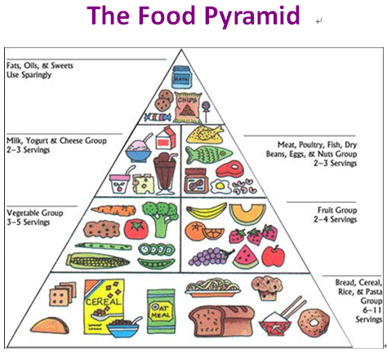
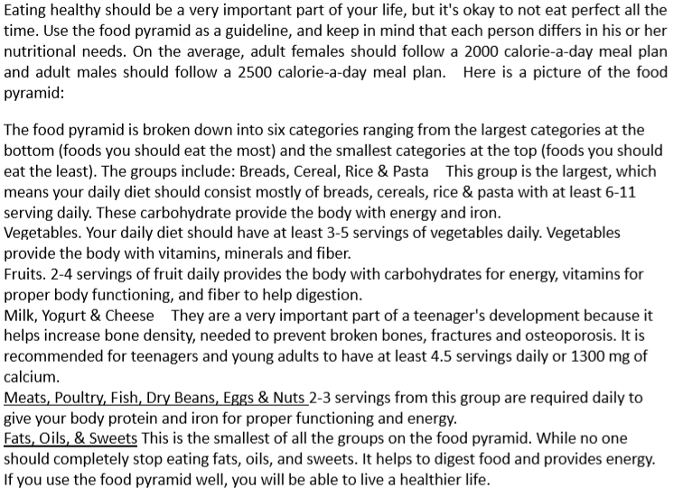

•Worksheet #1
Read the definitions of a word and then match it with the correct word

1. A condition in which your bones lose calcium and become more weakly |  | ♥a. carbohydrate
2. Any of the regular occasions, such as breakfast, lunch, dinner, etc. |  | ♥b. fracture
3. It is one of the three major nutrients that are included in bread and rice a lot. |  | ♥c. poultry
4. Refer to chickens, ducks, and other birds that are kept for their eggs and meat |  | ♥d. osteoporosis
5. The breaking of a bone |  | ♥e. meal
6. The measure of energy produced by food.  EX) Low- foods you have to snack, eat those. |  | ♥f. calorie
7. Any general or comprehensive division; a class. |  | ♥g. category

- Worksheet #2

Reading Comprehension Questions for Main idea

Circle T if the statement is true or F if it’s false

1. If you use the food pyramid well, you will be able to live a healthier life. | T / F
2. Milk increase bone density | T / F
3. You should completely stop eating fats | T / F
4. The group which includes fats is the largest groups on the food pyramid. | T / F

- Worksheet #3
Comprehension Questions for Details

Read the text and find the correct answer.
1. What is the largest category in the Food pyramid?

1) Breads, Cereal, Rice & Pasta
2) Fruits.
3) Milk, Yogurt & Cheese
4) Meats, Poultry, Fish, Dry Beans, Eggs & Nuts
5) Fats, Oils, & Sweets

2. Why are Milk, Yogurt & Cheese’ group a very important part of a teenager's development?
1) Provide the body with energy and iron.
2) Provide the body with vitamins, minerals and fiber.
3) Help increase bone density and prevent broken bones, fractures and osteoporosis.

3. Sunny, who is 20 years old, is eating only vegetables for her diet. What will happen if you continue to eat on this diet?
Write down your opinion in the blank. (Find a hint in the text.)

a

- Worksheet #4
Write down some food that you ate yesterday in the food pyramid. Write based on the six food categories. Then share your food pyramid and give feedback to each other on which areas are lacking.
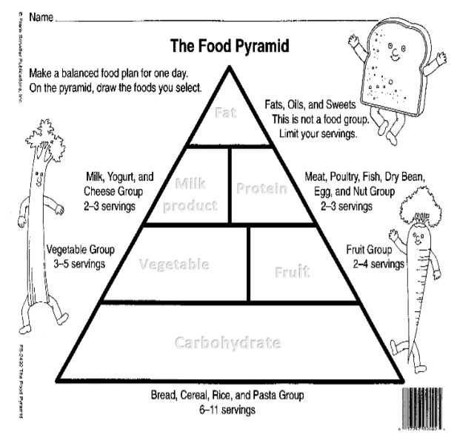

- Worksheet #5(SOS)
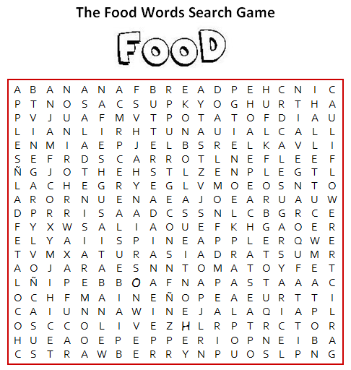
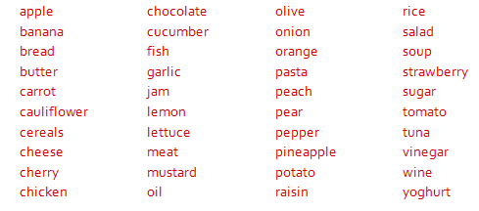

- Realia (4 photos)

- Worksheet solution

Worksheet #1
1. (d)
2. (e)
3. (a)
4. (c)
5. (b)
6. (f)
7. (g)

Worksheet #2
1. T
2. T
3. F
4. F
Worksheet #3
1. (1)
2. (3)
3. It is close enough
-> She will gradually become weak.
Carbohydrate deficiency- Lack of energy to be active
Protein deficiency- Problems with the function of the body (alopecia)
Milk products deficiency- The bone weakens.
Fat deficiency- Lack of energy to be activity
- Worksheet solution(SOS)

