Listening Speaking Reading Grammar Writing
Topic: Christmas is coming!

Instructor:  Sonia | Level:  Intermediate | Students:  12 students | Length:  30 Minutes

Materials:
- Counter, dice for board games
- Timer for checking time
- Worksheet #1 – Board game paper
- Worksheet #2 – Search word game

Aims:
- Main aim: Students will improve their fluency by speaking in small groups.
- Secondary aim: Students will be able to learn and build their vocabulary by listening to each other’s Christmas experiences.
- Personal aim: I want them to share their opinion to each other.

Language Skills:
- Reading: Students will read sentences on the square.
- Listening: Students will listen to each other’s Christmas experiences.
- Speaking: Students will speak and present their Christmas experiences.
- Writing: Students will write down the words to listen other’s presentation.

Language Systems:
- Phonology: /r/, /l/
- Lexis: new vocabulary in the board game square (spare time, resolution, tradition, present, depress, real)
- Grammar: past tense, present tense
- Function: give statement
- Discourse: students’ Christmas experience

Assumptions: Students already know
- How the class is organized and operated.
- Students know they should speak only English in the class.

Anticipated Errors and Solutions:
- If students can’t understand the questions on the square.
→ explain to students in simple terms.
- If some students speak too quietly
→ encourage them to take risks and walk further away from them so they can speak louder.

References:
- Christmas crossword
→http://endic.naver.com/
- Board game paper
→http://www.onestopenglish.com/searchResults.aspx?keywords=Christmas+is+coming&x=0&y=0
- Word search game paper
→http://festival-collection.com/christmas-song-christmas-word-search/

Lead-In
Materials: None
Time | Set up | Student Activity | Teacher Talk
1 min | Whole  class | Answering the teacher’s questions | Good morning, everyone! How are you doing today?  Today we are going to practice speaking. The topic will be “Christmas is coming!”

Pre-Activity
Materials: None
Time | Set up | Student Activity | Teacher Talk
2 min  3 min  1 min | pairs  Pairs  Whole class | Students talk to their partner about their Christmas day.  Students match a crossword with their partner  Students check answers | Procedure:  1.Prediction  Discussion  Let’s think about your Christmas day. How was it? What were you doing on Christmas day? Think about your Christmas day and talk about it to your partner. I’ll give you 2 minutes.  ICQ  What do you do now?  Are you working in pairs?  How much time do you have?  Let’s start!  Monitoring  (Monitor discreetly. Answer to questions.)  Give time warning:  30 seconds left.  Time’s up!  2. Vocabulary  Word Match  Ok class, let’s review or learn some popular Christmas vocabulary. Here is a worksheet.  (Hand out worksheet #1)  You can fill in the crossword by taking a hint below. You will do with your partner. I will give you 3 minutes.  ICQ  What do you do now?  Are you working in pairs?  How much time do you have?  Let’s start!  Monitoring  (Monitor discreetly. Answer to questions.)  Give time warning:  30 seconds left.  Time’s up!  3. Check Answers  Let’s check the answers together. (Write the answers down on the board)

Main Activity
Materials: Worksheet #2 – Board game paper
Time | Set up | Student Activity | Teacher Talk
2 min  13 min | Individually  Groups | Students listen the teacher’s introduction  Students play the board game with their groups. | Procedure:  1. Board Game  Introduction  Now, we are going to talk about your Christmas day experience by playing board game. I will give you the worksheet paper.  (Hand out worksheet #2)  And, I ‘ll divide you into four groups.  (Divide student into four groups. Each 3 students in a group)  First, one student rolls the dice and moves on the board according to the number on the dice. When a student lands on a square, you will have to answer the question for 30 seconds without stopping. If you stop talk for more than 3 long seconds, you go back to previous square.  You can use timer and dice on your phone. The game continues until one of the players reaches the FINISH square.  Demonstration  For example, I roll my dice and I get #. So I will move # squares. This square says .... so I will talk about ... for 30 seconds. If I stop for 3 long seconds...  (count "1 Mississippi, 2 Mississippi, 3 Mississippi") then I lose my turn and try again next time.  ICQ  Are you working in groups?  How long do you have to talk without stopping?  And what happens if you stop for 3 seconds?  Let’s start!  Monitoring  (Quietly walk around the classroom. Check to see if the students are on track. Answer to questions.)  (One group finish the game)  (Give them the SOS activity)  Ok, every group has finished the game. Great job everyone!

Post Activity
Materials: Worksheet #2
Time | Set up | Student Activity | Teacher Talk
7 min  1 min | Individually  Whole class | Students present their experience to choosing any question from the board game  Students listen | Procedure:  1. Presentation  Instruction  Now, you each have to choose one question from the game board and present it to the class. You can choose any question. Write down your response and be ready to read it to the class. Keep it short. About 4-5 lines. You have 5 minutes.  ICQ  What are you doing now?  How long should it be?  Will you present in pairs?  How much time do you have?  Great. Go ahead.  (Monitor discreetly and help any students that are struggling).  Okay. Let’s present from the first student.  (listen each students’ presentation one by one)  2. Feedback  (give a feedback to students and conclude the lesson)  Everybody did great job today.  I’m sure that you can speak well in English about Christmas from now on.  Thank you all for your participation and have a great day.

SOS Activity
Materials: Worksheet #3
Time | Set up | Student Activity | Teacher Talk
5 min | pairs | Play word search game | 1. Searching Christmas word  Instruction  Now I will hand out worksheet #3 and you can search Christmas word in this paper with your partner. I will give you 5 minutes.  (Hand out worksheet #3)  ICQ  What do you do now?  Are you working in pairs?  How much time do you have?  Let’s start!  Monitoring  (Monitor discreetly. Answer to questions.)  Give time warning:  30 seconds left.  Time’s up!  Asking question to student  Anyone found all 45 words?  44 words? 43 words? …  (Student who found the most words raise hand)  Ok. The word you can’t find is your homework. You all did a good job today!

- Worksheet #1

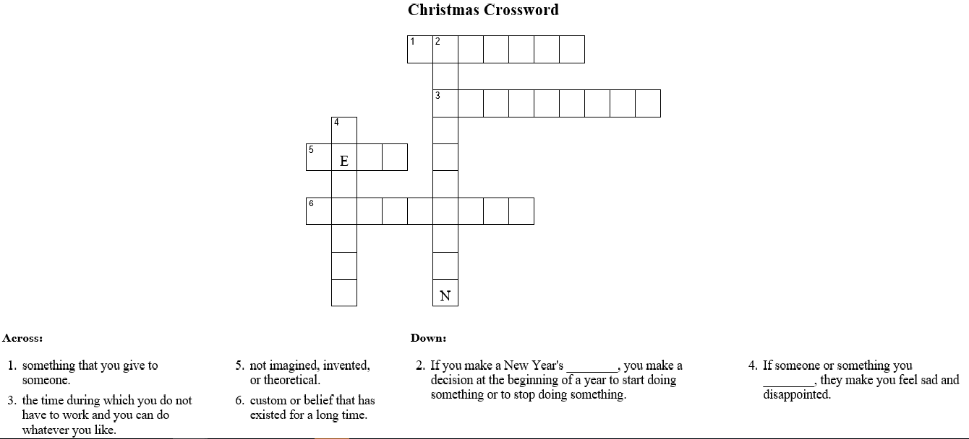
spare-time resolution tradition present depress real
- Worksheet #2
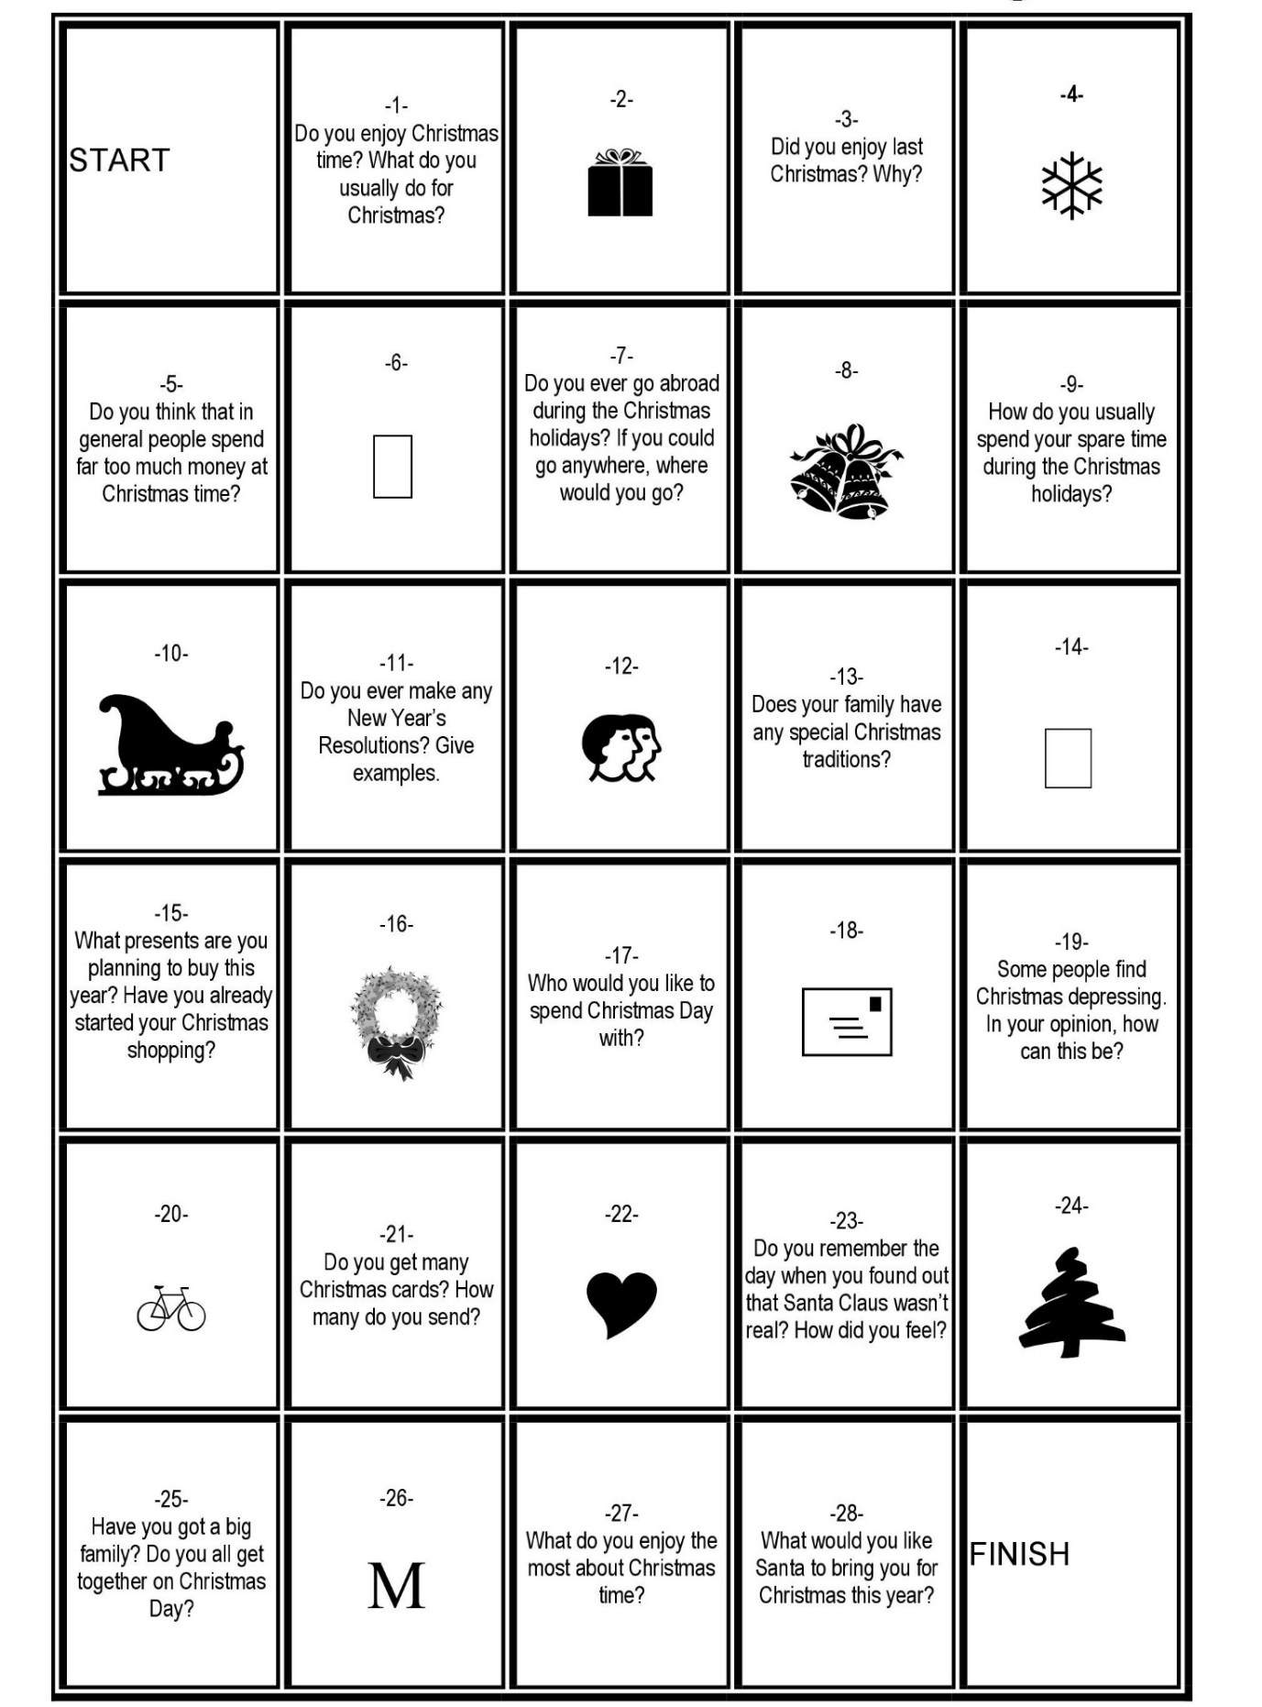
What do you think is so special about Christmas?
What was the most terrible Christmas memory?
What was your favorite place to visit during Christmas?
What kind of food would you like to eat for Christmas?
Where do you hate to go on Christmas? Why?
What is your favorite Christmas song?
To whom do you want to write the card this Christmas?
Who do you want to spend this Christmas with?
What is one gift you really hope to receive this Christmas?
What is the best Christmas gift you have ever given someone else?
What is the best Christmas gift you have ever received?
What is your favorite Christmas movie?
What are the signs of Christmas that make you realize it’s coming soon?
- Worksheet #3