Listening Speaking Reading Grammar Writing
Topic: Let’s talk about the ‘Future’

Instructor:  Heerae | Level:  Pre-Intermediate | Students:  12 students | Length:  30 Minutes

Materials:
- A white board and markers
- A big screen showing 5 pictures about future
- A big paper (For 3 groups)
- Color pens, crayons, color markers
- A worksheet: A few eliciting questions (12 copies) – Worksheet #1
Various questions about “future talk” (3 copies) - Worksheet #2
A empty color papers (12 copies) – Worksheet #3

Aims:
- Main aim: to develop intensive speaking skill by practicing pair discussion and group working. Students may express their various imaginations about future.
- Secondary aim: Student can set up their aim of life with thinking of the future.
- Personal aim: I am going to make students to think more about their future and circumstances surrounding them.

Language Skills:
- Listening: teacher’s elicitation, partner’s opinion in discussion, presentation of students in a group working and letter sharing
- Speaking: share information with a partner, group discussion, presentation and reading the letter in front of the class mates
- Reading: Students will read various questions in worksheet #2, they will read their letter
- Writing: Writing an answer on the worksheet #1, write a letter to themselves of 10 years later

Language Systems:
- Lexis/Phonology: clone, horoscopes, uninhabitable and practice these words
- Grammar: practice future tenses
- Function: discussion with a partner and in a group, presentation from a group working, a letter composition to themselves of 10 years later
- Discourse: partner discussion and a letter composition

Assumptions:
- Some students cannot use a complete sentence when they speak
- Some students are not good at using past, present and future tenses when they speak

Anticipated Errors and Solutions:
- If a student feels difficulty for answering on the worksheets, student can be guided to find proper information, e.g., scientific and medical articles in internet.
- If student answer is too simple for the “future talk” worksheet #2, student is going to be guided to add more information from internet.

Lead-In
Materials: none
Time | Set up | Student Activity | Teacher Talk
1 min | Whole  class | Answering the teacher’s questions | - Good morning, everyone!  - How are you?  - Who doesn’t have smartphone now in this class?  -When smartphone invented?  -Even several years ago phone was not so smart like these days.

Pre-Activity
Materials: big screen with photos, work sheets #1(12copies), board and marker
Time | Set up | Student Activity | Teacher Talk
3min  2min  2min | Whole class  Pair work  Whole class | Students are guess about teacher prepared pictures and answer the questions.  Writing their own answers and share with their partner’s tonight and tomorrow plan  Students see and check the words on the board or answer what they already knew the meaning of those words | Procedure:  1. Brainstorming  Elicit  (turn on the big screen and show 6 pictures)  -Look at the pictures on the TV.  -What can you See?  (wait and repeat after students)  -Chinese zodiac, AI, Clone, warms: future food  -Who knows about future?  (talk about question mark)  -So let’s talk about the “future” today.  -But, before start, let’s think about my near future.  (hand out the worksheet #1 to students)  -Everyone take one.  (Check everybody got the worksheet)  -There are very simple questions.  -Next, let’s talk about it with your partner.  -And write down your partner’s information.  - I’ll give you totally 2 minutes.  ICQ  -Do you work alone?  -Whose information do you write on your worksheet?  -How much time do you have?  Monitoring  (while students are doing their working, write words of worksheet #2 on the board-clone, horoscopes, uninhabitable)  (After 2 minutes)  -O.K. Time’s up.  -Now we are realized your partner’s tonight and tomorrow plan?  -Tonight and tomorrow are our near future. Right?  2. New vocabulary  Introduction  - Now, before going to start group activity, let’s check some vocabularies.  -What’s the first word on the board?  Clone  (demonstrate and show students a picture on TV again)  -This is cloned dogs. Means copied one or two something like that.  CCQ  -Brothers or sisters are clone?  Horoscope  -Has anyone heard of this word?  (If some student answer this, ask the meaning)  -Can you tell the class what it means?  (demonstrate and show students a picture for more can helping understand students)  -There are similar words, for examples are palm reading or tarot card.  CCQ  -Everyone’s horoscopes are same?  Uninhabitable  -What is ‘uninhabitable’ means?  (wait and listen students answers)  -means not fit for live  CCQ  -A dirty restroom is uninhabitable to us?

Main Activity
Materials: worksheet #2(3copies), big screen with the worksheet #2, big paper, color pens, crayons, color markers
Time | Set up | Student Activity | Teacher Talk
1min  15min  5min  1min | Whole class  Group work  1or2  volunteers in their group  Whole class | Students listen to teacher introduce about activity  Discuss about several questions and display group member’s answering on the big paper  One or two selected students will present their task in front of classmates  Students listen and some answering | Procedure:  1. Introduce group activity  -We are going to make a poster in group.  -We will divide into 3groups with A, B, C  -I’ll give you big paper, color pens, crayons, color markers.  -You may answer those questions on your poster.  -Write words, drawing or text…etc.  -I’ll give you some examples.  (①Demonstrate how to display their poster on the board)  (②Demonstrate the examples in the worksheet. Easy questions and hard questions)  -Of course can use internet.  -And at the end  -One or two persons in a group will have a presentation about your poster.  -And you have 15 minutes. OK?  ICQ  -Is this work pair or group?  -Do we write or drawing on that big paper? Right.  -Will you present your answer after group working? Yes.  -Can you use your language? No~  -How long do you have?  -OK! Let’s start!  2. Group working with discussion  Monitoring  (If students have a problems involve in their group and give my example opinions.)  (Before 5 minutes notice to students.. before 3minutes as well…)  -It’s almost time to finish your working.  (After 3 minutes from those notice)  -OK! Time’s up.  3. Presentation group working  -Please come up and show your group’s opinions to your class.  -Who will go first?  (finish presentations of all the groups)  4. Conclusion & Feedback  -All right! Is this good sharing about future?  -Which part of the poster was impressive?  -Did you have fun today?  -OK! Thank you all for participating well in your group working.  -Hope you to consider your future life at this time.

Post Activity
Materials: Worksheet #3-empty color paper(12copies)
Time | Set up | Student Activity | Teacher Talk
7~8min | Individually | Students write a letter to themselves. | -OK! Here’s one more activity.  (hand out worksheet #3)  -You are going to write a letter to yourself in 10years later.  -You do this activity individually for 7 minutes.  -You will present it after 7 minutes in front of class.  ICQ  -Are you work alone?  -How much time do you have?  OK. Let's start!  (after 7 minutes later)  OK. Time's up!  -Let's present it.  (After finish all the students )

SOS Activity
Materials: worksheet#4-picking-up strips of papers in a small box
Time | Set up | Student Activity | Teacher Talk
12min | Whole class | Students pick up the strips of papers questioning unknown future and answer about it in front of the classmates  one by one | (A teacher make students to choose the picking-up papers)  - you are going to have a funny question about future, you can choose one of these picking-up strips of paper, and you can see the question and answer about it.  - You got it? It’s simple Huh…

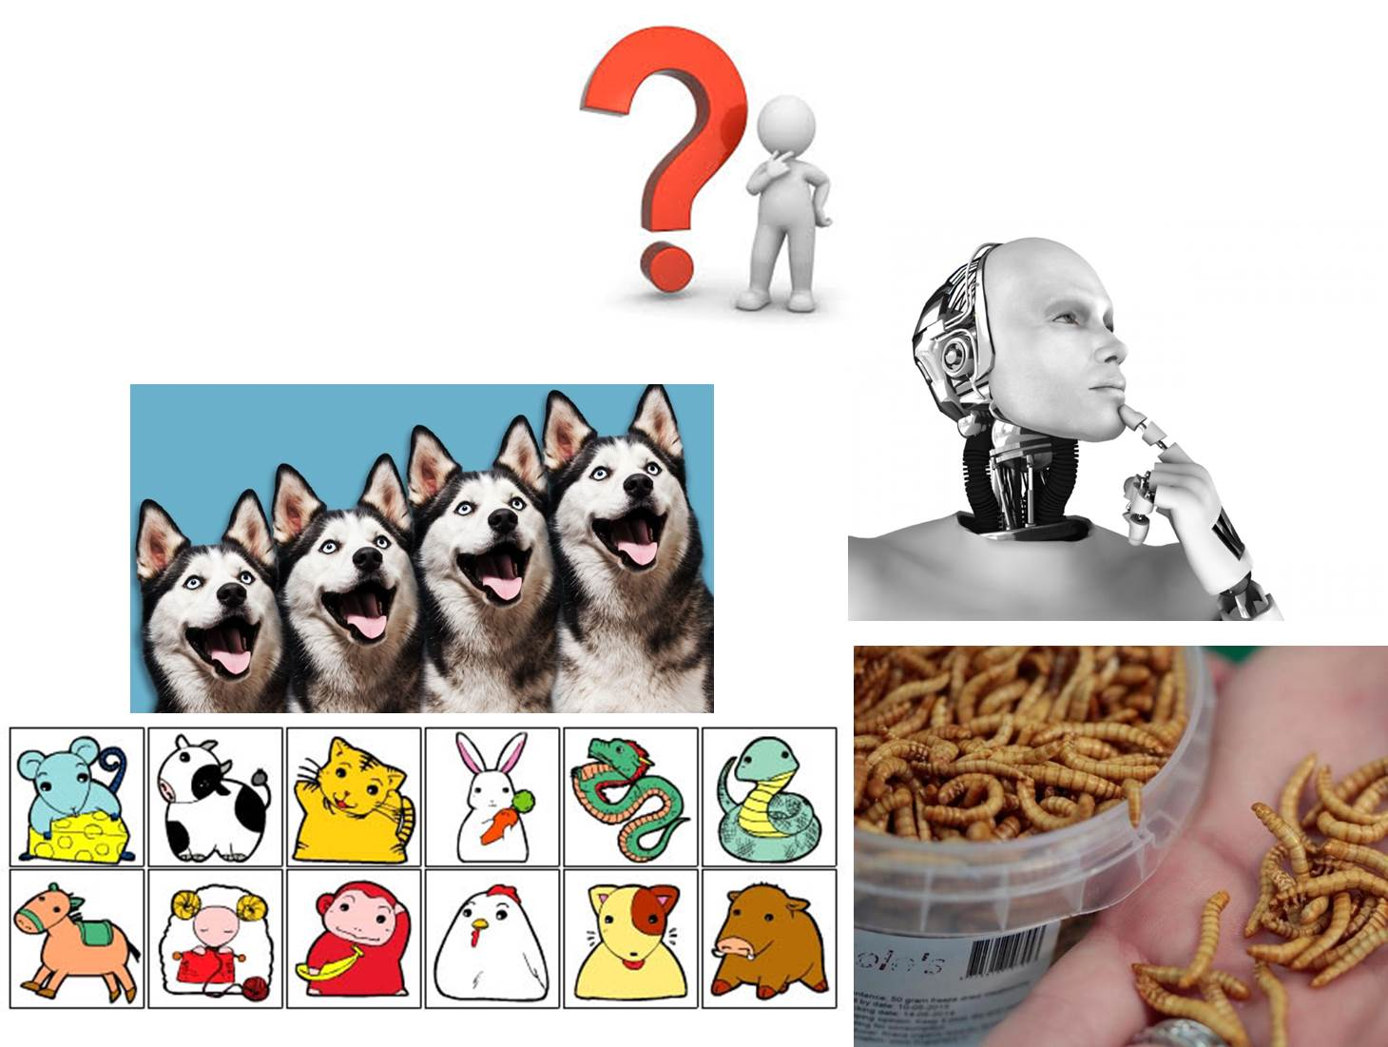

Worksheet #1
1) What do you think the weather will be tomorrow? (Give your prediction)
2) What are you going to do tomorrow? (Describe you plan)
3) What are you doing tonight? What fixed appointments do you have?

Worksheet #2

Group A Group B Group C
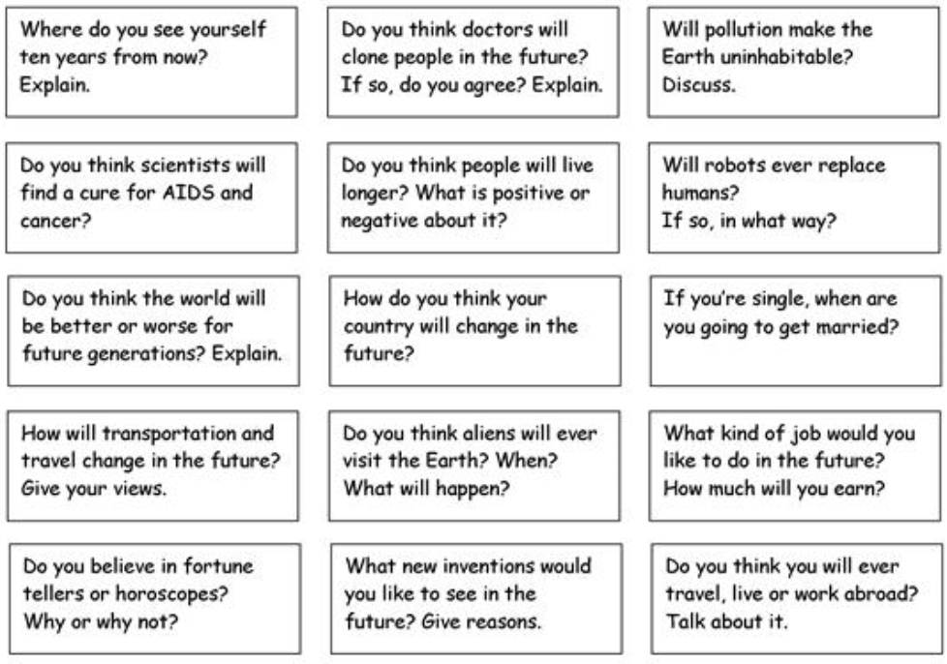

A Letter composition (Worksheet #3)

Worksheet #4

