|  |
| --- |
| 🞏Listening 🞏Speaking 🞏Reading 🗹Grammar 🞏Writing |
| Topic: Present progressive in positive and negative sentences |

|  |  |  |  |
| --- | --- | --- | --- |
| Instructor:  Hyun-Ji, Sonia | Level:  Intermediate | Students:  12 students | Length:  30 Minutes |

|  |
| --- |
| Materials:   * Computer, screen, white board, board markers * Worksheet #1 – (12 copies) * Worksheet #2 – (12 copies) * Worksheet #3 – (12 copies) * Worksheet #4 – (12 copies) * Table # 1 and 2 (1 copy each) * Image-Halloween (2 copies) * Definition paper (1 copy) |

|  |
| --- |
| Aims:   * Main aim: Students will practice how to use the present progressive in positive and negative sentences by completing the worksheet. * Secondary aim: Students will be able to practice and writing sentences by using the present progressive. * Personal aim: I want them to learn the patterns to express the present progressive in positive and negative sentences by completing the worksheet. |

|  |
| --- |
| Language Skills:   * Reading: Student will read sentences what they make. * Listening: Students will listen to each other’s sentences. * Speaking: Students will speak and present their own sentences. * Writing: Students will write down the sentences by using the present progressive. |

|  |
| --- |
| Language Systems:   * Phonology: drilling * Lexis: verbs: playing, to wear, to have, to read etc * Grammar: present progressive in positive and negative sentences * Function: give a statement * Discourse: Student’s own experience |

|  |
| --- |
| Assumptions: Students already know   * How the class is organized and operated. * Students know they should speak only English in the class. * Students know that today’s topic is grammar. * Students know the most of the meaning in verbs |

|  |
| --- |
| Anticipated Errors and Solutions:   * Students finish their work faster than expected   -> Give them SOS activities   * Students may have difficulties in understanding the patterns and use it.   -> Give them more examples and explanation |

|  |
| --- |
| References:   * The present progressive definition:   Google.com   * worksheets activities:   [www.bogglesworldesl.com](http://www.bogglesworldesl.com)  www.cse.google.com   * Tables:   [www.learnenglishhavefun.com](http://www.learnenglishhavefun.com) |

|  |  |  |
| --- | --- | --- |
| **Lead-In** | | |
| Materials: None | | |
| Time | Set up | Teacher Talk |
| 1 min | Whole class | Good morning, everyone! How are you feeling today? Good!  Today we are going to practice grammar as you all know. The topic is present progressive. So today we are going to practice how to use the present progressive in positive and negative sentences in any situation. |

|  |  |  |
| --- | --- | --- |
| **Pre-Activity** | | |
| Materials: Computer, Image-Halloween, board, board markers, table# 1 and2, definition paper | | |
| Time | Set up | Teacher Talk |
| 9 min | Whole class  Whole class | **Procedure:**  **1.Prediction**  **Elicit**  (Sonia -show the image)  Please, look at the image. What is this?  (point at black cloth person)  what the child is doing at this moment?  (point the other one)  What about another one?  What they are wearing?  (Sonia: writes down on the board all verbs from the questions in the present progressive)  (possible:  she is holding a wand woods,  The boy is sitting on a jack O’lantern  She is wearing a hat  The body is looking at a spider)  **CCQ:**  Is she holding a bag? (no, she is not)  Are you looking at me? (Yes, I am)  Who is playing on the image? (the girl)  **2.Topic**  (Sonia-writes ‘What they are doing?’ on the top of the board”)  Now, I want you to make three groups and discuss “what they are doing” try to discuss ongoing action at this moment  I will give 3 minutes  **ICQ:**  How much time do we have?  What do you discuss?  (HyunJi monitor discretely)  after 3 minutes  Ok, can anyone tell me what they are doing?  Yes, They- are- playing!  ‘playing’ is happening now?  Let’s talk about the discussion    (Sonia hold the image)  Can you tell from the image that the girl will play with the boy after 10 hours? for sure?  The girl is playing with the boy now?  What about the boy?  What is he doing?  Was he sitting on the jack?  Can anyone compete this sentence?  ‘ he --- is---‘  what do you think in the form of this sentence?  **Present Grammar**  We just have learned Present Progressive tense  (Sonia-Fill in the top of the board “Present progressive)  (Sonia hold the the image again)  Ok, let’s talk about image again  Is she holding a mask?  Was she hold the mask a long time ago?  Is she going to hold the mask after 2 hours?  No, we don’t know  She is holding the mask at this moment, ongoing action at the present time  For example, I am talking to you  She is standing in the classroom  They are looking at me  Like those examples, this form use to describe actions at the present time or at the moment  Everyone is ok here?  Any question?  **CCQ:**  Can we use the form to describe action in future?  Can we use the form to describe action in the past?  **Definition**  (Sonia hold the definition paper)  Please look at the paper that Sonia is holding  It is definition for present progressive  Thank you Miss, Sonia can you write the present progressive from for us?  **Form:**  (Sonia-write down the form:  Subject +present simple of ‘be’ + infinitive +-ing)  The present progressive in English is easy to make and is the same for all verbs  We make it using subject +present simple of ‘be’ + verb-ing called present participle  **CCQ**  Do we need verb+ing to make the sentence?  **Drilling**  (Sonia- show the positive table to student and Sonia hold the table)    Okay, listen to what I say and repeat after me  We are going to do only one time  I**CQ**:  What do you do?  How many time we will shout out?  I am going -----  You are doing  He is playing  .  .  .  (Sonia shows the negative form in the table)  You can make the sentence in negative just simply adding “not” before the verb+ing  **ICQ**  How to make a negative sentence in present progress form?  Can we add ‘not’ before the verb-ing?  Good-  Liston and repeat after me  I am NOT going  You are Not doing  ...  Can anyone make one positive sentence and one negative sentence in present progressive?  (Sonia writes down sentences from the student on the board) |

|  |  |  |
| --- | --- | --- |
| **Main Activity** | | |
| Materials: Worksheet #1, #2, #3, white board and marker | | |
| Time | Set up | Teacher Talk |
| 3 min  1 min  3 min  1 min  7 min | individually  Whole class    individually  Whole class  Pairs | **Procedure:**  **1. Complete worksheet**  **Introduction**  Now, we are going to complete the worksheet we have learned before. Hyun Ji will give you the worksheet paper.  (Hyun Ji-hand out worksheet #1)  You can write down the sentences by using present progressive in positive sentences. You will do it alone and I’ll give you 3 minutes.  **ICQ**  What do you do now?  Are you working in pairs?  How much time do you have?  Let’s start!  **Monitoring**  (Quietly walk around the classroom. Check to see if the students are on track. Answer to questions.)  **2. Check Answers**  Ok, everyone has finished the worksheet. Now, let’s check the answers together.  (Hyun Ji-write the answers down on the board)  Ok, good job everyone!  Now, we are going to practice present progressive in negative sentences.  (Hyun Ji- handout worksheet #2)  You will complete the sentences with the verb in the brackets. Use the negative form of the present progressive.  So, you will do it alone too and I’ll give you 3 minutes.  **ICQ**  What do you do now?  Are you working in pairs?  How much time do you have?  Let’s start!  **Monitoring**  (Quietly walk around the classroom. Check to see if the students are on track. Answer to questions.)  (If students finished the worksheet #2,  give them the SOS activity)  **Give time warning:**  30 seconds left.  Time’s up!  Do you need more time? Ok I’ll give you 1 minute more. Go ahead.  **3. Check Answers**  Ok everyone. Let’s check the answers together.  (Hyun Ji -write the answers down on the board)  **4. Spot the difference**  **Instruction**  Now, we are going to find different things in between two pictures. I’ll give you a worksheet.  (Hyun Ji-hand out worksheet #3)  (Give each partner a different worksheet A,B)  Look at this worksheet. You and your partner get each other pictures. So, talk to with your partner what is differences in between two pictures and write down as many things as possible that are happening in the picture. Don’t show your paper to your partner. You should use present progressive tense. The pair that writes down the most things wins.  I’ll give you 10 minutes  **ICQ**  What do you do now?  Are you working in pairs?  How much time do you have?  Let’s start!  **Monitoring**  (Monitor discreetly and help any students that are struggling).  **Give time warning:**  1 minutes left.  Time’s up!  Everybody finish?  **5. Asking question to student**  How many things did you found differences?  10? 9? …  (Student who found the most differences raise hand)  Ok let’s review the pictures that you found.  Tell me about what you found different.  Everybody did a great job! |

|  |  |  |
| --- | --- | --- |
| **Post Activity** | | |
| Materials: White board and marker | | |
| Time | Set up | Teacher Talk |
| 5 min | Whole class | **Error correction**  Mis Sonia is going to write four sentences  (Sonia write on the board 1.  2.  3.  4.  There are senteces used by you all during the class  Two good sentences and two incorrect sentences  Sentence #1 (correct)  (Sonia write down on the sentence #1 after hyunji spoke)  Sentence #2 correct  (Sonia write down on the sentence #2 after hyunji spoke)  Sentence # 3 incorrect  (Sonia write down on the sentence #3 after hyunji spoke)  Sentence #4 incorrect  (Sonia write down on the sentence #4 after hyunji spoke)  What do you think? Which one is correct and which one incorrect and why?  (let students talk the about it and correct them)  **Feedback**  Okay, that would be all for today  Did you enjoy today’s class?  How were the worksheets?  I hope you had fun today and have a wonderful evening! |

|  |  |  |
| --- | --- | --- |
| **SOS Activity** | | |
| Materials: worksheet #4 | | |
| Time | Set up | Teacher Talk |
| 12 min | Individually | **1. Searching present progressive**  **Instruction**  Now I will hand out worksheet #4.  (Hand out worksheet #4)  You should find the word by changing the word to the present progressive type. You should do it alone and I will give you 12 minutes.  **ICQ**  What do you do now?  Are you working in alone?  How much time do you have?  Let’s start!  **Monitoring**  (Monitor discreetly. Answer to questions.)  **Give time warning:**  30 seconds left.  Time’s up!  **Asking question to student**  Anyone found all 18 words?  17 words? 16 words? …  (Student who found the most words raise hand)  Ok. The word you can’t find is your homework. You all did a good job today! |

* **Images**

**Halloween Costumes**

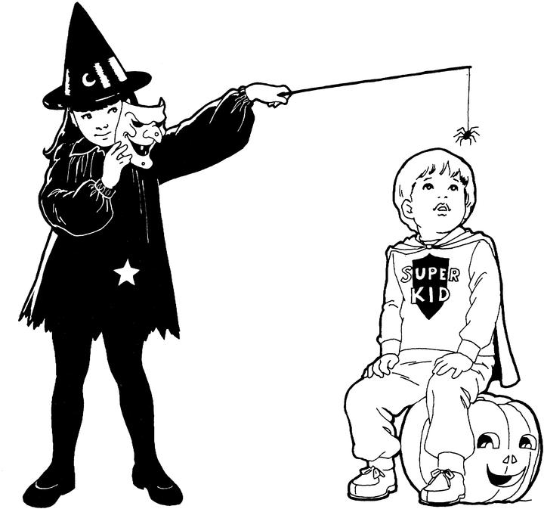

* **Worksheet #1**



* **Worksheet #2**

**\*Complete the sentences with the verb in the brackets. Use the negative form of the present continuous**

Ex. I _ am _not doing _ (to do ) my homework.

1. I ________(to wear) sunglasses at the moment.
2. Jack ______(to have) a shower.
3. Mark _____________(to read) a book.
4. They _______________ (to play) tennis.
5. You ______________ (to take) me seriously.
6. My dad_____________ (to drive) to work.
7. He____________(to feel) well at the moment.
8. I________________(to eat) a pizza.
9. The Students_______(to listen) to the teacher.
10. .The teacher_______ ( to take) to the students.

* **Worksheet 3**

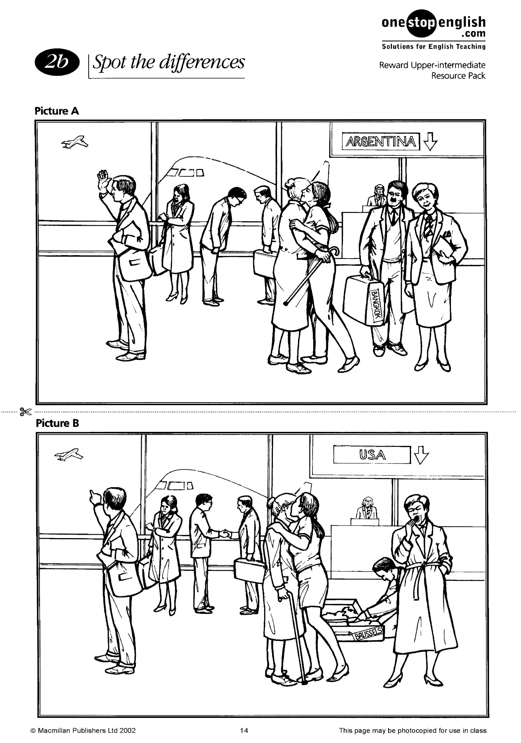

* **Worksheet #4**

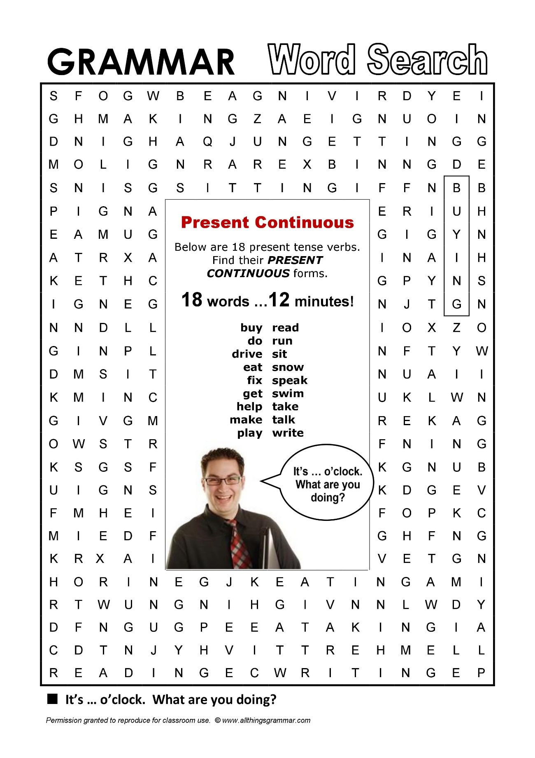

* **Table 1**

Present progressive positive form

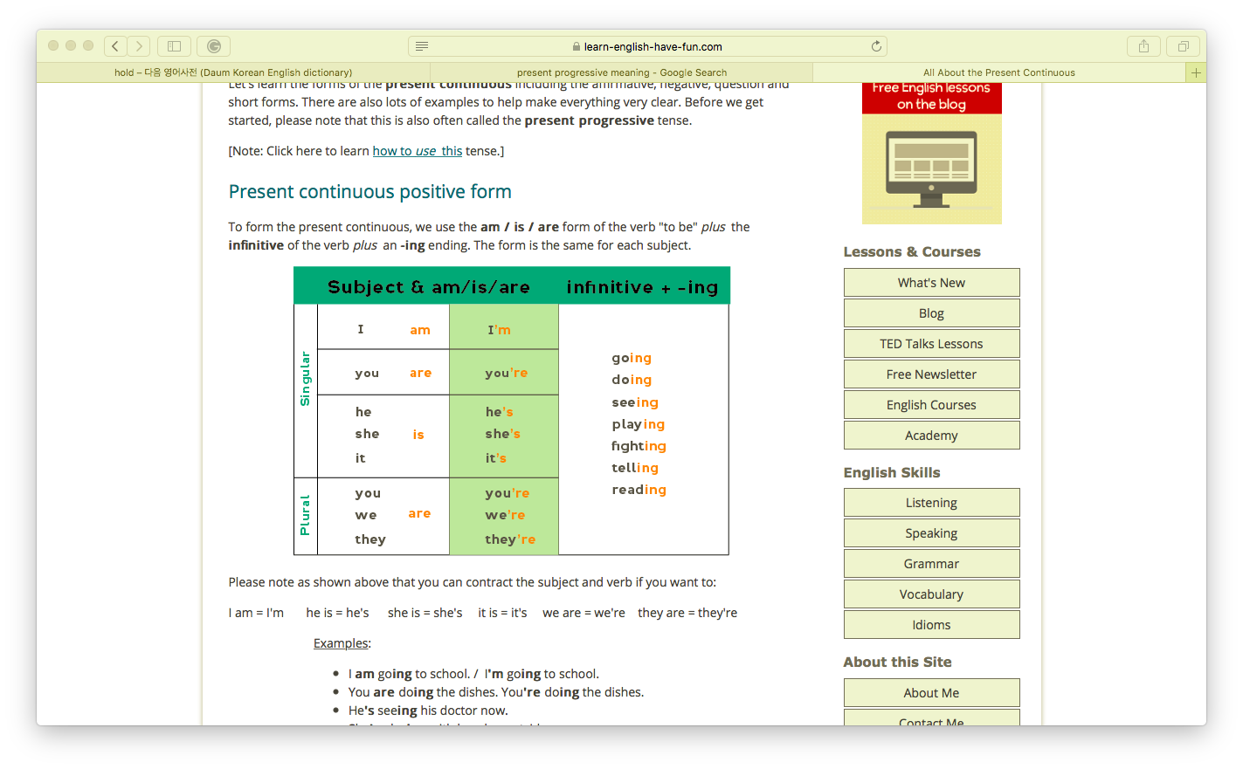

* **Table 2**

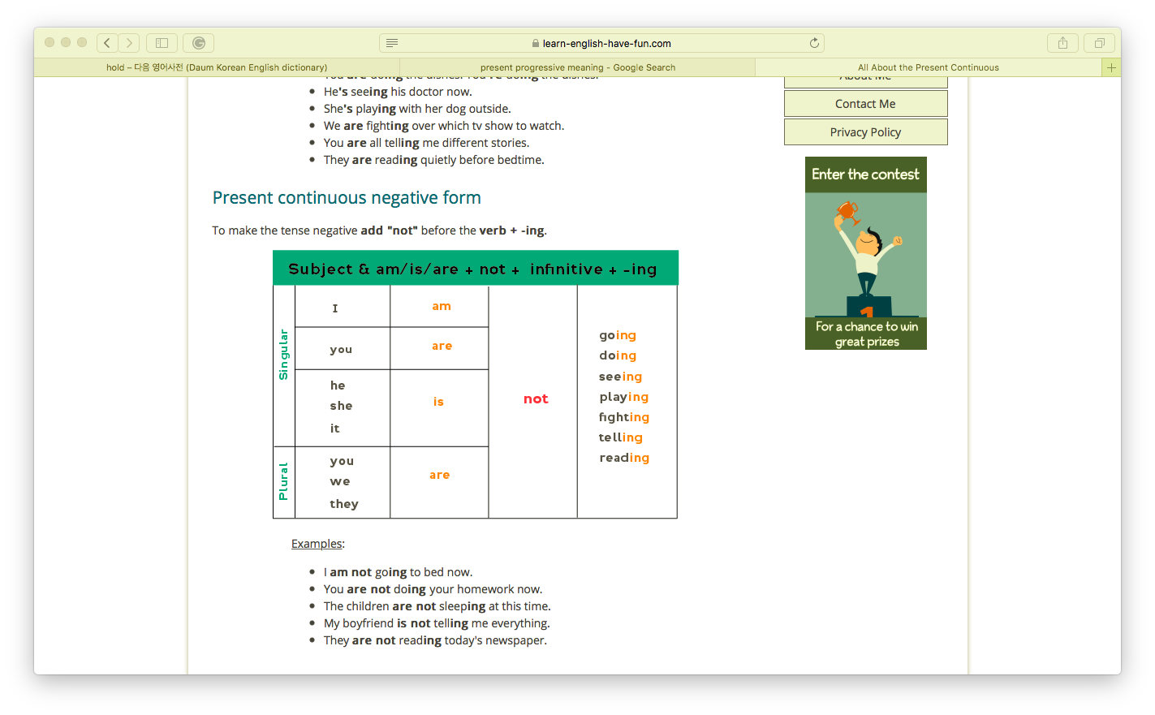

**Definition**

**Present Progressive**

In English grammar, the present progressive is a verb construction (made up of a present form of the verb 'to be' plus a present participle) that usually conveys a sense of ongoing action at the present time