Listening script

The truth about lying

We all like to think of ourselves as honest people who try to tell the truth. But we have to admit that there are times when almost everyone lies. For example, we often tell “white lies” when it would be considered rude or offensive to “tell it like it is.” Telling a lie may or may not be a terrible thing, depending on the situation. Here are four of the most common types of lies:

- Lying to protect someone’s feelings. You want to avoid saying what you really think because it might hurt another person’s feelings, so you say something complimentary, a white lie that will make the person feel good.

- Lying to protect yourself. You want to get out of an uncomfortable or “sticky” situation, so you say something to make people think you’re innocent. Criminals always deny responsibility in order to get away with something.

- Lying to impress others. You want to be popular, gain approval, or sound important, so you say something that will make people think well of you.

- Lying to make a polite excuse. You want to avoid doing something that you find unpleasant, so you make up a polite excuse that will satisfy the other person.

When it comes to lying, the best advice for people with good intentions may be to follow the Golden Rule: “Do unto others as you would have them do unto you.”
Pre- Activity_ Visual aid
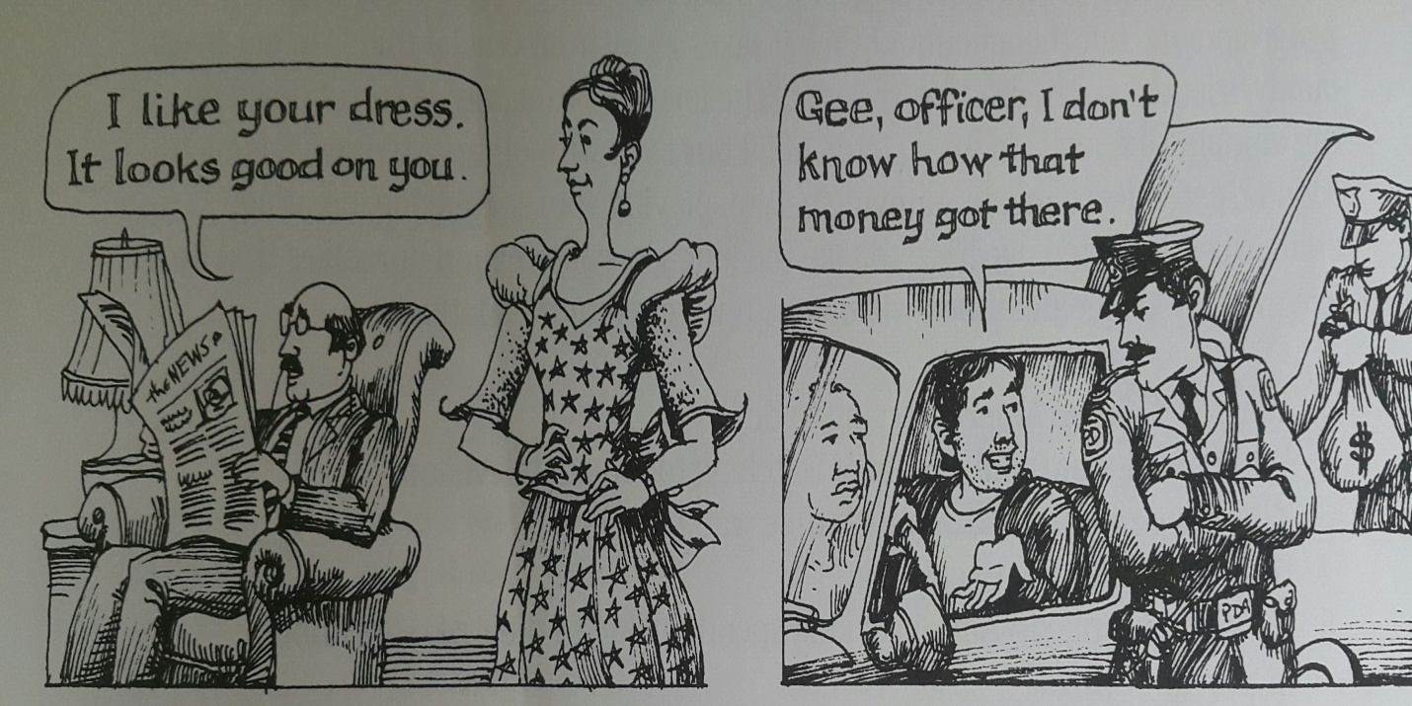

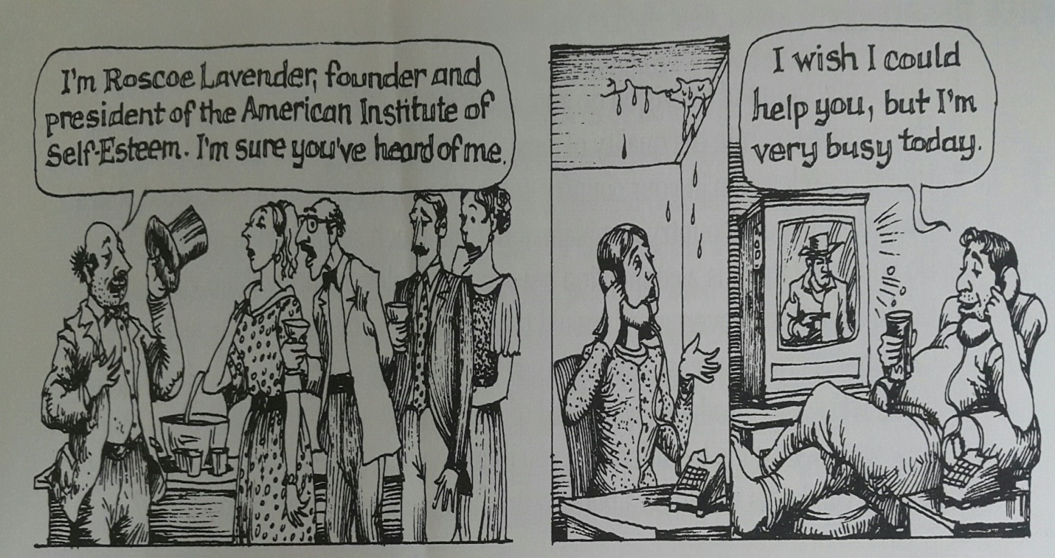
Pre-Activity_ New vocabulary (worksheet #1)

Answer Key
Word bank

- Rude b. complimentary c. truth d. offensive e. sticky f. honest
g. innocent h. responsibility i. approval j. uncomfortable

- * Fill in the blanks with the words from the “word bank” to match the definition.

- ( ) – A fact has been verified.
- ( ) – Not disposed to cheat or defraud.
- ( ) – Socially incorrect in behavior.
- ( ) – Violating or tending to violate or offend against.
- ( ) – Conveying or resembling a compliment.
- ( ) – Conducive to feeling mental discomfort.
- ( ) – Hard to deal with especially causing pain or embarrassment.
- ( ) – Free form evil or guilt.

Main Activity- Phrase Match (worksheet #2)

*Write the letter of the right answer on the blank from the box below.

- ______ Because it might hurt another person feelings.
- ______ A white lie that will make the person feel good.
- ______ You say something to make people think you’re innocent.
- ______ Criminals always deny responsibility.
- ______ You may say something that will make people think well of you.
- ______ You make up a polite excuse that will satisfy the other person.

- You say something complimentary.
- You want t to avoid saying what you really think.
- To get away with something.
- To be popular, gain approval, or sound important.
- To get out of an uncomfortable or sticky
- To avoid doing something that you find unpleasant.

Post – Activity_ Discussion Paper

*Topic: People should always tell the truth.

*Opinion:

*Reason:

1.

2.

3.

SOS-Activity_Crossword Puzzle.
Name:
- Complete the crossword below.

Across
1. A true statement.
3. Free from evil.
4. The social force that binds you to the courses of action demanded by that force.
9. The formal act approving.
10. Meet the requirements or expectations of

Down
2. Not disposed to cheat or defraud.
5. Hard to deal with.
6. Socially incorrect in behavior.
7. Violating or tending to violate or offend against.
8. The general state of thing.

