☐ Listening ■Speaking ☐ Reading ☐ Grammar ☐ Writing
Topic: Blind date

Instructor:  Julie & Angela | Level:  Intermediate | Students:  5 | Length:  45 Minutes

Materials:
White board and board maker
Worksheet # 1~5

Aims:
Main aim: Ss will be able to practice their speaking skill by dealing with some conversation related with a blind date.
Secondary aim: Students will practice speaking by expressing their ideal type to another.
Personal aim : I Want to students have a fun time to think about their ideal type

Language Skills:
Listening : Drilling / following instructions / Role play
Speaking : Role play / Discussion
Reading : Dialogue
Writing : Changing the underlined words / Role play

Language Systems:
Lexis : New vocabularies in the article
Function : Ranking, Discussion, Drill, Roll playing
Discourse : Dialogue

Assumptions:
Students already know
- How the class is set up and run
- They know their ideal type.

Anticipated Errors and Solutions:
- If shy students don’t want to express their idea together.
- Let them skip their turn freely.
- If there is a student who didn’t think about their ideal type.
- Ask them if there is a favorite actor or celebrity.

References:
None
Lead-In
Materials: None
Time | Set Up | Student Activity | Teacher Talk
2min | Whole class | Answering to teacher’s questions. | Greeting students  Good morning!  How are you today?  Hey guys, Do you have favorite actor or actress?  And why do you like him or she?

Pre-Activity
Materials: work sheet #1 , work sheet #2

Time | Set Up | Student Activity | Teacher Talk
1min  5min  2min  5min | Whole class  Individually  Whole class  Work  In pair | Listen  Brainstorm  & complete Worksheet #1  Discuss freely  complete Worksheet #2 | Introduce Topic  Today we will talk about “ideal type”.  (Board today’s topic on the board)  Prediction & Ranking  (Hand out work sheet #1)  Have you ever gone on any blind dates before?  If not, Let’s imagine it.  Which part of him or she would be most attractive to you?  There is a list at the top of the page.  Please check it all and make your own priority alone.  I will give you 2 min.  ICQ  How much time we have?  Do you work in pair?  Monitoring  Check if there are any students doesn’t understand teacher’s instruction.  Instruction  Ok. Did everybody finish well?  Let’s share your priority one by one.  (let students share their idea)  Discussion  And Do you have any other factors that you think are important but are not listed?  (Check volunteers and let them speak their idea)  Wow there are many factor which we are care of, isn’t it?  New vocabulary  Let check new vocabularies related with main conversation.  (Hand out work sheet #2)  On the activity sheet, There are list of vocabularies and sentences. Please fill out the sentences using right vocabulary.  Demonstrate  Let’s check the first sentence together. we…  Instruction  I will give you 3mins to finish. Please do it with your partner.  ICQ  How much time do we have?  Are you working alone?  Check answer  Time’s up.  Let’s check answer together.

Main Activity
Materials: work sheet #3(dialogue), a celebrity photo, work sheet #4(role cards), photographs of three men.

Time | Set Up | Student Activity | Teacher Talk
7min  7min  7min | Whole  pairs  Whole  Pairs  Pairs | Listening for the dialogue and repeat – drill the text.  Changing the words or phrases and practice.  Real practice role playing. | Procedure:  - Dialogue Drilling (Controlled Practice)  Instruction  This is a conversation between two friends.  (distribute the dialogue)  Look at the text, first just listen.  (Teacher reads)  Now, repeat after me.  (Teacher reads line by line, Students repeat-drill the text)  Now, practice with your partner, Read it twice; once as the friend A and once as the friend B. I’ll give 4min. Try to memorize the script while practicing.  ICQ  How much time do you have?  What should you do?  Will you work with your partner?  (Run the task, monitor and correct students if they make errors)  You have 1min left.  (After 1min)  Time’s up! You did a good job!  - Change the words or phrases (Less-Controlled Practice)  Instruction  Work with the same partner. Change the underlined words or phrases. (demonstrate by reading the dialogue and changing the underlined words) I’ll give you 5min.  ICQ  What do you have to do?  How much time do you have?  Let’s start!  (Monitor and assist students having difficulty. Have some pairs read their changed dialogue for the class)  You have 1min left  Time’s up! You did a great job!  - Role play (Free Production)  Instruction  Now, we’re going to do a real practice. Take one role card each. You will be Friend A or Friend B. Read the role card carefully and follow the instructions. I’ll show you what to do.  (Demonstrate with a student volunteer)  You have 4min. Work with your partner. You will share your acting to your classmates.  ICQ  What should you do?  Will you work alone?  How much time do you have?  (Run the task, monitor and help students as needed! Have pairs perform their role play in front of the class. Take note of any noticeable errors students make with the new expressions learned today.)  You have 30 sec left.  Now, time’s up! Great job!

Post Activity
Materials: None
Time | Set Up | Student Activity | Teacher Talk
2mins  1min  1min | Whole class  Whole class  Whole class | Check errors  Response teacher’s talk | 1. Error correction  Write down students error during the discussion or roll play on  The board. Let student try to speak out own their mouth.  2. Feedback  OK guys. How was today’s lesson topic?  Was it interesting? I hope so.  3. Conclusion  You did good job today. Let’s have a break time.

SOS Activity
Materials: work sheet #5 (The odd one out game worksheet )
Time | Set Up | Student Activity | Teacher Talk
3min  2min | pairs | Complete the worksheet  Check answer | Now we are going to solve the worksheet related to learning. Read carefully and answer the question. You have to pick the odd one among 4 words. Work your with your partner. You will have 3minutes to do so.  (Distribute the worksheet)  ICQ  What word will you pick among 4?  Will you work individually?  How much time will you have?  Ok, let’s start!  Monitoring  (Quietly walk around the classroom Check to see if the students need help. Answer to student.)  You have 1min left.  Time’s up. You did a great job!  Check answer  Each team will go around and answer to each question.

Worksheet 1# (Ranking & Discussion)

- Let’s think about that when you did a blind date with someone, which point was most attractive to you?

LIST
Outward appearance | Occupation | Personality | Something in common
Age | Background | Sense of humor | Educational level
Fashion sense | Hobby | Competency | Amount of property

Your own priority
1
2
3

2. Except above the items on the list, Is there anything else?

Worksheet 2# (Match vocabulary with sentence)

Please make right each sentences using vocabulary list.

Vocabulary
Break up Serious Swimming
Introduce Personality Hobby
Wise Witty Theater
Handsome Actor Active

Sentence

1. Many families ( break up ) because of a lack of money.

2. This isn't a ( serious ) course. It's nothing but fun and games.

3. The drowning took place in the ( swimmi ng ) pool.

4. How can we ( introduce ) our products to a lot of people?

5. She has such a kind, friendly ( personality ).

6. My ( hobby ) is to collect coins.

7. A word to the ( wise ) is enough.

8. He is, by nature, a joker, a ( wit ty) man with a sense of fun.

9. At the ( th eater ), most of Shakespeare's plays were performed.

10. Looking pretty or ( handsome ) can be great.

11. Speak naturally; don't try to imitate some ( actor ).

12. They are ( active ) in the feminist movement
Worksheet 3# (Dialogue)

Main Activity-

Dialogue- Blind date

A: I know a good guy and really want to introduce him to you!
B: Thanks! Could you tell me more about him?
A: Looks-wise, He is tall and handsome.
Also he kind of looks like an actor, Gong-Yu.
B: Oh, really? What does he do for a living?
A: He is a teacher.
B: Is he too serious? What about his personality?
A: No, he is not too serious. He is witty and humorous. Also he is very active. So he likes active sports like swimming.
B: I like swimming too. Is that his hobby?
A: Yes. He often goes to the theater to see a play as well.
B: Wow he is Just like me!
Can I see a photo?
OMG, I crush on him. He is my type. Thanks!
Main-Activity-Visual aid
A celebrity photo- Korean Actor Gong-Yu
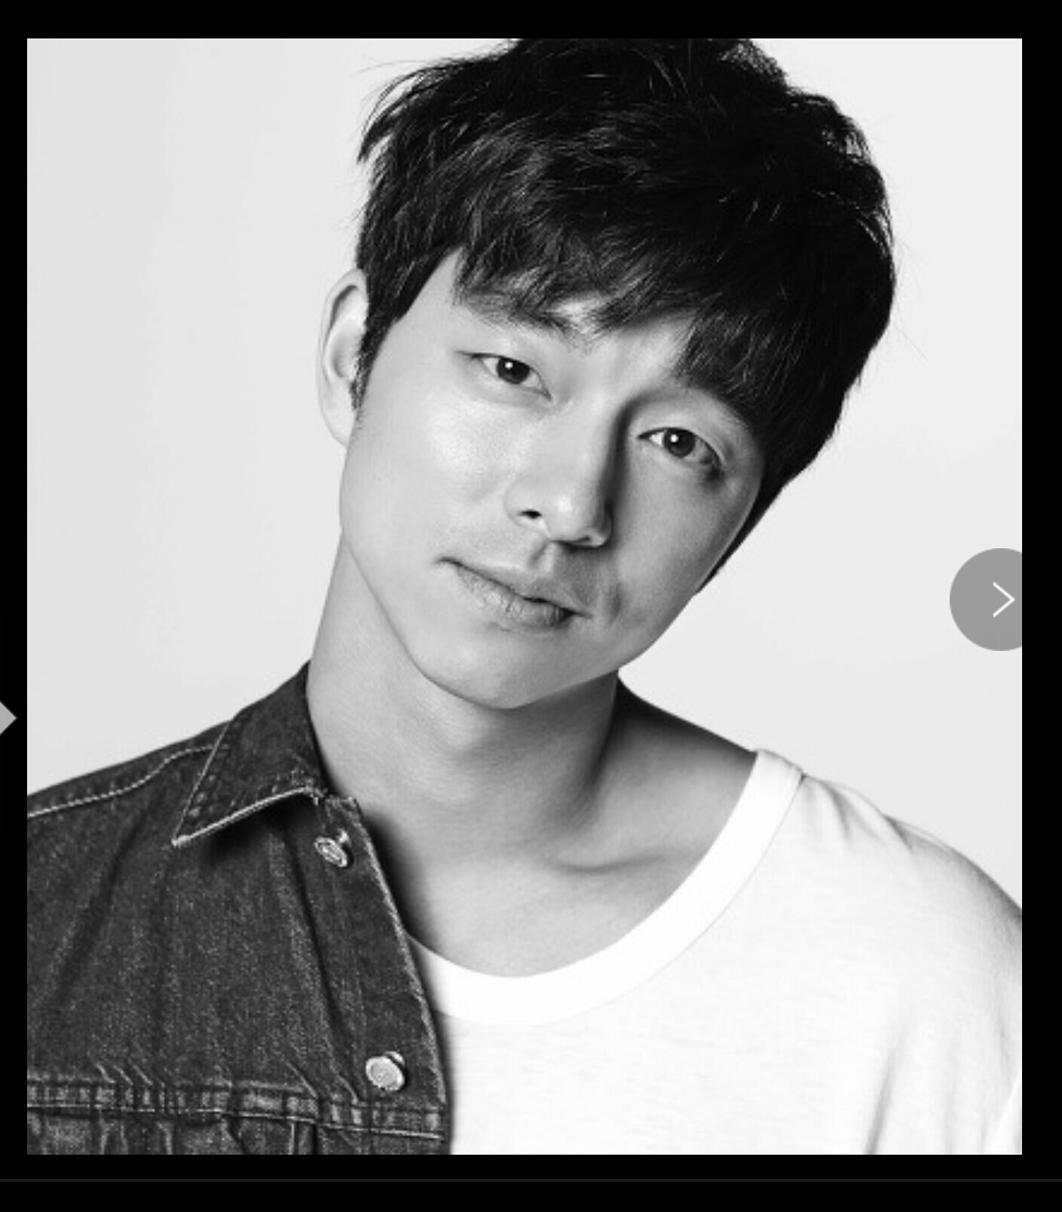
Worksheet 4# (Role play)
Role cards for role play
Type A: Doctor – Friend A

You tell your friend you really want to introduce a good guy to your friend. Also, you have to say

He is/ he….
- Appearance: Looks pleasant, average height with a killer smile, kinds of looks like an entertainer
- Occupation: Doctor.
- Personality: Not so emotional detached, rational and kind, very passionate. So he likes dancing.
- Hobby: goes to dance academy on weekends.

Type A – Friend B

When you hear that your friend wants to introduce a guy who she knows, giving thanks, you have to ask her to tell more about him and some questions;

- What does he do for a living?
(After hearing his job)
- Isn’t he emotional detached?
- What about his personality?
- What is his hobby?
(After hearing his hobby)
- Can I see a photo?

While hearing A’s words, you find one thing in common he likes dancing. After seeing the photo, you have to tell your friend what you think.

Type B: Head Chef – Friend A

You tell your friend you really want to introduce a good guy to your friend. Also, you have to say

He is/ he….
- Appearance: has a face and is tall, kind of looks like an announcer.
- Occupation: head chef
- Personality: not so fastidious, gentle and romantic. So he likes watching a movie.
- Hobby: watching movies and often goes bowling as well.

Type B– Friend B

When you hear that your friend wants to introduce a guy who she knows, giving thanks, you have to ask her to tell more about him and some questions;

- What does he do for a living?
(After hearing his job)
- Is he fastidious?
- What about his personality?
- What is his hobby?
(After hearing his hobby)
- Can I see a photo?

While hearing A’s words, you find one thing in common he likes watching movies. After seeing the photo, you have to tell your friend what you think.
Type C: Business Man – Friend A

You tell your friend you really want to introduce a good guy to your friend. Also, you have to say

He is/ he….
- Appearance: Seems calm. his height is 170 centimeters. Kind of looks like an actor James Mc Avoy.
- Occupation: business man.
- Personality: hardworking, brilliant and romantic guy. So he likes to travel.
- Hobby: travel and he is talented at playing musical instrument as well.

Type C – Friend B
When you hear that your friend wants to introduce a guy who she knows, giving thanks, you have to ask her to tell more and some questions;

- What does he do for a living?
- What about his personality?
- What is his hobby?
(After hearing his hobby, you find he is a little different from you though..)
- Can I see a photo?

After seeing the photo, you have to tell your friend what you think.

Type A- Doctor

Type B- Head Chef

Type C- Business man

Worksheet 5# (Vocabulary review)
SOS-Activity
The Odd One Out Game
Which of the following doesn’t belong? State your reason.
- witty serious cheerful wise
*Reason:
(2) tall clever handsome short
*Reason:
(3) physician nurse teacher surgeon
*Reason:
(4) hiking swimming golf basket ball
*Reason:
(5) handicraft English movie play
*Reason:
(6) parting boyfriend date bouquet
*Reason:
(7) Gong-Yu Bruno Mars Chris Evans Hugh Jack man
*Reason:
(8) fall in love be enamored be charmed get to like
*Reason:

