☐ Listening ☐ Speaking ☐ Reading ■ Grammar ☐ Writing

Topic: The conditional past with the word “wish”

Instructor:  Julie Yoon  Soojung Wang | Level:  Low Intermediate  (level 4 - adults) | Students:  5 | Length:  45 Minutes

Materials:
- Music video, Collin Raye’s “I wish I could” (shown on screen)
- Whiteboard, board markers
- Computer, projector
- Collin Raye’s “I wish I could” song lyrics paper (5 copies)
- Practice worksheets (5 copies)
- Free practice worksheets (5 copies)
- SOS activity worksheets - crosswords (5 copies)

Aims:
Main aim: Ss will practice the meaning of the conditional past with the word “wish” by watching the Collin Raye’s song “I wish I could,” substitution table, discussion and worksheets.
Secondary aim: Ss will practice speaking and listening ability by sharing ideas in group and present each other’s opinions.
Personal aim: We want out Ss to be familiar with using the conditional past with the word “wish” in their real life.

Language Skills:

Speaking: drilling, practice activities, and sharing ideas
Listening: listening to the music, teacher’s instructions and explanation, and classmates’ ideas
Reading: reading worksheets to answer questions
Writing: worksheet answer and completing activity

Language Systems:

Grammar: use of the unreal past with the word “wish” (“I wish I could…”)
Function: describing unreal situations, expressing desire that cannot happen for real
Discourse: hypothetical situations, desire and wishes

Assumptions:
- Ss have already learned the second conditional in the previous class.
- Ss remember the previous lesson on I wish I had and I would wish.
- Students are adults
- Students know the past modals
- Students are generally enthusiastic about watching music videos

Anticipated Errors and Solutions:
- Students may have difficulty in understanding the meaning of the rules we teach
- Teacher provides more examples
- Students may have hard time drilling
- Teacher gives the students more chances to practice
- If students need more time to finish their activity (cut-off plan)
- Be flexible with the time and provide extra time to finish the activity
- If students finish their activity earlier
- Provide them SOS activity - crosswords activity
- The song may be unfamiliar to remember
- Distribute the lyrics to the student so that they can grasp the main idea if needed
- The singer Collin Raye is not as popular as it seems
- Briefly introduce him as a musician to spark interest

References:
https://www.youtube.com/watch?v=plKrzYcPJDI
Collin Raye: I wish I could
https://bogglesworldesl.com/worksheets.htm
“I wish I could” practice pattern worksheet

Lead-In
Time | Set Up | Activity
2 min | Whole class | Greeting  J,S: Hello, everyone! How are you today?  (Students greet back)  Introduce Topic  J: In our previous lesson, we learned about “I wish I had” and “I would wish” remember?  Today, we will continue to learn about the conditional past with the word “wish”.

Pre-Activity
Materials: Music video from the screen, whiteboard, board markers.
Time | Set Up | Activity
3 min  7 min  4min  3 min | Whole class  Whole class  Whole class  Whole class | Spark Interest  Have you ever regretted not being able to do what you wish? What was it?  (eliciting students, yes or no, what the story is.)  Here is a country song that expresses such feeling and wishes. The singer’s name is Collin Raye. Let’s watch the music video!  1. Do  When you watch the video try to remember the story that you see. Also, notice what changes the man faces.  ICQ  What should we do when we watch?  (Play video and let students watch.)  2. Recall  Did you enjoy the song? What is the title of the song?  (Students answer)  The song is Collin Raye’s “I wish I could.”.  Now I want you to make two groups and discuss what happened in the video. I’ll give you 5 minutes and afterwards we’ll discuss as a whole group.  ICQ  How much time do we have?  What will you discuss?  (Let students discuss and monitor discreetly. After 5 minutes let groups take turns to tell you the story of the video)  3. Reflect  Great job, guys! Now can you tell me why Collin was saying “I wish I could” in his song?  (Try eliciting more questions from students to pull out the rules of meaning of the conditional with the word “wish”. Some possible questions:  ‘Could Collin save these moments that he wants?’  ‘Could he shelter his daughter from everything?’  ‘What’s the reality?’  -The rule to try to elicit are the following: regretting something in the present that is not the way we would like it.)  Can anyone complete this sentence ‘I wish I could..’ from any lyric of the song? (Let a student answer and finish the sentence on the board)  What do you see in the form of this sentence?  (Let students tell of each word and write the part of speech/form under the sentence using another color marker.)  4. Conclude  Meaning:  Great job guys. We have just learned the meaning of the conditional past with the word “wish”.  ( Julie - Board “the conditional past with the word ‘wish’)  Okay. Let’s talk about the meaning of the title “I wish I could”  Does the singer get what he wished for?  Does everything the singer wish for come true?  Is it possible for his wishes to come true?  (Students answer)  The singer wishes for so many things in the song, but there is no possibility to make his wishes come true. But, he expresses his desire to keep the memory the way it is. It’s a hypothetical situation that he wants to keep things just the way they are and protect her or him from everything. However, it is unlikely to happen. It’s not true or possible to happen in the future.  For instance, I say to Julie,  “I wish I could sleep more in the morning instead of coming to TESOL.”  It means I want to sleep more in the morning instead of coming to TESOL, but it will never happen. It is a wish for the future.  Like this case, this form is used to express a desire for the future. This is why we use the modal “could”.  (CCQ)  Can I sleep more in the morning instead of coming to TESOL? (x)  Do I want to, but cannot sleep more in the morning? (o)  Will I be able to sleep more insteading of coming to TESOL? (x)  Form  The conditional past with the word “wish” is the I wish I + modal verb. + infinitive verb. + clause.  (Board the form “I wish I (modal verb) + infinitive verb. + ….)  Okay.  (CCQ)  Do you guys notice something weird about this form “I wish I could”?  (Student answer)  We use past tense modals like “could” because we are talking about wishes for the future. So we can’t use “can”.  You can use past modals to express what you could have done in the past or express regret.  5. Prepare  Drilling  Great. Now let’s do a simple drilling by creating your own sentence by using “I wish I could.”  Demonstration:  “ I wish I could hang out with our TESOL classmates more together, but we have TESOL classes.”

Main Activity
Materials: practice worksheets (5 copies), free practice worksheets (5 copies),

Time | Set Up | Activity
3 min  2 min  4min  8 min | Whole class  Individually  Whole class  Whole class  Whole class  Pair | Controlled Practice 1  Instruction  Do the worksheet questions number 1-6. Choose the correct answer individually. You have 2 minutes.  (ICQ)  How much time do you have?  What will you do?  Will you read alone?  (distribute practice worksheets)  Do you need more time to read? (If yes, give 30 more seconds, if not continue the next practice)  Controlled Practice 2  Instruction  Now, do the worksheet questions number 7-11. Choose the correct answer individually. You have 2 minutes.  Would you like more time? (If yes, give 30 more seconds, if not, check the answers together)  (Check the answers together)  Less Controlled Practice  We will do a chain-drill activity. Here are some slips of paper with different circumstances. Every one pick one. The first student will open it and read. Next student has to imagine the situation and say “I wish I could or I wish I + the past tense…” And then she also has to read the note she picked for next student. (Demonstrate by reading a slip of paper and then saying a full sentence with ‘I wish I could..”) Then we will go around until everyone has had a chance to make a sentence.  ICQ  How would you start a new sentence after hearing the note read?  And then what do you have to do?  Ok! Let’s start!  (Let all students make a sentence. Correct errors of form and meaning appropriately.)  Free Practice  Instruction  Now, we will give out a worksheet where you imagine to be in different situations and write down the sentence on the worksheet.  Please complete the worksheet first on your own. And then, we will give you 3 minutes to discuss with your partner. Choose the best sentence in the team you discuss.  Demonstration  I wish I had travelled Europe.  I wish I could be a cat, so I can sleep all day.  If there is a genie asking me for a wish, I would wish for 1 billion dollars.  (ICQ)  What will you do?  How much time do you have?  Do you work alone first or work with partners first?  What are you going to share with the class?  (monitor discreetly)  Have you all finished? (If not, give 30 more seconds for extra time)  Let’s share each pair’s ideas, this group #1, please share the best sentences out of the worksheet.  (Go through all groups)

Post Activity
Time | Set Up | Activity
3min | Whole class | Error Correction  Write down students’ errors and some easily mistakable parts on the board during the discussion and remind them correct grammar.  Feedback  How was today’s lesson topic? Was it interesting and instructive? I really hope so!  Conclusion  You did a great job!! You don’t have homework today!!

SOS Activity
Materials: crosswords worksheets (5 copies)
Time | Set Up | Activity
10 min | Individually or whole class (depends) | Those of you who have completed the worksheet first, I will distribute a crossword in which you can work on. You can have as much as time you need to finish the crossword.  When you are done, submit your crossword worksheet, and I will correct the answers for you.

Main Activity worksheet #1

The Unreal Past with the word “wish”

- I don’t like my work. I wish I _________ a job.
  - Could get
  - Can get
  - Will get
  - Would get

- Angela: Can you help me?
Betty: Oh, I ______ I _______, but I ______ want to!
  - Wish….could …. Don’t
  - Want….can… didn’t
  - Wish…can… never
  - Could...wish...hope

- I wish I __________ my first love why he broke my heart.
  - Can yell at
  - Could ask
  - Will yell at
  - Will ask

- She is so stupid! I wish she _________ smarter like a prodigy.
  - Could be going to
  - Can be
  - Could be
  - Can be going to

- My mother has passed away for 3 years. I wish I ____________ my mother.
  - Can see
  - Could hug
  - Could hugged
  - Could have seen

- We love TESOL so much. We wish _________ TESOL forever.
  - Could learn
  - Could have learned
  - Can learn
  - Can be learning

*Choose the right answer and fill in the blank as following sentence.
7. I am sorry I have to go. I cannot stay longer. ___________________________.
- I wish I could have stayed longer
- I wish I can stay longer
- I wish I would stay longer
- I wish I stayed longer
8. I have met that man before._________________________________
- I wish I could remember his name.
- I wish I would remember his name.
- I wish I have remembered his name.
- I wish I can remember his name.

9. I am dying of hunger. ___________________________________.
- I wish I can share this pizza.
- I wish I would share this pizza.
- I wish I could share this pizza.
- I wish I shared this pizza.

10. You are lucky to be going to Peru. ____________________________.
- I wish I could come with you.
- I wish I would come with you.
- I wish I came with you.
- I wish I can come with you.

11. I have missed her so much. ________________________. But I cannot.
- I wish I would be with her.
- I wish I could be with her.
- I wish I can be with her.
- I wish I was with her.

Main Activity worksheet #2

Situation #1  When you are outside and enjoying sightseeing, you are suddenly getting on urgent call of nature. But….you cannot find public restrooms🚻 anywhere.💦😣 | Situation #2  You are on a diet. But your friends come over to your house tonight with chicken beer!!🍗🍗🍺
Situation #3  You are going to go hiking tomorrow. But the rainy season began today.☂⛆⛈ | Situation #4  You just had your hair permed. But it looks messy!💇 You have a date in an hour….
Situation #5  You are super tired for lack of sleep💤. But final exam is in half an hour…. | Situation #6  Your boyfriend, So Ji-Sup is waiting for you outside for an hour. But Sumi never allows you to go. This annoys you….😤😤

Main Activity worksheet #3
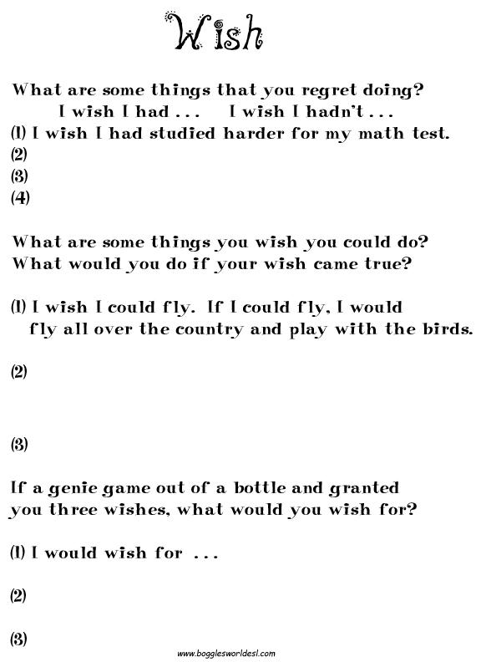

SOS Activity
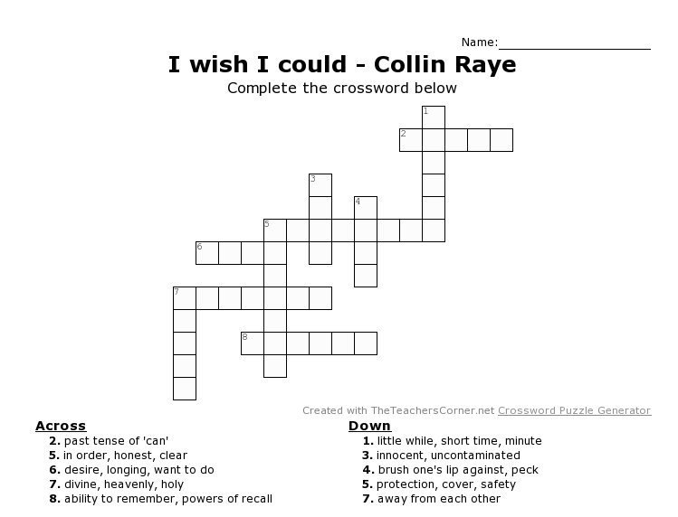

"I Wish I Could" by Collin Raye - lyrics

Looking out my window
See you playing in the leaves
It's amazing how a little girl
Means all the world to me
When I tell you that I love you
I love you more than words can say

Smile, say cheese pretty-please
I wanna take your picture
How'd you ever get so big
I gotta take your picture
Hold on to the memory before the whole thing slips away

(Chorus)
I wish I could save these moments
And put 'em in a jar
I wish I could stop the world from turning
Keep things just the way they are
I wish I could shelter you from everything
Not pure and sweet and good
I know I can't, I know I can't
But I wish I could

When you kiss me for no reason
It goes straight to my heart
When I feel your arms around me
I almost fall apart
It's time for bed you whisper
Daddy, we forgot to pray

(Chorus)
I wish I could save these moments
And put 'em in a jar
I wish I could stop the world from turning
Keep things just the way they are
I wish I could shelter you from everything
Not pure and sweet and good
I know I can't, I know I can't
But I wish I could

And when I watch you sleeping
All my worries fade away
A little bit of heaven glows on your angelic face

(repeat the chorus again)

