Worksheet #1.
In a café - Furniture
Write the words
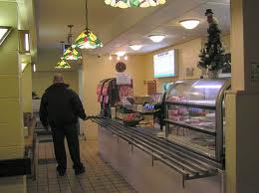
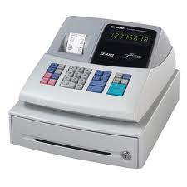
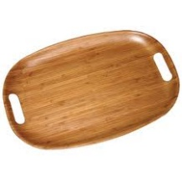
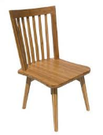
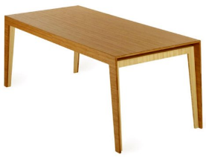
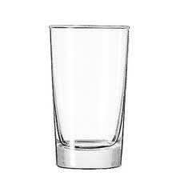
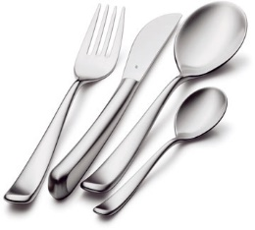
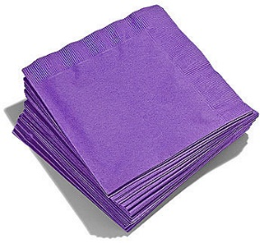
Worksheet #2.
In a café - Menu

Write the words in the right places.
Muffin Bagel Cake Sandwich Tea Coffee Juice Soft Drink

MENU  Food  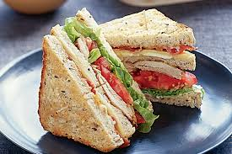  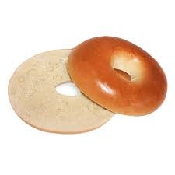  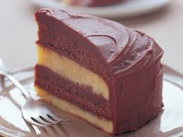 | MENU  Drink

Worksheet #3.
In a café – What to do

Put the sentences in order.

Enjoy your food and drink.
Choose the items you want. | 1
Ask for your food and drink at the counter.
Choose a table to sit down.
Collect cutlery and napkins.
Pay for your food.

1 ………………………………………………………………………………………………
2……………………………………………………………………………………………….
3……………………………………………………………………………………………….
4……………………………………………………………………………………………….
5……………………………………………………………………………………………….
6……………………………………………………………………………………………….

Worksheet #4.
In a café – Order the dialogue
Put the sentences in the speech bubbles
Ok, thanks.
Good morning. What would you like to have? | 1
That’s 2 dollars please.
Thank you and please wait a moment.
Here’s your change. Anything else?
No, thanks.
Can I have a plain bagel and a cup of coffee please?

