☐ Listening ☐ Speaking ■ Reading ☐ Grammar ☐ Writing

Topic: Film Review Time

Instructor:  Soojung Wang | Level:  Advanced | Students:  6 | Length:  35 Minutes

Materials:
- White board, board markers
- Worksheet # 1 – vocabulary for movie review (6 copies), worksheet #2 – reading materials on movie reviews (6 copies), worksheet #3 – writing a review movies (6 copies), worksheet #4 - SOS activity (6 copies)

Aims: (3)
Main aim: Ss will learn to comprehend different kinds of movie reviews with the advance level of vocabulary by reading the text and working on the worksheets and discussing the text together.
Secondary aim: Ss will learn to use different kinds of expressions to describe their thoughts on films through working on the worksheets.
Personal aim: I want my students to be able to enjoy themselves reading film reviews and talking and writing about films with a variety of adjectives and vocabulary.

Language Skills: (4- Integrated)

Speaking: answering the questions on the worksheets, presenting students’ own film review to class
Listening: the teacher’s explanation about new vocabulary, reading the text, and instruction
Reading: Matching worksheets, fill in the blank, reading film reviews, comprehension questions and the text
Writing: Writing students’ own film review

Language Systems: (3-5)
Lexis: action-packed, outstanding, brings to life, give a brilliant performance, waste of time, box office hit, worth seeing, disappointed, dull, entertaining, hilarious, moving, talented, weak, spectacular, must-see, nauseating, ,obnoxious, feel-good comedy, laughable, wooden, gripping, rubbish, tug on the heart strings, to heighten the tension, unwatchable
Function: Writing a film review, partner discussion
Discourse: presenting the film reviews

Assumptions:
Ss have a strong grasp on the vocabulary, so they mostly already know the words on the worksheet.
This is a review class from the previous lesson on learning the vocabulary.
This is a reading class to use more reductive skills, which are writing and speaking.
Ss find it interesting and relaxing to read the film reviews.

Anticipated Errors and Solutions:
- Some students may find it difficult to recall the vocabulary again from the previous reading class.
      - Have Ss to do the worksheet on the vocabulary to review the vocabulary again.
- If Ss finish early with the film review (SOS plan)
      - Let the Ss to do the SOS activity by filling the blank in the passage
- Ss might need extra time to finish their film review
      - Be flexible with time. Give Ss more time if she or he needs, and cut off the post activity time
- Some students might find it easy to do the worksheet
      - Encourage Ss to write a difficult film review by using the words we learned. Encourage Ss to share their writing to their partner as well as to the class to challenge themselves

References:

https://en.islcollective.com/resources/printables/worksheets_doc_docx/movie_reviews_reading__vocabulary/movies--tv/51116

Lead-In
Time | Set Up | Activity
3 min | Whole class | Hello, everyone. How is your day, and how is everybody?  Do you like films or movies?  (Ss answer)  Remember in the previous lesson, we have learned different vocabulary about film review?  Today, we will continue learning about film reviews, and also writing one by ourselves.

Pre-Activity
Materials: worksheet #1, white board, board marker
Time | Set Up | Activity
10 min | Whole class | (Teacher board the title ‘film review’ on the top of the whiteboard)  Before we read the text, let’s learn and review some vocabulary from last class as well as some new vocabulary.  (Distribute worksheet #1 to class)  Vocabulary  Instruction  Please complete the worksheet by your own. We have a matching activity on the top, and below, there is fill in the blank. Please complete both of them. You have 5 minutes to complete the worksheet. After finishing, please raise your hand so that I can know.  Demonstration  Let’s do the first question together.  “The critics highly recommended the new film”  What is the response for this sentence?  (Elicit the answer)  Yes. Great, the answer is h! Can someone read the answer for us? Thank you.  ICQ:  What do you do on the worksheet?  How much time do you have?  Do you work alone or with your partner?  What do you do when you finish?  Okay. You may begin to work on the worksheet  (Monitor student discreetly)  Let’s check the answers together.  What did you get for No.2?  Let’s have a turn to say the answers. Start from here?  (Check all the answers orally with the Ss)  Great job, everyone. Let’s start reading our text on film reviews.

Main Activity
Materials: worksheet #2 – film reviews, worksheet #3 – to write a film review, whiteboard, board marker
Time | Set Up | Activity
6 min  4 min  7 min | Whole class  Whole class  Pairs  Whole class | Controlled Practice  Instruction  There are 6 short film reviews on the worksheet. Please read the text and complete the questions on each film review. You have 6 minutes. Work alone.  (Distribute the worksheet #2)  ICQ:  Do you read the text alone?  What should you do?  How much time do you have?  (Monitor students discreetly, check the time as they read)  1 minute left.  Now, discuss the questions on each film review as the whole class.  What is the answer for the first one?  (Check the students’ answer)  Great job, everyone!  Less Controlled Practice  (Board on the whiteboard the following guiding questions)  How do you write a film review?  What do you write in a film review?  Instruction  There are 6 short film reviews on the worksheet. Please skim and scan the text again. Think about these guiding questions when you read. You have 4 minutes. Work alone. You can write down the possible answers on your worksheet if you need.  Demonstration  When I read the first film review, I think I need to write about brief story about the film, maybe the genre of the film, what’s great about the film… and so on. Think about as many possible answers as you could.  ICQ:  Do you read the text alone?  What should you do?  How much time do you have?  (Monitor students discreetly, check the time as they read)  1 minute left.  Now, discuss the questions on the board with your partner.  (Monitor discreetly)  (Check the students’ answer and share them with the class)  Good job, everyone.  Free Production  Instruction  Now, since we have discussed what we should write in a film review, why don’t we write our own film review?  (Distribute the worksheet #3)  Let’s the read the text by line. Let’s start with ____. Could you read No.1? Next…. (Read the whole text by turn in class)  So, we have 12 tips for you to write a film review.  I want all of you to use at least 5 from this to complete your own film review. Any movies are fine, just one that you have watched. Use 5 from the worksheet to complete your own short film. It doesn't have to be long. Please write at least 5 sentences. Of course, you can write more than that if you want. I will give you 5 minutes on this. Please work alone.  Demonstration  Let me show you what I have written by using some tips from this worksheet.  I wrote a short film review about Twilight.  Twilight is a romantic fantasy film about vampires and humans. It casts Robert Pattinson, and Kristen Steward, who I think are awesome. The movie is entertaining because it has special effects about vampires flying in the forests, fighting against the wolfs as well as other vampires who drink human blood. I love the casting about the film because Robert Pattinson as a vampire is very charming. I recommend this movie to anyone who loves a romantic fantasy film.  ICQ  How much time do you have?  How many do you use to write your own film review?  How many sentences do you need to write at least?  Do you work alone?  (Monitor Ss discreetly, check if they are following the instruction to write their own review)  Please let me know if you have any question when you write. You may start now.  If you finish early, please raise your hand. I will give you extra activity to work on.  Let’s share our own film reviews in class. Any volunteer?  (Have volunteers to present their film reviews to class)  Great job, everyone!

Post Activity
Time | Set Up | Activity
5 min | Whole class | Error correction  (Talk about any errors that occurred during the discussion, presentation, and so on)  Feedback  How was today’s class? Did you have fun? Did you learn more about how to write a film review?  Conclusion  Great job, everyone. I hope that you have enjoyed today’s class and learned how to write a film review on your own. We have no homework today. See you tomorrow!

SOS Activity
Materials: worksheets – SOS activity with the ‘Hobbit” movie review (6 copies)

Time | Set Up | Activity
5 min | Individually | Great job. Here is an extra worksheet to fill in the blank to complete another reading passage about movie review. Please let me know when you complete! You have as long as you need to do the worksheet.

****Plus include all worksheets, PPTs, scripts, photos of realia… EVERYTHING you use

Worksheet #1 – Vocabulary

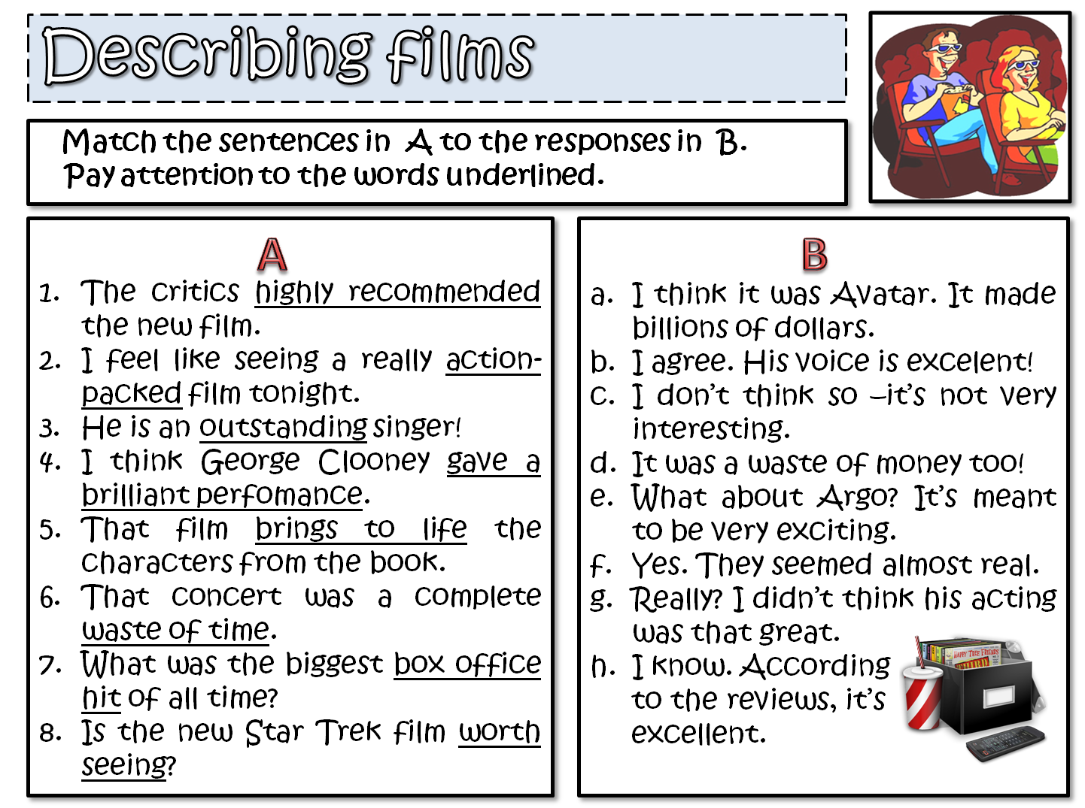

E

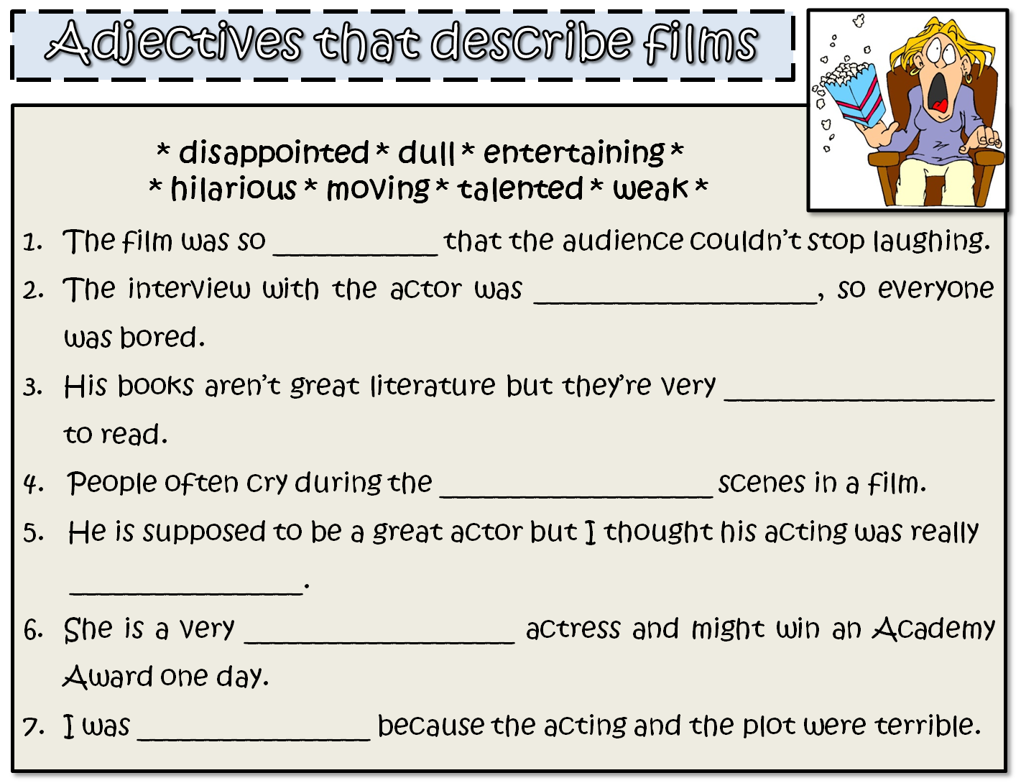

Worksheet #2 – Read the film reviews

Read these film reviews and choose the word that best describes it

AVATAR (2009)
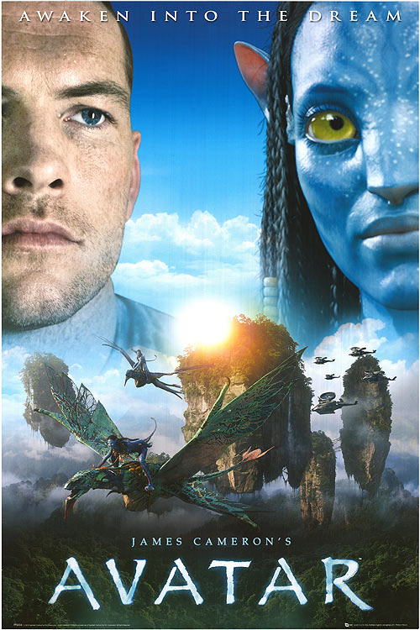
One of the most successful films of all time, Avatar (directed by James Cameron) tells the story of a reluctant hero who sets off on an epic adventure to save the alien world he has learned to call home. Now available in 3-D and 2-D this visually spectacular film is a must-see for all the family with important messages for both young and old

a nauseating b inspiring
с unrealistic

THE PROPOSAL (2009)
An ambitious and obnoxious boss (played by Sandra Bullock) hears that she will have to return to Canada as her visa has run out. To avoid deportation, she forces her young assistant (Ryan Reynolds) to marry her so that she can stay in the United States legally. After many crazy adventures to prove to his family that they do actually love one another, they finally really fall in love. This is a good
old-fashioned feel-good comedy which is the perfect vehicle for both stars

a entertaining b nonsense c moving

A NIGHTMARE ON ELM STREET (2010)
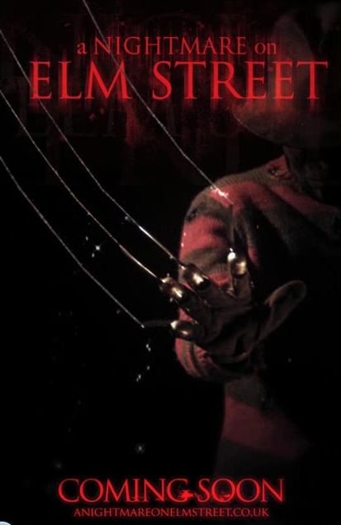
As a fan of horror films, I was looking forward to this remake of the Wes Craven cult classic which first appeared on our screens almost twenty years ago. Terrifying when it first came out, this remake, however, doesn’t compare in any way. The special effects are laughable and the acting is wooden. I’d recommend watching the original any day and I certainly hope they don’t bother to remake the others

a gripping b annoying
c rubbish

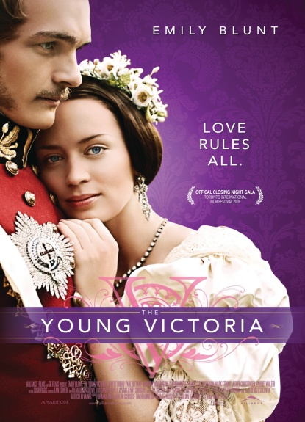
YOUNG VICTORIA (2009)

Nominated for three Academy Awards and winner of Best Costume Design, this is a perfectly crafted period drama. The film stars Emily Blunt as the young Queen Victoria and Rupert Friend as her husband Albert. It tells the story of the first few years of her reign with all the dramas and emotions that a young woman in her position would have to face. The acting by both young stars is excellent and totally believable a annoying b nonsense
c moving

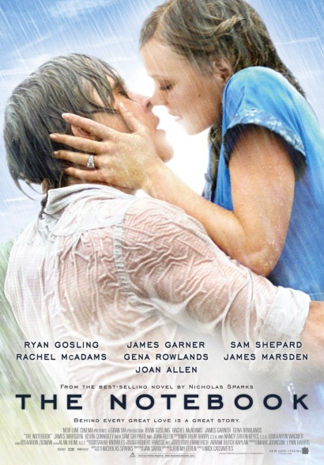
THE NOTEBOOK (2004)
If you enjoy sickly sweet romantic films that unashamedly tug on the heart strings to make you cry, then this is most definitely the film for you. From the moment the film begins you know where it is taking you. A boy meets a girl. The boy is poor and the girl is rich. The girl’s parents don’t approve. Fast forward to years later … Have your box of tissues to hand!
a nonsense b nauseating c gripping

THE BOURNE ULTIMATUM (2007)
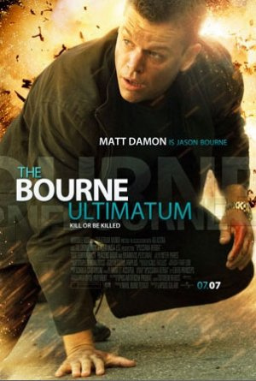
This is the third in the Bourne series starring the excellent Matt Damon. Filmed on location in Tangier, London, Paris, Madrid, Berlin and New York City, the story is fast-paced but to my mind rather confusing. My concentration was disturbed by the hand-held camera effect which meant that the film was constantly ‘shaking’. I appreciate that this was supposed to heighten the tension but I found it almost impossible to focus in places.

a unwatchable b unrealistic
c exciting

Worksheet #3 – To write a film Review
Please write your own short film review by answering the following questions, and also using different vocabulary from the film reviews passages as well as the vocabulary worksheets.

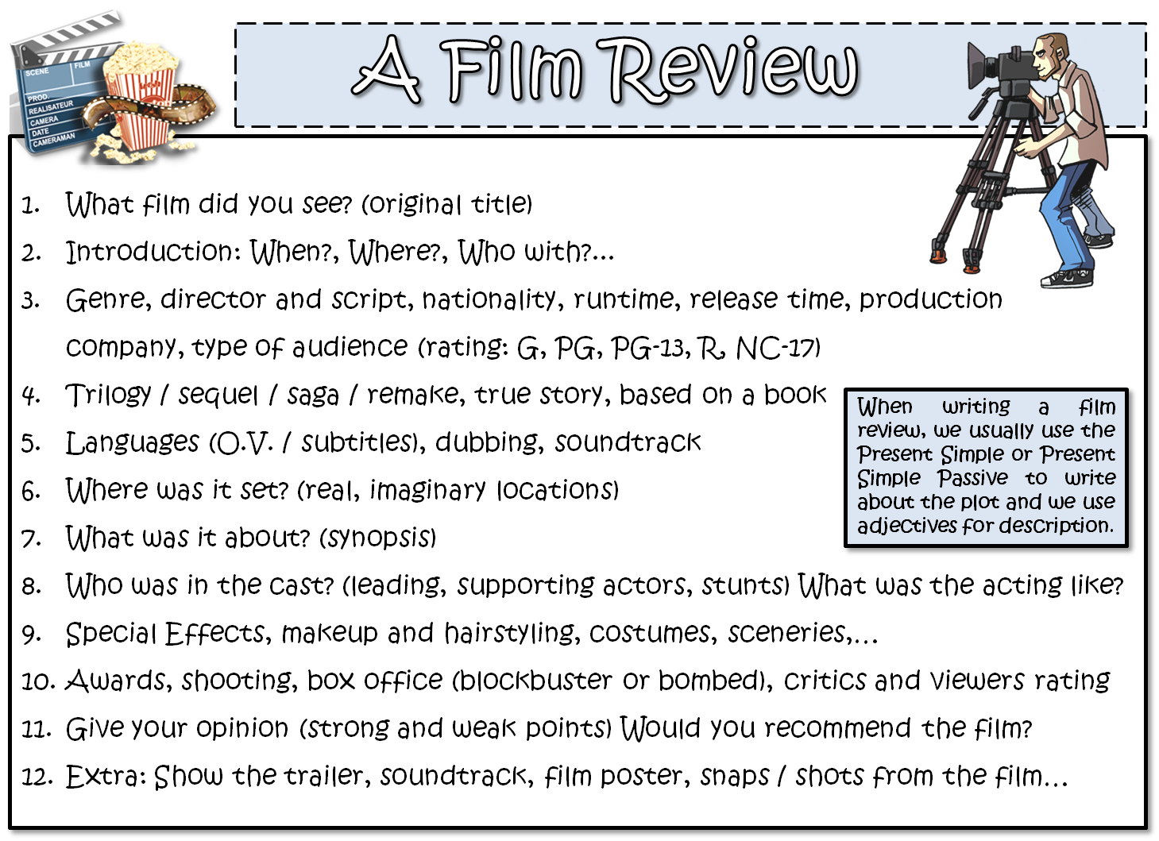

Worksheet #4 - SOS Activity

Please read the film review and complete the text by filling the blank with the vocabulary in the box on the right.

Worksheet #4 – SOS activity
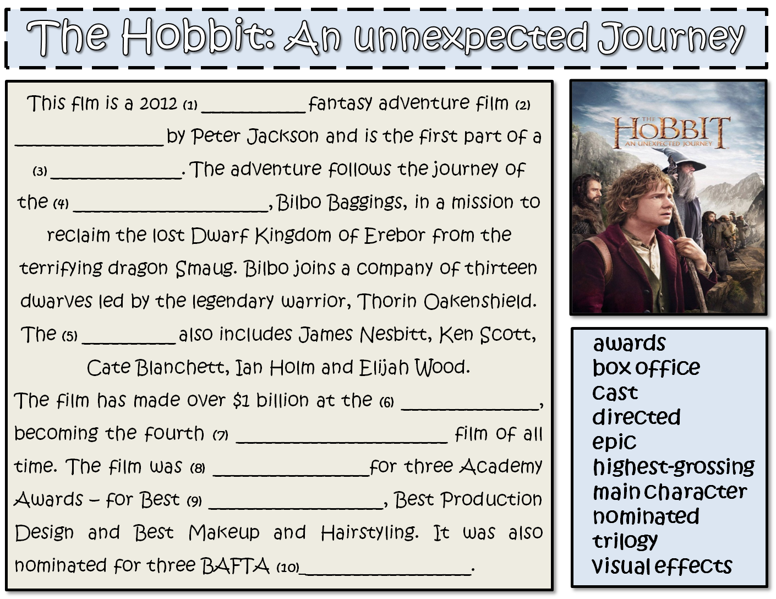
Please complete the following film review on “The Hobbit: An unexpected Journey” by using the vocabulary on the box in the right.

