☐ Listening ☐ Speaking ☐ Reading ☐ Grammar ☐ Writing

Topic: Reveal your deepest truth

Instructor:  Alicia Moon | Level:  Upper-Intermediate | Students:  6 | Length:  35 Minutes

Materials:
- White board
- Markers
- PPT slides & Projector & Monitor &Computer
- Worksheet #1 – Vocabulary
- 9 cards (1 copy each team, total 3 copies)
- Explanation of the cards (9 sheets each team, total 27 sheets)

Aims:
- Main aim: Ss will be able to improve their reading abilities by reading definition of words and explanation cards.
- Secondary aim: Ss will be able to speak fluently by giving their opinions and stating your thoughts towards the partner.
- Personal aim: I want Ss to be able to understand some psychological terms and contents

Language Skills:
- Speaking: Stating their thoughts towards the partner
- Listening: Teacher’s instruction, other groups’ presentation
- Reading: Explanation of cards, Definition of vocabulary
- Writing: Writing down their thoughts towards the partner

Language Systems:
- Lexis: Main vocabularies in the worksheet
- Function: Presentation
- Discourse: Explanation of cards, Definition of vocabulary

Assumptions:
- Students already know how the class arranged and prepared (6 Students at each table)
- Students already have experiences to take some psychological tests
- Students will enjoy the activity

Anticipated Errors and Solutions:
- Students may find unfamiliar vocabulary words
- Ask Ss to circle those words and their group members can figure them using their dictionary.
- If students need more time for each work.
- Give them an extra minute or help them to answer it on time.
- If anyone who feels shy or too much pressure to present in front of the class
- Let them stay sit and present

References:

Test is edited from:
https://www.youtube.com/watch?v=9lWFIS5IP6o&t=300s

Worksheet is generated from:
https://worksheets.theteacherscorner.net/make-your-own/match-up/

Lead-In
Materials: None
Time | Set Up | Student Activity | Teacher Talk
1 min | Whole | Ss answers | Good morning everyone,  How are you today?  Do you think that you know well about yourself?

Pre-Task
Materials: Board and markers, worksheet #1
Time | Set Up | Student Activity | Teacher Talk
2 min  3 min | Pair | Ss talk with their partners  Ss do the worksheet #1. | - Spark Interest/Introduce Topic  Let’s talk with the one thing that others do not know about yourself. It can be all about your personality, habits and so on.  I will give you 2 minutes to talk with your partner.  (After 2 min, write the today’s topic on the board “Reveal your deepest truth”)  Today’s topic is “Reveal your deepest truth”  - Vocabulary/Pronunciation  Now, we will figure out the main vocabularies. I will distribute the worksheet #1 first. (Distribute worksheet#1)  There are nine vocabularies, then you write a letter of the correct match next to each problem.  Demonstration  Let’s solve No.1 together. What would be the definition of “Assessment”? Yes! The answer is ‘H”  I will give you 3 minutes to finish then check together. Do by yourself.  ICQ  How much time do you have?  Do you work alone?  (After 3 min, check answers together)  Well done! I will read aloud each word then you repeat after me. Good work!!

Task Preparation
Materials: PPT file, Monitor, Projector, Computer, 9 cards (1 copy each team, total 3 copies)
Time | Set Up | Student Activity | Teacher Talk
3 min  5 min | Whole  Pair | Ss watch PPT slides and write a note what they see.  Ss talk with their partners | - Prepare materials for task  I will show you 9 pictures, each will be shown only for 10 seconds. Watch each of the picture carefully and note down your response what you see.  Remember! You have to be honest to yourself while writing down your responses.  ICQ  What will you see?  What do you have to do after watching every pic?  (Show Ss PPT slides)  The name of the test is “RORSCHACH Test” it is a method of psychological evaluation.  Are you ready to write down your responses? Okay then let’s begin!  (After all slides were shown)  Everyone wrote down for every cards?  Is there anyone who missed something?  (If so, show them one more time for a second)  Good! now I will give you all cards and then talk about what you wrote down and why you thought so with your partner.  Please be sure that you should not change your answer after checking cards. Changing your answer means you will not get a precise answer about yourself.  I will give you 5 mins for this  ICQ  How much time do you have?  Who do you work with?  What thing you should not do after checking cards?  (Monitoring)  (After 5 min) Well done, everyone !

Task Realization
Materials: Explanation of the cards (9 sheets each team, total 27 sheets)
Time | Set Up | Student Activity | Teacher Talk
7 min  5 min | Pair  Pair | Ss read explanation from 1 to 9.  Ss do the given work and present | - Complete the task  At this time, I will distribute the explanation of each card. You corelate your response to the explanation of each of the cards.  Each team will have 9 explanations. And share to read them all. Each member of team should read them all explanation from 1 to 9. It will reveal your deepest truth.  I will give you 7 mins to read them all.  ICQ  How much time do you have?  What do you have to read?  Do you share the explanation with your team member?  Okay Let’s start to read.  (After 7 min)  Everyone is done? Then, we got our result from that explanations. I think someone is hard to accept your result, right? Ha-ha  Now, we will be ready to present your partner’s deepest truth. Please pick one explanation that describes your partner the best.  You will describe this way.  (Write on the board)  _____is described Card__ as__________.  It means she _________________.  Write down all your thoughts related to explanation and present one by one.  I will give you 5 minutes.  ICQ  Do you pick the explanation that describes yourself?  How much time do you have?  What will you do after pick explanation?  (Monitoring discreetly)  Have you done? Or need more time?  Okay who do you want to present first? Okay___ here you go first!  (after each Ss presents)  Perfect job everyone!

Post Task
Materials: Board and Markers
Time | Set Up | Student Activity | Teacher Talk
4 min | Whole | Ss listen and repeat after T | - Error Correction  (Correct Ss mispronounced words or phrases)  - Feedback  Do you think that this test really shows your deepest truth? Please do not rely on this result too much. It keeps changing as time goes by, because your point of view also keeps changing.  - Conclusion  I am glad you enjoyed today’s activity.  (In case of finished on time)  Now I will assign you a homework. Please choose any fiction you prefer and read it. Then write a book report and submit it tomorrow.  (Distribute the worksheet)  Thank you !

SOS Activity
Materials: Homework sheet
Time | Set Up | Student Activity | Teacher Talk
5 min | Pair | Ss read the short story and ready to write a report | (In case of time left)  Okay based on the short fiction I will distribute now, please read it and write a report with your partner. I will give you 3min to read and 2min to start writing a report.  ICQ  How much time do you have?  Do you work alone?  (Monitoring)  (After 5 minutes)  Okay good job!  No problem if you didn’t complete.  please bring your report tomorrow. We will use it as tomorrow’s material.

Worksheet #1 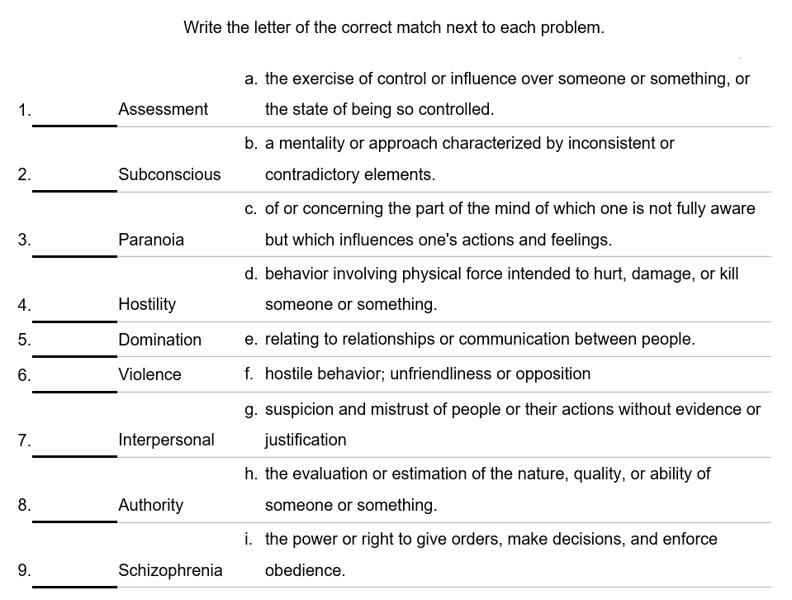

Cards
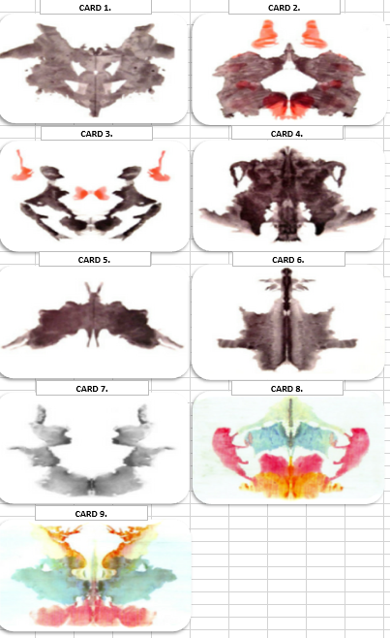

Explanation

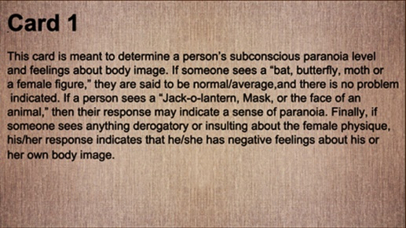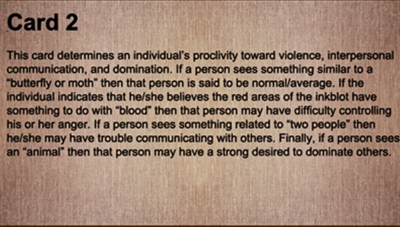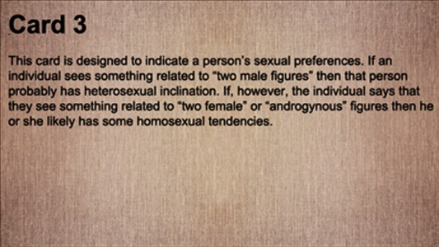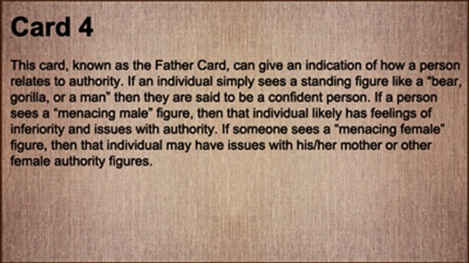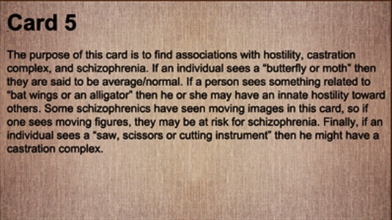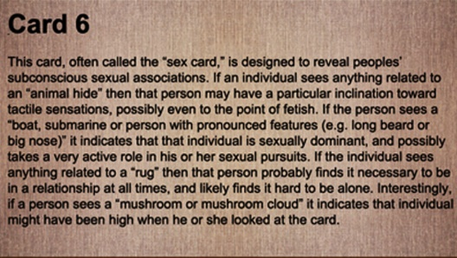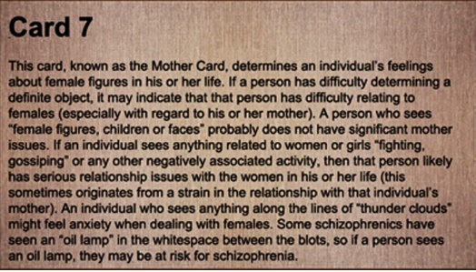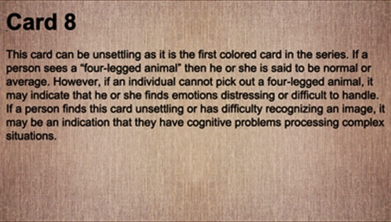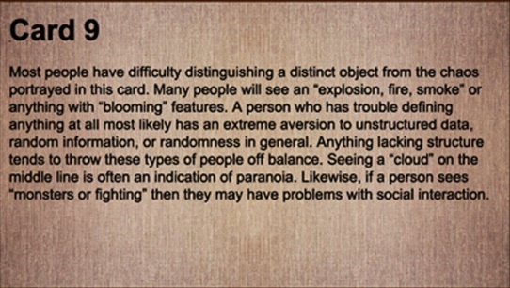
(In case of class work or Homework)

A Wise Deer and A Cowardly Tiger
There was a dense forest on the sides of a mountain. Many kinds of animals lived in the forest. A deer was eating grass and leaves with her two young ones. The young ones wandered happily here and there. The deer followed her fawns. The young ones entered a cave. The deer was frightened. It was a tiger’s cave. There were bones of dead animals all over the cave. Fortunately, the tiger was not inside the cave at the time.
The deer was trying to lead her young ones out of the cave. AT that time she heard a loud roar. She saw the tiger at a distance. The tiger was coming towards the cave. It was dangerous to go out of the cave now. She thought of a plan. The tiger had come closer to the cave. The deer raised her voice and shouted, “My deer young children do not weep. I shall capture a tiger for you to eat. You can have a good dinner."
The tiger heard these words. He was disturbed. He said to himself, “Whose is that strange voice from the cave? A dangerous animal is staying inside to capture me. I shall run away to escape death."
So saying, the tiger began to run away from there as fast as possible.
A jackal saw the running tiger. “Why are you running in great fear?" the jackal asked. The tiger said, “My friend, a powerful and fierce animal has come to stay in my cave. The young ones are crying for a tiger to eat. The mother is promising to capture a tiger for them. So, I am running away in great fear."
The cunning jackal was now sure. The tiger was a coward. It said to the tiger. “Do not be afraid. No animal is fiercer or stronger than a tiger. Let us go together to find out."
But the tiger said, “I do not want to take a chance. You may run away. I will be left alone to die. So, I will not come with you."
The jackal said, “Trust me. Let us knot our tails together. Then I will not be able to leave you."
The tiger agreed unwillingly to this proposal. The jackal tied their tails in a knot. Now they walked towards the cave together.
The deer saw the jackal and the tiger coming together. She again raised her voice. She shouted towards her children standing inside the cave, “My dear children, I had requested her friend, the clever jackal, to capture a tiger for us. Now look the jackal has captured a tiger for us. He has tied the tiger’s tail to his tail. This is to prevent the tiger from escaping. You will soon have the tiger for our dinner."
The tiger heard this. He was shocked. He was sure now. The jackal cheated him. So, the tiger decided to escape from the terrible animal standing inside his cave. He started running. He forgot about the jackal. He dragged the jackal over rocks and thorns. In the mad escape the jackal was caught between two rocks. The tiger pulled with all his might. His tail got cut. The jackal was killed in this incident. The tail-less tiger ran away to another part of the forest.
The deer and her young ones left the tiger’s cave. They joined their herd safely.

Title_______________________________
Story Report

Who was the main character in this story? ___________________

Where does this story take place? ____________________________

List the characters
____________________________________________________________________________________________________________________________________

What was the main idea of this story
_____________________________________________________________
______________________________________________________________________________________________________________________________________________________________________________________________________

Did you like this story? Tell me why and why not
________________________________________________________________________________________________________________________________________________________________________________________________________________________________________________________________________

