☐ Listening ☐ Speaking ☐ Reading ☐ Grammar ☐ Writing

Topic: How to describe person in English

Instructor:  Sueun Shin(Chloe) | Level:  Intermediate | Students:  12 students | Length:  30 Minutes

Materials:
White board and board marker
Computer
: for picture and audio file
PPT file (Listening script)
Before listening worksheet
: true or false questions and discussion topics
Fill in the blanks worksheet

Aim:
Main Aim: Ss will be able to improve their listening skills by listening to and understanding the idea and the details in the passage.
Secondary Aim: Ss will be able to talk and share different viewpoints of thinking about someone’s appearance by group work and discussion
Personal Aim: I want them to follow my instruction with attention and have an open-minded to understand other’s opinions.

Language Skills:
Reading: Students will read the definitions and the details given in the worksheet.
Listening: Ss will listen to the passage on the computer.
Speaking: Ss will discuss “How would they describe someone in English”
Writing: Ss will fill in the blank the passage and complete the worksheets.

Language Systems:
Lexis: New Vocabulary in the passage
Function: Giving Information
Discourse: passage from the computer.

Assumptions:
Students already know
How the class is set up and run (each table will be set up in pairs.)
Four language skills and language systems
Different characteristics of people

Anticipated Errors and Solutions:
If students need linguistic help to express their opinions during discussion
give them linguistic support by providing definitions and some examples.
If students get lose attention
Try to chunk the instructions and make sure many students speak.

References:https://www.youtube.com/results?search_query=how+to+describe+a+person+in+english

Lead-In

Materials: None

Time | Set Up | Student Activity | Teacher Talk
1min | Whloe  class | Answering teacher’s questions | Good morning, everyone! Did you guys have some time to say hello to each other? How do you think about seeing new people?  Do you have any experience describing someone in English or Korean?

Pre-Activity
Materials: Computer, PPT file, Board markers, Worksheet #1
Time | Set Up | Student Activity | Teacher Talk
2min  3min  1min | Whole  class  pairs  Whole  class | Answering teacher’s questions  students discuss about the picture on screen.  Worksheet #1  Student check answers | Procedure:  1. Spark Interest  Elicit  (Show the students on the screen)  What do you see in this picture?  Is he tall?  What do you think about him?  What about her? How does she look like?  How would you describe them?  Now I’m going to give you 3 minutes to share your thought with your partners.  (After 3 minutes...)  Time’s up! I guess you guys are getting the topic well.  Model  (Write the topic on the board)  Today we are going to learn ‘How to describe person in English’  CCQ  Think about someone you know well. How would you describe them? What does that person look like? What kind of personality does this person have?  2. New Vocabulary  Instruction  “We are going to learn the new vocabulary before listening. I will give you a worksheet. Frist, read the definitions of words with the blanks and then fill in the blanks with the correct word from the list below. Work together with your partners. I will give you 4 minutes.  (Hand out worksheet #1)  Demonstration  Now look at the worksheet. Let’s solve numer1 together. “right, the answer is..”  ICQ  What do you write in the blanks?  Are you working alone?  How much time de we have?  “Let’s get it started”  Monitoring  Walk around quietly and check if they are answering.  Give time warning:  1 minute/30 seconds left  “Time’s up“  Check Answers  Lets check the answers together.

Main Activity
Materials: Worksheet, Computer for listening
Time | Set Up | Student Activity | Teacher Talk
3min  4min  2min  5min  15min | Pairs  individually  individually  whole class | Student guess whether the  sentences are true or false.  Listening  Students check answers.  Students drawing  students present about their drawing | 1.Prediction  “As I mentioned, today’s topic is ‘How to describe person in English’”  Instruction  I will give you another worksheet before listening. There are the true or false questions about the passage. You can try and guess if the details are true or false. I will give you about 4 minutes to work individually and predict about the passage.  (Distribute the worksheet #2)  ICQ  What are we doing now?  Are you working in groups?  How much time do we have?  “Ok, everyone, time’s up. I think you guys are done, Let’s go on and listen to the passage to check the answers. See if your or partner’s answer is right.”  2. Listening for the main idea.  Instruction  “ Listen carefully without taking notes. After listening, we will look wee the worksheet again to find out correct answer.”  ICQ  Do you take notes while you are linstening to this passage?  Whats the topic of this passage?  (Play the audio on the computer)  Check Answers  Now let’s check the answers together.  (Check the answers with teacher)  3. Listening for details.  Instruction  Now that we have listened once, we will listen one more time. There is a script with blanks. Please fill in the blanks with words the speakers says on your own.  ICQ  What are we going to do?  Are you doing alone?  (play the audio file)  Check Answers  Ok, now lets check the answers together.  (Check answers all together)  4. Free Production  Now we are going to do draw someone you want to describe. It can be your family, your friend, or classmates in this class or anyone else. After finish drawing, we will discuss about your drawing. I will give you 5 minutes to draw first.  ICQ  What are we doing?  Are we doing in pairs?  “Let’s begin”  Monitoring  Monitor discreetly.  Presentation  Alright, now it is time to discuss about your picture. Speak clearly and loudly. Other students have to pay attention to the reporter.

Post Activity
Materials: None
Time | Set Up | Student Activity | Teacher Talk
2min | Whole  class | students answering questions | Error Correction  If there’s any grammatical error or pronunciation, help correct them.  Feedback  How did you feel about describing you know?  Do you have any question?  Conclusion  Everyone did great job today, I wish you guys had fun today and don’t be afraid of using English to describe someone and introduce to someone else.  Thank you.

SOS Activity
Materials: Worksheet
Time | Set Up | Student Activity | Teacher Talk
5min | individual | Students filling in the blank | Instructions  In this worksheet, you will match sentences with pictures. Before correct the answer you will work on your own for 5minutes.  ICQ  What are you doing now?  Are you working alone?  How much time do we have?  Monitoring  (watch if they are doing right)  Give time warning “2 minutes left....”  “Okay, time up!”  Check Answer  “Ok let’s check the answers together.  What is the answer for A?“  Go through all the answers on worksheet.

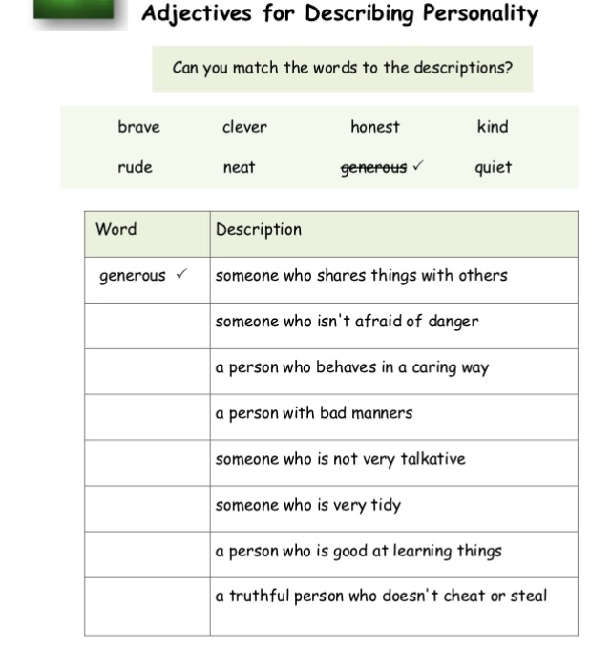

Answer
brave, kind, rude, quite, neat, clever, honest

True or False

- Old woman with brown hair (T/F)
- Pretty blond woman with long hair and black eyes (T/F)
- Cute little black girl (T/F)
- Old-aged bald Man (T/F)

Answer True or False
1. F
2. F
3. T
4. F

Listening

Old woman with
brunette girl with long hair and blue eyes.
Pretty woman with short hair and black eyes.
Little boy with brown hair and black eyes
Cute little girl
Brunette young man with a beard and
Middle-aged bald man
boy with bron hair and green eyes.

Listening script Answer

Old woman with gray hair
Beautiful brunette girl with long hair and blue eyes.
Pretty blond woman with short hair and black eyes.
Little boy with brown hair and black eyes
Cute little black girl
Brunette young man with a beard and moustache
Middle-aged bald man
Attractive boy with bron hair and green eyes.

