Lesson Plan – Listening Lesson Plan
v Listening ☐ Speaking ☐ Reading ☐ Grammar ☐ Writing

Topic: Cinderella’s Dream

Instructor:Juil Jung (Tony) | Level: Intermediate (Middle school) | Students:  14 students | Length:  30 Minutes

Materials: White board and black marker
Dramatized script
Visual aid
Listening MP3 file and speaker
Worksheets- Note taking, New vocabulary, picture sequence, Fill in the blank,
role card for Cinderella’s dream, evaluation worksheet, bingo worksheet

Aims: Students will be able to improve their listening skills by listening to dramatized script.
Students will be able to do role-play by practicing dramatized script
Personal aim: I want them to cooperate with other students to do role-play.

Language Skills: (4- Integrated)

Speaking: Ss will act by speaking dramatized script.
Listening Ss will listen to the dramatized script.
Reading: Ss will read the dramatized script.
Writing: Ss will write take notes for reconstruction about words.

Language Systems: (3-5)
Lexis: New vocabulary in the dramatized script about Cindrella.
Grammar: Future tense, Interrogative sentence.
Function: Complaint, request
Discourse: Dramatized script

Assumptions:
Students already know
- Their told when they do role-play
- They practice dramatized script.
- Cinderella story

Anticipated Errors and Solutions:
- If students make some mistake on pronunciation when they speak the script.
- I will teach them how to pronounce.
- If students have conflict that they want to have a role they want.
- I will assign the role fairly.
- If students are shy to talk,
- I will encourage them to speak with confidence.

References:
- Evaluation Worksheet: Jung, S,, & Park, H. (2002). Improving English Speaking and Listening Ability through Drama Techniques. Education Theory and Practice, 12(3), 119-147.
- Script: Jung, J. (2018), A Case Study on the Development of Middle School Students’ Vocabulary Proficiency, Their Risk-Taking, and Academic Self-Efficacy through English Drama. Unpublished Master degree thesis. Chung-Ang University, Seoul.
.

Lead-In
Materials: None
Time | Set Up | Activity
1 min | Whole class | Greeting  T share Cinderella story  “Do you like to read a story? Disney, fairy tale?”  “Which story do you like? Pinocchio, Snow White, Cinderella?”  “Have you read Cinderella?”  “Wonderful”  “Now we are going to share Cinderella.”

Pre-Activity
Materials: Visual aid, note taking worksheet, vocabulary worksheet
Time | Set Up | Activity
1 min  2 min  4 min | Whole  Class  Group work  Whole class | 1. Brainstorming  T presents pictures related to Cinderella  “Do you like Cinderella?”  “If you were Cinderella, what would you do?”  T writes Ss opinions on the board.  2. Note taking to make up sentences by using words.  T assigns Ss into 3 groups.  T explains how to do the activity about reconstructing words. .  T has them listen to drama script  T asks Ss to write words as many so possible on the bubbles on the paper.  T turns on the recording to have Ss listen to the drama script on the second time.  T asks Ss to write many words by listening to it.  T has Ss listen to the dialogue on the third time. .  T has Ss make 2 sentences with group members by using the words they heard.  T goes around to help Ss to write two sentences in their group.  T asks one S to come to the board to tell their group’s sentences.  3. New Vocabulary  T hands out the vocabulary worksheet that has word bank and asks Ss to fill in appropriate word in the blank that is presented with definition.  “We are going to learn the new vocabulary before we listen to the drama script. You need to fill in the blank with the suitable word. Do this activity individually. I will give you 3 minutes.  ICQ  What are you going to do?  What time do you have to finish the worksheet?  Are you working in pairs?  Monitoring  T monitors students’ activity by going around desks. If they need help, T will help Ss.  Check Answers  Let’s check the answers together.

Main Activity
Materials: worksheet-picture sequence, fill in the blank, role card, evaluation worksheet
Time | Set Up | Activity
3 min  4 min  10 min | Whole class  Whole class  Group work | 1. Listening for the main idea  Picture sequence  T hands out worksheet with picture sequence.  T has Ss listen to audio from the drama script and write the number in order for three pictures by scenes.  “Now, I am going to give you worksheet, You are going to write the number in order below picture per scenes after you listen to the audio from drama script. You are going to do this activity individually. I will give you 2 minutes.  ICQ  Do you write number in order per scene?  Do you work in pair?  How much time do you have to finish this activity?  2. Listening for the detail  Fill in the blank  “Now, we are going to listen to the drama script. You will fill in the blanks with the right word while listening. I will have the audio played 2 times. Work individually.  T hands out the worksheet.  ICQ  Do you fill in the blank while you listening or after listening?  Do you work in pairs?  How many times do I have the audio played?  T plays the audio. Let Ss fill in the blanks while listening.  Check answer  “Now let’s check the answer together. I will play the audio and let’s check it.”  3. Production  Role-Play  T assigns 14 of Ss into two groups.  T introduces the roles of each characters on drama script.  T gives each student role by handing out the cards.  T has them practice Cinderella script.  T has one group come to the front and asks them to act.  T has other group evaluate how the performance goes well.  T has the other group come to the front and asks them to act.  T has the one group evaluate the other group’s performance.  “Now, we are going to do role-play. I will divide you into 2 group. Your group has 7 members each. You will practice the drama. Then, you will come to the front to perform the act. During one group’s performance, the other group evaluate their performance.  ICQ  How many groups do you have in the class?  What should we perform?  During one group’s performance, what should other group do?

Post Activity
Materials:
Time | Set Up | Activity
1 min  1 min  1 min | Whole class  Whole class  Whole class | 1. Error correction  T corrects errors Ss made after their activity.  2. Feedback  T hosts Ss’ feedback.  “How is the listening activity? Was it good? Do you have something to share in thiese activity?”  3. Conclusion  T concludes the lesson.  “You did a great work. After listening, I hope that you improve your listening skills and you perform act very well. I believe you can do it. Now, wrap up the class today. I hope you have a nice day.”

SOS Activity
Materials: Bingo worksheet
Time | Set Up | Activity
2 min | Pair work | 1. Bingo activity  T hands out the bingo worksheet.  “Now, We are going to play bingo using the words we learned with Cinderella drama script. We have nine squares. Write the words in all the squares, You work in pair. When you finish one line first, you will be the winner.”  ICQ  How many squares are there in bingo worksheet?  How many line do you finish to win the game?  Do you work in pairs?
Cinderella’s Dream

Scene 1

(While Cinderella is dancing, her mom enters)

Mom : Hey. what are you doing?
Cinderella : (Being surprised) Oh, no. I‘m not doing nothing.
Mom : (Showing her school report) Do you think it is right time to dance? Look at your school report.
Cinderella : No.. Mom.. I want to be a dance singer. I am happy when I am dancing.
Mom : (Interrupting her talk) What? Do you think you can be an entertainer with your looks? That's nonsense. Study like your sisters.

(Sister 1(Yuna) and Sister 2(Alice) enter carrying a book)

Yuna : Huu.. You are not good at studying. You don't study at all. What? Do you want to be a dance singer? If you can be a dance singer, anyone can be.
Alice : You are so pretentious saying that you want to be a singer and you always spend the money.
Yuna : That's right. You are not as beautiful as me, but you keep trying to be a dance singer. Why?
Alice : You are right. She doesn't have a nice figure.

(Cinderella sighs.)

(Cinderella’s friend calls to her.)

(Ring Ring)

Amy : Cinderella. I am going to see a street performance, today. Do you want to go? Friend2 will go with me, too.
Cinderella : Yes!! I’ll go!! Mom, I am going out.
Mom : Where are you going? Did you finish your homework? Do you think you can get into an good university behaving like this?
Yuna : Cinderella has no manners.
Alice : That's what she is. What else should we expect from her?
Mom : Huu.. That's right.

Scene 2
Amy : Why are you late?
Cinderella : Whew! My mom and sisters were nagging me. I am sorry.
Emily : Why were your mom and sisters nagging you?
Amy : So, that’s why you are upset.
Cinderella : Let’s change the subject. Let's play now.

(They enter the shopping mall)

Amy : Choose your birthday gift.
Cinderella : Really?

(Cinderella and her friends go to a dress shop.)

Emily : We will choose it for you. Which one do you think it is best?
Amy : How about this one? It looks good on you.
Cinderella : Um.. This one is beautiful, but I don't like the color.
Emily : How about that one?
Cinderella : Isn't it too expensive?
Amy : I think it is the best one. I'll recommend this.
Cinderella : Oh..Oh..!! I found the dress that suits me. This one looks like a great dress. I'll try it on.

(Cinderella enters changing her dress.)

(Amy and Emily are impressed by her look.)

Emily : Wow. That suits you. You look amazing.

Scene 3

(Dance Battle participant is dancing and people are impressed by her dance.)

Amy : Look at the performance.
Emily : You can dance, too. You should try.
Cinderella : I'm a little shy.
Emily : You dance and we will post it on Youtube. Then, you will be famous.
Cinderella : Ok, I'll give it a try.

(Cinderella is dancing with dance battler participant.)

(Curing dance battle)

(Ending dance battle)

Dance Battle participant : Oh!! You can dance well.
Cinderella : Oh..!! Thank you.
Dance Battle participant : I believe that you can be an entertainer.
Cinderella : Thank you. You have some great dancing skills as well.

Character

Cinderella
Mom – Cinderella’s mother
Yuna – Cinderella’s first sister
Alice - Cinderella’s second sister
Dance Battle participant
Amy – Cinderella’s friend
Emily – Cinderella’s friend

Visual Aid

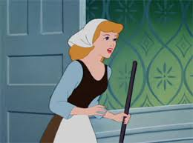

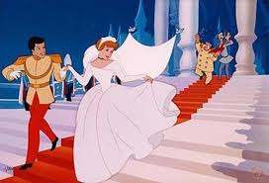
Group Activity

Write as words as you can in your group while you are listening to the drama script.

Make 2 sentences using the words you listen to the drama script in your group.

1. ________________________________________________________.

2. ________________________________________________________.

New Vocabulary

Fill in the word for the definition by using words in the wordbank.

1. _________________ : It is very surprising and makes you feel pleasure, approval, or wonder.

2. _________________: They suggest that you would find that person or thing good or useful.

3. _________________ : They keep asking you to do something you have not done yet or do not want to do.

4. _________________: Because something unpleasant has happened to you, you feel that way.

5. _________________ : Something such as a conversation, letter, or book is the thing that is being discussed or written about.

6. _________________: You believe that it will happen.

7. _________________ : A person who sings, especially as a job.

8. _________________: You pay money for things that you want.

9. _________________ : Someone or something is very well known.

10. _________________: Entertaining an audience by doing something such as singing, dancing, or acting.

Wordbank

Famous, upset, expect, nag, subject, recommend, amazing, singer, spend, performance
Picture sequence activity

Write number in the correct order with pictures given per scenes by listening to drama script.

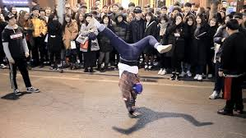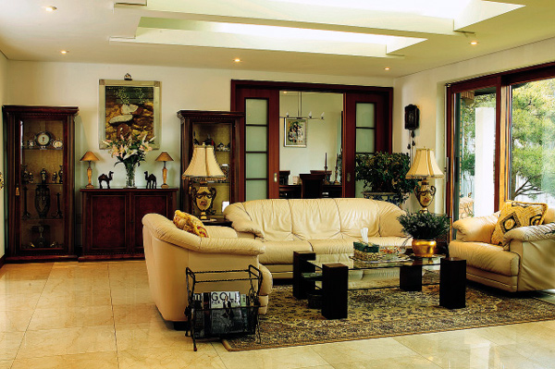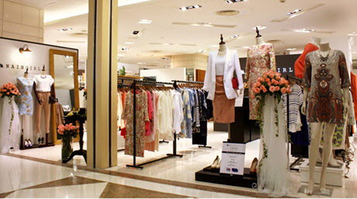
( ) ( ) ( )

Cinderella’s Dream

Scene 1

(While Cinderella is dancing, her mom enters)

Mom : Hey. what are you doing?
Cinderella : (Being surprised) Oh, no. I‘m not doing nothing.
Mom : (Showing her school report) Do you think it is right time to dance? Look at your school report.
Cinderella : No.. Mom.. I want to be a_______ ______. I am happy when I am dancing.
Mom : (Interrupting her talk) What? Do you think you can be an entertainer with your looks? That's nonsense. Study like your sisters.

(Sister 1(Yuna) and Sister 2(Alice) enter carrying a book)

Yuna : Huu.. You are not good at _______. You don't study at all. What? Do you want to be a dance singer? If you can be a dance singer, ________can be.
Alice : You are so pretentious saying that you want to be a singer and you always _________ the money.
Yuna : That's right. You are not as beautiful as me, but you ________ ________ to be a dance singer. Why?
Alice : You are right. She doesn't have a _______ ________.

(Cinderella sighs.)

(Cinderella’s friend calls to her.)

(Ring Ring)

Amy : Cinderella. I am going to see a ________ _________, today. Do you want to go? Emily will go with me, too.
Cinderella : Yes!! I’ll go!! Mom, I am going out.
Mom : Where are you going? Did you _________ _______ ________? Do you think you can get into a good university __________ like this?
Yuna : Cinderella has ______ ________.
Alice : That's what she is. What else should we expect from her?
Mom : Huu.. That's right.

Scene 2
Amy : Why are you late?
Cinderella : Whew! My mom and sisters were _______ me. I am sorry.
Emily : Why were your mom and sisters nagging you?
Amy : So, that’s why you are _________.
Cinderella : Let’s _________the subject. Let's play now.

(They enter the shopping mall)

Amy : Choose your birthday gift.
Cinderella : Really?

(Cinderella and her friends go to a dress shop.)

Emily : We will choose it for you. Which one do you think it is best?
Amy : How about this one? It _________ ________ ________ you.
Cinderella : Um.. This one is beautiful, but I don't like the color.
Emily : How about that one?
Cinderella : Isn't it too __________?
Amy : I think it is the ________ ________. I'll recommend this.
Cinderella : Oh..Oh..!! I _______ the dress that ________ me. This one looks like a ________ ________. I'll try it on.

(Cinderella enters changing her dress.)

(Amy and Emily are impressed by her look.)

Emily : Wow. That suits you. You look _________.

Scene 3

(Dance Battle participant is dancing and people are impressed by her dance.)

Amy : Look at the _________.
Emily : You can dance, too. You should try.
Cinderella : I'm a little shy.
Emily : You dance and we will _______ _______t on Youtube. Then, you will be famous.
Cinderella : Ok, I'll give it a try.

(Cinderella is dancing with dance battler participant.)

(Curing dance battle)

(Ending dance battle)

Dance Battle participant : Oh!! You ________ ________ well.
Cinderella : Oh..!! Thank you.
Dance Battle participant : I ________ that you can be an entertainer.
Cinderella : Thank you. You have some great _________ _________ as well.

Role card for Cinderella’s Dream

Cinderella  She is the main character of this story. She wants to be a dance singer. She wants to achieve her dream. | Cinderella’s mom  She is Cinderella’s mother. She is cynical. She loves her two daughters more than Cinderella. She nags many times.
Yuna  She is the first step sister of Cinderella. She studies well. She is brave. | Alice  She is the second step sister of Cinderella. She loves music. She is shy.
Amy  She is the friend of Cinderella. She is outgoing. She treats Cinderella kindly. | Emily  She is the friend of Cinderella. She is active. She treats Cinderella kindly.
Dance Battle participant

She dance well. She can’t sing. She is tall. She loves to listen to music.

Evaluation worksheet

The name of drama |  | The date of act
Evaluator’s group name |  | Act group name
Place of performance
Content |  | Scale
 |  | Very good | Good | So-so |  | Bad | Very bad
1. Do actors know the story?
2. Do actors pronounce well?
3. Do they have right stress on the sentence?
4. Do they use a proper gesture?
5. Do they have normal speech tone and speed?
6. Do they express their emotion well?
7. Do they prepare well?
8. What is the strong point of their performance?
9. What do they change for the next performance?
Bingo Game

Fill in the words you learned in the drama script. Finish one line first. Then, you will be the winner.

(Example)
spend | Beautiful | angry
figure | performance | subject
recommend | expect | singer

