■ Listening ☐ Speaking ☐ Reading ☐ Grammar ☐ Writing

Topic: At the hospital

Instructor:  Pauline | Level:  Upper elementary | Students:  10 students | Length:  30~35 Minutes

Materials:
- Realia: the pictures of doctor and patient at the hospital
- White board and board markers
- Vocabulary worksheet
- Computer for audio file
- Audio file

Aims:
- Main Aim: Ss will be able to improve their listening skills by listening to and understanding the topic in the article.
- Secondary aim: Ss will be able to use expressions at the hospital by learning new vocabulary.
- Personal aim: I would like to inform Ss about expressions at the hospital in English.

Language Skills:
- Listening: Ss will listen to the audio file about conversation at the hospital.
- Speaking: Ss sill duscuss “What expression can we use at the hospital?”
- Reading: Ss will read scripts of topic.
- Writing: Ss will take notes on details of the text.

Language Systems:
- Lexis: New vocabularies
- Function: Giving Information
- Discourse: Conversation at the hospital

Assumptions:
Students already know
- How the class arranged and prepared
- The basic knowledge about the hospital
- Their partners

Anticipated Errors and Solutions:
- If students are hesitant to speak loudly about their thoughts,
- Encourage them to speak more loudly and give some advice
- If some students need more time for each work,
- Give them an extra minute.
- If certain students dominate the talking time,
- Make other Ss to take turns.

Lead-In
Materials: None

Time | Set Up | Student Activity | Teacher Talk
1 min | Whole class | Answering teacher’s questions | Good morning! How are you today?  Is anyone feel sick or get a cold?  If you feel sick, where should you go?

Pre-Activity
Materials: Visual Aid(Picture), worksheet #1 (10 copies)

Time | Set Up | Student Activity | Teacher Talk
3 min  5 min  3 min | Whole class  Pairs | Answering teacher’s questions.  Students start writing down the words with their partner.  Students check answers | - Spark Interest  - Eliciting  (Show the students pictures about a doctor and a patient)  There is a doctor and a patient in the picture. Where is it?  What are they doing?  How do you feel when you go to a hospital?  How can we express our symptoms at the hospital in English?  - CCQ  Where are they?  What are they doing?  What should we know?  - Pre-teach Vocabulary  Instruction  “We are going to learn the new vocabulary before listening. I will give you a worksheet. I will give you a worksheet. First, read the words related to health problem, write the name under the correct picture. Work together with your partners. If you are having trouble, you can use dictionary. I will give 5 minutes to finish.”  Demonstration  Let’s solve the first word together.  Look at #1. Can anyone guess the meaning of this word? “Yes, it’s ”  ICQ  What do you write in the blanks?  Are you working in groups?  Are you working in pairs?  How much time do you have?  “Let’s get it started”  Monitoring  Monitor discreetly. Answers  students if they ask questions.  Give time warning  1 minute; 30 seconds left.  (Be flexible with time.)  “Time’s up”  Check answers  Let’s check the answers together.  After checking answer, do complement.

Main Activity
Materials: Listening audio file, Worksheet #2 and #3 (12 copies each)

Time | Set Up | Student Activity | Teacher Talk
5 min  5 min  5 min | Individual  Whole  class  Whole  class  Groups  Whole class | Students listen to the audio  Students complete worksheet #2  Students check the answer  Students see the worksheet#3  Students discuss in groups  Students present their opinions. | - Listening for Main idea  “As I mentioned, today’s topic is the conversation between a doctor and  a patient at the hospital.  Instruction  “Now, we are going to listen to the article. You have to fill the blanks with the right words while listening. Work individually, please.”  (Distribute the worksheet #2)  ICQ  Do you fill in the gaps while you listening or after listening?  Are you working in group?  (Teacher plays the CD. Let students to fill the blanks while listening)  “Do you need to listen again?”  If yes, play it one more time.  Check answer  “Check the answers together. Please read aloud each sentences slowly and correctly by all students in rotation.”  Go through the all the answers in the worksheet #2.  - Production - Discussion  Instruction  Okay everyone, now we will work on groups for the discussion. Please look at the worksheet#3.  I will give you 5 minutes to discuss about 2 questions in worksheet#3.. After discussion, choose 1 representer to represent your group’s opinion.  ICQ  How many questions are you answering to?  How much time will you have?  Ok, start.  Monitoring  (Walk around and check if everyone comes up with the instructions)  (Give time warning)  2 minutes left.  Presentation  It’s time to represent each group’s idea about 2 questions. One representer from each group will present. Any volunteers?  Great ideas. Good job, everyone.

Post Activity
Materials: White board and board Marker

Time | Set Up | Student Activity | Teacher Talk
2 min  1 min  2 min | Whole class  Whole class | Students listen and answer questions  Students listen and ask questions & answers | - Error Correction  (Teacher correct errors if Ss have any errors in their expression)  - Feedback  Did you get to know how to express your symptoms at the hospital in English?  Do you have any questions so far?  - Conclusion  (Conclude today’s lesson by checking their understanding)  Thank you for your participation. You did a great job today. I hope you can express your symptoms at the hospital in English.

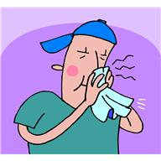
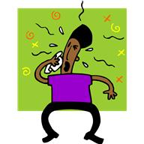
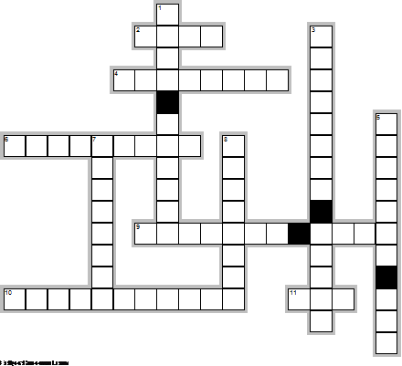
2
8
1
EclipseCrossword.com
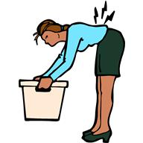
4

5

3
10
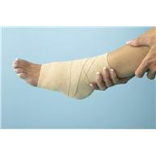
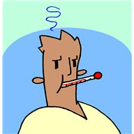
9
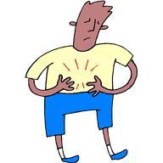

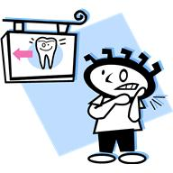
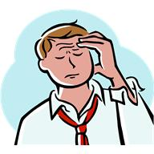
7
11

6

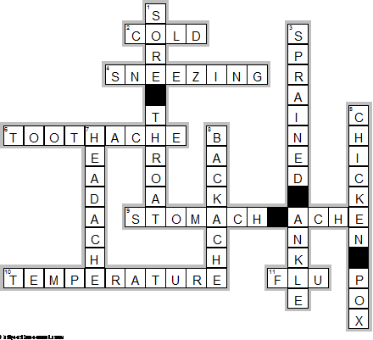
EclipseCrossword.com

Worksheet # 2 (Gap fill) “Conversation between a doctor and a patient ”
Patient: Good morning, Dr. Sharma!
Doctor: Good morning! What’s with you?
Patient: I have been suffering from since .
Doctor: Do you have any other ?
Patient: also feel headache and .
Doctor: Let me take your . At this time the fever is 102 degree. Don’t worry, there is nothing . I am giving you the , and you will be all right in couple of days.
Patient: Thank you, doctor.
Doctor: But get your tested for malaria, and come with the report tomorrow.
Patient: OK doctor.
Doctor: I shall at least two days rest for you.
Patient: Would you prepare a for me to submit it in my office?
Doctor: Oh sure…………. This is your medical certificate.
Patient: Thank you very much. Please tell me how shall I take this medicine?
Doctor: This medicine is for one day only. Take this dose as soon as you your home and the second at 3 pm and the third at night before sleeping.
Patient: What should I eat doctor?
Doctor: You should eat only . You can take milk and fresh fruit also.
Patient: How much shall I pay you doctor?
Doctor: You can pay fee at the reception desk.
Patient: Thanks doctor.
Doctor: It’s all right.
Patient: Thank you doctor. I shall see you tomorrow with my .

Worksheet # 2 Script

< Conversation between a doctor and a patient >
Patient: Good morning, Dr. Sharma!
Doctor: Good morning! What’s wrong with you?
Patient: I have been suffering from fever since yesterday.
Doctor: Do you have any other symptoms?
Patient: also feel headache and shivering.
Doctor: Let me take your temperature. At this time the fever is 102 degree. Don’t worry, there is nothing serious. I am giving you the medicine, and you will be all right in couple of days.
Patient: Thank you, doctor.
Doctor: But get your blood tested for malaria, and come with the report tomorrow.
Patient: OK doctor.
Doctor: I shall recommend at least two days rest for you.
Patient: Would you prepare a medical certificate for me to submit it in my office?
Doctor: Oh sure…………. This is your medical certificate.
Patient: Thank you very much. Please tell me how shall I take this medicine?
Doctor: This medicine is for one day only. Take this dose as soon as you reach your home and the second at 3 pm and the third at night before sleeping.
Patient: What should I eat doctor?
Doctor: You should eat only light food. You can take milk and fresh fruit also.
Patient: How much shall I pay you doctor?
Doctor: You can pay consultation fee at the reception desk.
Patient: Thanks doctor.
Doctor: It’s all right.
Patient: Thank you doctor. I shall see you tomorrow with my blood report.

Worksheet#3

Discussion Topic (Post-Activity)

- What kind of disease are there? Write the names of disease in English.

- How can we express our symptoms at the hospital? Write some expressions we can use at the hospital.

양식의 맨 위

