☐ Listening ■ Speaking ☐ Reading ☐ Grammar ☐ Writing

Topic: A Job Interview

Instructor:  Sarah & Chloe | Level:  Intermediate | Students:  12 students | Length:  30 Minutes

Materials:
● White board and board markers
● Eliciting Pictures (12 copies)
● Worsheet #1 - New vocabulary worksheet (12 copies)
● Worsheet #2 - Dialogue practice (12 copies)
● Worsheet #3 - Discussion worksheet (12 copies)
● Worsheet #4 - Board Game worksheet (12 copies)
● Worsheet #5 - SOS Worksheet (12 copies)

Aims:
● Main aim: Ss will become familiar with common expressions used in a job interview by drilling and doing a role-play.
● Secondary aim: Ss will be able to talk about their own thinking by doing a board game.
● Personal aim: I want Ss to be confident to feel free to speak their opinion in a real job interview.

Language Skills:
● Reading: dialogue
● Listening: drilling/following instructions/role-play
● Speaking: dialogue/board game
● Writing: discussion

Language Systems:

● Lexis: new vocabularies
(proactive, easy-going, hard working etc.)
● Function: investigating/asking Qs
● Discourse: dialogue

Assumptions:
Students already know
● How long the class is
● Four language skills and language systems
● Basic grammar
● Most of words in the dialogue

Anticipated Errors and Solutions:
● If some students have difficulties in understanding key vocabulary,
-> give them further examples.
● If certain students have trouble with the board game,
-> give them instructions in detail.
● If some students have trouble with drilling practice,
-> read the dialogue more slowly.

References:
● Eliciting pictures
https://www.google.com/search?q=interview&source
https://www.google.com/search?biw=929&bih
● Vocabulary (Worksheet #1)
https://www.ef.com/blog/language/useful-phrases-for-a-job-interview/
● Dialogue Practice (Worksheet #2)
https://esol.britishcouncil.org/sites/default/files/
● Discussion (Worksheet #3)
https://www.ef.com/blog/language/useful-phrases-for-a-job-interview/
● Job Interview Board Game (Worksheet #4)
https://busyteacher.org/
● SOS Worksheet (Worksheet #5)
https://www.google.co.kr/search?biw

Lead-In
Materials: None
Time | Set Up | Student Activity | Teacher Talk
1min | Whole  class | Answering teacher’s  questions | Good morning everyone! How are you doing? Have you ever applied for a college or a job? Then, have you had interview?

Pre-Activity
Materials: Board, Board markers, Visual Aid, Worksheet #1
Time | Set Up | Student Activity | Teacher Talk
2 min  3 min  10 min  1min  3 min  4-5min  5 min | Whole  class  Individually  Whole  class  Whole  class  Whole  class  individually  Whole  class | Students answering  Teacher’s questions  Students fill in the blanks  Students answering  teacher’s questions  Listening to teacher with worksheet  Work together  With number 1  On worksheet #1  Students finish the worksheet #1  .  Check answers  together | Procedure:  1. Brainstorming  Elicit  (Hand out work sheet#1)  First, I’m going to give you a worksheet.  What do you see in these pictures?  Please fill in the blank now.  I’m going to give you 3 minutes to work on your own.  ICQ  What are you doing?  Are you working alone?  (after 3 minutes)  Additional explanation  Let’s check the answers together. What is the first one?  Yes, it’s newspaper.  What about second picture?  It is job application form  What about third one?  Yes, It’s a job interview.  What about the last one?  They are shaking their hands.  Model  (Write down the “Job interview” on the board.)  Today we are going to study about Job Interview.  CCQ  Have you ever applied for the job or school?  What do you need to prepare for the interview?  What do you think, How can you progress on the interview?  2. New vocabulary  (Distribute the Worksheet #1)  Now I’m going to give you another worksheet. Finish the crossing words.  Demonstration  Before starts, let’s try number one together. Number 1, proactive rely on. Read answer together.  (student answers)  Right, its f.  Now I’m going to give you 4 minutes to get this done on your own.  ICQ  What are you going to do?  How much time do we have?  Are we working in pairs?  Let’s start!  Monitoring  Monitor discreetly. Answers students if they ask something.  Give time warning.  1 minute; 30 seconds left.  (Be flexible with time. Give 1 more minute if they need)  “Time’s up”  Check Answers  Let’s check the answers together.  I’m going to say the word first, please tell me answers all together.  (If students get wrong with pronunciation or answer, correct them.)

Main Activity
Materials: Board, Board Markers, Worksheet #2, #3, #4
Time | Set Up | Student Activity | Teacher Talk
3 min  3 min  4 min  5 min  5 min | Whole  class  In pairs  In pairs  Individually  In pairs | Listen to teacher, and then repeat  (Worksheet #2)  Role-play  (Worksheet #2)  Discussion  (Worksheet #3)  Presenting  Board Game  (Worksheet #4) | 1. Dialogue Drilling (Controlled Practice)  (Board Role-Play)  (Hand out Worksheet #2)  Instruction  “Okay, now we are going to start a role-play. Before we do, I will divide pairs to work together. Look at the dialogue first, and repeat after me.  (Teacher reads line by line, Ss repeat – drill the text)  Now, practice with your partner. A is an interviewer, and B is an interviewee.  Can you see the words in the box at the bottom? You can change the expressions underlined by using these vocabularies that we have learned today.  I will give you 3 minutes.  ICQ  What are we going to do?  Are you working alone?  How much time do you have?  Ok. Great. Let’s begin.  (monitor)  Time warning: (After 2.5 min)  30 seconds left!  Great. Let’s move on the next part.  2. Discussion (Less-Controlled Practice)  (Hand out Worksheet #3)  Instruction  The topic you will discuss with your partner is “What skills do you have?”  Before doing discussion, imagine your future job in your mind, and then discuss in detail as possible as you can.  There are some useful expressions on the worksheet, so you can use that.  After you discuss, one person for each pair will present in the class.  I’ll give you 4 min.  ICQ  How much time?  Are you working in pairs?  What are you going to do after discussion?  Good. “Let’s start”  Monitoring  Monitor discreetly. Answer students if they ask.  Time warning: (After 2.5 min)  30 seconds left!  Presentation  Ok, great job everyone. We will stop here. Decide a person who present for each pair. You will present in a rotation from here.  (After presenting)  Ok. Thank you. Great job. We will move on the next part.  3. Board Game (Free production)  (Board “Board Game” / “Vocab Card” – 1. Give a definition or 2. Make a sentence)  (Hand out Worksheet #4)  Instruction  Then, now we have another worksheet, and this will be fun. This is a board game.  You will have same partner, and you can use dice to play.  Look at the sheet first.  There are five “Vocab card” section on the board, and I have the Vocab cards.  (Show Ss the 8 Vocab cards in my hands)  When you are on the “Vocab card” section, you will call me. You have to pick one of them, and you can choose whether you give a definition or make a sentence with the word you picked. I’ll give you 5 min.  ICQ  How much time do you have?  What will you do when you’re on  “Vocab Card” section?  Great. Let’s start.  (Monitor, and help Ss as needed)  Time warning: (After 4 min)  1 minute left!  (After 1 min)  Ok. Great job everyone. We will stop here.  Who reached at the end?  How was it? Was it fun?  This game can be effective to think yourself and express your opinion in a real situation.

Post Activity
Materials: None
Time | Set Up | Student Activity | Teacher Talk
3 min | Whole  class | Answering  Teacher’s questions | 1. Error correction  Write sentences on the board that students misspoke during the role play.  2. Feedback  Did you have fun today?  How did you feel with activities?  3. Conclusion  Thank you for participating in this class. I hope you enjoyed today.  Please don’t forget what you learned and try to use in actual job interview.

SOS Activity
Materials: Worksheet #5
Time | Set Up | Student Activity | Teacher Talk
2 min  3 min | Whole  class  In pairs | Students listening to teacher  Find words in  The puzzle. | Instruction  Now we are going to complete the crossword puzzle. There are many job names on the right, you are going to find those words on the left.  You are going to work in pairs.  I will give you 3 minutes to get this  done.  ICQ  Are you working alone?  How much time do we have?  Monitor and check answers  (Monitor them and answer if students ask)  Great job everyone!

- Pictures (Eliciting)

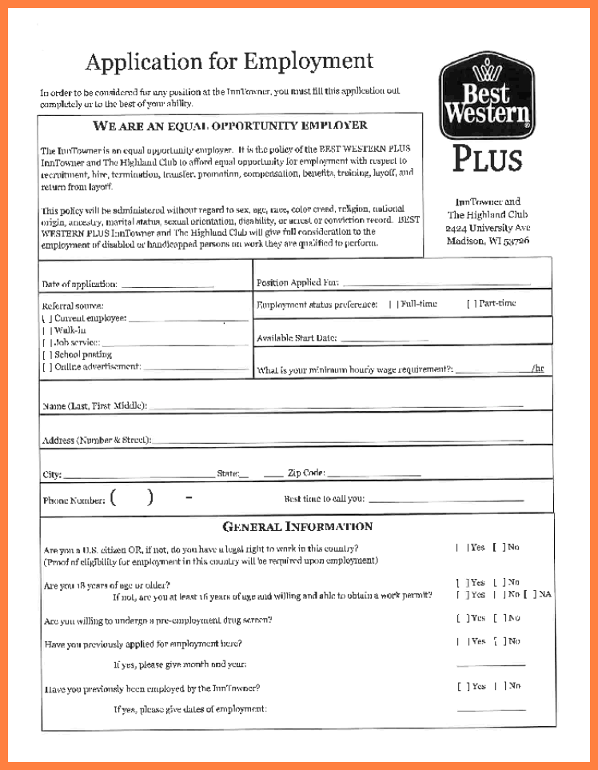

__________________ __________________

__________________ __________________

- Pictures (Eliciting) ANSWER KEY

Newspaper Job application form

Job Interview They are shaking their hands

- New Vocabulary (Worksheet #1)

Match the word to the definition by drawing a line

1. Proactive a. someone who you can rely on

2. Easy-going b. someone who tells the truth

3. Hard-working c. a relaxed person who is easy to get along with

4. Committed d. a person who is loyal to a project or person

5. Trustworthy e. a person who pays attention to details and works in a logical way

6. Focused f. someone who takes steps to complete tasks without supervision

7. Methodical g. someone who is not easily distracted

8. Honest h. someone who works well and isn’t lazy

- New Vocabulary (Worksheet #1) ANSWER KEY

1. Proactive a. Someone who you can rely on

2. Easy-going b. Someone who tells the truth

3. Hard-working c. a relaxed person who is easy to get along with

4. Committed d. a person who is loyal to a project or person

5. Trustworthy e. a person who pays attention to details and works in a logical way

6. Focused f. someone who takes steps to complete tasks without supervision

7. Methodical g.Someone who is not easily distracted

8. Honest h. someone who works well and isn’t lazy

- Dialogue practice (Worksheet #2)

Instruction : Repeat after teacher first, and then practice with your partner. You can change the expressions underlined by using other vocabularies in the box at the bottom.

양식의 맨 위
Interviewer : A / Interviewee : B
A: Good Afternoon, nice to meet you.
B: Hello. Nice to meet you, too.
A: We’d like to ask you a few questions.
B: Ok, great. I’ll do my best to answer them.
A: What skills have you got that would help you in this job?
B: I’m very organized and always on time. I have good people skills as well.
A: Why do you want this job?
B: I would like the job because this is a good organization to work for. I like meeting people and talking to customers. Also, the hours are good for me.
A: Do you work well in a team?
B: Yes. I like working together with other people.
A: Have you got any questions?
B: Which days will I have to work?
A: You’ll work Wednesday to Sundays.
B: Thank you very much. I look forward to hearing from you.
A: Thank you for coming today. We’ll be in touch.

Proactive / Easy-going/ Hard working/ Committed/ Trustworthy/ Focused/ Methodical/ Honest
- Discussion Topic – What skills do you have? (Worksheet #3)

Your interviewer will also want to know what you’re good at. Why? Because the job you’re applying for requires certain skills – so now’s the time to explain what you can do well. Discuss with your partner.

Some positive traits and skills managers look for include:

- Organization
- The ability to multitask
- Perform to a deadline
- Solve problems
- Communicate well
- Work in an international environment and with people from all over the world
- Speak foreign languages
- Enthusiasm

- Job interview Board Game (Worksheet #4)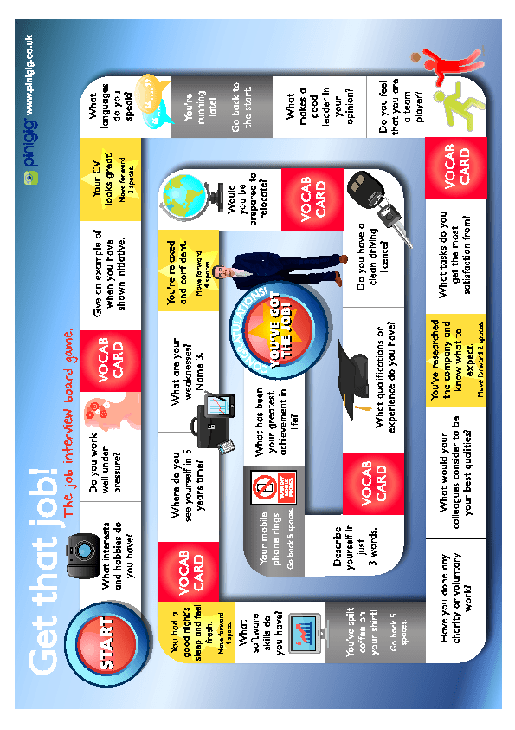

- SOS Activity (Worksheet #5)

