Speaking Lesson Plan- Task-Based Approach

☐ Listening v Speaking ☐ Reading ☐ Grammar ☐ Writing

Topic: Food in a restaurant

Instructor:  Lee, DongChan (Chan)  Lee, SeungHee (Chris)  Jung, Juil (Tony) | Level:  Intermediate | Students:  9 | Length:  45 Minutes

Materials:
PPT slide
A board for the game
Dice
Toy cars
Cards for game
New vocabulary worksheet #1 (8 copies)

Aims:
Main; Ss will be able to learn conversation about ordeing food by role playing.
Secondary; Ss will be able to speak their opinions about food items by playing a board game.
Personal; I want my Ss order their meals without difficulties.

Language Skills:

Speaking: Ss will speak the dialogue by having conversation.
Listening Ss will listen to the interlocutor’s talk.
Reading: Ss will read the dialogue script.
Writing: Ss will write dialogue script for practice.

Language Systems:
Lexis: New vocabulary related to food.
Grammar: Relative pronoun, interrogative sentence.
Function: Request, Order for food
Discourse: Dialogue script

Assumptions:
Students already know
- How to do role-play.
- They practice dialogue script for roleplay.
- How to make sentences by using relative pronouns.

Anticipated Errors and Solutions:
- If students make some mistakes on pronunciation when they speak the dialogue,
- I will teach them how to pronounce.
- If students have conflict that they want to have a role they want,
- I will assign the role fairly.
- If students are shy to talk,
- I will encourage them to speak with confidence and to take risks with not being afraid to make mistakes while they speak.
- If students don’t know how to play a board game,
- I will explain to students with various examples.

References:

https://www.google.com/search?q=mcdonald+%EC%A0%90%EC%9B%90&tbm=isch&tbo=u&source=univ&sa=X&ved=0ahUKEwiH5--zsqXcAhXMlpQKHTLoAxYQsAQIJQ&biw=1067&bih=521#imgrc=4M1hBrYqcCVGxM:&spf=1531805025778

https://www.google.com/search?biw=1067&bih=521&tbm=isch&sa=1&ei=ZH1NW-uXPIbP0ASHnZG4BA&q=pay+the+bill+at+the+restaurant&oq=pay+the+bill+at+the+restaurant&gs_l=img.3...668562.683970.0.684348.53.41.8.0.0.0.384.5631.0j22j7j3.32.0....0...1c.1j4.64.img..14.17.3340.0..0j0i24k1j0i10k1j0i30k1j0i8i30k1j0i19k1j0i30i19k1j0i5i30i19k1.0.UQm3E371U-8#imgrc=NV7ZUHBcSQ7UXM:&spf=1531805711412

Lead-In
Materials: None
Time | Set Up | Teacher | Student
1min | Whole class | Greeting  “What did you have for breakfast?”  “I hope you had a nice breakfast.” | Greeting  Answer what they had for breakfast.

Pre-Activity
Materials: PPT Slide
New vocabulary worksheet #1 (dialogue at the restaurant ; 8 copies)
New vocabulary worksheet #2 (board game ; in the back of worksheet #1)
Game board, Toy cars, word cards
Time | Set Up | Teacher | Students
2min.  2min  6min | Whole class  Whole class  Group work | 1. Brainstorming  Present pictures related to food.  Ask Ss to give their opinions.  Write Ss’ opinions on the board.  (* Pre Teach)  #1 New Vocabulary  Demonstrate how to practice worksheet.  Have Ss answer the worksheet questions.  (*Instruction)  “We are going to learn new vocabularies.  I will give you a worksheet. Find the best match for each question. If you hardly guess the meaning of the word, just raise up your hand then I will work with you.  (Distribute the worksheet #1)  Now you have 3 minutes.”  (* ICQ)  What are you going to do?  Are you doing alone?  How much time do you have?  Okay, start now.  (* Monitoring)  Monitor discreetly.  Give time warning.  Ask for help if there are any words that can not be guessed.  Time is up.  (* Check answers)  Do you have any question from new vocabularies?  #2 New vocabulary  Assign the group of 3.  Announce that Ss are going to play a car racing game using words related to food.  Give Ss direction how to play it by showing PPT slide.  Show the car racing game board to Ss.  Show the card by informing them of how to get the answer.  Ask Ss to find what the correct answer is between 2 words on the card.  Give Ss instruction checking question.  Let Ss play the game for 5 minutes.  Tell Ss to finish the game.  Ask Ss who the winner is in their group.  Ask group representative to bring the game material back to front. | Look at pictures related to food.  Prepare to give their opinions about food.  Give their opinions about food.  Watch T’s demonstration.  Be ready to practice worksheet.  Listen to T’s introduction.  Find the best match.  Yes.  3 minutes.  Practice worksheet individually.  Stop practicing the worksheet.  Check answers with T.  Form the group of 3.  Be ready to play the next activity.  Listen to T’s direction.  Be aware of card system.  Be aware of how to find the correct word on the card.  Respond to T’s instruction checking question.  If Ss are unsure of how to play it, ask T for further instruction.  Play the game for 5 minutes.  Stop playing the game.  Raise their hand if one of the group members wins the game.  Bring the game material back to T.

Main Activity
Materials: worksheet Dialogue

Time | Set Up | Teacher | Students
4 min  4min  7min  10  min | Group work  Group work  Groupwork  Groupwork | 1.Dialogue Drilling  (Controlled Practice)  Introduce the conversation in a restaurant.  “This is a conversation between three people at the restaurant.  (distribute the dialogue)  Look at the text, first just listen.  (Teacher reads)  Now. Repeat after me  (Teacher reads line by line, Ss repeat – drill the text)  We’ll divide you group of 3 to work together.  We have 3 groups. .  Now, practice together in a group. Read it twice : once as the guest#1, #2, and  Once as server, I’ll give 3 min. Try to memorize the script while practicing.  Let’s start!”  ICQ  How much time do you have?  What should you do?  Assign the roles for each student.  Run the task  Monitor and correct Ss if they make errors.  2. Change the words or phrases(Less-Controlled Practice)  Work with the same group. Change the underlined words or phrases.  And I will give you 3min. Let’s start!  Demonstrate by reading the dialogue and changing the underlined words.  ICQ  What do you have to do?’  How much time do you have?  Run the task  Monitor and assist Ss having difficulties.  Check Ss’ errors  Have some group read their changed dialogue for the class.  3. Role Play  (Free Production)  Introduce how to perform the role play.  Do the demonstration  “Now, We are going to do a real practice.  I’ll show you what to do.  (demonstrate with student volunteers)  You have 5 min. Work with a group.  You will share your acting to your classmates.  Let’s start!”  ICQ  How much time do you have?  What should you do?  Run the task.  Monitor and help Ss as needed.  Have group perform their role play in front of the class. Take notes of any noticeable errors Ss make with the new expressions learned today)  4. Board Game  Announce that students are going to play a game.  Arrange group of 4 students.  Show the picture of monopoly.  Explain to students how to play the monopoly game by showing the slide.  Ask students if they have questions when they don’t know how to play it.  Tell students that they have 8 minutes to play it.  Go around and help students.  Give students time to count how much money they get for 30 second.  Tell students that the game is finished.  Ask students who the winners of each group for the game are. | Think of the topic about food in a restaurant.  Listen to T’s introduction.  3mins  Read the dialogue twice.  Have their roles.  Do the task.  Ask for help if they need help.  Read the dialogue by changing the underlined words or phrase.  3mins  Do the task.  Ask for help.  Read their changed dialogue.  Watch T’s explanation for role-play.  Watch T’s explanation for role-play.  5min.  Do the role in group.  Do the role play.  Perform the roleplay.  Find their group for 4 members.  Watch the slice that they are familiar with monopoly game.  Recognize how to play the game.  Ask the teacher questions when they want to know more how to play it.  Play the game for 8 minutes.  Ask the teacher more information while playing.  Count how much money they get from the game for 30 second.  Finish playing the game.  Raise their hands if they are the winners of each group for the game.

Post Activity
Materials: None
Time | Set Up | Teacher | Students
2min  1min  1min | Whole class  Whole class  Whole class | 1. Error Correction  Correct Ss’ errors after monitoring.  Ask Ss to speak full sentences instead of word for conversation and dialogue.  2. Feedback  Ask Ss how the activities went.  3. Conclusion  Conclude the lesson.  Ask Ss if there are any questions for the lesson.  Praise Ss’ work. | Try to correct errors they made  through instruction.  Give their feedback to the lesson.  If they ask some questions, they feel free to ask T questions.  Appreciate T’s lesson.

SOS Activity
Materials: Worksheet (Find Someone Who)
Time | Set Up | Teacher | Students
5min | Wholeclass | Find Someone Who..  Explain how to play the game.  Ask Ss to move around classroom.  Ask Ss to ask questions to their friends to find who matches the questions.  Ask Ss to stop it.  Ask Ss to present their friend’s information about food to the whole class. | Listen to T’s explanations  Move around classroom.  Ask their friends some questions  to match the questions.  Stop asking questions.  Present their friends’ information  about food to the whole class.

#1 New Vocabulary

- Find the best match from suggested answers

- crisps
snowflakes / potato chips

- junk food
healthy / unhealthy

- spicy
hot / sour

- topping
cheese / dough

- traditional
new / old

- allergic
sensitive / dull

- beverage
liquid / solid

- a diet
go on / leave

#2 New Vocabulary

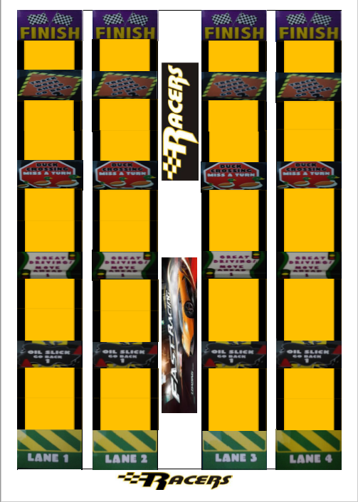

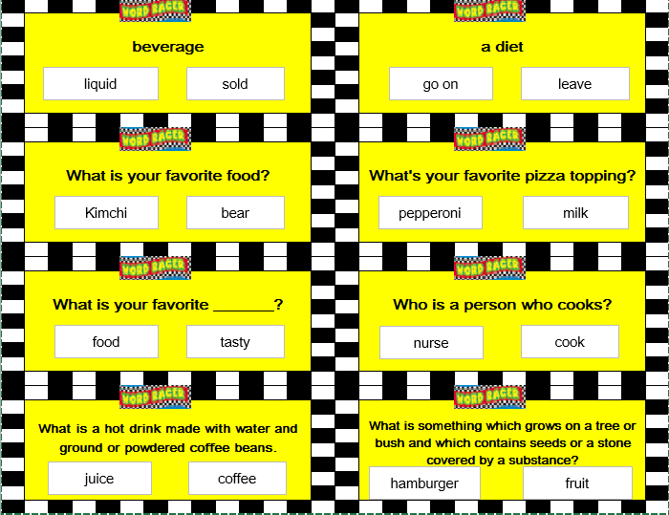

(DIALOGUE)

□ CONVERSATION – IN RESTAURANT

Guest 1 : What are you going to have?
Guest 2 : Just a cheeseburger and french fries. What about you?
Guest 1 : I think I'll have the salad.
I'd like a hamburger.
I'll have a sandwich.
Server : Are you ready to order now?
May I take your order?
Would you like to order now?
Shall I take your order?
Ready to order?
Guest 1 : Yes, We'd like a hamburger, french fries, and the salad, please.
Server : All right, Will you have something to drink?
Would you like anything to drink?
Something to drink?
Guest 1 : Well, I'll have a coffee, then.
Guest 2 : Same here. Make that two.
I'll have the same.
The same for me.
Server : How would you like it?
Guest 1 : With cream and sugar, please.
Guest 2 : With cream, please.
Server : Would you like to order some dessert now?
Will you have something else?
Is there anything else I can get you?
Anything else?
Guest 1 : I'd like a piece of apple pie.
Guest 2 : I don't have room for dessert
I am full.
I've had enough.
Server : Fine, I'll be right back.. Is everything all right?
Guest 1 : Oh, yes, excellent. Thank you.
Server : Can I give you a little more coffee?
Guest 2 : No, thanks. Uh... could you bring us the bill, please?
May I have the bill, please?
Check, please.
Bring me the bill, please.
Server : Yes, right away. Here you are.
Guest 1 : Let me share the bill, shall we?
Let's split the bill.
Let's go Dutch, shall we?
Guest 2 : No. This lunch is on me………, How much is it?
It's on me.
Let me treat you this time.
This is my treat.
Server : It’s 30 dollars. Would you like to pay with credit card or cash?
Guest 2 : Credit card / cash .
Server : Thank you, Have nice day!

Board Game

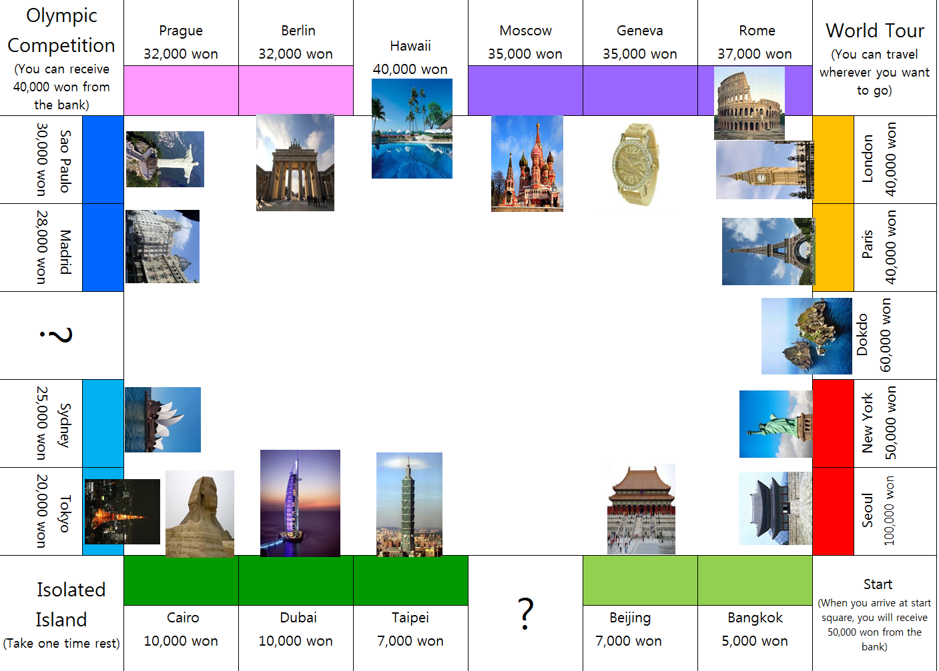

What is your favorite meal? | Do you prefer crisps or chocolate?
What is the most unusual food you've eaten? | What is your favorite dessert?
Do you eat junk food? | What is your favorite vegetable?
Do you eat healthy diet? | Name a type of fish or seafood.
Do you like spicy food? | What do you normally eat for breakfast?

Find someone who

Name :

Move around the classroom and ask your friends some questions below.
While you ask some questions to your friends, if the answer from your friends is matched, please, write your friend’s name. Then, stop asking it and move to another friends to ask it.

Friend’s name | I find my friend who ~~~
 | I find my friend who is a good cook.
 | I find my friend who prefer to drink tea.
 | I find my friend who likes spicy food.
 | I find my friend who is allergic to food.
 | I find my friend who eats healthy food.
 | I find my friend who prefer drinking coffee.
 | I find my friend who likes to eat fish.
 | I find my friend who likes to put topping on pizza?
 | I find my friend who can cook bulgogi.
 | I find my friend who likes to eat ice cream.
 | I find my friend who ate McDonald’s this week.
 | I find my friend who does not like kimchi.
 | I find my friend who like eating hamburger.
 | I find my friend who can like to eat bread.

How to ask question

Do you like to cook? Or Can you cook?
Do you like to drink tea?
Do you like spicy food?
Are you allergic to any food?
Do you eat healthy food?
Do you like to drink coffee?
Do you like to eat fish?
Do you like to put toppings on pizza?
Can you cook bulgogi?
Do you like to eat ice cream?
Did you go to McDonald’s this week?
Do you like to eat kimchi?
Do you like to eat hamburger?
Do you like to eat bread?

