☐ Listening ☐* Speaking ☐ Reading ☐ Grammar ☐ Writing

Topic: The Great Balloon Debate

Instructor:  Lucie Jeong  Lizzie Noh | Level:  Intermediate | Students:  12 | Length:  50 Minutes

Materials:
Visual Aid: Board the situation with illustrations
White board and board markers
Vocabulary worksheet #1
Character cards
Debate Worksheet #2
SOS worksheet #5
Computer for the audio file

Aims:
- Main aim- Ss will be able to improve their speaking skills by discussing about the characters and showing their opinion whether they agree or disagree and also convincing the other students.
- Secondary aim- Ss will be able to rank the orders by combining all the ideas they collected during the discussion.
- Personal aim- I want the students to cooperate with the overall main activities so I will try hard to monitor student’s process and let them accept others’ idea.

Language Skills:
- Reading: Ss will read the definitions and the details given in the worksheet.
- Listening: Ss will listen to additional information about the characters after the first decision.
- Speaking: Ss will discuss and convince others by talking actively.
- Writing: Ss will complete their worksheets and take notes for the details.

Language Systems:
- Lexis: New vocabularies in the passage
- Fuction: Giving information
- Discourse: Discussions and conversation that happened during the class

Assumptions:
Students already know
- The Big Balloon and how it works
- The characteristics that can be a useful benefit for a survival situation

Anticipated Errors and Solutions:
- If students are not aware of certain vocabularies in the cards or insturctions
- Be sure to go over the vocabularies before discussion.
- If the students feel embarrassed to discuss about the characters
- Encourage the students who participate and allow them to give certain chances to the quiet students.

References:
Worksheets and characteristic cards
http://www.efl4u.com
crossword SOS activity
https://worksheets.theteacherscorner.net/make-your-own/crossword/

Lead-In
Materials: none
Time | Set Up | Student Activity | Teacher Talk
1 min | Whole class | Answering teacher’s questions | Good morning everyone! How are you feeling today? Have you ever seen a big balloon floating in the sky? Where can you usually see them? Have you ever tried one?

Pre-Activity
Materials:
Board, Board markers, worksheet #1
Time | Set Up | Student Activity | Teacher Talk
5 min  4 min | Whole class  Work  alone | Answering teacher’s questions  Students start writing down the words. | Procedure:  - Eliciting  Elicit  (Boarding the situation)  What can you see on the board that I just drew?  What is happening under the bid balloon?  What do you think will happen to this balloon?  Additional Explanation  At a remote island, volcano suddenly started to erupt. There was no time for an escape and there were no means of transportation of the small island except for one hot air balloon. All of the people in your group managed to climb abroad the hot air balloon but it is dangerously heavy. If three people are thrown abroad, the balloon will have a better chance to make it to the safety of a distant island. If not, everyone will surely die. The balloon is quickly descending, and there is no rescue in sight. Suicide is not permitted. Everyone must fight for their survival.  Model  Write the subject ‘The Great Balloon Debate’ on the top and list the character’s name to board additional information.  CCQ  What happened to the island?  What should we do to survive?  Can we commit a suicide?  - New Vocabulary  Instruction  We are going to learn new vocabularies before we listen to the passage. I am now handing out the worksheets. (Hand out the worksheet #1) Now, first let’s read the definitions of words with the blanks and fill them with the matching words. Try it together as a pair. I will give everyone 3 minutes to finish.  Demonstration  Let’s solve number one together just to make sure. It says…  ICQ  What do we do with the blanks?  Do we work alone?  How much time do we have?  “Let’s get it started.”  Monitoring  Monitor discreetly. Answer students if they ask questions. Try to roam around the class to make sure everyone understood what they are doing.  Give time warning:  1 minute. 30 seconds left.  (Be flexible with the time.)  “Time’s up.”  Check Answers  Let’s check the answers together.  Accept any additional questions.

Main Activity
Materials: Character cards, debate worksheet
Time | Set Up | Student Activity | Teacher Talk
10 min  10  min  5  min  5  min | Groups  Groups  Groups  Groups | Students take turns and explain their characteristics. First they introduce their character and based on that speech, we rank.  Second, they can discuss the characters as a class and come up with different opinions to share as a class.  Lastly, they have to listen to the additional information given to change or stick to their decisions.  One representative can express the class’ opinion to summarize their discussion | - Prediction  As I mentioned, the situation is to throw aboard 3 people in order to survive.  Instruction  There will be 3 discussions held with time limit of 10 minutes and the last one with 5 minutes. First, we pick a card of characters. Then, let’s introduce the characters to the class. We will go clockwise. You can feel free to show your card to the class.  (Distribute worksheet #2)  ICQ  What are we doing now?  Which way are we going to introduce the cards?  Do we share out cards to the class?  Okay everyone had their turn. I am pretty sure that all of you can decide which one to kill. You can circle ‘YES’ for the characters you would like to throw aboard.  - Debate about the Characters  Instruction  This time, all of you can discuss as a whole class about your first decision and why you made your decisions like that. I will give you 10 minutes to discuss as a class. You can convince the other students to make your character survive, but the main point is to select 3 people to throw aboard, just remember that you don’t get additional points because you are alive. You can always take notes about the details so that you can never forget.  ICQ  Can you take notes about the details?  What should we do now?  (Monitor discreetly about the discussion. If anyone has a question, answer them but never give more hints about the characters.)  Check Answers  Now everyone can tell me the decision we all made as a class. Who was the first one to be killed? Second? Third?  (present the answers together)  - Additional information and the last debate  Instruction  Since we all made a decision to kill the characters, I will give additional information about the characters. These infos might change your decision. Take notes as I go on, and please take a look at your vocab worksheets if you have any words that made you confused.  ICQ  What are we doing now?  Are we working in a group?  How much time do we have to discuss?  “Let’s begin.”  Monitoring  Monitor discreetly. Anyone who misunderstood or lost should feel free to ask questions anytime.  - Presentation  Instruction  Now we will have one representative ready to present our class’ opinion. Tell them in the orders to be killed, using the phrases in the box on your worksheet, but include the reasons to support your answer.  ICQ  What are we going to do now?  Do we present only the characters?  “Let’s begin.”  Presentation  It is time to listen. Please stand up and report your opinion. Speak clearly and loudly so that others can be focused and respect your opinion.

Post Activity
Materials: none
Time | Set Up | Student Activity | Teacher Talk
5 min | Whole  class | Students answering questions | - Error Correction  We were doing an outstanding job today. I hope all of you won’t be unhappy that there are no answers in this activity. The whole and the most important point is that we discussed about the topic and we can now prepare for the real situation.  - Feedback  So What do you all think about the debate? After this activity if you get a chance to get on the big balloon, what would you prepare?  - Conclusion  Class you did a splendid job today. I hope everyone felt energized and joyful.

SOS Activity
Materials: Worksheet #4
Time | Set Up | Student Activity | Teacher Talk
5 min | Work  alone | Students filling out the blank | Instruction  For now, let’s work on this worksheet. This is an interesting puzzle about the vocabularies you learnt today. You have to fill in the blank with the right words Let’s work as a pair.  Demonstration  Let’s fill in the first one as a class. So let’s look at the horizontal one. It says…  (Distribute worksheet #4)  ICQ  What are you about to do now?  Do we work as a group?  Check the answers  Check the answers together. Let’s go clockwise to slowly and correctly answer our answers. (Go through all the answers in the worksheet.)

Pre-activity worksheet

1. The _______________ an organization for boys which teaches them discipline and practical skills.
2. _____________ is informal conversation, often about other people's private affairs.
3. If you talk about the _____________ of something or someone, you are indicating that you find them morally or sexually offensive.
4. The ____________ of something is how good or bad it is.
5. A _____________ is someone who does work without being paid for it, because they want to do it.
6. A _____________ is a person whose job is in politics, especially a member of parliament or congress.
7. Someone who is ______________ is hopeful about the future or the success of something in particular.
8. You use ______________ when you are stating something that you believe is probably true, in order to make it sound less strong or direct.
9. A _____________ is the formal ending of a marriage by law.
10. A _____________ is a sum of money or something valuable that one person offers or gives to another in order to persuade him or her to do something
11. A _____________ is a member of the Christian clergy in the Catholic, Anglican, or Orthodox church.
12. If you accuse someone of _______________, you are accusing them of breaking the law or the rules of their profession in order to gain some advantage for themselves.
13. ______________ is a period of time during which a person who has committed a crime has to obey the law and be supervised by a probation officer, rather than being sent to prison.
14. If you _____________ someone of doing something wrong or dishonest, you say or tell them that you believe that they did it

Boy scout quality priest Volunteer gossip politician optimistic probation indecency accuse malpractice suspect divorce bribe
Pre-activity worksheet – Answer key

1. The (Boy scout) an organization for boys which teaches them discipline and practical skills.
2. (gossip) is informal conversation, often about other people's private affairs.
3. If you talk about the (indecency) of something or someone, you are indicating that you find them morally or sexually offensive.
4. The (quality) of something is how good or bad it is.
5. A (Volunteer) is someone who does work without being paid for it, because they want to do it.
6. A (politician) is a person whose job is in politics, especially a member of parliament or congress.
7. Someone who is (optimistic) is hopeful about the future or the success of something in particular.
8. You use (suspect) when you are stating something that you believe is probably true, in order to make it sound less strong or direct.
9. A (divorce) is the formal ending of a marriage by law.
10. A (bribe) is a sum of money or something valuable that one person offers or gives to another in order to persuade him or her to do something
11. A (priest) is a member of the Christian clergy in the Catholic, Anglican, or Orthodox church.
12. If you accuse someone of (malpractice), you are accusing them of breaking the law or the rules of their profession in order to gain some advantage for themselves.
13. (probation) is a period of time during which a person who has committed a crime has to obey the law and be supervised by a probation officer, rather than being sent to prison.
14. If you (accuse) someone of doing something wrong or dishonest, you say or tell them that you believe that they did it.

SOS Activity – CROSSWORD
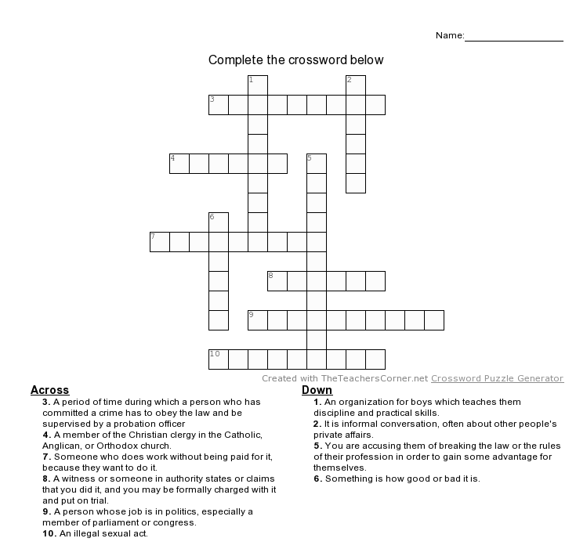

SOS Activity - CROSSWORD Answer key

ACROSS Down
3. probation 1. boy scout
4. priest 2. gossip
7. volunteer 5. malpractice
8. accuse 6. qulity
10. indecency

