☐ Listening ■ Speaking ☐ Reading ☐ Grammar ☐ Writing

Topic: Where are you from?

Instructor:  Emily & Pauline | Level:  Intermediate | Students:  10 students | Length:  40~45 Minutes

Materials:
- White board and board markers
- Worksheet#1: New Vocabulary (10 Copies)
- Worksheet#2,3,4: Main Activity (10 Copies)
- S0S Worksheet: Wordsearch (10 Copies)
- Pictures of countries

Aims:
- Main Aim: Ss will be able to improve their speaking skills by doing a role-play and sharing information about 12 countries around the world.
- Secondary aim: Ss will be able to use expressions related to countries by learning new vocabulary.
- Personal aim: I would like to inform Ss about key features of 12 countries in English.

Language Skills:
- Listening: Teacher’s eliciting of topic and drilling of some expressions
- Speaking: Ss will discuss about countries.
- Reading: Ss will read scripts of topic.
- Writing: Ss will take notes on details of the text.

Language Systems:
- Lexis: New vocabularies related to countries (Country, Nationality, Landmark, Structure, Location, Temple, Reunification, Goddess, Borders, Lean)
- Function: Giving Information
- Discourse: Conversation about countries

Assumptions:
Students already know
- How the class arranged and prepared
- The basic knowledge about the name of countries
- Their partners

Anticipated Errors and Solutions:
- If students are hesitant to speak loudly about their thoughts,
- Encourage them to speak more loudly and give some advice
- If some students need more time for each work,
- Give them an extra minute.
- If certain students dominate the talking time,
- Make other Ss to take turns.

- Worksheet #2: Nationalities and Countries
https://www.englishwsheets.com
- Worksheet #3: Landmark Description
https://en.islcollective.com/resources/printables/worksheets_doc_docx/famous_landmark_cards_4_lets_explore_game/places-landmarks-monuments/72196
- SOS Worksheet:
http://quickworksheets.net

Lead-In
Materials: None

Time | Set Up | Student Activity | Teacher Talk
1 min | Whole class | Answering teacher’s questions | Good morning! How are you today?  Have you ever been to other countries? Do you have any plans to go abroad for this summer vacation?

Pre-Activity
Materials: Visual Aid(Picture), worksheet #1 (10 copies)

Time | Set Up | Student Activity | Teacher Talk
3 min  5 min  3 min | Whole class  Pairs | Answering teacher’s questions.  Students start writing down the words with their partner.  Students check answers | - Spark Interest  - Eliciting  (Show the students pictures about other countries)  Do you know the name of these countries? Have you ever been to these countries? Which country do you want to go? Let’s talk about our experience related to these countries.  - ICQ  What are these?  What should we do now?  - Pre-teach Vocabulary  Instruction  We are going to learn some new vocabulary. I will give you a worksheet.  (Hand out Worksheet#1)  First, read the words related to countries, Fill in the blank with the words listed. Work together with your partner. If you have trouble, you can use a dictionary. I will give 5 minutes to finish.  Demonstration  Let’s solve the first word together.  Look at #1. Does anyone know the answer of this? “Yes, the answer is nationality.”  ICQ  What do you write in the blanks?  Are you working in groups?  Are you working in pairs?  How much time do you have?  “Let’s get it started”  Monitoring  Monitor discreetly. Answer to  students if they ask questions.  Give time warning  1 minute; 30 seconds left.  (Be flexible with time.)  “Time’s up”  Check answers  Let’s check the answers together.  After checking answer, do complement.

Main Activity
Materials: Worksheet #2,3 and 4 (10 copies each)
Time | Set Up | Student Activity | Teacher Talk
4 min  2 min  3 min  7 min  2 min  2 min  7 min  3 min | Individual/Pairs  Whole  class  Whole class  Pairs  Whole  class  Pairs  Pairs  Pairs/ Whole class | Students complete worksheet #2  Students shout the answers together in pairs  Students go over the dialogue and its expression together (Worksheet #3)  Students listen to the instruction and do a role-play.  Students check answers  Students complete worksheet #4  Students complete worksheet #4  Students hold up their worksheets and check their answer in pairs. | - Controlled Practice  As I boarded here, today’s topic is “Where are you from?” We will take a look at 12 countries and their key features.  (Hand out the worksheet #2)  Instruction  First, we are going to learn about the difference between the countries and nationalities.  (Board Korea vs Korean)  For example our country is Korea, and we are Korean. So, Korea is the country name and Korean is our nationality. Please look at your worksheets and repeat after me for the bolded words.  (Teacher reads by each section)  Great job. Now, guess the right answer with your partner for each box. I’ll give 3min.  ICQ  Do you work with your partner?  How much time do you have?  (Run the task. Monitor and correct Ss if they make errors)  Check answers  Ok, everyone, let’s go over the answers. Let’s take turns in pairs to say the answers  - Less-Controlled Practice  Instruction  Now, let’s find out some famous landmarks for each countries.  (Hand out Worksheet #3)  On the left side, you can see the  dialogue between Joe and Anna.  They met for the first time in the ESL class and they are sharing some famous landmarks in their country. First, as a class let’s read out-loud. Left side of the class will be Joe and the right side of the class will be Anna.  (Read together.)  Great job, everyone. Now, in pairs, I want you to do a role-play using the countries and famous landmark listed on the right side of your worksheet. The underlined words should be changed each time for the right country and the right explanation.  You also want to switch your roles for each countries. Try to cover all the countries. I will give you 7 min for the role-playing.  ICQ  What are you doing?  Who are you working with?  How much time do you have?  (Monitor and answer to student’s questions. Give time warning)  1 min left.  Check answers  Let’s have two groups to do a role-play. Good Job.  - Free Practice  Instruction  Okay everyone, now we will have some fun activity called ‘info gap.’ I’m going to pass out the worksheets but do not show it to your partner.  (Hand out worksheet#4.)  You will work with a same partner again. However, this time you and your partner have different type of worksheets. Your job is to draw a complete flag for every 12 countries. If you have a blank flag, it means your partner has the right flag. Please explain to your partner what you see on your paper such as the country name and the shape and colors of the flag.  Demonstration  Let’s do the first flag together.  (Draw a rectangle on the board)  It’s the flag of France.  It is divided in 3 parts evenly by 2 vertical lines. The left portion is colored in Blue, middle with White and right with Red. Since we don’t have colored pens, you can just indicate the color by writing.  So, now let’s work in pairs. Do not use your hand gestures. Please try to explain by only speaking. I will give you 7 min.  ICQ  How much time will you have for the activity?  Can you use body language?  Ok, start.  Monitoring  (Walk around and check if everyone is speaking and following the instructions)  (Give time warning)  You have one minute left.  Presentation  It’s time to see if everyone got the flags right. Please match you’re your partner’s worksheet. Hold up your papers and let’s see which group got the most similar flags. Did any group got every flags filled correctly?  Great work! Good job, everyone.

Post Activity
Materials: White board and board Marker

Time | Set Up | Student Activity | Teacher Talk
1 min  1 min  1 min | Whole class  Whole class | Students listen and answer questions  Students listen and ask questions & answers | - Error Correction  (correct errors if Ss have any errors in their expression)  - Feedback  Did you get to know about many countries around the world?  Do you have any questions so far?  - Conclusion  (Conclude today’s lesson by checking their understanding)  Thank you for your participation. You did a great job today. I hope you know more about countries around the world.

SOS Activity
Materials: Wordsearch worksheet (10 copies)

Time | Set Up | Student Activity | Teacher Talk
4 min  1 min  1 min | Individual | Students complete the worksheet  Students check their answers with partners.  Student listen to teacher | - Wordsearch Game  Instruction  We are going to play the Wordsearch Game using the vocabularies we learned today.  (Hand out worksheet)  In the lettered box, you are to find out 12 words presented in the bottom on your own. You can make circles as you find the word listed. Words can be shown in a shape of horizontal, vertical and diagonal but orders are not in backwards. You have 3 mins.  ICQ  How many words are you finding?  Are you working in a group?  How much time will you get?  (After 2 minutes with time warning)  Okay, Please check your answers with your partners.  Review  Does anyone have questions?  Good Work, everyone!

- Pictures for Eliciting

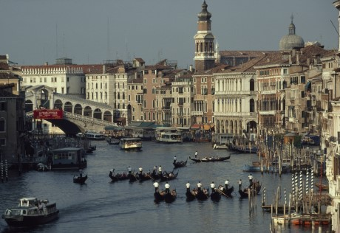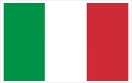

- Worksheet #1
Pre-Activity – New Vocabulary
Word Bank
- Landmark b. Country c. Nationality
d. Structure e. Location f. Temple
g. Re-unification h. Goddess i. Lean
j. Borders

- : The place you were born or have the legal right to be a
citizen
- : A female spirit or being that is believed to have power
over a particular part of the world or nature
- : The place where something happens or is situated
- : The way in which it is made, built, or organized
- : A building or feature which is easily noticed and can
be used to judge your position or the position of other
buildings or features
- : A building used for the worship of a god or gods,
especially in the Buddhist and Hindu religions, and in ancient Greek and Romans time
- : The dividing line between two countries or regions
- : One of the political units which the world is divided into,
covering a particular area of land
- : The joining again of a country or city that has been
divided into two or more parts for some time
- : When you are in a particular direction, you bend your body in that direction

worksheet #1 Answer Key

- Nationality: The place you were born or have the legal right to be a
citizen
- Goddess : A female spirit or being that is believed to have power
over a particular part of the world or nature
- Location : The place where something happens or is situated
- Structure : The way in which it is made, built, or organized
- Landmark : A building or feature which is easily noticed and can
be used to judge your position or the position of other
buildings or features
- Temple : A building used for the worship of a god or gods,
especially in the Buddhist and Hindu religions, and in ancient Greek and Romans time
- Borders : The dividing line between two countries or regions
- Country : One of the political units which the world is divided into,
covering a particular area of land
- Reunification : The joining again of a country or city that has been
divided into two or more parts for some time
- Lean: When you are in a particular direction, you bend your
body in that direction

- Worksheet #2
- Circle the right expression.
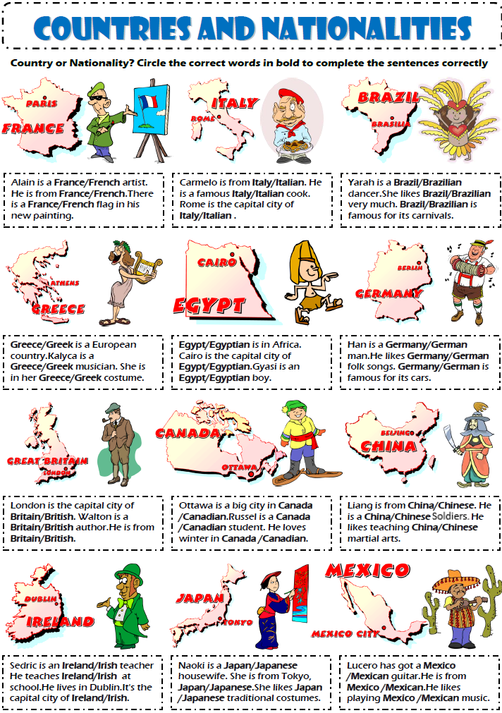
- Worksheet #2 Answer Key

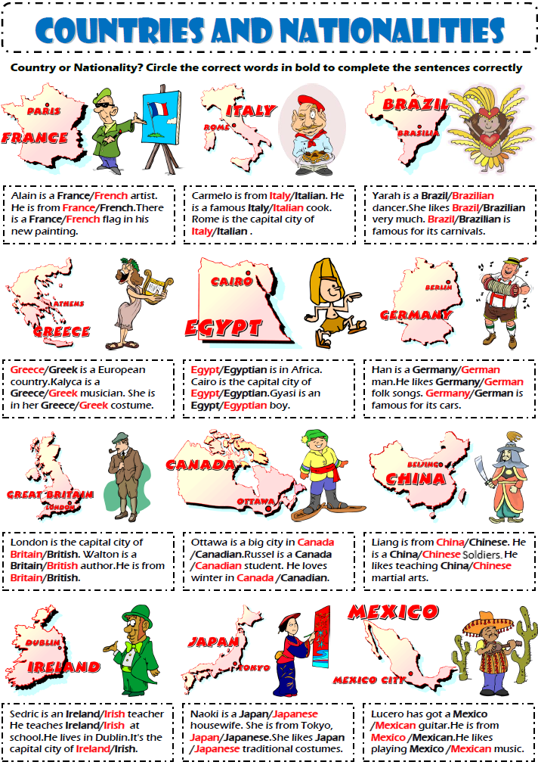
- Worksheet #3 - Dialogue Practice
Conversation: Where are you from? | Famous Landmarks
Joe and Anna met for the first time in the ESL class today and they are sharing some famous landmarks in their country.  J: Hello Amanda.  A: Hi, Joe. Where are you from?  J: I’m from France.  A: Ah ha. What is the famous landmark in France?  J: One of our landmark is the Eiffel Tower.  A: Oh, I see. What are some features of Eiffel Tower?  J: Well, It is located in Paris, and it was built in 1889. Also, it’s 300 meters tall. It is one of the most visited landmark in world.  A: Wow. Good to know. Thank you for sharing.  J: You are very welcome.  -----------------Countries-----------------  France, Italy, UK, Egypt, Brazil, Greece, Germany, England | 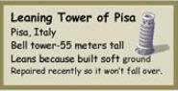
 | 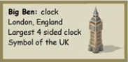
 | 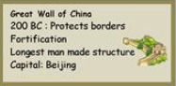
 | 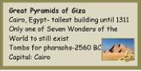
 | 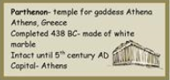
 | 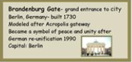
 | 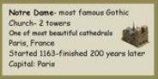
 | 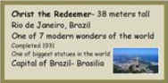
- Worksheet #4 (Option A) – Info Gap

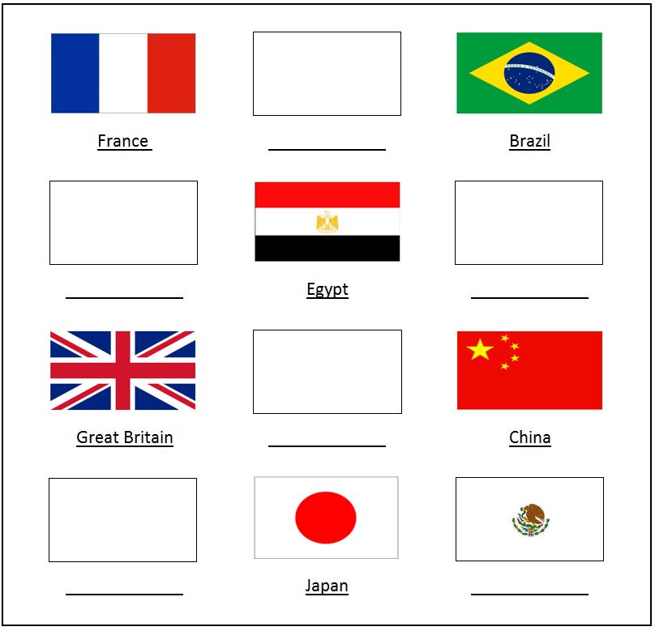
- Worksheet #4 (Option B) – Info Gap

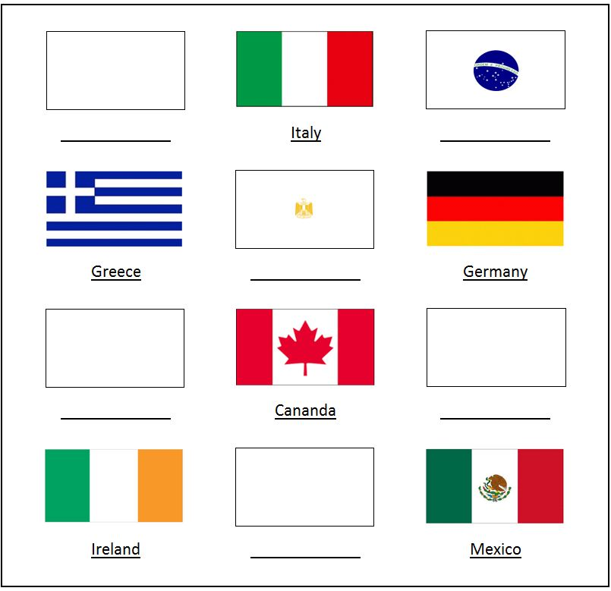
- Worksheet #4 Answer Key

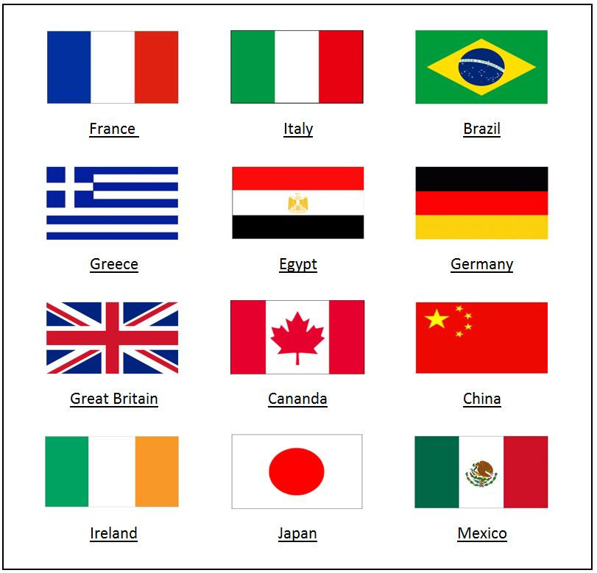
- SOS Worksheet – Wordsearch

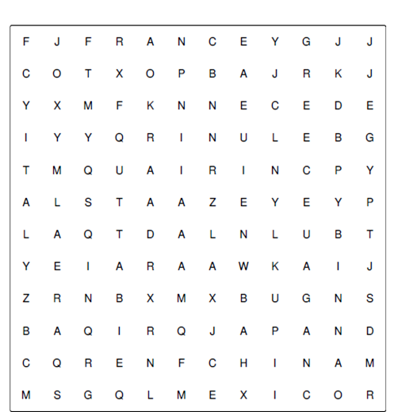

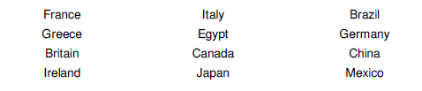

- SOS Worksheet – Wordsearch Answer Key

