|  |
| --- |
| ☐ Listening ☐ Speaking ☐ Reading ■Grammar ☐ Writing |
| **Topic: Emily is taller than Sarah** |

|  |  |  |  |
| --- | --- | --- | --- |
| Instructor:  Emily & Sarah | Level:  Pre-Intermediate | Students:  10 students | Length:  45 Minutes |

|  |
| --- |
| Materials:  ● White board and board markers  ● Computer & projector (ppt - less controlled practice)  ● Worksheet #1 - Grammar quiz (10 copies)  ● Worksheet #2 - SOS worksheet (10 copies) |

|  |
| --- |
| Aims:  ● Main aim: Ss will become familiar with comparative adjective by playing  a board race game and drilling activity  ● Secondary aim: Ss will be able to compare two things by completing  worksheets and sharing ideas in a group  ● Personal aim: I want Ss to figure out how to use ‘er’, ‘ier’ and ‘more’ |

|  |
| --- |
| Language Skills:  ● Reading: reading worksheets to answer questions  ● Listening: drilling, following instructions  ● Speaking: practice activities, sharing ideas  ● Writing: worksheet |

|  |
| --- |
| Language Systems:  ● Phonology: drilling  ● Lexis: comparative adjective  (easier, faster, more beautiful etc.)  ● Grammar: use of comparative adjective  ● Discourse: discussion |

|  |
| --- |
| Assumptions:  Students already know  ● How long the class is  ● Four language skills and language systems  ● Basic grammar  ● Most of words in the worksheet |

|  |
| --- |
| Anticipated Errors and Solutions:  ● If some students have difficulties in understanding the rules of activities,  -> give them instructions in detail.  ● If some students walk during the game rather then walk,  -> give them some reward to motivate their participation.  ● If certain students have trouble with the grammar,  -> give them more examples.  ● If some students have trouble with drilling practice,  -> read the sentence more slowly. |

|  |
| --- |
| References:  ● Warmer activity  <https://www.youtube.com/watch?v=wam5PscoSjU>  ● Grammar rules & examples  *Grammar Juice for Kids Workbook*(THE LAB Education Research Center) |

|  |  |  |  |
| --- | --- | --- | --- |
| **Lead-In** | | | |
| Materials: None | | | |
| Time | Set Up | Student Activity | Teacher Talk |
| 1min | Whole  class | Answering teacher’s  questions | Good morning everyone! How are you today? The weather has been just so hot. Is today better (hotter) than yesterday? |

|  |  |  |  |
| --- | --- | --- | --- |
| **Pre-Activity** | | | |
| Materials: Board, Board markers | | | |
| Time | Set Up | Student Activity | Teacher Talk |
| 1 min  2 min  5 min    4 min  3 min  6 min | Whole  class  Whole  class  2 Groups  Whole  Class  Whole  class  Whole  class | Students answering  Teacher’s questions  Students listen to the instruction  Students play the game  Students answer to the questions.  Students answer to the questions.  Students listen and answer to teacher  . | (Set up ahead for the Board Race:  Make 5 columns and list adjectives: small, useful, colorful, fast, short, interesting, tall, expensive, slow, clean)   |  |  |  |  |  | | --- | --- | --- | --- | --- | | -er | more | words | -er | more | |  |  | Small  Useful  …. |  |  |   Does anyone like to play a game? Let’s start with a fun game for today’s class.  **1. DO**    So, we are going to play the game.  Let’s make into two groups. Please come up in the middle and stand in a line by each group.  (Wait for students to make lines)  It’s a race. On the board, we have list of words. You need to choose which column the word goes in.  (Demonstrate on the board)  For example, SMALL, when comparing two things, does it become smaller or more small?  (Students answer)  Very good. So you need to write the full word in the [–er] column. We are going to show you how to play.  (Demonstrate with Sarah)  Ready set go. (Write and hand the marker to the next person.) You want to hand your marker to the next person, so that the next person can run after you. The faster team wins the game.  ICQ:  Is it a race?  How do you win this game?  So, let’s get started. Ready-Set-Go!  Pass the marker to the next person and get back to the end of the line.  (Encourage them to race and monitor + check answers)  Great job everyone. As you can see Team A (or B) wins this game!  (If finishes too early, do one more round: few, easy, long, happy, big, famous, heavy, hot, cool, beautiful)  OK, please go back to your seats.  **2. RECALL**  Did you enjoy the game? What do you think we were practicing? (Students answer)  Yes, we were practicing the comparative adjectives. Now, I want you to recall some words that were listed on the board. Discuss with your partner to remember 2 words and come up with the original word and the comparative adjective form. If you cannot remember, you can come up with a new word.  Demo  For example, “Happy & Happier”.  ICQ  What are you doing?  Are you working alone?  How much time do we have?  (After pair discussion, let groups to take turns to tell the class their words. List them on the board.)  **3. REFLECT**  Great job guys! Now can you tell me how the forms are different? Let’s compare the two. Taller vs. More interesting  What do you see in the form of these words? How is it used differently?  (Let students tell of each word and how –er and more are used differently for each word.)  **4. Conclude**  **Meaning**  Great job everyone. We have just learned comparative adjectives.  (Write comparative adjectives on the board.)  OK, the comparative adjectives are used when comparing differences between the two objects.  For instance, if I want to compare the height for myself and Sarah, I say “Emily is taller than Sarah.”  **Form**  Do we always put –er to make the comparative adjectives? What about “interesting?” or “happy?”  (Write down the box on the board)   |  | | --- | | (tall) taller | | (big) bigger | | (expensive) more expensive | | (happy) happier | | (good) better |   (Let students to guess the rule)  *1 Syllable Adjectives*  : add *–er* (if the word has single  : vowel + consonant spelling, the final consonant must be doubled.  *2 syllables or more*  : use *more* before the word  *consonant+y*  : -ier  Irregular comparatives  :better, worse, less, more  CCQ  Do we use comparative adjectives when comparing differences?  Do we always put –er?  Which one is correct form? (easier or more easy)  Do we have any other example for irregular comparatives? (further)  Let’s look at the board to see how it is used in the sentences in details.  We use *than* in the sentences to express the differences.  (write down the form)  n. + v. + c. a. + than + n  **Drilling**   |  |  |  |  |  | | --- | --- | --- | --- | --- | | I | am | taller | than | you. | | The tiger | is | bigger | the rabbit | | The robot | is | more  expensive | the doll | | She | was | happier | him | | My French | is | better | yours |   OK. Listen and repeat after me for each sentences.  Good job. Let’s take turns from Lizzy to read out loud each sentences.  Great work everyone. |

|  |  |  |  |
| --- | --- | --- | --- |
| **Main Activity** | | | |
| Materials: Worksheet #1, ppt | | | |
| Time | Set Up | Student Activity | Teacher Talk |
| 3 min  1 min  1 min  2 min  1 min  6 min  4 min  3 min | Individually  Individually  Whole  Class  In pairs  Whole  Class  Whole  Class  In pairs  Whole  Class | Fill in the blank  Worksheet #1  (#2 to #4)  Check the answers  Ss complete worksheet #1  (#5 to #8)  Check the answers  together  Practice with pictures  Discussion  Ss present to the whole class | **1. Controlled Practice**  **: Fill in the blank**  (Hand out Worksheet #1)  Instruction  “Okay, we have learned how to use comparative adjective so far. So, now you are going to practice by completing the worksheet.  Demo  Look at #1 first. Let’s find the answer together. Sandy has much? or more stickers than Andrew?  Yes, more is correct.  Instruction  OK, now do #2 through #4. Work individually. I’ll give you 1 min.  ICQ  How much time do you have?  Are you working alone?  (after 1 min)  OK, let’s check the answers. Is there any volunteer?  (Ss answer)  Great. Now let’s do the next part.  Demo  Look at the example first. The sentence is changed, and slow becomes slower. Like this example, change the sentences.  Instruction  Work as a pair. (Make pairs) I’ll give you 2 min.  ICQ  How much time do you have?  Are you working in a pair?  Great. Let’s start.  Time Warning  (after 1 min)  1 min left!  Ok. Time’s up! Would you like to have more time?  (If yes, give them more time)  Let’s check the answers together. Take turns and say the given sentence first, and say the next sentence.  Great job everyone. Let’s move on the next part.  **2.** **Less-controlled practice**  **:Make a sentence with pictures** (Set up computer, and show Ss ppt)  Instruction  Now, we will do an activity with pictures. You are going to make a comparable sentence by using comparative adjective.  Demo  (show Ss the first slide)  For example, how can you compare these pictures? Which one is big and tall?  (Ss answer) Yes. I would say “Robot B is bigger than A or Robot A is smaller than B. Also, I can say Robot B is taller than A or Robot A is shorter than B. There are more than one answer. So, look at the pictures, and make one sentence with comparative adjectives.  CCQ  Which grammar do you have to use in the sentence? (SS answer)  Right.  Which one is the comparative adjective? Big or bigger?  That’s right.  There are 10 slides, so everyone gets chance to speak. We will go around from here (SoJeong)  (Go to next slide when a student finished, and while doing activities, correct the errors if needed)  Everyone did great job.  How was the activity?  **3. Free Practice**  Instruction  Now, it’s time to discuss with your partner. Make 4 sentences for each group.  Demo  For example, Emily is taller than Sarah. Emily is older than Sarah.  Sarah looks better than Emily.  Sarah has more pens than Emily.  Instruction  Work as a pair, and when you are done, you will present as a class.  I’ll give you 3 min.  ICQ  How much time do you have?  What are we going to do after discussion?  Are you working alone?  Ok. Great. Let’s begin.  (monitor and give a feedback)  **Time warning: (After 2 min)**  **1 minute left!**  Time’s up!  Now, let’s present from SoJeong’s group.  (While Ss present, correct errors if needed)  Great job everyone. |

|  |  |  |  |
| --- | --- | --- | --- |
| **Post Activity** | | | |
| Materials: None | | | |
| Time | Set Up | Student Activity | Teacher Talk |
| 2 min | Whole  class | Answering  Teacher’s questions | **1. Error correction**  Write down the errors that Ss have made on the board  **2. Feedback**  How was today’s lesson?  How did you feel today?  Can you make a sentence by using comparative adjective?  **3. Conclusion**  Thank you for participating in this class. I hope you enjoyed today.  Practice what you have learned today with classmates, and please don’t compare between classmates. |

|  |  |  |  |
| --- | --- | --- | --- |
| **SOS Activity** | | | |
| Materials: Worksheet #3 | | | |
| Time | Set Up | Student Activity | Teacher Talk |
| 3 min  2 min | In pairs  Whole  Class | Find the mistakes  Check the answers | Instruction  Now we are going to find the mistakes in the sentence. Work in pairs. I’ll give you 3 min.  ICQ  Are you working alone?  How much time do you have?  (Monitor them and answer if students ask)  Time warning  (after 2 min)  Time’s up!  Let’s check the answers together.  We will go around from Lizzy.  (After checking answer)  Ok. Great job everyone.  How was it?  Thank you so much. |

* Worksheet #1 – Grammar quiz

★Instruction: Choose the correct word to complete sentences.

1. Sandy has (much / more) stickers than Andrew.

2. The train is (more long / longer) than the car.

3. The quiz is (easier / more easy) than the test

4. The purse is (more cheap / cheaper) than the bag.

★Instruction: Read and change the sentences with highlighted word.

|  |
| --- |
| Example  Peter is faster than Tom.  slow  Tom is slower than Peter. |

5. Troy is shorter than Jenny.

tall

6. The hippo is bigger than the hyena.

small

7. The blanket is thicker than the towel.

thin

8. The mountain is higher than the house.

low

* Worksheet #1 – Grammar quiz **ANSWER KEY**

★Instruction: Choose the correct word to complete sentences.

1. Sandy has (much / more) stickers than Andrew.

2. The train is (more long / longer) than the car.

3. The quiz is (easier / more easy) than the test

4. The purse is (more cheap / cheaper) than the bag.

★Instruction: Read and change the sentences with highlighted word.

|  |
| --- |
| Example  Peter is faster than Tom.  slow  Tom is slower than Peter. |

5. Troy is shorter than Jenny.

tall

Jenny is taller than Troy.

6. The hippo is bigger than the hyena.

small

The hyena is smaller than the hippo.

7. The blanket is thicker than the towel.

thin

The towel is thinner than the blanket.

8. The mountain is higher than the house.

low

The house is lower than the mountain.

* Less-Controlled Practice

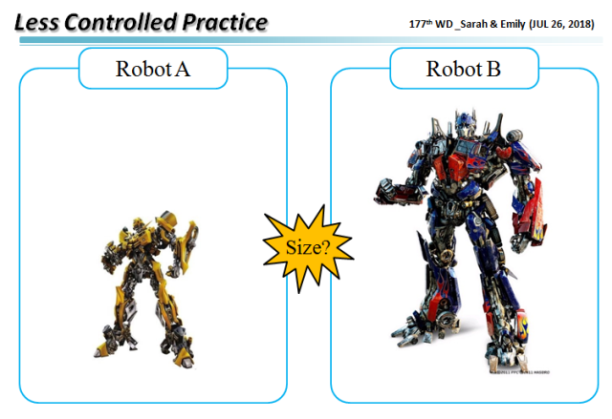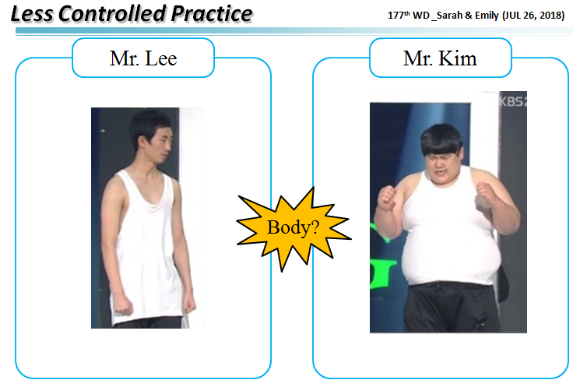

**Example**

3

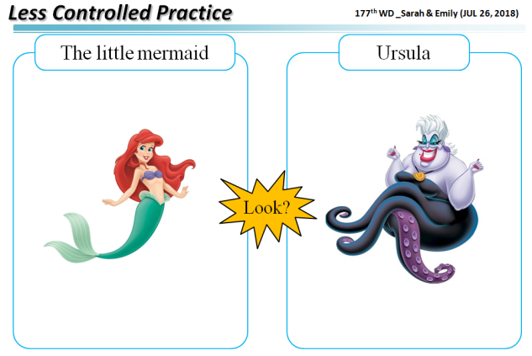 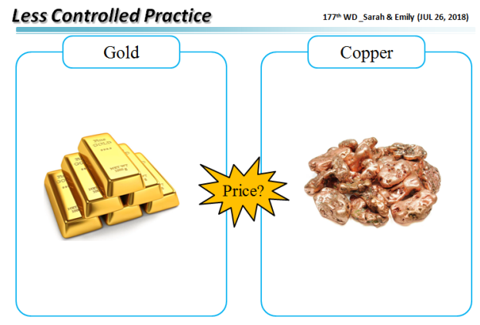

4

1

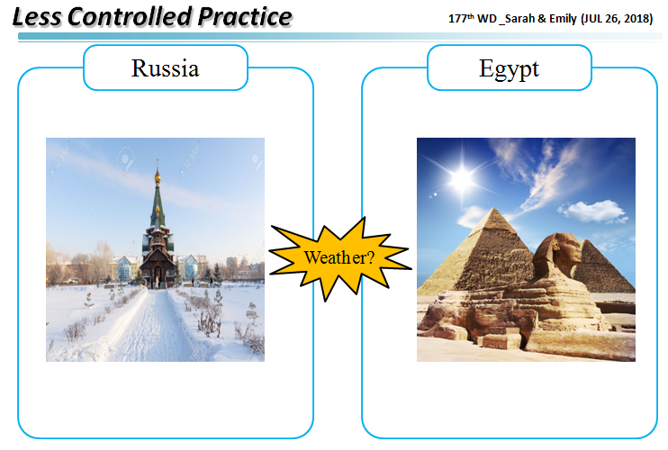 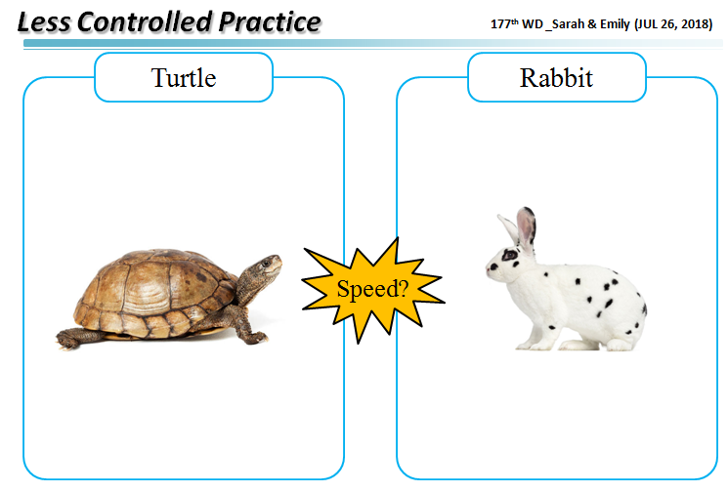

5

2

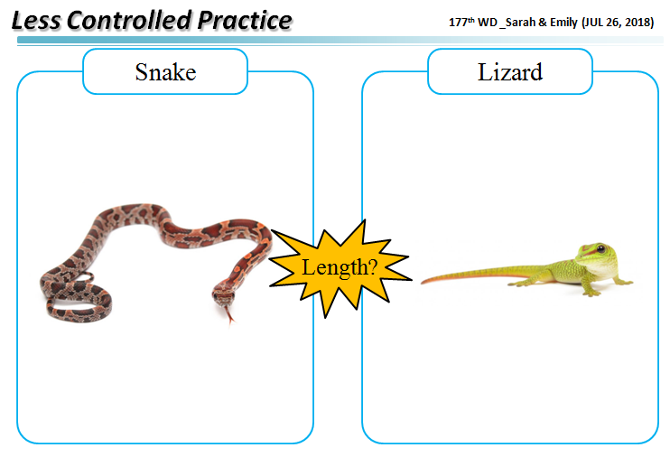 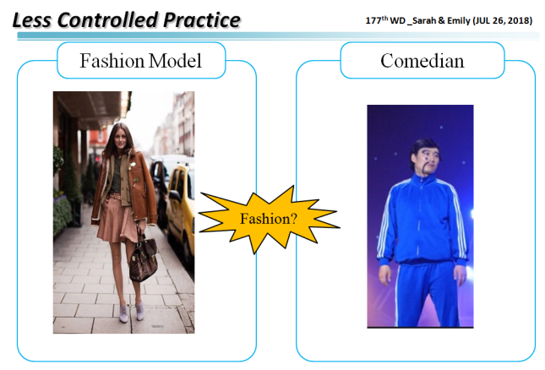 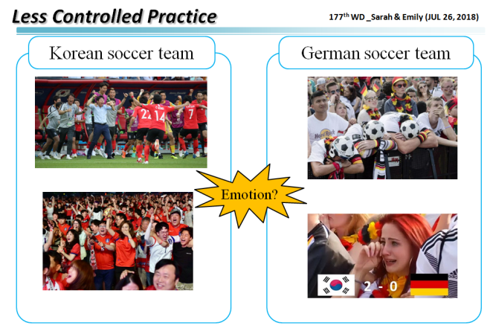 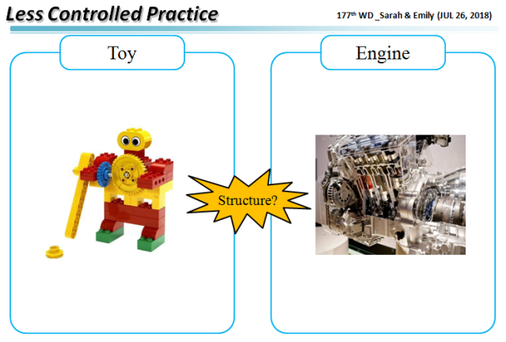

10

9

6

7

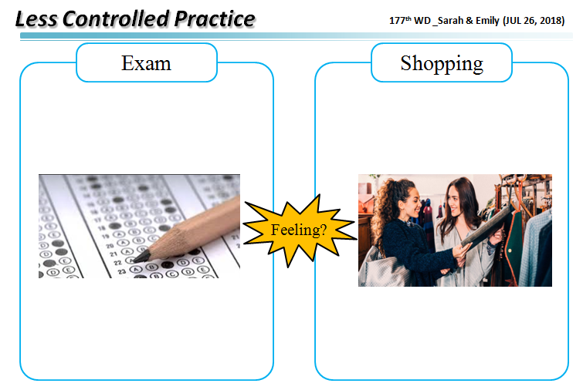

8

* Less-Controlled Practice **ANSWER KEY**

**Example**

Robot A is smaller than Robot B.

Robot B is bigger than Robot A.

**1. The little mermaid vs Witch**

The little mermaid is more beautiful than the witch.

The witch is less beautiful than the little mermaid.

**2. Mr.Lee vs Mr.Kim**

Mr.Lee is thinner than Mr.Kim.

Mr.Kim is fatter than Mr.Lee.

**3. Russia vs Egypt**

Russia is colder than Egypt.

Egypt is hotter than Russia.

**4. Gold vs Copper**

Gold is more expensive than copper.

Copper is cheaper than gold.

**5. Turtle vs Rabbit**

The turtle is slower than the rabbit.

The rabbit is faster than the turtle.

**6. Snake vs Lizard**

The snake is longer than the lizard.

The lizard is shorter than the snake.

**7. Korean vs German**

Korean is happier than German.

German is sadder than Korean.

**8. Math vs Shopping**

Shopping is more interesting than math.

Math is less interesting than shopping.

**9. Robert vs Brad**

Brad is more famous than Robert.

Robert is less famous than Brad.

**10. Toy vs Engine**

The toy is simpler than the engine.

The engine is more complicated than the toy.

* **Worksheet #2 - SOS Activity**

**★Instruction: Find the mistakes.**

1. The singer is more famous then the actor.

2. A picnic is excitinger than homework.

3. His drawing is more bad than my drawing.

4. Coffee isn’t good than milk.

5. Paul and Smith are more young than me.

6. His cookies aren’t deliciouser than my cookies.

7. Alaska is cold than Africa.

8. The used car was cheap than the new car.

* **Worksheet #2 - SOS Activity ANSWER KEY**

**★Instruction: Find the mistakes.**

1. The singer is more famous then the actor.

-> The singer is more famous **than** the actor.

2. A picnic is excitinger than homework.

-> A picnic is **more exciting** than homework.

3. His drawing is more bad than my drawing.

-> His drawing is **worse** than my drawing.

4. Coffee isn’t good than milk.

-> Coffee isn’t **better** than milk.

5. Paul and Smith are more young than me.

-> Paul and Smith are **younger** than me.

6. His cookies aren’t deliciouser than my cookies.

-> His cookies aren’t **more delicious** than my cookies.

7. The used car was cheap than the new car.

-> The used car was **cheaper** than the new car

8. John has much more money than Peter.

-> John has **more** money than Peter.