Grammar Lesson Plan- PPP Approach

☐ Listening ☐ Speaking ☐ Reading v Grammar ☐ Writing

Topic: There is / are

Instructor:  Lee, DongChan (Chan)  Jung, Juil (Tony) | Level:  Intermediate | Students:  10 | Length:  45 Minutes

Materials: worksheet #1, #2, #3
PPT slide, Yut Board, Yut sticks, black counters, white counters.
worksheet for grammar battleship

Aims:
Students will be able to identify there is / are ~ expression.
Students will be able to speak by using there is / are ~ expression.

Language Skills:
Listening: Students can listen to conversation with script and listen to drill practice.
Speaking: Students can practice drill by using there is ~ / there are~.and perform the role play
Reading: Students can read the script and read the discrete sentences with there is~ and there are ~.
Writing: Students can write the script for role play.

Language Systems:
Lexis: Noun words to make the sentences related to there is ~ / there are ~.
Grammar: The expression by using there is ~ and there are ~.
Function: Asking for existence for the objects.
Discourse: Situational conversation on park, shopping center, museum.

Assumptions:
Students already know
- How to do role-play.
- They practice dialogue script for roleplay.
Students don’t know
- The distinction between singular and plural form by using there is~ and there are~ expression.
- How to play a board game because it is the new game and they are not familiar.

Anticipated Errors and Solutions:
- If students make some mistakes on using singular form and plural form for expression, there is ~ and there are~.
- I will teach them how to distinguish the singular form and plural form.
- If students don’t know how to solve questions on worksheet.
- I will help them to work it out.
- If students are shy to talk,
- I will encourage them to speak with confidence and to take risks with not being afraid to make mistakes while speaking.
- If students don’t know how to play a board game.
- I will explain to students with how to play it and use ICQ with various context.

References:
박용호. (2012). 라이언 샘, 이렇게 가르쳐서 영어수업 대박내다2 활동편. 도서출판 성우.

Lead-In
Materials: None
Time | Set Up | Student Activity | Teacher Talk
3min | Whole class | Greeting  Answering Questions | Procedure:  “Hello everyone! How are you?  Did you have breakfast? Was it good?  I hope everyone enjoyed breakfast.”  Do you have plan to visit your friend’s or grandparents’ house or your family’s house?  S: I will go to my parent’s house.  “What about you guys?  Do you have any plan to visit your family members for this weekend?  Tell us who you're going to visit.”  (Elicit each students ideas)  “Good job. I hope you have nice visiting your friend’s or grand parents’ house or your family’s members’ house.”

Pre-Activity
Materials: PPT slide
Time | Set Up | Student Activity | Teacher Talk
5 min  3 min  1 min  1 min | Whole class  Whole class  Whole class  Individual wrok | Introduce topic  visiting a house.  Show the structure of the house.  Write down what Ss answer.  Elicit the grammatical structure by using “There is ~ or there are~”  Show the kitchen.  Show the table.  Explain the definition of “There is / are~” by using object such as apple  Show the substitution table  Match the words into right order. | “Have you been invited to your friend’s house?  “Let’s look at the picture. What can you see in your friend’s house?”  “Good. A tree. A sofa, a refrigerator. A dog house.”.  “How can you say by sing sentence?”  Good job. We can say, “There is a tree.”  “Now we are in the kitchen to be ready to have dinner at your friend’s house.”  “How can you say by using “There is~.?”  “Well done. There is a spoon on the table.”  “Now we are at the table for dessert.”  “What can you see on the table?”  “Good job. How can you say by using There is~.?”  “I show an apple to you. We can say there is an apple when you want to show the existence of object.”  “When we say there is~, it refers to an item.”  “When we say there are ~, it refers to more than two items.”  “This is substitution table using there is~ and there are~. As you can see, there is an item, you can say there is an apple on the table. There is a tree in the garden. There is a window in the room.”  “On the other hands, when we say there are items, you can say there are apples on the table. There are trees in the garden. There are windows in the room.”  You can find out the difference between there is and there are. When you say there is, you can find an item named singular form. When you say there are, you can find more than two items named plural form.  “We have words that are not right order. Now we are going to say the right order of the words. Is there volunteer to answer the right sentence by using there is~?”  “Good Job. Now, we are going to answer another sentence by using there are~.” Is there volunteer to answer the right sentence by using there are~?”  Well done. Now we are going to move on to the next activity.”

Main Activity
Materials: worksheet #1, #2, #3
PPT slide, Yut Board, Yut sticks, black counters, white counters.
Time | Set Up | Student Activity | Teacher Talk
7 min | Whole class  Pair work | 1. Controlled Practice  Hand out worksheet # 2  Ss will solve the grammar worksheet  SS shoud complete the sentences.  Ask for help if they need help.  Monitor and correct Ss if they make errors.  2. Free Practice  hand out worksheet # 3  SS should complete the sentences  4mins  Free practice  Ss explain that made sentences  3. Less controlled Practice  Announce that students are going to play a game.  Arrange pair.  Show the PPT slide of playing Yut board.  Explain to Ss how to play the Yut game.  Ass Ss to speak the expression, “There is ~. There are~.”  Ask Ss if they have questions when they don’t know how to play by using ICQ(Instruction checking question).  Go around and help students.  Tell students that the game is finished.  Ask Ss who the winner of each pait for the game is.  Ask Ss to praise the winners.  4.Dialogue Drilling  (Controlled Practice)  Introduce the dialogues.  Listen to T’s introduction.  Hand out worksheet # 1 | “next, this is to solve the puestion using “there is”, “there are”  (distribute worksheet #2 )  Choose the correct answer individually. I will give you 2 minutes.  Let’s start!”  ICQ  How much time do you have?  Are you working alone?  Have you all finished?  Times up!  “Now, We are going to do a real practice.  (distribute worksheet #3)  We’ll divide group 3, to work together  “Write down the sentences in different situation by each team using “there is”, “there are”  A team is acting in a park,  B team is acting in a shopping center  C team is acting in a museum  Write down 3 different types sentences. It’s statement (regular) sentence, question sentence, and negative sentence containing “there is” by each group.  Now, practice with a group.  I’ll give you 4 min.  Let’s start!  ICQ  How much time do you have?  What do you do?  Monitor and correct Ss if they make errors.  Times up!  Let’s talk about how each group made sentences.  So, let’ start with A team!  Good job! You got all excellent sentences.  ICQ  Do you work in pair?  How much time can you play?  Can you understand what the basic patterns are?  “This time, We are going to learn a conversation using “there is”, “there are”  (distribute the dialogue)  We’ll divided group of a pair at class to work together.  Now, practice with a pair.  I’ll give you 2 min.  Let’s start!”  ICQ  How much time do you have?  Are you working alone?  Monitor and correct Ss if they make errors.  Times up!

Post Activity
Materials: PPT slide
Time | Set Up | Student Activity | Teacher Talk
2 min  1 min  1 min | Whole class  Whole class  Whole class | 1. Error correction  After monitoring students’ error while activities and correct Ss’ errors in the whole class.  2. Feedback  Make the feedback for the class.  3. Conclusion  Make the conclusion for the class. | You are well done for our activities.  I found that you made the errors  by making that expression like  there is chairs..”  “We can say that there is a chair when we say by using an item. When we say with more than two items, you can say there are chairs.”  “Good job. Everyone. How was the class? Did you improve there is ~ and there are ~ expression? I hope you recognize how to use there is ~ and there are ~ expression properly.”  Now, we are going to wrap up our class. Do you have questions for this lesson? I hope you have a nice day. I hope you will meet your friend’s house or your family’s house.” If you have a chance to use there is ~ / there are ~ expression. You can use it to your friends. For example, there is a hamburger on the table..”

SOS Activity
Materials: PPT Slide, worksheet for grammar battleship
Time | Set Up | Student Activity | Teacher Talk
7 min | Team work | Grammar Battleship Game  Announce Ss for grammar battleship game.  Announce that Ss need to take quiz related to there is / are.expression.  Explain how to play the game.  Assign Ss into 2 teams made of each 5 students.  Present 5 questions related to there is / are~.  Ask Ss to find where the incorrect word is.  Show the correct word to Ss. | “Now we are going to play  Grammar Battleship Game.  This is the game you need to  find where is the incorrect part on  the sentences.”  You are going to make up 2 teams  with each 5 students on one team.  “Please, put the 5 ships anywhere  on the grid by shading three  squares vertically or horizontally  for each battleship. You cannot  position your battleship diagonally.  When I show the PPT slide  with sentences, please, find  erroneous part, then answer it  as quickly as possible.”  “The first team which finds the  error have the right to attach other ship  by calling out a grid code to launch  5 missiles at a time. If you hit your  Opponent’s ship, other team say  that you are right. If you miss the  grid, you can say that you miss it.”  “The team that sinks the most ships  will win this game.”  ICQ  How do you play the game?  Do you answer it first or second  to have the right to launch missiles?  How many missile can you launch at  a time?

Main activity Worksheet #1

□ Dialogues : Using “There is”, “There are” expression

- Situations #1
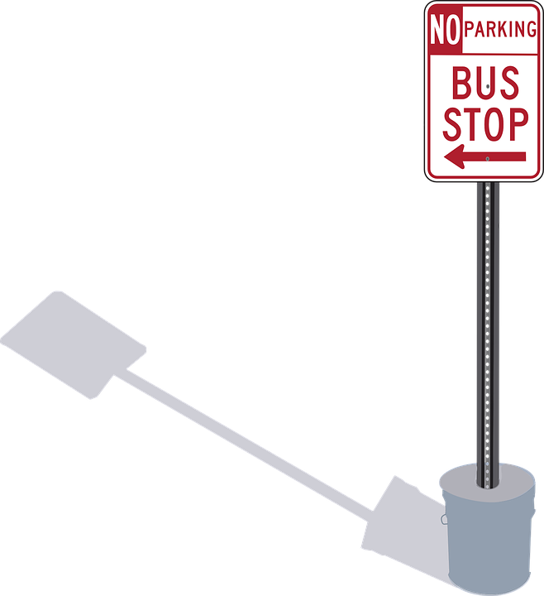
A : Can I ask you something?
B : Yes, sure. What is it?
A : Is there a bus stop around here?
B : Yes, it’s right next to that building

- Situations #2
A : We have to get the car fixed.
B : How much will it cost?
A : I’m told it will be 50 dollars or more?
B : That’s much? Are there many bills to pay this month?
A : I don’t know. Let’s buy a lottery ticket.
B : No. There are lots of lottery tickets that we bought before.
Main activity Worksheet #2

□ Solving : Using “There is”, “There are” expression

Complete the sentences and Fill in the blanks with an appropriate types.
- A lot of money is in the drawer
→ There _____________________________________
- Many pupils are in class
→ There _____________________________________
- TV sets are in the shop
→ There _____________________________________
- A fish is in the green bowl
→ There _____________________________________
- Many friends are with me
→ There _____________________________________
- There _______ a very big tree near my house
- There _______ two women there
- There _______many tall buildings in Seoul
- There _______ some milk in the glass.
- _____ there any good news ?

Board Game for Less controlled

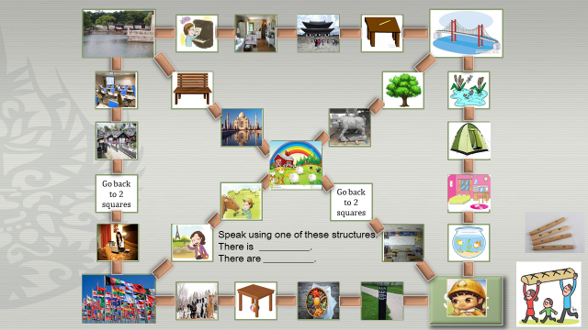

□ Free Practice : Using “There is”, “There are” expression
(A team : in a park, B team : in a shopping center, C team : in a museum)

A Team | ㅇ statement  ㅇ negative  ㅇ question
B Team |  | ㅇ statement  ㅇ negative  ㅇ question
C Team |  | ㅇ statement  ㅇ negative  ㅇ question

