☐ Listening ☐ Speaking ■ Reading ☐ Grammar ☐ Writing

Topic: Driverless Cars Coming Soon

Instructor:  Emily Kwon (Youyoung) | Level:  Intermediate | Students:  10 students | Length:  30-35 Minutes

Materials:
● White board and board markers
● Worksheet #1 - New Vocabulary (10 copies)
● Worksheet #2 - Comprehension Questions for Main Idea (10 copies)
● Worksheet #3 - Comprehension Questions for Details (10 copies)
● Worksheet #4 - Drawing worksheet (10 copies)
● Worksheet #5 - SOS worksheet (10 copies)

Aims:
- Main Aim: Ss will develop their reading skills by skimming and scanning of reading passage and solving comprehension questions.
- Secondary aim: Ss will be able to write and speak about their dream cars by sharing their own ideas with classmates.
- Personal aim: I would like to give Ss clear instructions and provide them fun activities.

Language Skills:
- Reading: Ss will read the definition of the words and reading passage.
- Listening: Ss will listen to teacher’s instructions
- Speaking: Ss will discuss about the main idea and comprehensive questions.
- Writing: Ss will write the correct words in the underlined area. (worksheets)

Language Systems:
- Lexis: New vocabularies in the worksheet
(radar, hacker, vehicle, parallel, driverless, automated, slipping, etc.)
- Function: Giving Information
- Discourse: Reading the article

Assumptions:
Students already know
- What skimming and scanning are
- The basic knowledge about the cars
- Their discussion groups and partners

Anticipated Errors and Solutions:
- If students are hesitant to speak out loud about their thoughts,
- Encourage them to speak freely and give some advice
- If some students need more time for each work,
- Give them an extra minute or make other students who finished early to helped them
- If certain students dominate the talking time,
- Make Ss to take turns when answering questions.

References:
- Reading passage and comprehension questions:
https://www.englishclub.com/reading/driverless-cars.htm
- SOS Worksheets:
https://quickworksheets.net/

Lead-In
Materials: None

Time | Set Up | Student Activity | Teacher Talk
1 min | Whole class | Answering teacher’s questions | Good afternoon, everyone! What kinds of transportation do you usually use when you spend time with you family? Does anyone have driving experiences by cars? Personally, I love going to the new places by driving a car.

Pre-Activity
Materials: Board, markers, worksheet #1 (10 copies)

Time | Set Up | Student Activity | Teacher Talk
1 min  2 min  3 min  1 min | Pairs  Whole  Class  Individually  Whole  Class | Answering teacher’s questions and students talk each other.  Answering teacher’s questions  Students complete the worksheet#1  Students check answers | - Spark Interest/ Introduce the topic  How many of you have experienced riding a car before? If you can’t drive, who usually drives for you? What was the most difficult part when you learned how to drive? Share your driving experiences with your partner. You have 1 minute.  - ICQ  Are you working alone?  How much time do you have?  Let’s talk about this in whole class.  (Board numbers and answers)  How many of you can drive a car?  What is the longest time you have driven before? What were some factors you felt difficult in driving?  How do you feel when you drive for long time or when you are in the car for the long time?  Can anyone guess today’s topic? Today’s topic is “Driverless Cars Coming Soon.”  (Write the topic on the board.)  - Pre-teach Vocabulary  Instruction  Before we read the text, let’s learn some new vocabulary.  (Hand out worksheet#1)  Demonstration  Let’s solve the first word together.  Look the first definition. Can anyone guess what the definition is describing? “Yes, it’s hacker.” I will give you 3 minutes to solve them all, work on your own.  Please try to match the words with the its definitions. If you are having trouble, you can use dictionary.  ICQ  What do you do with the words?  Can you use dictionary?  Are you working alone?  How much time do you have?  Monitoring  (Give time warning) You have 1 minute left.  Time’s up  Check answers  It is time to check the answers together.  After checked, give a compliment.

Main Activity
Materials: Worksheet #2, #3, and #4 (10 copies each)

Time | Set Up | Student Activity | Teacher Talk
4 min  2 min  1 min  4 min  1 min  5 min  4 min | Individually  Pairs  Whole class  Paris  Whole  class  Individually  Whole Class | Students read the text for main idea.  Working on the worksheet #2  Check answers  Working on the worksheet #3  Students complete worksheet #4  Students present their ideas. | - Skimming for Main idea  It’s time to read today’s text. I’ll give you worksheets.  (Hand out the worksheet #2)  This time, you want to read the passage to find out the main idea. You have 4 minutes to skim the text. Read the text alone.  ICQ  Do you work with your partner?  How much time do you have?  (Monitoring and Give time warning) Time is up.  Now, please work on the  worksheet in front of you with your  partners. You have 2 min.  ICQ  Do you work with your partner?  How much time do you have?  Let’s check answers together.  - Scanning for Details  Instruction  Now, let’s read again for the details.  (Hand out Worksheet #3)  This time, scan the text and find .  the answers to the questions on the worksheet #3. You will do the worksheet on your own first, and check with your partner after. I will give you 4 minutes.  ICQ  What do you do?  When are you working in pairs?  (Monitor and time warning)  Check answers  Let’s check answers together. Great job everyone  - Free Production  Instruction  Okay everyone, now we will be working alone for some fun activity.  (Handout Worksheet #4)  Pretend you are a future car maker or designer. On the worksheet provided, please draw your own dream car and name your car after drawing. Also, write down 5 key features of your own car. Features can vary as its color, shape, technology, target market, and etc. We will present to the class after the activity.  Demonstration  Here is an example of mine. (Show prepared picture.)  I will give you 5 minutes.  ICQ  How much time will you have?  Do we present after the activity?  Ok, start.  Monitoring  (Walk around and check if everyone is following the instructions)  (Give time warning)  You have one minute left.  (If some students need more time, give them more time and give SOS activity to those who finished early.)  Presentation  It’s time to present to the class. Do we have any volunteers? (If no, take turns)  (Write down errors when they are presenting)  Great ideas. Good job everyone.

Post Activity
Materials: White board and board Marker

Time | Set Up | Student Activity |  | Teacher Talk
1 min  1 min  1 min | Whole class  Whole class  Whole class | Students listen and answer questions  Students listen and answer questions  Students listen and ask questions & answers |  | - Error Correction  (If there’s any, fix grammatical and pronunciation that students made, and correct them)  - Feedback  How did you feel about the text?  Do you have any questions?  - Conclusion  (Conclude today’s lesson by checking key vocabularies, and their understanding of the topic)  I appreciated your great participation today and everyone did a very good job. Let’s look forward seeing the driverless cars soon in our town.
SOS Activity
Materials: Wordsearch worksheet (10 copies)

Time | Set Up |  | Student Activity |  | Teacher Talk
3 min  1 min  1 min | Individual |  | Students complete the worksheet  Students check their answers with partners.  Student listen to teacher |  | - Wordsearch Game  Instruction  We are going to play the Wordsearch Game using the vocabularies we learned today.  (Hand out worksheet)  In the lettered box, you are to find out 7 words presented in the bottom on your own. You can make circles as you find the word listed. Words can be shown in a shape of horizontal, vertical and diagonal but orders are not in backwards. You have 3 mins.  ICQ  How many words are you finding?  Are you working in a group?  How much time will you get?  (After 2 minutes with time warning)  Okay, Please check your answers with your partners.  Review  Does anyone have questions?  Good Work everyone!

- Worksheet #1
Vocabulary Preview
- Fill in the blank: Write the correct word for its definition.
radar hacker vehicle parallel driverless

- : a person who breaks into a network, computer, file, etc., usually with malicious intent

- : a transportation moving on wheels, runners, tracks, or the like, as a cart, sled, automobile, or tractor.

- : a device for determining the presence and location of an object by measuring the time for the echo of a radio wave to return from it and the direction from which it returns.

- : not having a human driver in control

- : extending in the same direction, equidistant at all points, and never meeting no matter how far extended

- Circle all words that mean the same(synonym) as the underlined word.

- Automated:
Motorized Programmed Championed Computerized

- Slipping:
Sleeping Sliding Relaxing Losing balance

- Worksheet #1 (ANSWER KEY)
Vocabulary Preview
- Fill in the blank: Write the correct word for its definition.
radar hacker vehicle parallel driverless

a. hacker : a person who breaks into a network, computer, file, etc., usually with malicious intent

b. vehicle : a transportation moving on wheels, runners, tracks, or the like, as a cart, sled, automobile, or tractor.

c. radar : a device for determining the presence and location of an object by measuring the time for the echo of a radio wave to return from it and the direction from which it returns.

d. driverless : not having a human driver in control

e. parallel : extending in the same direction, equidistant at all points, and never meeting no matter how far extended

- Circle all words that mean the same(synonym) as the underlined word.

- Automated:
Motorized Programmed Championed Computerized

- Slipping:
Sleeping Sliding Relaxing Losing balance

Driverless Cars Coming Soon
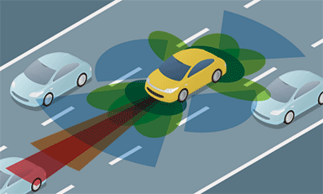
Car makers and others are already testing driverless cars or AVs (automated vehicles) in the U.S. and other countries. Some companies are working together on driverless technology. Intel (USA) is working with BMW (Germany) and Mobileye (Israel) on a driverless car. Google (USA) and Nissan (Japan) are making their own driverless cars. In the U.S. car makers can test AVs in Florida, California, Nevada, and the District of Columbia. Driverless cars may be for sale by 2025!
Google’s name for its driverless system is “chauffeur.” It’s a good name because a chauffeur is a person who drives your car and takes you places. Google’s chauffeur system drives your car and takes you places, but it is not a person! The Google chauffeur system takes the place of the human chauffeur.
Most cars already have some driverless technology like the Anti-Lock Braking System (ABS). When a car is slipping on an icy road, the ABS can tap the brakes quickly. Many cars also have parallel parking technology. These cars can park themselves along a street. No driver is needed. As cars get more driverless technology, they will be safer than cars with a driver.
A driverless car can see the road better than people with the help of radar, cameras, and lasers. Radar helps the car see things up to 100 meters away even in darkness or rain. There are some problems with AVs. Hackers may take over the car. There will probably be fewer jobs for people who drive taxis and trucks. In the future, both vehicles with drivers and vehicles without drivers may share the road. You will have a choice. You can be the driver of your car, or you can look out the window while the car drives you.

- Worksheet #2

Reading Comprehension Questions for Main Idea

- True or False

- Most cars today have some driverless technology (T / F)

- You may not be able to buy a driverless car in 10 years (T / F)

- Car makers are already testing driverless cars or AVs (automated vehicles) in the U.S. and other countries. (T / F)

- What is the name of Google’s driverless system?

- Driven
- Chauffeur
- Balloon
- Lacer

- Worksheet #2 (Answer Key)

Reading Comprehension Questions for Main Idea

- True or False

- Most cars today have some driverless technology (T / F)

- You may not be able to buy a driverless car in 10 years (T / F)

- Car makers are already testing driverless cars or AVs (automated vehicles) in the U.S. and other countries. (T / F)

- What is the name of Google’s driverless system?

- Driven
- Chauffeur
- Balloon
- Lacer

- Worksheet #3

Reading Comprehension Questions for Details

1. Thanks to _______ , AVs can see up to 100 meters away even at night.
a. ABS
b. radar
c. phones

2. AVs could be taken over by
a. Goolge
b. hackers
c. drivers

3. What does the underlined part mean?
a. A driverless car is harmful.
b. A driverless car will fight with the real drivers
c. A driverless car may cause unexpected problems.
d. A driverless car is not realistic.

4. Would you like to ride in a driverless car? Explain why or why not.

5. New technology makes new jobs and takes away old jobs. What old jobs may driverless technology take away? What new jobs may be created by automated vehicles?

- Worksheet #3 (Answer Key)

Reading Comprehension Questions for Details

1. Thanks to _______ , AVs can see up to 100 meters away even at night.
a. ABS
b. radar
c. phones

2. AVs could be taken over by
a. Goolge
b. hackers
c. drivers

3. What does the underlined part mean?
a. A driverless car is harmful.
b. A driverless car will fight with the real drivers
c. A driverless car may cause unexpected problems.
d. A driverless car is not realistic.

4. Would you like to ride in a driverless car? Explain why or why not.

5. New technology makes new jobs and takes away old jobs. What old jobs may driverless technology take away? What new jobs may be created by automated vehicles?

- Worksheet #4
- Draw your own dream car

- Name your car:

- List 5 key features:

- SOS Activity
Wordsearch Activity
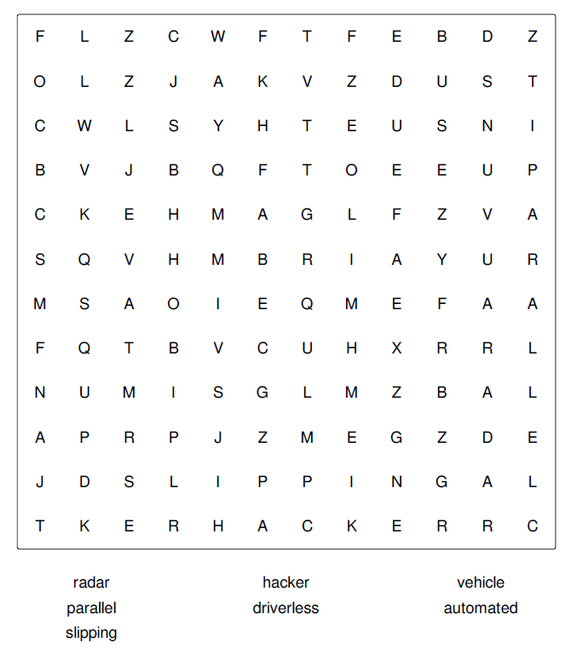

- SOS Activity (Answer Key)

