☐ Listening ☐ Speaking ☐ Reading ☐ Grammar ☐ Writing

Topic: The Story of McDonald’s

Instructor:  Lizzie Noh | Level:  Pre-intermediate | Students:  12 | Length:  40 Minutes

Materials:
〮 White board, markers, colored pens & crayons
〮 12copies of the reading text “The story of McDonald’s”
〮 12copies of the worksheet #1 for pre-teaching vocabulary
〮 12copies of the worksheet #2 for finding main idea
〮 12copies of the worksheet #3 for finding details
〮 12copies of the worksheet #4 for free production
〮 SOS activity worksheet

Aims:
〮 Main aim : Students will develop intensive reading skill by answering questions to find the main idea and detailed information.
〮 Secondary aim : Students will be able to learn about ‘The story of McDonald’s’
〮 Personal aim :
- I want my students to make their own burger.
- I want to give my students simple and clear instructions

Language Skills:
〮 Speaking : Answering the guiding question and partner discussion in free production
〮 Listening : The teacher’s explanation about new vocabulary and listening to teacher’s instruction
〮 Reading : matching worksheet, reading text to find main idea, detailed information
〮 Writing : answering worksheet, making own burger on the paper

Language Systems:
〮 Lexis : The meaning of new words. (one billion, counter, daily, one million, no longer, simple, soda, successful)
〮 Phonology : Pronunciation of new vocabulary words.
〮 Function : Making a new burger

Assumptions:
〮 Students know what skimming and scanning are.
〮 Students have visited McDonald’s before.

Anticipated Errors and Solutions:
〮 If students need more time to finish their activities
- Be flexible with the time and give them more time to finish their activity.
〮 If some students finish their worksheets or a task earlier than others
- Give them SOS activity sheet (If not used in the class, give it to students as homework)
〮 If students do not know some words
Explain the meanings of the words to the students.

References:
https://www.allthingstopics.com/fast-food.html

Lead-In
Materials: None
Time | Set Up | Student Activity | Teacher Talk
1min | Whole class | Answering the teacher’s questions | Good morning, everyone! How are you today?  Do you like McDonald’s?  How often do you visit?

Pre-Activity
Materials: Board, Markers, Worksheet#1
Time | Set Up | Student Activity | Teacher Talk
2mins  2mins  3mins | Pairs  Individually | Talking about the guiding questions with the partner.  Answering the teacher’s questions.  Working on the worksheet #1 | - Prediction  Why do you think McDonald’s is so popular in so many countries? Talk about this with your partner.  I’ll give you 2minutes.  ICQ  Are you working alone?  What are you going to do?  How much time do you have?  (After 2 mins…)  Times up.  Now we will talk about this whole class. What do you think about the question?  Since when did people start eating hamburgers?  Can you guess today’s topic?  (Write the topic on the board)  Today’s topic is “The story of McDonald’s”  - Pre-teaching Vocabulary  Before we read the text, let’s learn some new vocabularies.  Let me give you worksheet #1.  Instruction  You’ll preview words by matching the words on the left with the meanings on the right. Work alone.  I’ll give you 3 minutes for this activity.  Demonstration  For example, Read the meaning of A together. Which word can match with A? Right, “Daily”. Like this match the words.  ICQ  Are you working alone?  What are you going to do?  How much time do you have?  Let’s get started!  Monitoring  (Monitoring discreetly)  Give time warning :  30seconds left.  Time’s up  Check Answers  Let’s check answers together.  What did you get for number 2?  Good job class. Repeat after me.

Main Activity
Materials: Worksheet #2, #3, #4, reading text
Time | Set Up | Student Activity | Teacher Talk
3min  2mins  1min  3mins  1min  5min  3mins | Individually  Individually  Whole class  Individually, Pairs  Whole class  Pairs or  Group  Whole class | Read the text for main idea.  Checking the answers  Checking the answer  Working on the worksheet#4 | - Skimming for the main idea  It’s time to read today’s text. I’ll give you worksheet. This time, you will skim the text to find the main idea. You have 3minutes. Work alone.  (Hand out worksheet #2)  ICQ  Are you working alone?  How much time do you have?  What will you do?  Monitoring  (Monitoring discreetly)  Give time warning :  30seconds left.  Ok, Time’s up!  Find the answers on the worksheet#2. Work alone and you’ll have 2 minutes.  ICQ  Are you working in pairs?  How much time do you have?  Monitoring  (Monitoring discreetly)  Give time warning :  30seconds left.  Check Answers  Let’s check the answers together. What’s the answer for number 1?  - Scanning for details  (Hand out worksheet #3)  This time, scan the text and find the answers to the questions on the worksheet#3. You will do this alone and then check with your partner. I’ll give you 3 minutes.  ICQ  What do you do now?  Are you scanning in pairs?  How much time do you have?  Monitoring  (Monitoring discreetly)  Give time warning :  30seconds left.  (If students need more time, give them 30seconds more.)  Check Answers  Let’s check the answers together.  What’s the answer for number1?  - Free production  (Hand out worksheet #4)  Instruction  Now let’s do fun activity. We’ll make our own burger.  You will work with your partner. In pairs make one burger.  In the paper, draw the burger and write the name of it.  And then, one of the representatives of each group will make the presentation.  You can use crayon or pen.  I will give you 5 minutes.  Demonstration  For example I made a ‘lamb burger’.  I will have lamb instead of beef of chicken with barbecue sauce.  ICQ  What do you do?  Are you working alone?  How much time do you have?  Let’s get it started!  Monitoring  (Monitoring discreetly)  Give time warning :  1minute left.  (If students need more time, give them 1minute more.)  Times up.  Who wants to start first?  (Go through all pairs)  Everyone did great job!

Post Activity
Materials: White board and markers

Time | Set Up | Student Activity | Teacher Talk
2mins | Whole class | Trying to self-correct their errors. | - Error correction  Before wrapping up today’s lesson, we’ll review some errors.  (Board sentences with errors and ask students to try to self-correct first, and then let them know the correct sentences)  - Feedback  Did you have fun today?  How did you feel the activities?  - Conclusion  You guys were great today. I’m so proud of you. Please review the words you learn today.  Have a good day!

SOS Activity
Materials: SOS activity worksheet
Time | Set Up | Student Activity | Teacher Talk
3mins | Those who finished earlier | Working on the extra activity | Instruction  You finished the activity early.  While waiting for other pairs to finish it, fill in the blank. You will review the reading text with this.  Work alone. I’ll give 3mins.  Demonstration  First, Let’s try number1 together. What do you think for number one? Yes, it’s a ‘serve’  ICQ  Are you working in pairs?  How much time do you have?  Monitoring  (Monitoring discreetly)  Give time warning :  30seconds left.  Check answers  Ok, I can see everyone finished. Let check the answers together. I’m going to say the numbers, and you will tell me the answers all together.  Number 2…….  (Students answer)  Alright, you did great job!

The Story of McDonald’s
There are many restaurants in the world, but probably the most famous is McDonald’s. McDonald’s has more than 34,000 restaurants around the world in 119 countries, and they serve about 68 million customers every day.
The story of McDonald’s began in 1940 when two brothers, Richard and Maurice (‘Mac’) McDonald opened a new restaurant called ‘McDonald’s Famous Barbeque’. It was a successful business, but the brothers wanted to sell more food and make more money, so in 1948 they made some changes. For example, they tried a new way to cook and serve food faster – and McDonald’s became one of the first fast food restaurants in the world. In addition, they made the menu more simple: hamburgers, cheeseburger(s), sodas, and milkshakes.
There were no longer any waitress to serve food, so customers ordered food by themselves at a counter. In 1954, a man called Ray Kroc joined the company and later bought it for 2.7 million dollars. The company is now worth many billions of dollars. There is a McDonald’s museum that is located in San Bernardino, California where the first McDonald’s was built. It’s open daily from 10:00 am to 5:00 pm.

Worksheet #1 - vocabulary worksheet
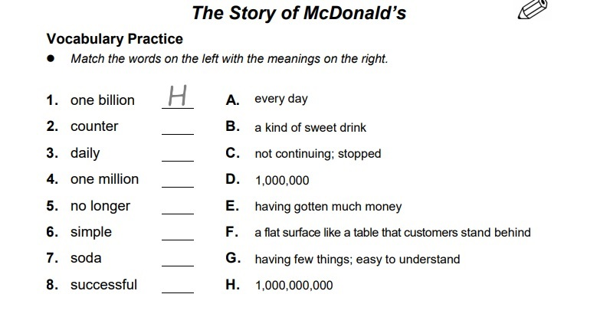

Worksheet #2

Reading Comprehension Questions for Main Idea

- What is the main idea for the passage?
- How to make hamburger
- Differences between McDonald’s and burger king
- What’s your favorite fast food?
- The history of McDonald’s

- Write ‘T’ (True) or ‘F’ (False) next to each statement.

a. The paragraph is about hamburgers (T/F).

b. There are about 119 McDonald’s restaurants around the world. (T/F)

c. Almost 70 million people eat McDonald’s food every day. (T/F)

d. There are not many kinds of food on the McDonald’s menu. (T/F)

e. Ray Kroc later bought the company for 2.7 billion dollars. (T/F)

- There is a McDonald’s museum in the United States.(T/F)

Worksheet #3

Reading Comprehension Questions for Details

- According to passage, why McDonald’s made change in 1948?
- They wanted to open a new restaurant.
- They wanted to sell more food and make more money
- Because their restaurant went bankrupt
- Because the customers didn’t like the food

- According to passage, why McDonald’s museum was built in San Bernardino California?
- Because San Bernardino is one of the most popular places in the world.
- Because Richard and Maurice wanted to build in San Bernardino.
- Because the first McDonald’s was built in San Bernardino.
- Because there was no other place to build.

- Do you think that which is more convenient?
The machine receiving the food order or The person receiving the food order
Write the reason to support your idea.

Worksheet#4
Draw your own restaurant menu!(only burger) Use your imagination!
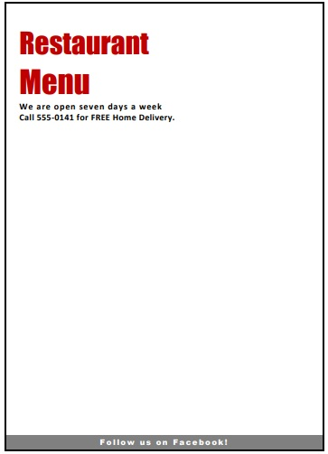
SOS activity
The Story of McDonald’s There are many restaurants in the world, but probably the most famous is McDonald’s. McDonald’s has more than 34,000 restaurants around the world in 119 countries, and they (1)______________ about 68 million (2)______________s every day.
The story of McDonald’s began in 1940 when two brothers, Richard and Maurice (‘Mac’) McDonald opened a new restaurant called ‘McDonald’s Famous Barbeque’.
It was a successful (3)______________, but the brothers wanted to sell more food and make more money, so in 1948 they made some changes. For example, they tried a new way to cook and serve food faster – and McDonald’s became one of the first (4)______________ restaurants in the world.
In addition, they made the (5)______________ more simple: hamburgers, (6)______________s, sodas, and milkshakes. There were no longer any (7)______________es to serve food, so customers (8)______________ed food by themselves at a counter.
In 1954, a man called Ray Kroc joined the company and later bought it for 2.7 million dollars. The company is now worth many billions of dollars. There is a McDonald’s museum that is (9)______________ in San Bernardino, California where the . first McDonald’s was built. It’s (10)______________ daily from 10:00 am to 5:00 pm.

business cheeseburger customer fast food located menu open order serve waitress

Worksheet #1 - vocabulary worksheet (answer key)

1. H
2. F
3. A
4. D
5. C
6. G
7. B
8. E

Worksheet #2 (answer key)

- What is the main idea for the passage? D
a. How to make hamburger
b. Differences between McDonald’s and burger king
- What’s your favorite fast food?
- The history of McDonald’s

- Write ‘T’ (True) or ‘F’ (False) next to each statement.

a. The paragraph is about hamburgers (T/F). F

b. There are about 119 McDonald’s restaurants around the world. (T/F) F

c. Almost 70 million people eat McDonald’s food every day. (T/F) T

d. There are not many kinds of food on the McDonald’s menu. (T/F) T

e. Ray Kroc later bought the company for 2.7 billion dollars. (T/F) F

- There is a McDonald’s museum in the United States.(T/F) T

Worksheet #3

Reading Comprehension Questions for Details

- According to passage, why McDonald’s made change in 1948? B
- They wanted to open a new restaurant.
- They wanted to sell more food and make more money
- Because their restaurant went bankrupt
- Because the customers didn’t like the food

- According to passage, why McDonald’s museum was built in San Bernardino California? C
- Because San Bernardino is one of the most popular places in the world.
- Because Richard and Maurice wanted to build in San Bernardino.
- Because the first McDonald’s was built in San Bernardino.
- Because there was no other place to build.

- Do you think that which is more convenient?
The machine receiving the food order or The person receiving the food order
Write the reason to support your idea.
- I think machine is more convenient. Because we can save time and it is easy to use.

SOS activity (answer key)

1. serve
2. customer(s)
3. business
4. fast food
5. menu
6. cheeseburger(s)
7. waitress(es)
8. order(ed)
9. located
10. open

