Reading Lesson Plan

☐ Listening ☐ Speaking ☐ Reading ☐ Grammar ☐ Writing

Topic: Our military

Instructor:  Lee, DongChan (Chan) | Level:  Intermediate | Students:  12 | Length:  35 Minutes

Materials:

White Board, board markers, worksheet #1 Brainstorming
worksheet #2 New vocabulary, worksheet#3 Main idea
worksheet #4 Details, worksheet #5Free production
worksheet #6 Sos activity-1, worksheet #7 Sos activity-2

Aims:

Students will be able to understand about our military organization and specific
Students will be able to speak their opinion about military by debating
Students will be able to improve their reading and speaking ability by reading and
discussing the topic with other students.

Language Skills:

Speaking: Ss will speak sharing their ideas in a group
Listening: Ss will listen to the teacher’s presentation, and classmate’s opinions
Reading: Ss will read the data, information worksheet.
Writing: Ss will write take notes while reading, and discussing with the class

Language Systems:

Lexis: New vocabulary related to military
Phonology: pronunciation of new vocabulary words
Function: pair work, article reading and speaking
Discourse: interaction between students

Assumptions:
Students already know
- Ss have learned about our military at least once in their life
- SS are aware of importance about defense ministry and security
- Ss know how to skim and scan, and can discuss with other students in English.

Anticipated Errors and Solutions:
- Some students may not know much about military
- I will explain the basic background of military
- Some students may not be able to understand the text and have difficulties.
- Give the students extra time, and help the students
- Some students may be finished reading much earlier than other students.
- I will discuss the topic with the finished students, making sure they have
understood

References:
http://www.mnd.go.kr/mbshome/mbs/mnd/
http://dic.daum.net/word/view.do?wordid=eew000015940&q=regime
https://www.google.co.kr/search?source=hp&ei=AE9gW5-RCMXr-QaGgb_YDg&q
https://namu.wiki/w/%EC%84%B8%EA%B3%84%20%EA%B5%B0%

Lead-In
Materials: None
Time | Set Up | Teacher | Student
1min | Whole class | Greeting  Ask what Ss had lunch.  “What did you have for lunch?”  “I hope you had a nice lunch.” | Greeting  Answer what they had lunch.

Pre-Activity
Materials: boards, markers, worksheet #1 Brainstorming, worksheet #2 New vocabulary

Time | Set Up | Teacher | Students
2min.  2min  3min  2min | Pairs  Whole class  Individually  Whole class | 1. Prediction  * Brainstorming  Do you like animal?  Do you know many types of animals in the world?  Who are the most powerful animals in the land, sea, air?  I will give you a worksheet#1.  Discuss about this with your partner.  You have 2minutes  * ICQ  What are you going to do?  Are you doing alone?  How much time do you have?  Now we will talk about this in whole class. Who’s the king of animals in land? Sea? Air?  Do you love our nation and our military? Do you know how is our military organized?  Today’s topic is “Our military”  (Write the topic on the board)  * Pre teaching Vocabulary  Instruction  Before we read the text, let’s learn some new vocabularies.  I will give you a worksheet#2. Find the best match for each question individually.  If you hardly guess the meaning of the word, just raise up your hand then I will work with you.  Now you have 3 minutes.  * ICQ  What are you going to do?  Are you doing alone?  How much time do you have?  Okay, start now.  * Monitoring  Monitor discreetly. Give time warning.  Ask for help if there are any words that can not be guessed.  Time is up.  * Check answers  Let’s check the answers together.  What did you get for number 1?  OK. Good job! | Talking about the questions with the partner.  Working on the worksheet#1  Answering the teacher’s questions.  Answering the teacher’s questions.  Working on the worksheet#2  Listen to T’s introduction.  Ss find the best match.  Practice worksheet individually.  Stop practicing the worksheet  Check answers with T

Main Activity
Materials: Materials, worksheet #3,#4, #5 , Text
Time | Set Up | Teacher | Students
4 min  1min  3min  2min  6min  2min | Individually  Whole class  individually  Whole class  group  Whole class | 1. Skimming for the main idea  It’s time to read the text about military. I’ll give you the text and worksheet #3.  This time after you will read the text, find the main idea and answer the questions.  You have 4 minutes to skim the text.  Read the text alone.  ICQ  How much time do you have?  What should you do?  Are you working alone?  One minute left  Ok, times up!  Let’s check the answers. What’s the answer for number 1?  2. Scanning for details  This time, scan the text and find the answers to the questions on the worksheets#4. You will do this alone. I’ll give you 3 minutes .  ICQ  What do you have to do?  Are you working alone?  How much time do you have?  Monitor and assist Ss having difficulty.  Time’s up!  Check the answers together. What’s the answer for number 1?  3. Free Prodution  Now, let’s do fun activity.  I’ll give you worksheet#5.  Before we’ll divided with group 3 to work together.  Look at this. This weapons you see on the worksheet are dangerous but are essential for our country defense. Choose the best necessary weapons in Korea.  First of all, select 7 things individually, and then 5 things as a group. Finally I will decide three things through discussion of everyone.  Now, just complete the group discussion. You have 6min. Work with a group.  You will share your acting to your classmates.  Let’s start!”  ICQ  How much time do you have?  What should you do?  Are you working a group?  Run the task.  Monitor and help Ss as needed  One minute left.  Times up!  Let’s check What’s the best necessary weapons in a class?  From C group, What is the best necessary weapons ?  At first, next group, ______  Like your thoughts, I think so.  This weapons is essential to need for our nations defense. | Read the text  Checking the answers  Work on the worksheet  .  .  Ask for help if they need help.  Work on the worksheet  Attending final choice

Post Activity
Materials:
Time | Set Up | Teacher | Students
2min  1min  1min | Whole class  Whole class  Whole class | 1. Error Correction  Correct Ss’ errors after monitoring.  Before wrapping up today’s lesson, we’ll review some errors.  2. Feedback  Did you have fun today?  What did you learn today?  Was it helpful to think about our military situations?  (share student’s ideas and wrap up the class)  3. Conclusion  Today’s class is great. I’m so proud of you. Please review to learn today. I hope you become a good patriot.  Have a nice day. See you next time. | Trying to self –correct their errors.  Give their feedback to the lesson.  Appreciate T’s lesson.

SOS Activity
Materials: Worksheet #6, #7
Time | Set Up | Teacher | Students
7min | Wholeclass | We are going to play a fun activity.  Suppose our class is an army quadrant. So you are all soldiers. you must complete the mission for hardworking classmate. | Listen to T’s explanations

 |  | I prepared a mission card for you.  You should choose one card and run it individually. You do your best to complete it.  Are you ready now?  I’ll give you a mission card in turn.(Worksheet#6)  ICQ  Are you running alone?  What do you do?  Next, let’s set the order of activities.  First come out and complete the mission.  (Please make it within 2 minutes)  1.singing in Eglish  2.salute  3. dancing  4. education feeling  5. nothing etc  Next, this worksheet is your homework(Worksheet #7) | Hand out Worksheet #6  Hand out Worksheet #7

Worksheet #1
Pre-Activity Brainstorming

Who is the king of animals to each part ? (at present)
Discuss with a pair, write down only one in each space

evaluate | ground | sea | air
size
Aggressiveness
(violence)
king

Generally, aggressiveness and violence of animals are proportional to their size. So we know the king of animal, ground sector is lion or tiger, marine is whale or shark, and air is eagle
As like animals, most of nations military is consist of three sector, Army, Navy contained Marine, Air force. Those defend the country from the ground, from the sea, and from the sky.

Worksheet #2, Pre-Activity New Vocabulary

Fill in the blank with proper meaning. Match each definition.

WORD |  | EXAMPLE
Provocation (C) |  | A : relating to or characteristic of the motion of objects moving under their own momentum
Reunification(H) |  | B : provide with headquarters
Ballistic (A) |  | C : unfriendly behavior that causes anger or resentment
Regime(F) |  | D : growth by rapid multiplication of parts
Proliferation(D) |  | E : the aggregation of a country’s military aircraft
Alliance(K) |  | F : the organization that is the governing authority of a political unit.
Headquarter(B) |  | G : handling an operation that involves providing labor and materials
Command(J) |  | H : the act of coming together again
Aviation(E) |  | I : laying explosive something in concealed place to destroy enemy personnel and equipment
Logistics(G) |  | J : an authoritative direction or instruction to do something
Mine(I) |  | K : the state of being allied confederated

Reading text 《Military introduction》

National Defense Objectives

The National Defense Objectives are: “protecting the nation from external military threats and attack,” “supporting a peaceful reunification of the Korean peninsula,” and “contributing to regional stability and world peace.” These objectives are discussed below in detail:
First, the constant military threats and provocations from North Korea are the primary security threats the ROK faces today. In particular, North Korea’s nuclear weapons including ballistic missiles, weapons of mass destruction (WMD), cyber-attacks and terrorism pose major threats to our national security.
Second, the ROK will achieve sustainable peace that is oblivious to the fear of nuclear proliferation, and make preparations for a blissful era of reunification that both Koreas can look forward to.
Third, within the framework of the ROK-U.S. Alliance, the ROK will promote common interests with regional neighbors and increase strategic cooperation.
the ROK will strive to regional stability and world peace.

Military Organization and forces

| Army | The Army consists of the Army Headquarters, two Field Army Commands, the Second Operations Command, Capital Defense Command, Special Warfare Command, Army Aviation Operations Command, Missile Command and support units. The key organizations and assets of the Army are detailed in <Chart 3-2>: The Army, while maximizing its current capabilities through their efficient deployment, is also continuously reinforcing its intelligence, surveillance and reconnaissance (ISR) capabilities including reconnaissance UAVs capable of carrying out integrated offensive, full-battlefield operations
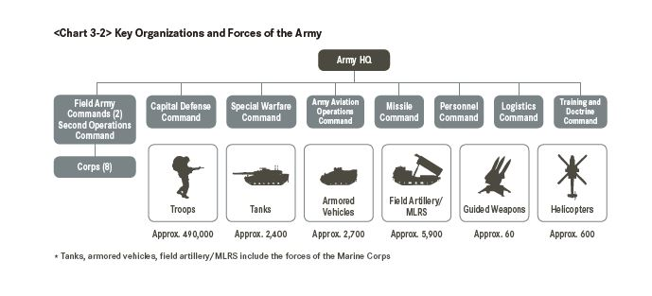
| navy | The Navy, organized under the Navy Headquarters, is composed of the Naval Operations Command, Marine Corps Headquarters, Northwest Islands Defense Command(NWIDC), and various support units. The key organizations and assets of the Navy are shown in <Chart 3-3>:
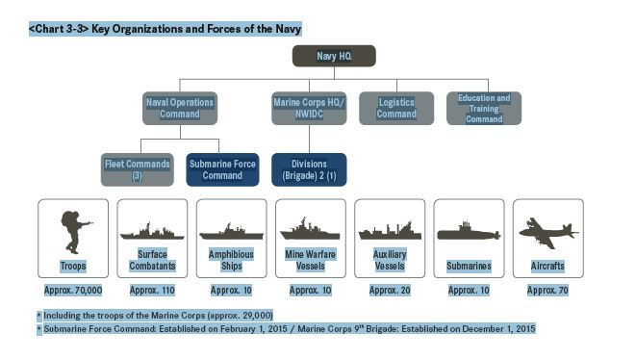

The Naval Operations Command has command authority over naval operations as a whole, conducting anti-surface operations, anti-submarine operations, mine and counter-mine operations and amphibious operations. The Marine Corps Headquarters is in charge of amphibious operations, while also being responsible for defense operations in its assigned areas and coastal islands.

| Air force | The Air Force is composed of the Air Force Headquarters, Air Force Operations Command and various operations and support units. The key organizations and assets of the Air Force are as shown in <Chart 3-4>:
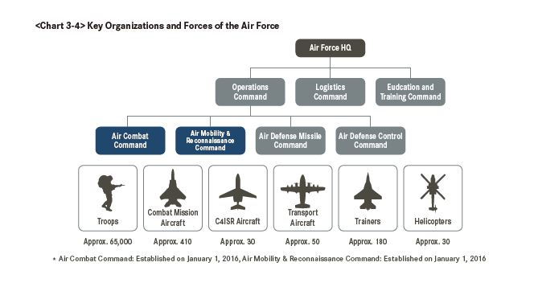
The Air Force Operations Command (AFOC) has command authority over overall air operations, carrying out counter-air operations (CAOs), air interdiction (AI) operations and close air support (CAS) operations. As part of a move toward a more centralized control of air operations, the AFOC has recently re-organized its Southern and Northern Combat Commands into the Air Combat Command and the Air Mobility and Reconnaissance Command, respectively.

Worksheet #3 Main Idea
□ Read the text and find the correct answer

Reading Comprehension Question for Main Idea

Q1. What is the best title for the passage?
⒜ difference of defense and military
⒝ our national defense objectives and organization
⒞ introduce to army, navy and air force
⒟ protection and aggression

Q2. Circle T if statement is true or Circle F if it is false.
⒜ The national Defense Objectives are consist of three points in the text.
( T / F )
⒝ Air force is contained of the Marine Corps Headquarters
( T / F )

Worksheet #4 Details
□ Read the text and find the correct answer
Reading Comprehension Question for Details

Q1. There is one sentence wrong with the contents of national defense
objectives. Choose one from the sentence below.
⒜ protection of the country from the enemy threats and aggression
⒝ supporting peaceful reunification
⒞ contribution to regional stability and world peace
⒟ obtaining soldiers and budgets
Q2. There is one sentence wrong with the contents of the Army
Choose one from the sentence below.
⒜ The Army is consist of the Headquarters and various troops.
⒝ The Army weapon is contained with tanks, helicopters, ships
⒞ The Army is continuously reinforcing its capabilities
Q3. Choose one the correct answer below.
⒜ The Navy conducts and leads the Marine Corps
⒝ The Air force has more soldiers than the Army
⒞ We have some nuclear weapons.

Worksheet #5,Main Activity Free Prodution
What is the best necessary military weapons in Korea at present ?
Weapon Types | Your Ranking  (Pick 7) | Group Ranking  (Pick 5) | Class Ranking  (Pick 3)
1. Missile 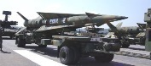
2. Submarine 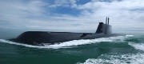
3. Tank 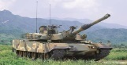
4. Combat fight 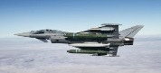
5. Helicopter 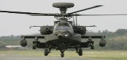
6. Nuclear weapon 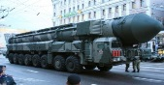
7. Combat ship 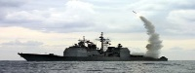
8. Stealth fight 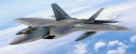
9. Stealth ship 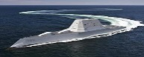
10. Biochemical weapon
11. Nuclear carrier 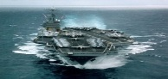
12. Armored vehicles 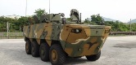
13. cannon 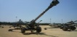

Worksheet #6, SOS Activity-1

#1 Your Misson  I should shout in front of my classmates.  “I love my classmates, I will salute twice for you.” → Salute relief is “Tesol” | #2 Your Misson  Your mission is just to rest.  Congratulations!!!
#3 Your Misson  You dance with your dancing classmates. Only for two minutes. Call the dancing members sitting in the class and dance them together. | #4 Your Misson  What’s feeling after Tesol education?
#5 Your Misson  Your mission is just to rest.  Congratulations!!! | #6Your Misson  You dance with your dancing classmates. Only for two minutes. Call the dancing members sitting in the class and dance them together.
#7Your Misson  Please sing one song with your classmate.  Call the singing members sitting in the class .  Only song in English | #8Your Misson  You dance with your dancing classmates. Only for two minutes. Call the dancing members sitting in the class and dance them together.
#9 Your Misson  Please sing one song with your classmate.  Call the singing members sitting in the class  Only song in English | #10 Your Misson  Your mission is just to rest.  Congratulations!!!

Worksheet #7, SOS Activity -2

The 10 most powerful militaries nations in the world
Ranking | Available Manpower | Military budget | Total
1 | China | USA | USA
2 | India | China | Russia
3 | USA | Russia | China
4 | Brazil | England | India
5 | Pakistan | Japan | England
6 | Russia | India | France
7 | Japan | France | Germany
8 | Iran | Italy | Turkey
9 | Turkey | South Korea | South Korea
10 | Germany | Brazil | Japan
《Word Bank》
France, USA, Russia, South Korea, England, China, Japan, India,
Germany , Turkey, Italy, Israel, Canada, Spain, Brazil, Iran, Taiwan,
Australia, Mexico, Pakistan, North Korea

