Activity or Task Based Lesson XXX Language Based or Presentation, Practice, Production PPP Based Lesson
Storytelling Lesson Plan Puppet Play Presentation

Topic: Party Time!

Instructor:  Julia | Students Competency Level and Student ages  7-8 years old, Elementary | Number of Students:  12 | Lesson Length:  50min
Materials:(List the Names of all materials used in the lesson. Materials must be shown at the end of this document)
- Party Picture
-Cone Hats
- Whiteboard and a Marker
-Pictures of Theme Parties
-Art Party
-Dance Party
-Royal Party
-Superhero Party
-Pirate Party
-Party Planning Worksheet
-Sample Invitation Card
-Papers and Colored Pens
Lesson Objectives (What do you want the students to know (new skill or knowledge that you want them to gain)? And What do you want them to be able to do?
Ss will enjoy being able to plan a party and present what their party are going to be
Aims:(What students will be able to achieve by participating in the activities of the lesson. (Ss gain or get by doing…)
Ss will get interested in lesson by listening to T presentation about parties
Ss will improve listening and speaking skills by responding to teacher and sharing opinions in class
Ss will participate with fun in English communication activity by creating their own party
Ss will improve interaction and communication skills by having discussion in a group and planning a party
Ss will gain writing skills by making an invitation card
Language Skills:(Lists what activities language skills students will be using by participating in the activities of the lesson.)
- Reading: (Where did reading occur in the lesson?)
Whiteboard, worksheet
- Listening:(Where did listening occur in the lesson?)
Teachers talk, discussion, presentation of other students
- Speaking: (Where did speaking occur in the lesson?)
Group discussion, answering teacher, presentation
- Writing: (Where did writing occur in the lesson?)
Worksheet, making invitation card
Assumptions:(What students must already be able to do and what concepts must already be mastered before the lesson in order to achieve the aims of the lesson.)
Ss have had a party before or seen a party by media
Ss think having a party is fun
Ss understand concepts of party theme
Ss know general vocabulary and basic grammar of the lesson
Anticipated Errors and Solutions:(What things might go wrong in the lesson and what the solution will be. An SOS activity should also be included)
If Ss my not have many ideas, T gives them some hints or suggestions
If the first activity lasts too long, T gives the second activity for the next lesson
If all the activities are finished too soon, T asks Ss to present their invitation cards
References:

Lead-In or Pre-Task Part (Warm-Up Part to activate and create interest in the lesson.)
Materials: (List the Names of all materials used in the Lead-In or Pre-Task Part of the lesson. Materials must be shown at the end of this document)
- Party Picture
-Cone Hat
- Whiteboard and a Marker
Time: | Classroom Set Up: | Student Activity and Goals: | Teacher Procedure &Instructions:
1  3  1  2 | Whole  Whole  Ss  Ss | Greet teacher  Listen to T about parties they like  Respond  Respond and see the whiteboard | Greet students  Wear a cone hat and share T’s love for parties with a party picture  Ask Ss what they want to buy for throwing a party  Ask Ss to tell shopping list for party and write down the list on the whiteboard

Pre-Activity or Task Familiarization Part (Presentation Part for Presenting the language structure to be covered in the lesson. Prepares students for the communication activity.)
Materials: (List the Names of all materials used in the Pre-Activity or Task Familiarization Part of the lesson. Materials must be shown at the end of this document)
-Pictures of Theme Parties
- Art Party
-Dance Party
-Royal Party
-Superhero Party
-Pirate Party
-Party Planning Worksheet
Time: | Classroom Set Up: | Student Activity and Goals: | Teacher Procedure &Instructions:
3  1  3  5  3 | Whole  Group  Group  Group  Group | Listen and see  Move into groups  Listen to what T says  Wear a cone hat and discuss about their party with team members  Write down on worksheet | Introduce themes of parties with pictures  Divide Ss into 3groups  Give instructions for planning a party  Hand out worksheet and cone hats  Ask Ss to wear cone hats and choose a theme of their party and discuss what they need to prepare for the party  Ask Ss to fill out the worksheet

Main Activity or Task Realization Part (Practice to Production Part Teacher lead practice of the language presented and move to communication based more student-centered activity)
Materials: (List the Names of all materials used in the Main Activity or Task Realization Part of the lesson. Materials must be shown at the end of this document)
-Party Planning Worksheet
Time: | Classroom Set Up: | Student Activity and Goals: | Teacher Procedure &Instructions:
1  3X  2  2 | Group  Group  Group  Group | Listen to T  Everything below happens three times  One group’s members come out and present their party and other groups listen to them  Listen what T says | Give instructions for presentation  Everything below happens three times  Each group comes out and present their party to invite other Ss of the class  Give Ss positive feedback and comments

Post Activity or Post Task Part (Wrap-Up Part to Close the Lesson on a high note to and consolidate language learned in a communication-based activity new situation.)
Materials: (List the Names of all materials used in the Post Activity or Post Task Part of the lesson. Materials must be shown at the end of this document)
-Sample Invitation Card
-Papers and Colored Pens
Time: | Classroom Set Up: | Student Activity and Goals: | Teacher Procedure &Instructions:
2  2  5  1 | Group  Group  Group  Group | Look at the invitation card and listen to T  Think about what to draw and write  Draw and write an invitation card  Applaud | Show a sample invitation card and explain about it  Hand out papers and ask Ss to make an invitation card of their team’s party  Move around the class and encourage their work  Congratulate and thank Ss for accomplishment

-Cone Hats
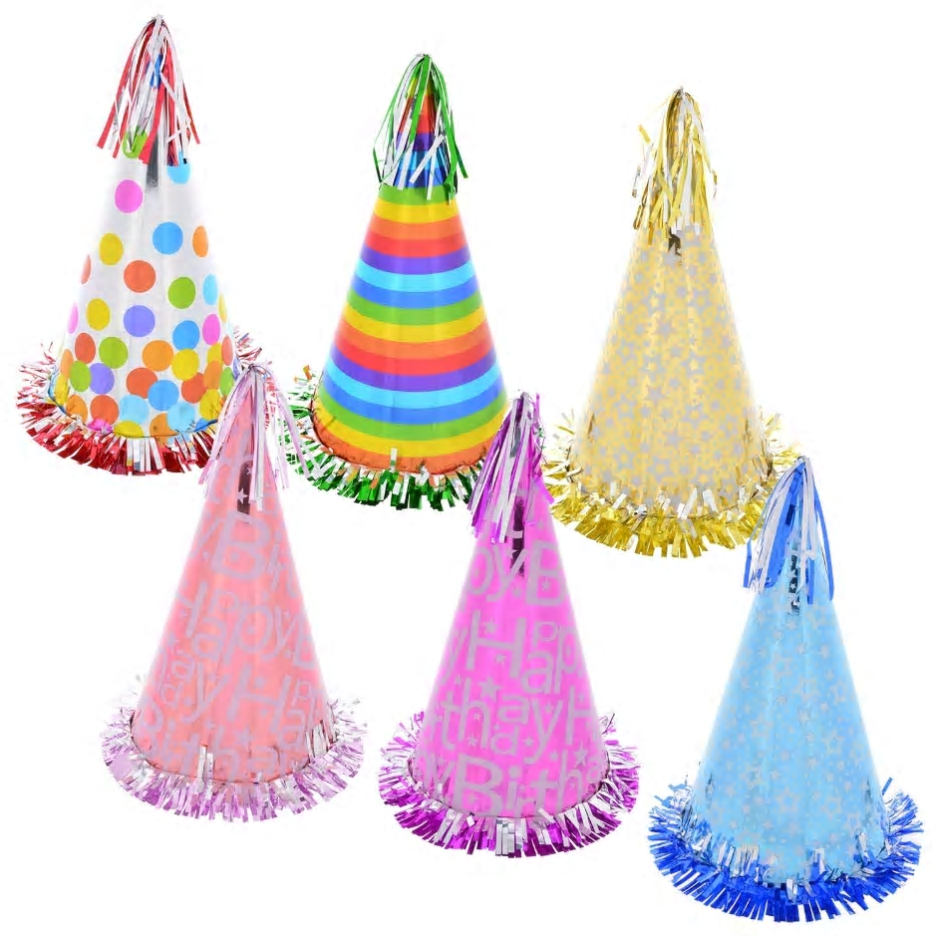

- Party Picture
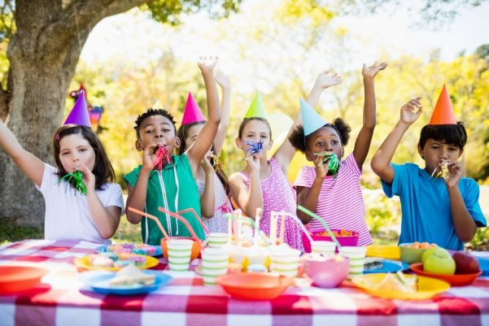

-Pictures of Theme Parties
-Art Party
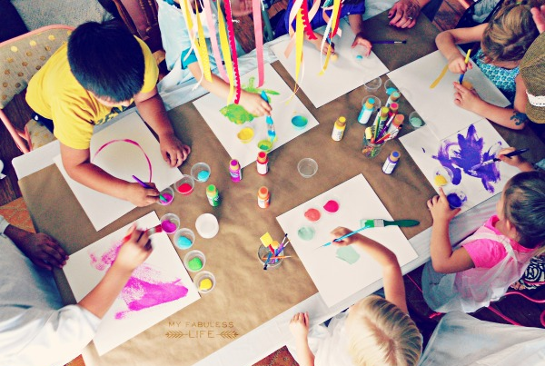

-Dance Party
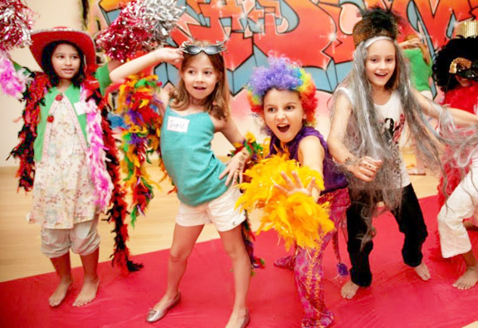

-Royal Party
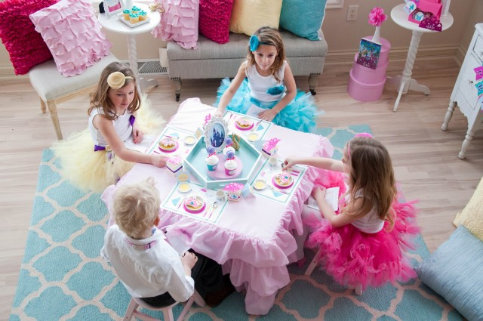
-Superhero Party
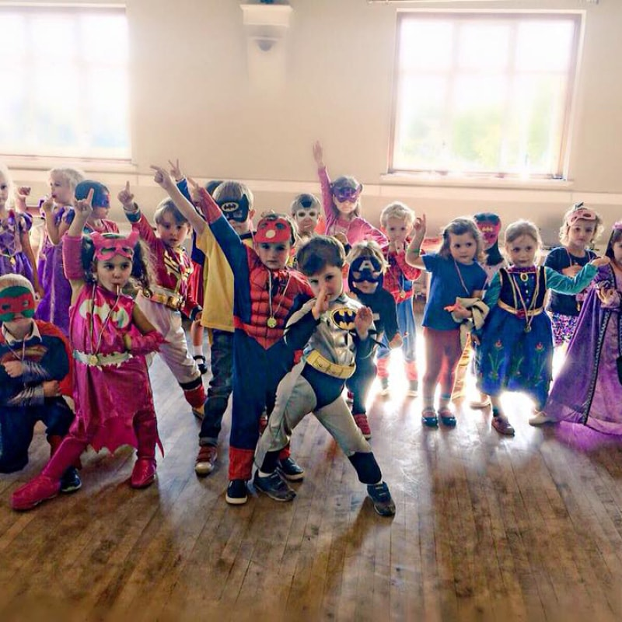

-Pirate Party
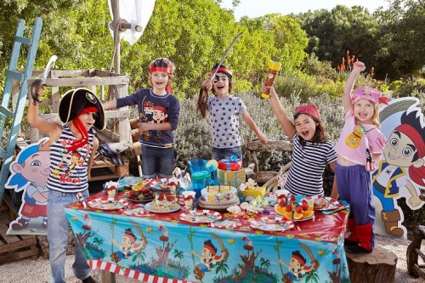

-Party Planning Worksheet

-Sample Invitation Card
