Activity or Task Based Lesson XXX Language Based or Presentation, Practice, Production PPP Based Lesson
Storytelling Lesson Plan Puppet Play Presentation

Topic: Let’s Travel Together!

Instructor:  Penny | Students Competency Level and Student ages  7-8 years old, Elementary | Number of Students:  12 | Lesson Length:  50min
Materials:(List the Names of all materials used in the lesson. Materials must be shown at the end of this document)
- Dora the Explorer Picture
- Whiteboard and a Marker
-Pictures of Themes of Travel
- Animal Farm Travel
- Museum Travel
- Camping Travel
- Amusement Park Travel
- Beach Travel
- Korean Tradition Travel
- What is Your Travel Plan Worksheet
- Teacher’s Sample Travel Plan Worksheet
- Travel Plan Map
Lesson Objectives(What do you want the students to know (new skill or knowledge that you want them to gain)?AndWhat do you want them to be able to do?
Ss will understand and be able to plan a travel and present what their travel plan are going to be

Aims:(What students will be able to achieve by participating in the activities of the lesson. (Ss gain or get by doing…)
Ss will get interested in lesson by listening to T presentation about travel plan
Ss will improve listening and speaking skills by responding to T and sharing opinions in class
Ss will participate in fun in English communication activity by creating their own travel plan
Ss will improve interaction and communication skills by having a discussion in a group and planning a travel plan
Ss will gain writing skills by preparing What is your Travel Plan Worksheet
Language Skills:(Lists what activities language skills students will be using by participating in the activities of the lesson.)
- Reading: (Where did reading occur in the lesson?)
Whiteboard, worksheet
- Listening:(Where did listening occur in the lesson?)
Teachers talk, discussion, presentation of other students
- Speaking: (Where did speaking occur in the lesson?)
Group discussion, answering teacher, presentation
- Writing: (Where did writing occur in the lesson?)
Travel Plan Map, What is your Travel Plan Worksheet,
Assumptions:(What students must already be able to do and what concepts must already be mastered before the lesson in order to achieve the aims of the lesson.)
Ss have had a travel before or seen about travel by media
Ss think going to travel is fun
Ss understand concepts of travel theme
Ss know general vocabulary and basic grammar of the lesson
Anticipated Errors and Solutions:(What things might go wrong in the lesson and what the solution will be. An SOS activity should also be included)
If Ss can not have many ideas, T gives them some hints or suggestions
If the first activity lasts too long, T gives the second activity for the next lesson
If all the activities are finished too soon, T asks Ss to present What is your Travel Plan Worksheet
References:
https://www.naver.com/
https://www.google.com/

Lead-In or Pre-Task Part (Warm-Up Part to activate and create interest in the lesson.)
Materials: (List the Names of all materials used in the Lead-Inor Pre-Task Partof the lesson. Materials must be shown at the end of this document)
- Dora the Explorer Picture
- Whiteboard and a Marker

Time: | Classroom Set Up: | Student Activity and Goals: | Teacher Procedure &Instructions:
1  3  1  2 | Whole  Whole  Ss  Ss | Greet teacher  Respond and  Listen to T  Respond and share about travel  Respond and write on the whiteboard | Greeting  Share what T likes about travel  Show a Dora the Explorer picture and ask Ss if they like Dora and adventure  Ask Ss where they want to travel  Asks Ss to tell travel plan and Ss write down the list on the whiteboard

Pre-Activity or Task Familiarization Part (Presentation Partfor Presenting the language structure to be covered in the lesson. Prepares students for the communication activity.)
Materials: (List the Names of all materials used in the Pre-Activity or Task Familiarization Part of the lesson. Materials must be shown at the end of this document)
Pictures of Themes of Travel
- Animal Farm Travel
- Museum Travel
- Camping Travel
- Amusement Park Travel
- Beach Travel
- Korean Tradition Travel
- What is Your Travel Plan Worksheet
- Teacher’s Sample Travel Plan Worksheet
Time: | Classroom Set Up: | Student Activity and Goals: | Teacher Procedure &Instructions:
3  2  2  3 | Whole  Ss  Ss  Ss | Listen and see  Look at the What is your Travel Plan Worksheet.  Think about what to write  Write What is your Travel Plan Worksheet and present | Introduce themes of Travel with pictures  Shows a sample What is your Travel plan Worksheet  Hand out paper. T asks Ss to think What is your Travel Plan Worksheet  Asks Ss what they write down What is your Travel Plan Worksheet individually and present  T encourages their work  Let’s make team travel plan

Main Activity or Task Realization Part(Practice to Production PartTeacher lead practice of the language presented and move to communication based more student-centered activity)
Materials: (List the Names of all materials used in the Main Activity or Task Realization Partof the lesson. Materials must be shown at the end of this document)
- Travel Plan Map
- Big size of Paper
Time: | Classroom Set Up: | Student Activity and Goals: | Teacher Procedure &Instructions:
1  2  6  3X  2  3  2 | Group  Group  Group  Groups  Groups  Groups  Whole | Move into groups  Listen what T says  Discuss and write down on Travel Plan Map  Prepare for the presentation  Everything below happens three times  One group’s members come out and present their Travel Plan Map and other groups listen to them  Each Ss presents and others listen  Listen what T says and about presentation | Divide Ss into 3 groups  Gives instruction for Travel Plan Map. Give an example of T’s Travel Plan Map  Hand out Travel Plan Map and Big size of Paper  Ask Ss to discuss the idea for the Travel Plan Map and write down the idea for the Travel Plan Map  Prepare for the presentation  Everything below happens three times  Each group comes out and present their Travel Plan Map to other Ss in the class  Each Ss presents the Travel Plan Map. Ss share the presentation  T gives Ss positive feedback and comments

Post Activity or Post Task Part (Wrap-Up Part to Close the Lesson on a high note to and consolidate language learned in a communication-based activity new situation.)
Materials: (List the Names of all materials used in the Post Activity or Post Task Part of the lesson. Materials must be shown at the end of this document)
- Travel Plan Map
- Big size of Paper
Time: | Classroom Set Up: | Student Activity and Goals: | Teacher Procedure &Instructions:
5  2 | Ss  Whole | Each Ss tells their opinion and others listen  Applaud | T asks Ss to tell what was a good idea about other team’s Travel Plan Map  And what would you add more?  T encourages their opinions  Congratulates and thanks Ss for accomplishment

Dora the Explorer Picture

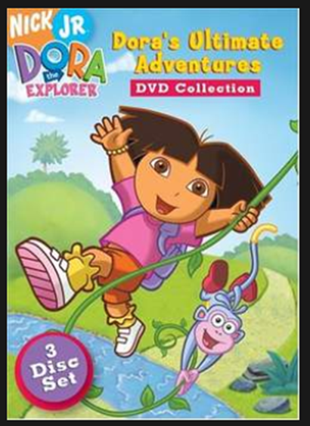

-Pictures of Themes of Travel
- Animal Farm Travel

- Museum Travel
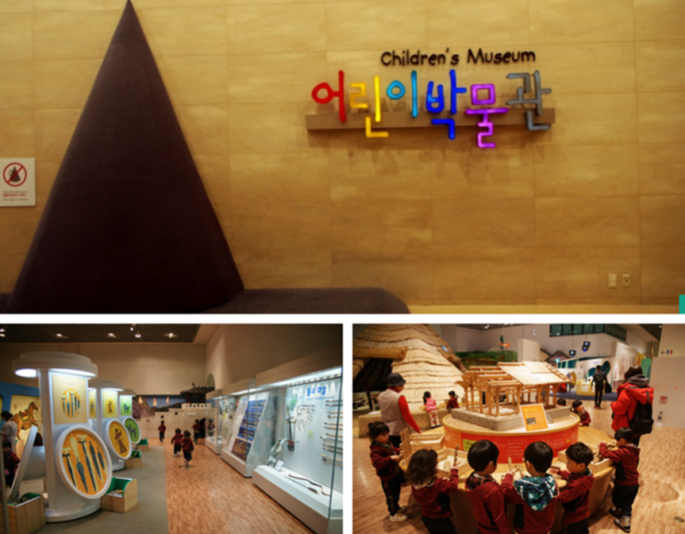
- CampingTravel
- Amusement Park Travel

- Beach Travel
- Korean Tradition Travel

- What is your Travel plan Worksheet
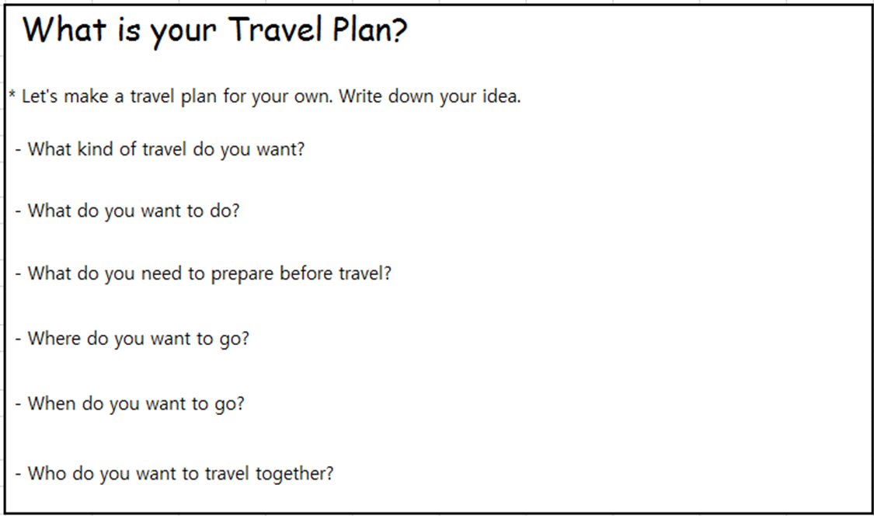
-Teacher’s Sample Travel Plan Worksheet
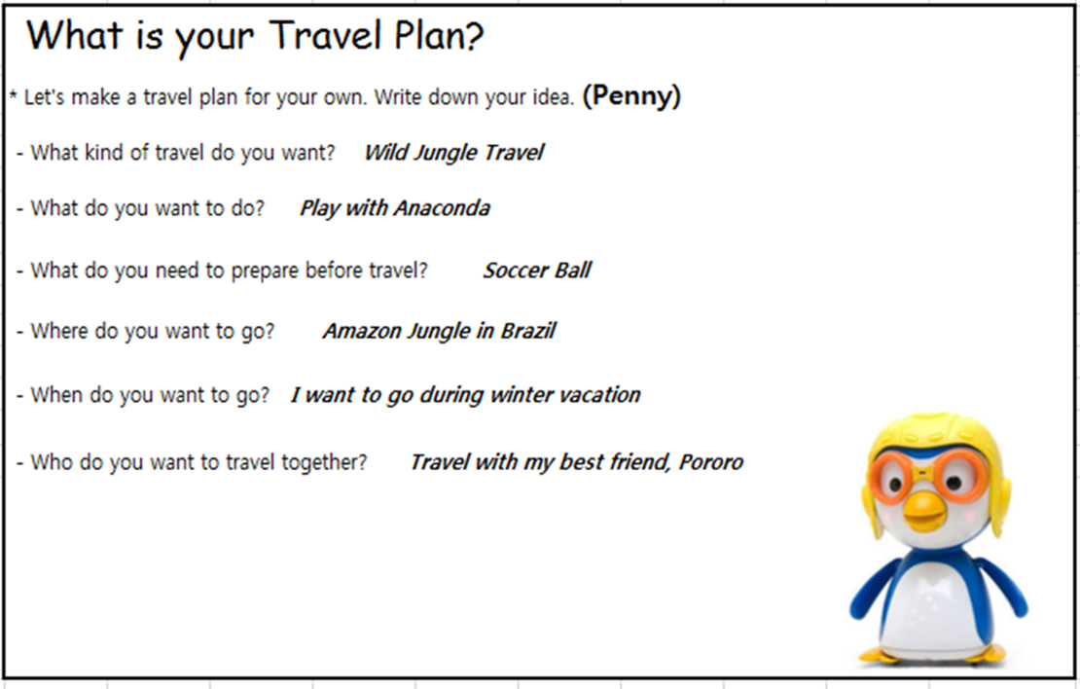

-Travel Plan Map

