XXX Activity or Task Based Lesson Language Based or Presentation, Practice, Production PPP Based Lesson
Storytelling Lesson Plan Puppet Play Presentation

Topic: It’s A Mystery

Instructor:  Julia | Students Competency Level and Student ages  Elementary 7-8 years old | Number of Students:  12 | Lesson Length:  55min
Materials:(List the Names of all materials used in the lesson. Materials must be shown at the end of this document)
- Mystery Box
- Owl Drawing
- Dog Drawing
- Snoring Drawing
- Clock Drawing
- Bathtub Drawing
- Stairs Drawing
- Mystery Story Script
- Phone
- Mystery Box Song MP3
- Sound Effects MP3
Owl Hooting
Dog Barking
Snoring
Clock Ticking
Water Dripping
Footsteps
Stairs Creaking
Door Opening
- Bluetooth Speaker
- It’s A Mystery Worksheet

Lesson Objectives (What do you want the students to know (new skill or knowledge that you want them to gain)? And What do you want them to be able to do?
Ss will enjoy being able to and improve guessing correctly and make up story with their ideas by participating in activities of this lesson.

Aims:(What students will be able to achieve by participating in the activities of the lesson. (Ss gain or get by doing…)
Ss will get interested in lesson by listening to mystery story with sound effects
Ss will improve vocabulary by listening the story and playing the activity
Ss will improve listening and speaking skills by asking and responding to Ss in English- communication activity
Ss will participate with fun in sharing their own ideas
Ss will gain writing skills by making up the following story

Language Skills:(Lists what activities language skills students will be using by participating in the activities of the lesson.)
- Reading: (Where did reading occur in the lesson?)
Worksheet
- Listening:(Where did listening occur in the lesson?)
Teacher’s talk, Mystery Story
- Speaking: (Where did speaking occur in the lesson?)
Mystery Box Activity, Questioning, Answering, Sharing their stories
- Writing: (Where did writing occur in the lesson?)
Making up story

Assumptions:(What students must already be able to do and what concepts must already be mastered before the lesson in order to achieve the aims of the lesson.)
Ss have interest in mystery stories
Ss think guessing what they cannot see is fun
Ss understand mysterious and scary atmosphere
Ss know general vocabulary and basic grammar of the lesson

Anticipated Errors and Solutions:(What things might go wrong in the lesson and what the solution will be. An SOS activity should also be included)
If phone is not working, teacher makes sounds
If all the lesson is finished too soon, T asks Ss to present their drawings

References:
https://www.youtube.com

Lead-In or Pre-Task Part (Warm-Up Part to activate and create interest in the lesson.)
Materials: (List the Names of all materials used in the Lead-In or Pre-Task Part of the lesson. Materials must be shown at the end of this document)
- Mystery Box
- Phone
- Mystery Box Song MP3
- Bluetooth Speaker

Time: | Classroom Set Up: | Student Activity and Goals: | Teacher Procedure &Instructions:
1  2  1  1 | Whole  Whole  Whole  Ss | Greet T  Listen to T  Listen to T and a song  Sing together | Greet students  Tell T’s story of how T found Mystery Box  Introduce Mystery Box and Mystery Box Song  Ask Ss to sing Mystery Box Song together

Pre-Activity or Task Familiarization Part (Presentation Part for Presenting the language structure to be covered in the lesson. Prepares students for the communication activity.)
Materials: (List the Names of all materials used in the Pre-Activity or Task Familiarization Part of the lesson. Materials must be shown at the end of this document)
- Mystery Box
- Owl Drawing
- Dog Drawing
- Snoring Drawing
- Clock Drawing
- Bathtub Drawing
- Stairs Drawing
- Phone
- Mystery Box Song MP3
- Bluetooth Speaker

Time: | Classroom Set Up: | Student Activity and Goals: | Teacher Procedure &Instructions:
1  1  2  3X  1  3  1 | Group  Group  Group  Group  Group  Group  Group | Move into groups  Listen to what T says  Listen to T  Everything below happens three times  Each group comes out and  follow T’s directions  Play the activity  Sing Mystery Box Song and see what is inside | Divide Ss into 3 groups  Give instructions that one team will come out and guess what is inside of the box. The team can ask 10 questions to find out and other teams would answer the questions  T gives demonstration by asking questions  Everything below happens three times  Ask one team to come out to the front and show the drawing in Mystery Box to the rest of Ss  Ask Ss to keep asking and answering until the student guesses right  Show what is in the Mystery Box with singing Mystery Box Song

Main Activity or Task Realization Part (Practice to Production Part Teacher lead practice of the language presented and move to communication based more student-centered activity)
Materials: (List the Names of all materials used in the Main Activity or Task Realization Part of the lesson. Materials must be shown at the end of this document)
- Phone
- Sound Effects MP3
Owl Hooting
Dog Barking
Snoring
Clock Ticking
Water Dripping
Footsteps
Stairs Creaking
Door Opening
- Bluetooth Speaker
- Mystery Story Script
- It’s A Mystery Worksheet

Time: | Classroom Set Up: | Student Activity and Goals: | Teacher Procedure &Instructions:
1  3  1  5  3 | Whole  Whole  Whole  Ss  Ss | Stay seated  Listen to T’s talk and sound effects  Guess what T asks  Make up own stories  Present their writing and others listen to the speaker | Make a classroom dark  Tell a mystery story with sound effects then make a classroom light  Ask Ss to guess who was coming in and what would happen next  Hand out worksheet and ask Ss to make up their stories  Ask Ss to present their stories

Post Activity or Post Task Part (Wrap-Up Part to Close the Lesson on a high note to and consolidate language learned in a communication-based activity new situation.)
Materials: (List the Names of all materials used in the Post Activity or Post Task Part of the lesson. Materials must be shown at the end of this document)
- Phone
- Mystery Box Song MP3
- Bluetooth Speaker

Time: | Classroom Set Up: | Student Activity and Goals: | Teacher Procedure &Instructions:
1  5  6  1 | Ss  Ss  Ss  Ss  Ss | Think about what to draw a scene of their story  Listen to the song  Draw a scene  Present and describe their drawings  Applaud | Hand out papers and ask Ss to draw a scene of their story  Play Mystery Box Song while Ss are drawing  Move around the class and encourage their work  Ask Ss to present their drawings to class and T facilitates class feedback  Congratulate and thank Ss for accomplishment

- Mystery Box

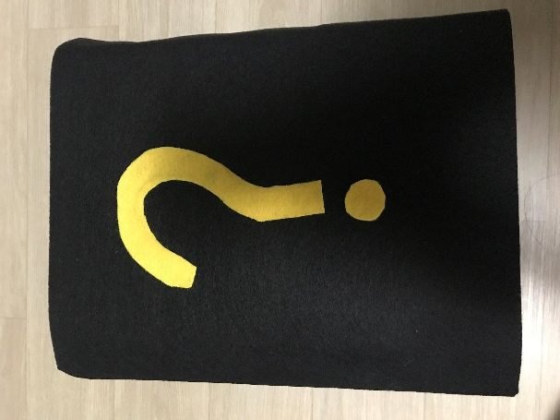

- Owl Drawing - Dog Drawing - Snoring Drawing

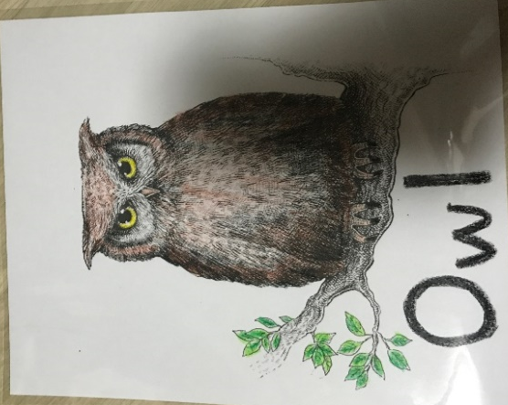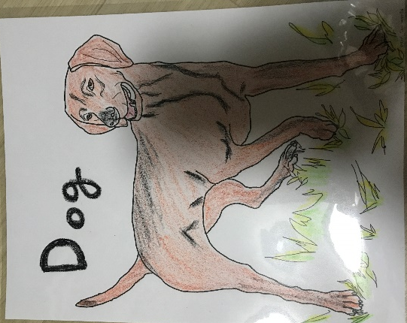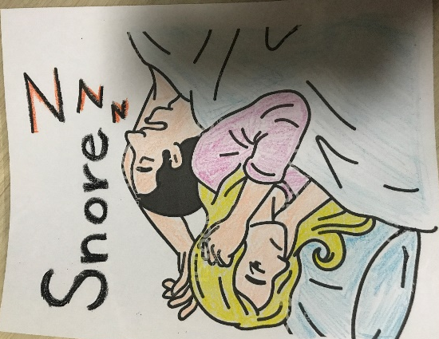

-Clock Drawing -Bathtub Drawing -Stairs Drawing

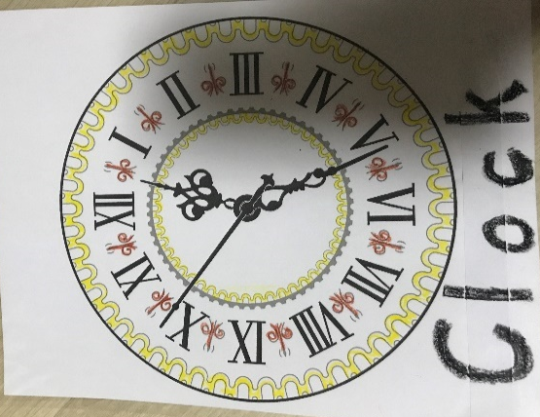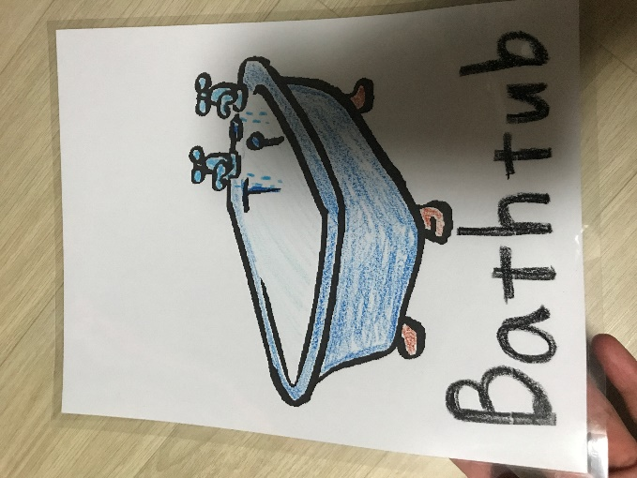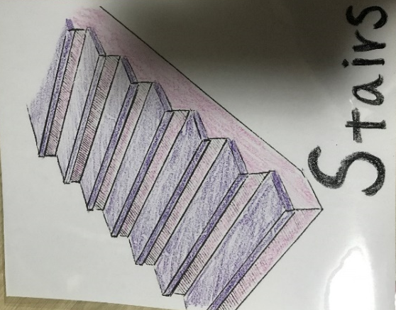

-Mystery Story Script
It was night-time. Everyone in Tommy’s house was sleeping. All but Tommy.
He was sitting up in his bed. There was too much noise.
Outside, an owl was hooting, and some dogs were barking.
In the house, his father was snoring.
Tommy’s clock was ticking. The water in the bathroom was dripping. Suddenly, there were footsteps up above.
Who was walking upstairs? What was that?
The stairs were creaking. Who was walking down the stairs?
Oh, no! His bedroom door was opening.
Who was coming in?

- It’s A Mystery Worksheet

