X Activity or Task Based Lesson Language Based or Presentation, Practice, Production PPP Based Lesson
Storytelling Lesson Plan Puppet Play Presentation

Topic: Animals Are Our Family

Instructor:  Penny | Students Competency Level and Student ages  7-8 years old, Elementary | Number of Students:  12 | Lesson Length:  50min
Materials:(List the Names of all materials used in the lesson. Materials must be shown at the end of this document)

- White Board and Markers
- Dog “ PO”
- Odd Eye Friend
- Role Situation Cards
- Snow Kick
- Piggy
- Max
- Biggy
- Skinny
- Cutty
- Mel
- Sharp
- Maxx
- Long
- Saddy
- Ham
- Paper
- Colored Pencils
Lesson Objectives(What do you want the students to know (new skill or knowledge that you want them to gain)?AndWhat do you want them to be able to do?
Ss will enjoy being able to role play about Family dinner time with pet human and learn about pet animals

Aims:(What students will be able to achieve by participating in the activities of the lesson. (Ss gain or get by doing…)
Ss will improve speaking skills by role play and discussion with a group and answering T
Ss will improve listening skills by role play and discussion with a group, responding to T
Ss will participate in fun in English communication activity by creating their own role play
Ss will improve interaction and communication skills by having a discussion in a group during planning a role play
Ss will gain writing skills by preparing To Do List for My Animal Family Worksheet
Language Skills:(Lists what activities language skills students will be using by participating in the activities of the lesson.)
- Reading: (Where did reading occur in the lesson?)
Role cards, note taking, worksheet
- Listening:(Where did listening occur in the lesson?)
Teachers talk, during the role play, discussion,
- Speaking: (Where did speaking occur in the lesson?)
Role play, group discussion, answering teacher, presentation
- Writing: (Where did writing occur in the lesson?)
Notes, worksheet
Assumptions:(What students must already be able to do and what concepts must already be mastered before the lesson in order to achieve the aims of the lesson.)
Ss understand the basic of role play and will enjoy family dinner time with pet human
Ss have an opinion about pet animal
Ss understand a pet animal care
Ss know general vocabulary and basic grammar of the lesson
Anticipated Errors and Solutions:(What things might go wrong in the lesson and what the solution will be. An SOS activity should also be included)
If Ss can not have many ideas, T gives them some hints or suggestions
If the first activity lasts too long, T gives the second activity for the next lesson
If all the activities are finished too soon, T asks Ss to present To Do List for My Animal Family Worksheet

References:
https://www.naver.com/
https://www.google.com/

Lead-In or Pre-Task Part (Warm-Up Part to activate and create interest in the lesson.)
Materials: (List the Names of all materials used in the Lead-Inor Pre-Task Partof the lesson. Materials must be shown at the end of this document)

- White Board and Markers
- Dog “ PO”
- Odd Eye Friend
Time: | Classroom Set Up: | Student Activity and Goals: | Teacher Procedure &Instructions:
1  4  3 | Whole  Whole  Ss | Greet teacher  Respond and listen to teacher  Ss talk their pet animal stories | Greeting  T share the story of the friend’s dog “ PO”  Show a Odd eye Friend Picture and tell a story about them  Elicit the pet animal stories from Ss  Let’s do a role play about pet human

Pre-Activity or Task Familiarization Part (Presentation Partfor Presenting the language structure to be covered in the lesson. Prepares students for the communication activity.)
Materials: (List the Names of all materials used in the Pre-Activity or Task Familiarization Part of the lesson. Materials must be shown at the end of this document)
- White Board and Markers
- Role Situation Cards
- Snow Kick
- Piggy
- Max
- Biggy
- Skinny
- Cutty
- Mel
- Sharp
- Maxx
- Long
- Saddy
- Ham
Time: | Classroom Set Up: | Student Activity and Goals: | Teacher Procedure &Instructions:
3  1  4  5 | Whole  Group  Group  Whole | Listen and what T says  Move into groups  Ss read role cards and share with group members  Ss prepare for role plays | Introduce the role play and describe setting.  Family dinner time with pet human  Divide Ss into groups  Hand out role cards. Ask Ss to discuss roles and pick roles. Tell Ss don’t share role cards with other group  Ask Ss to prepare for role play. T facilitates make notes to help plan role play.  Let’s present role plays

Main Activity or Task Realization Part(Practice to Production PartTeacher lead practice of the language presented and move to communication based more student-centered activity)
Materials: (List the Names of all materials used in the Main Activity or Task Realization Partof the lesson. Materials must be shown at the end of this document)
- White Board and Markers
- Role Situation Cards
- Snow Kick
- Piggy
- Max
- Biggy
- Skinny
- Cutty
- Mel
- Sharp
- Maxx
- Long
- Saddy
- Ham

Time: | Classroom Set Up: | Student Activity and Goals: | Teacher Procedure &Instructions:
1  2X  7  5 | Whole  Groups  Groups  Whole | Ss get ready for role play. Ss don’t use cards in the role plays  Everything below happens twice  One group at a time do role play and other group watches listens and enjoys  Ss listen what T says and Ss applaud other group | T give instruction for each group to come to front and present and enjoy role play and starts role play. Ss can’t use role cards or notes  Everything below happens twice  T monitors role playing. Give encouragement to each group and facilitates class feed back to role play group  Gives Ss positive feedback and comments Facilitates class members’ feedback

Post Activity or Post Task Part (Wrap-Up Part to Close the Lesson on a high note to and consolidate language learned in a communication-based activity new situation.)
Materials: (List the Names of all materials used in the Post Activity or Post Task Part of the lesson. Materials must be shown at the end of this document)
- Paper
- Colored Pencils
Time: | Classroom Set Up: | Student Activity and Goals: | Teacher Procedure &Instructions:
1  5  1 | Whole  Ss  Ss | Ss listen what T says  draw and present their pictures  Ss listen what other says and Ss applaud to others  Applaud | Let’s draw the picture for the dinner party for  our animal friends  Hand out paper. T asks Ss to draw and present their pictures  Close by giving Ss feedback about their accomplishment.  Thanks Ss for participation.

-Dog “ PO”
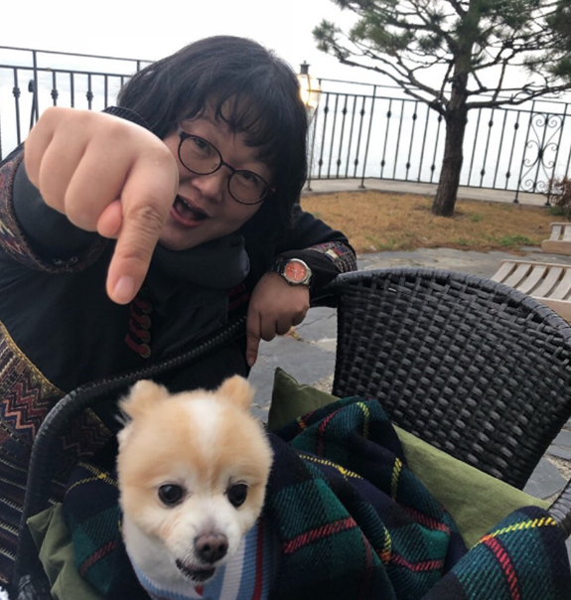
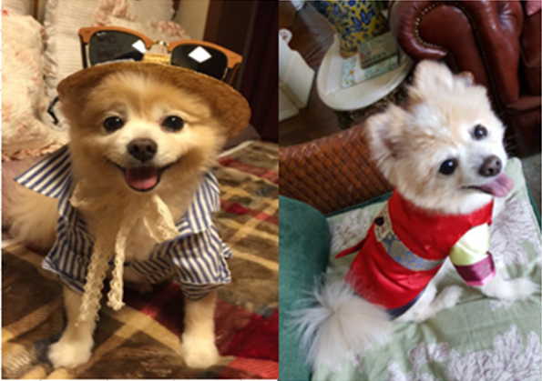

-Odd Eye Friend
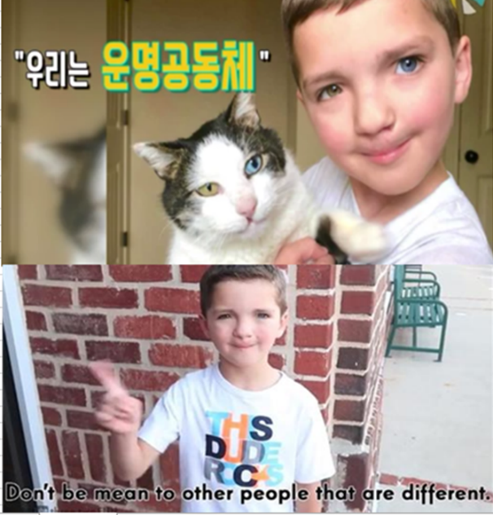

-Role Situation Cards
