XXX Activity or Task Based Lesson ☐ Language Based or Presentation, Practice, Production PPP Based Lesson
☐ Storytelling Lesson Plan ☐ Puppet Play Presentation

Topic: Find The Lost Memory

Instructor:  Elin | Students Competency Level and Student ages  7-8 years old, Elementary | Number of Students:  10 | Lesson Length:  40 min
Materials:(List the Names of all materials used in the lesson. Materials must be shown at the end of this document)
- Bakki
- Hello song
- ‘I Like My House’ Book
- Draw Family & House Worksheet
- Baby Sleep Video
- Bakki’s Brain Board
- Magic Wand
- Monkey doll
- Hula Hoop
- Balloons
- White Board or Paper
- Bakki’s Family Picture
- Bakki’s House Picture
- Wanted Worksheet
- Computer or Blue tooth speaker

Lesson Objectives(What do you want the students to know (new skill or knowledge that you want them to gain)? and What do you want them to be able to do?
Through board games and worksheets, Ss can improve our reading and speaking skills.

Aims:(What students will be able to achieve by participating in the activities of the lesson. (Ss gain or get by doing…)
Ss will get interested in lesson by listening to T presentation about making sandwiches.
Ss improve listening skills by responding to teacher and sharing opinions in class.
Ss improve speaking skills by playing board games.
Ss improve writing skills by making a worksheet.
Ss improve interaction and communication skills by talking with Bakki.
Ss will practice the expression of detailed behavior by participating in activities of the lesson.

Language Skills:(Lists what activities language skills students will be using by participating in the activities of the lesson.)

- Reading: (Where did reading occur in the lesson?)
Worksheet, Game Board

- Listening:(Where did listening occur in the lesson?)
Teachers talk, Monsters talk, presentation of other students

- Speaking: (Where did speaking occur in the lesson?)
Conversation with Monster, Answering teacher, Board game, Presentation

- Writing: (Where did writing occur in the lesson?)
Write the worksheet

Assumptions:(What students must already be able to do and what concepts must already be mastered before the lesson in order to achieve the aims of the lesson.)
Ss will enjoy and also have fun
Ss will become more comfortable and friendly with each other
Ss can make descriptive appearance or behavior

Anticipated Errors and Solutions:(What things might go wrong in the lesson and what the solution will be. An SOS activity should also be included)
If Ss may not understand > T shows demonstration
If activity finished too soon > Make post activity longer

References:

Lead-Inor Pre-Task Part (Warm-Up Part to activate and create interest in the lesson.)
Materials: (List the Names of all materials used in the Lead-Inor Pre-Task Partof the lesson. Materials must be shown at the end of this document)
- Hello song
- Computer or Blue tooth speaker
- Bakki

Time: | Classroom Set Up: | Student Activity and Goals: | Teacher Procedure &Instructions:
3  2  3 | W  W  W | Sing and dance together to greet T and each other  Listen and greeting Bakki  Conversation with Bakki | Greeting and dancing with Hello song  Introduce Bakki and Bakki greeting Ss  Bakki talking with Ss

Pre-Activity or Task Familiarization Part (Presentation Partfor Presenting the language structure to be covered in the lesson. Prepares students for the communication activity.)
Materials: (List the Names of all materials used in the Pre-Activity or Task Familiarization Part of the lesson. Materials must be shown at the end of this document)
- ‘I Like My House’ Book
- Draw Family & House Worksheet
- Bakki

Time: | Classroom Set Up: | Student Activity and Goals: | Teacher Procedure &Instructions:
3  1  3  3  1  1 | W  W  Ss  Ss  W  W | Listen and see  Think of my house and my family  Draw my family and house  Shows and presents their Wanted worksheet  Listen  Go to the Bakki’s Head | T Show ‘I like my house’ Book and tell the story  Ask Ss “What was your first home you remember.” and ask introduce your family  Ask Ss to draw the family and house worksheet  Encouragement to Ss  Bakki crying and tell her story  T suggest we get into Bakki's head and find a memory

Main Activity or Task Realization Part(Practice to Production PartTeacher lead practice of the language presented and move to communication based more student centered activity)
Materials: (List the Names of all materials used in the Main Activity or Task Realization Partof the lesson. Materials must be shown at the end of this document)
- Baby Sleep Video
- Bakki’s Brain Board
- Magic Wand
- Monkey doll
- Hula Hoop
- Balloons
- White Board or Paper
- Computer or Blue tooth speaker

Time: | Classroom Set Up: | Student Activity and Goals: | Teacher Procedure &Instructions:
1  1  2  10  3  1  2 | W  G  G  G  W  W  W | Go in Bakki’s head  Move into two groups  Listen to T say  Play the board game  Find her old memories, and look at the Bakki’s family and house  Go out Bakki’s head  Listen to T say and wake up Bakki | Say the Magic spell and go in Bakki’s head  Ask Ss divide into two groups  Explain how to remove worries or think in Bakki’s brain  T monitors and encourage and help Ss who are difficult  See and ask about Bakki’s family and house  Say the Magic spell and go out Bakki’s head  Gives Ss positive feedback and ask Ss wake up Bakki

Post Activity or Post Task Part (Wrap-Up Part to Close the Lesson on a high note to and consolidate language learned in a communication based activity new situation.)
Materials: (List the Names of all materials used in the Post Activity or Post Task Part of the lesson. Materials must be shown at the end of this document)
- Bakki’s Family Picture
- Bakki’s House Picture
- Wanted Worksheet
- Bakki

Time: | Classroom Set Up: | Student Activity and Goals: | Teacher Procedure &Instructions:
2  5  2  1 | W  Ss  Ss  W | Respond and think  Draw and write an Wanted worksheet  Shows and presents their Wanted worksheet  Listen and say good-bye | Asks Ss to make an Wanted paper for finding Bakki’s family  T and Bakki monitors and encourage  Gives Ss positive feedback and comments  T and Bakki say thank you and good bye to Ss

Draw Family & House Worksheet
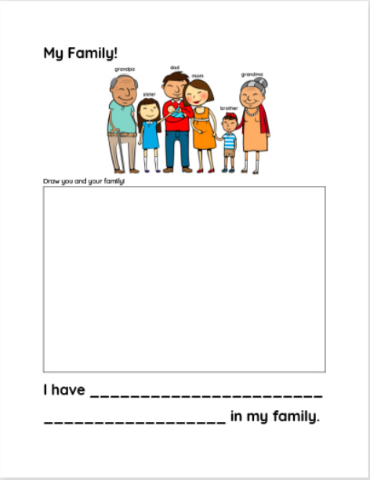

Monster’s Brain Board
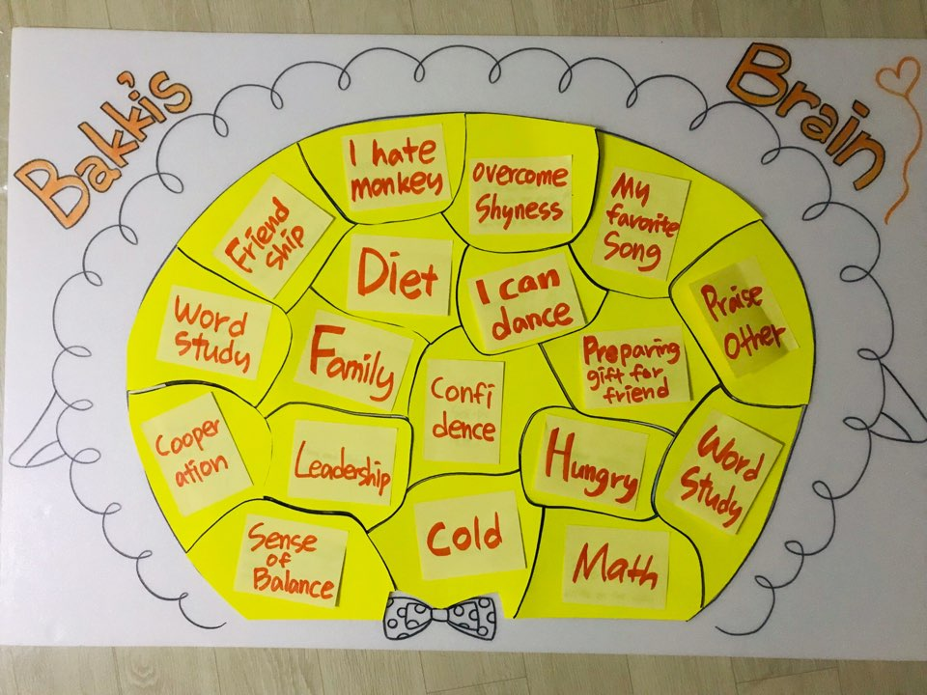

Wanted Worksheet

Monster’s dad
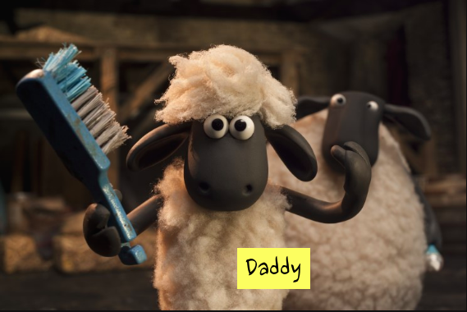

Monster’s mom
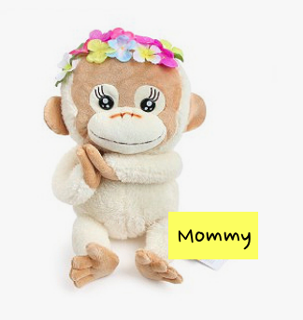

Monster’s brothers
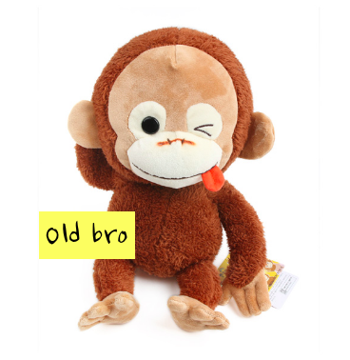

Monster’s grandma
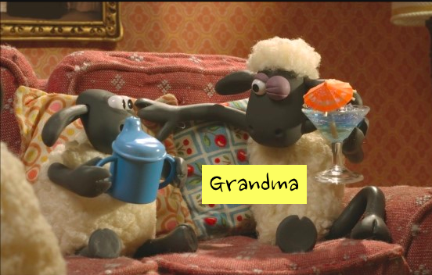

Monster’s grandpa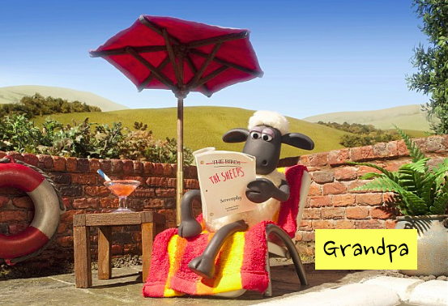

Monster’s house
