XXX Activity or Task Based Lesson □Language Based or Presentation, Practice, Production PPP Based Lesson
□Storytelling Lesson Plan □Puppet Play Presentation
Topic: Let’s Make A Chocolate House

Instructor:  Sally | Students Competency Level and Student ages  Elementary, 7-8 years old | Number of Students:  10 | Lesson Length:  50 min
Materials:(List the Names of all materials used in the lesson. Materials must be shown at the end of this document)
- Chocolate Cottage Pictures
- Hansel and Gretel House Made Of Chocolate Picture
- Pictures:
- Apartment
- Log Cabbin
- Stone House
- Earthen House
- Grass House
- Igloo
- Chocolate House Craft Pictures
- 8 Kinds Of Chocolate Pens
- Some Crackers
- Choco m&m
- 6 Types Of Sprinkle
- Oil Papers
- Packing Cases
- Draw Your Ideal House Worksheet
- Colored Pencils
- Whiteboard and a Marker

Lesson Objectives (What do you want the students to know (new skill or knowledge that you want them to gain)? And What do you want them to be able to do?
Ss are happy to learn and improve their ability to talk about many kinds of houses by making a chocolate house with interesting tools.
Aims:(What students will be able to achieve by participating in the activities of the lesson. (Ss gain or get by doing…)
Ss will be interested in knowing new things about houses by participating in activities about making a house.
Ss will improve listening and speaking skills by responding to teacher and sharing opinions in class
Ss will gain writing skills by writing their answers to the worksheet question.
Ss will have some creativity and concentration by making a chocolate house and drawing an ideal house.
Language Skills:(Lists what activities language skills students will be using by participating in the activities of the lesson.)
- Reading: (Where did reading occur in the lesson?)
Whiteboard, Worksheet
- Listening:(Where did listening occur in the lesson?)
Teacher talk, Presentation of other students
- Speaking: (Where did speaking occur in the lesson?)
Answering teacher, Presentation
- Writing: (Where did writing occur in the lesson?)
Worksheet
Assumptions:(What students must already be able to do and what concepts must already be mastered before the lesson in order to achieve the aims of the lesson.)
Ss are excited about making a chocolate house in an interesting way.
Ss like knowing new things like many kinds of houses.
Ss can make a chocolate house and draw a picture about what they want and express the meaning to peers.
Anticipated Errors and Solutions:(What things might go wrong in the lesson and what the solution will be. An SOS activity should also be included)
Teacher can give students more examples when they have difficulty understanding new terms.
Teacher needs to encourage a student who is not confident to give a presentation.
If the presentation is too long, teacher will cut the unnecessary parts.
References:

Lead-In or Pre-Task Part (Warm-Up Part to activate and create interest in the lesson.)
Materials: (List the Names of all materials used in the Lead-In or Pre-Task Part of the lesson. Materials must be shown at the end of this document)
- Chocolate Cottage Pictures
- Hansel and Gretel House Made of Chocolate Picture
Time: | Classroom Set Up: | Student Activity and Goals: | Teacher Procedure &Instructions:
1min  2min  3min  4min | Whole  Whole  Whole  Whole | Ss greet the teacher.  Listen the song and sing together  Respond  Ask Ss for Chocolate | Greeting.  T sings Chocolate song first and then sings it with Ss together  “If I have some chocolates, I’ll make my chocolate house.  When I finish making it, I’ll give it to my friend.”  Introduce ‘Hansel and Gretel’ as a fairy tale and show a house made of chocolate  Ask Ss for any exceptions of chocolate for eating.  T introduces a house made of chocolate in France

Pre-Activity or Task Familiarization Part (Presentation Part for Presenting the language structure to be covered in the lesson. Prepares students for the communication activity.)
Materials: (List the Names of all materials used in the Pre-Activity or Task Familiarization Part of the lesson. Materials must be shown at the end of this document)
- Pictures:
- Apartment
- Log Cabbin
- Stone House
- Earthen House
- Grass House
- Igloo

Time: | Classroom Set Up: | Student Activity and Goals: | Teacher Procedure &Instructions:
4min  3min  3min | Whole  Whole  Whole | Listen and look  Answer  Listen and respond | Introduce some kinds of houses with the related pictures.  Ask what kind of house they are living in and want to live in the future.  Explain about what to do for activity.

Main Activity or Task Realization Part (Practice to Production Part Teacher lead practice of the language presented and move to communication based more student-centered activity)
Materials: (List the Names of all materials used in the Main Activity or Task Realization Part of the lesson. Materials must be shown at the end of this document)
- Chocolate House Craft Pictures
- 8 Kinds Of Chocolate Pens
- Some Crackers
- Choco m&m
- 6 Types of Sprinkle
- Oil Papers
- Packing Cases

Time: | Classroom Set Up: | Student Activity and Goals: | Teacher Procedure &Instructions:
3min  10min  4min | Whole  Ss  Ss | Respond  Ss do activity.  Listen and respond | Show some chocolate house craft pictures.  Introduce the making materials.  Ask Ss to design your own chocolate house.  T monitors activity.  Gives encouragement to them individually.  Ask Ss to introduce about their own chocolate house. T praise Ss for their craft.  Facilitate class feedback to presentation.

Post Activity or Post Task Part (Wrap-Up Part to Close the Lesson on a high note to and consolidate language learned in a communication-based activity new situation.)
Materials: (List the Names of all materials used in the Post Activity or Post Task Part of the lesson. Materials must be shown at the end of this document)
- Draw Your Ideal House Worksheet
- Colored Pencils

Time: | Classroom Set Up: | Student Activity and Goals: | Teacher Procedure &Instructions:
2min  10min  1min | Ss  Ss  Ss | Imagine ideal house  Draw a picture and write their answers and show  Applaud | Ask Ss to imagine your ideal house.  Hand over the Draw Your Ideal House Worksheet.  Ask Ss to draw a picture whatever they want to express their future house and write their answers to the worksheet question and share them.  T expresses congratulations and thanks for the great effort for SS.

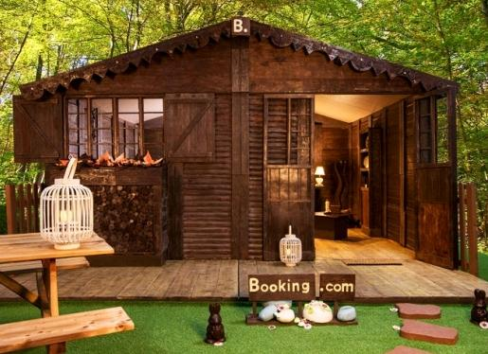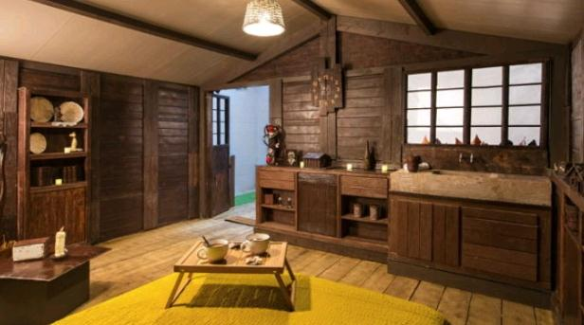
< Chocolate Cottages>

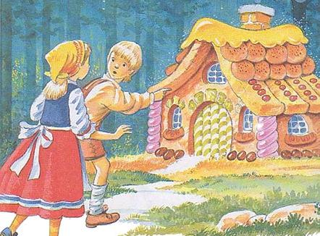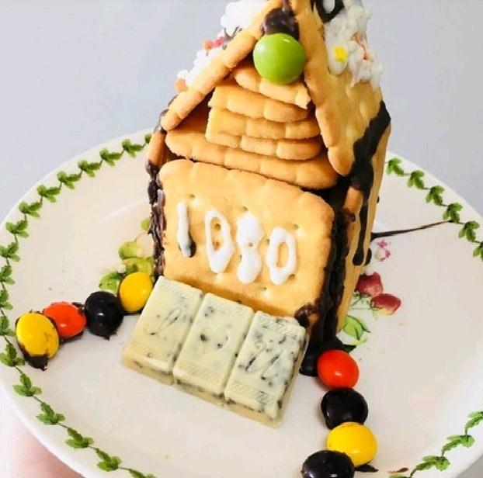
<Hansel and Gretel> <Chocolate craft 1>

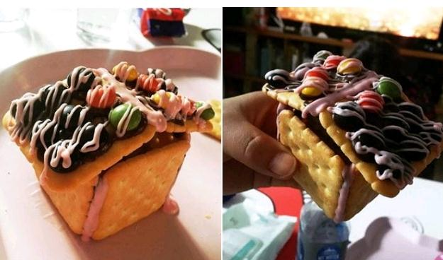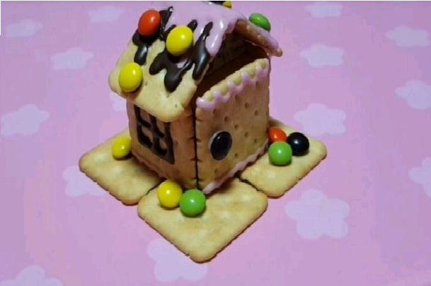
<Chocolate craft 2> <Chocolate craft 3>

l> 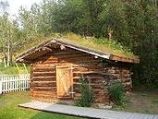
<APARTMENT> <LOG CABBIN>

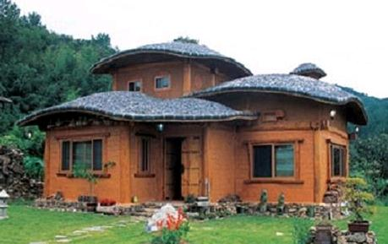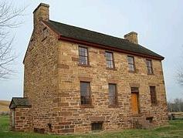
<EARTHEN HOUSE> <STONE HOUSE>

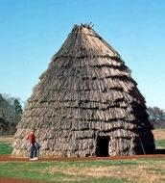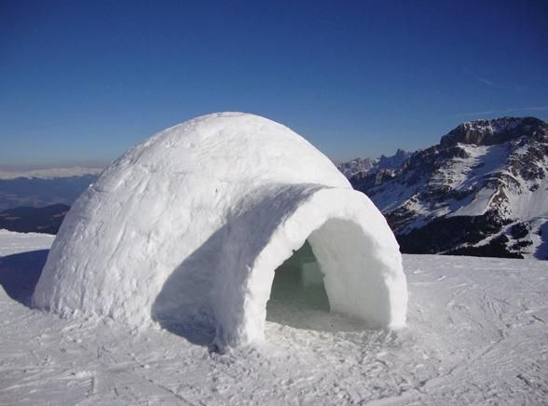
<GRASS HOUSE> <IGLOO>

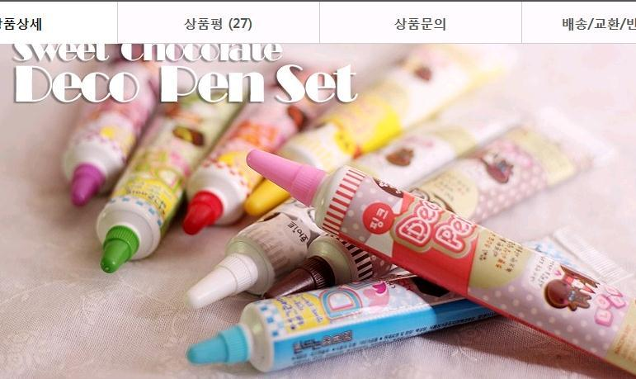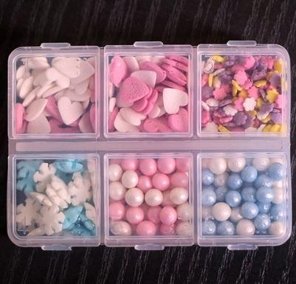
<8 Kinds Of Chocolate Pens> <6 Types Of Sprinkle>

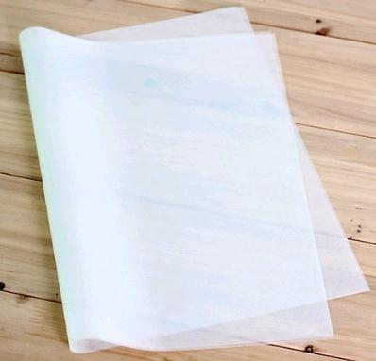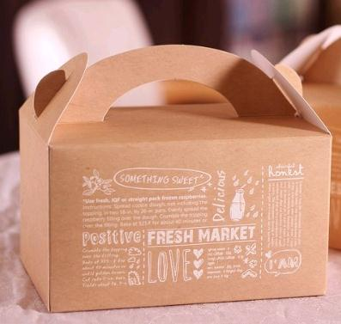

<Oil Paper> <Packing Cases>

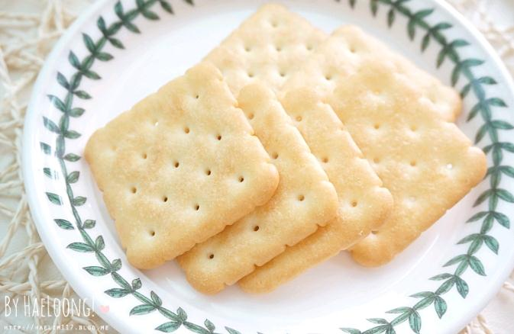
<Some Crackers> <m&m>

Draw Your Ideal House!

Think about it and write it down.

1) What do you think about your ideal house?

2) When will you build the ideal house and stay in?

3) What kind of material do you use building in your ideal house?

4) Who do you want to live in the house?

