Activity or Task Based Lesson Language Based or Presentation, Practice, Production PPP Based Lesson
X Storytelling Lesson Plan Puppet Play Presentation

Topic: Charlotte’s Web

Instructor:  Penny | Students Competency Level and Student ages  7-8 years old, Elementary | Number of Students:  12 | Lesson Length:  50min
Materials:(List the Names of all materials used in the lesson. Materials must be shown at the end of this document)
- Dog Hachiko
- SCENE # 1 ( Before Breakfast in Spring)
- SCENE # 2 ( Fern Loved Wilbur)
- SCENE # 3 ( Wilbur’s Barn Life/ Escape)
- SCENE # 4 ( Wilbur Meet Charlotte)
- SCENE # 5 (Some Pig on Summer)
- SCENE # 6 (Terrific and Radiant )
- SCENE # 7 (County Fair and Word Humble )
- SCENE # 8 (Last Day )
- SCENE # 9 (New Beginning in Spring )
- Wilbur
- Charlotte
- Fern
- Templeton
- Barn Family
- T’s Sample Story about Wilbur’s New Spring
- Book “Charlotte’s Web”
- Cellphone
- Bluetooth Speaker
- Charlotte & Wilbur Sound File
Lesson Objectives(What do you want the students to know (new skill or knowledge that you want them to gain)?AndWhat do you want them to be able to do?
Ss will understand and be able to interest in the story, and present their opinions about the story

Aims:(What students will be able to achieve by participating in the activities of the lesson. (Ss gain or get by doing…)
Ss will get interested in lesson by listening to T presentation about the story
Ss will improve listening and speaking skills by responding to T and sharing opinions in class
Ss will participate in fun in English communication activity by creating their own story
Ss will improve interaction and communication skills by having a discussion in a class
Ss will gain writing skills by preparing their own story about Wilbur’s new spring
Language Skills:(Lists what activities language skills students will be using by participating in the activities of the lesson.)
- Reading: (Where did reading occur in the lesson?)
Whiteboard, Scene picture
- Listening:(Where did listening occur in the lesson?)
Teachers talk, discussion, presentation of other students
- Speaking: (Where did speaking occur in the lesson?)
Answering teacher, presentation
- Writing: (Where did writing occur in the lesson?)
Own story about Wilbur’s new spring
Assumptions:(What students must already be able to do and what concepts must already be mastered before the lesson in order to achieve the aims of the lesson.)
Ss have read a book
Ss think reading and listening a book is fun
Ss know general vocabulary and basic grammar of the lesson

Anticipated Errors and Solutions:(What things might go wrong in the lesson and what the solution will be. An SOS activity should also be included)
If Ss can not have many ideas, T gives them some hints or suggestions
If the first activity lasts too long, T gives the second activity for the next lesson
If all the activities are finished too soon, T asks Ss to write their own story about Wilbur’s new spring
References:
https://www.naver.com/
https://www.google.com/
- YouTube(Charlotte’s Web Movie Clip)

Lead-In or Pre-Task Part (Warm-Up Part to activate and create interest in the lesson.)
Materials: (List the Names of all materials used in the Lead-Inor Pre-Task Partof the lesson. Materials must be shown at the end of this document)
- Dog Hachiko
- Whiteboard and a Marker

Time: | Classroom Set Up: | Student Activity and Goals: | Teacher Procedure &Instructions:
1  3  2 | Whole  Whole  Ss | Greet teacher  Respond and  Listen to T  Respond and share about miracle | Greeting  Share the story about Dog Hachiko  Show a Dog Hachiko picture and ask Ss if they like the story  Ask Ss what do you think about the miracle  Let’s hear more miracle story

Pre-Activity or Task Familiarization Part (Presentation Partfor Presenting the language structure to be covered in the lesson. Prepares students for the communication activity.)
Materials: (List the Names of all materials used in the Pre-Activity or Task Familiarization Part of the lesson. Materials must be shown at the end of this document)
- SCENE # 1 ( Before Breakfast in Spring)
- SCENE # 2 ( Fern Loved Wilbur)
- SCENE # 3 ( Wilbur’s Barn Life/ Escape)
- SCENE # 4 ( Wilbur Meet Charlotte)
- SCENE # 5 (Some Pig on Summer)
- SCENE # 6 (Terrific and Radiant )
- SCENE # 7 (County Fair and Word Humble )
- SCENE # 8 (Last Day )
- SCENE # 9 (New Beginning in Spring )
- Wilbur
- Charlotte
- Fern
- Templeton
- Barn Family
- Book “Charlotte’s Web”

Time: | Classroom Set Up: | Student Activity and Goals: | Teacher Procedure &Instructions:
5  3 | Whole  Ss | Listen and see  Ss share their opinions about the story and main characters | Introduce the scenes of the story  Introduce the main characters in the story  Asks Ss how they think about the story and main characters  T encourages their work  T gives Ss positive feedback and comments  Do you want to hear the story?  I will tell the story now

Main Activity or Task Realization Part(Practice to Production PartTeacher lead practice of the language presented and move to communication based more student-centered activity)
Materials: (List the Names of all materials used in the Main Activity or Task Realization Partof the lesson. Materials must be shown at the end of this document)
- SCENE # 1 ( Before Breakfast in Spring)
- SCENE # 2 ( Fern Loved Wilbur)
- SCENE # 3 ( Wilbur’s Barn Life/ Escape)
- SCENE # 4 ( Wilbur Meet Charlotte)
- SCENE # 5 (Some Pig on Summer)
- SCENE # 6 (Terrific and Radiant )
- SCENE # 7 (County Fair and Word Humble )
- SCENE # 8 (Last Day )
- SCENE # 9 (New Beginning in Spring )
- Wilbur
- Charlotte
- Fern
- Templeton
- Barn Family
- Book “Charlotte’s Web”
- Cellphone
- Bluetooth Speaker
- Charlotte & Wilbur Sound File
Time: | Classroom Set Up: | Student Activity and Goals: | Teacher Procedure &Instructions:
1  15  5  2 | Whole  Whole  Ss  Ss | Move to the in front of the board  Listen what T says  Listen what Charlotte & Wilbur Sound File is  Ss share their opinions about the story and making the sentence with vocabularies  Each Ss presents and others listen | T gives instruction Ss move to the in front of the board  T tells the story to use puppets  T plays Charlotte & Wilbur Sound File  Asks Ss how they think about the story  Asks Ss to make sentence with vocabularies used  In the story  Give an example of the T’s sample sentence  Each Ss presents a sentence with vocabularies  T gives Ss positive feedback and comments

Post Activity or Post Task Part (Wrap-Up Part to Close the Lesson on a high note to and consolidate language learned in a communication-based activity new situation.)
Materials: (List the Names of all materials used in the Post Activity or Post Task Part of the lesson. Materials must be shown at the end of this document)
- T’s Sample Story about Wilbur’s New Spring
- Paper and pencil
Time: | Classroom Set Up: | Student Activity and Goals: | Teacher Procedure &Instructions:
2  3  3  2 | Whole  Ss  Ss  Whole | Ss listen what T says  Ss to think and write their own story about Wilbur’s new spring  Each Ss present their story.  Ss listen what other says and Ss applaud to others  Applaud | T asks Ss to write their own story about Wilbur’s new spring  Give an example of the T’s sample sentence  Hand out paper. T asks Ss to think and write their own story about Wilbur’s new spring  T asks Ss to present their own story about Wilbur’s new spring  Close by giving Ss feedback about their good work and participation.  Congratulates and thanks Ss for accomplishment

Dog Hachiko
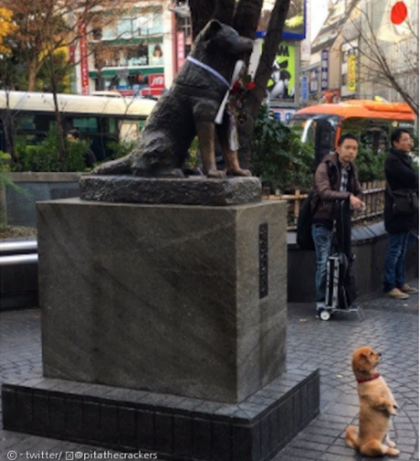

SCENE # 1
( Before Breakfast in Spring)
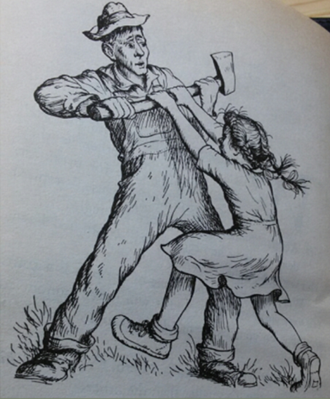

SCENE # 2
( Fern Loved Wilbur)
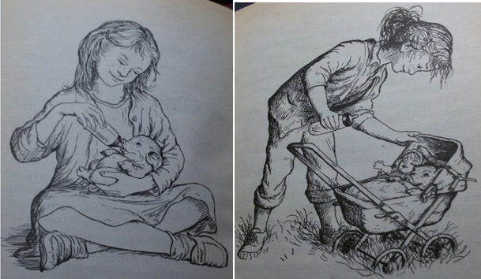

SCENE # 3
( Wilbur’s Barn Life/ Escape)
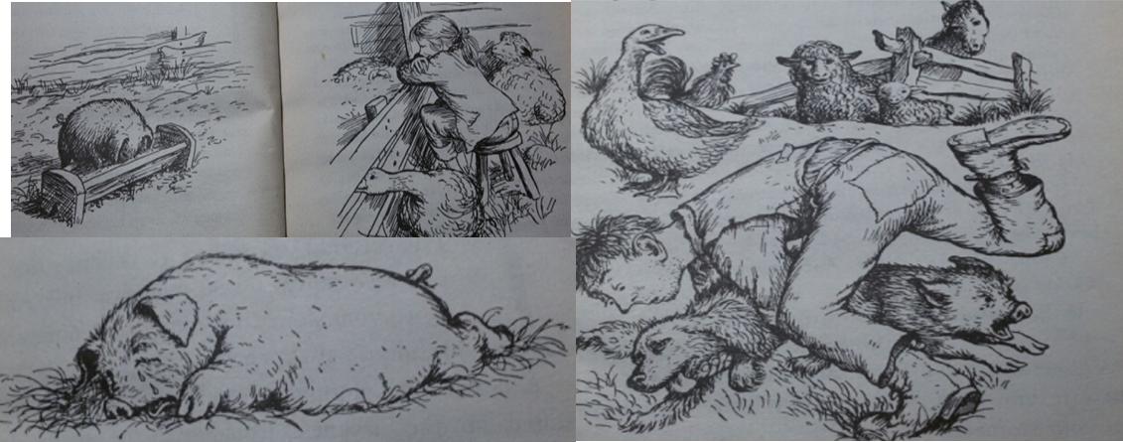

SCENE # 4
(Wilbur Meet Charlotte)
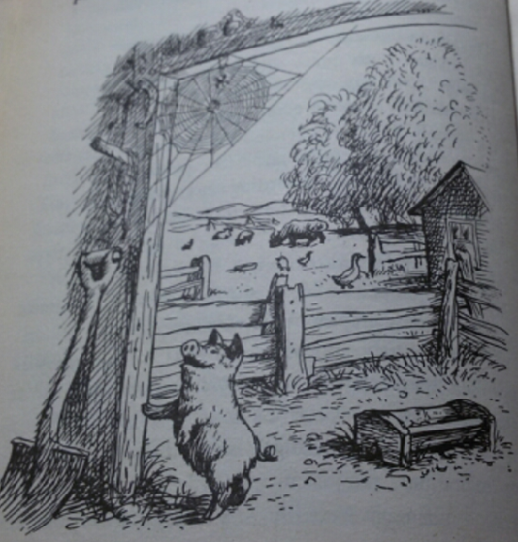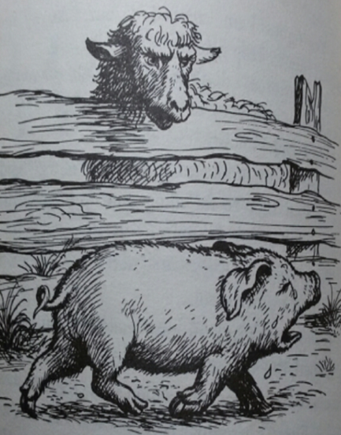

SCENE # 5
(Some Pig on Summer)
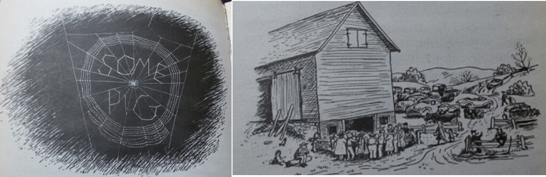

SCENE # 6
(Terrific and Radiant )
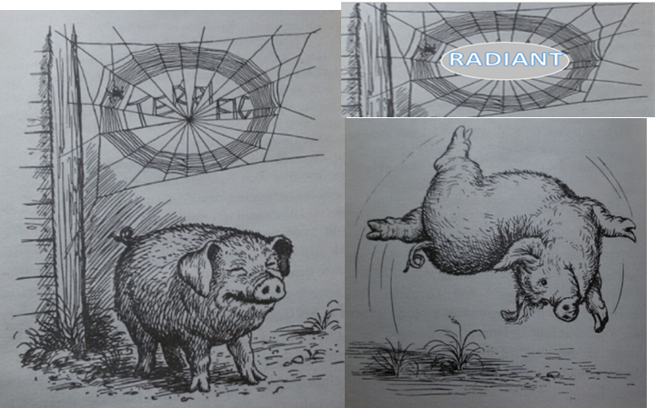

SCENE # 7
(County Fair and Word Humble )
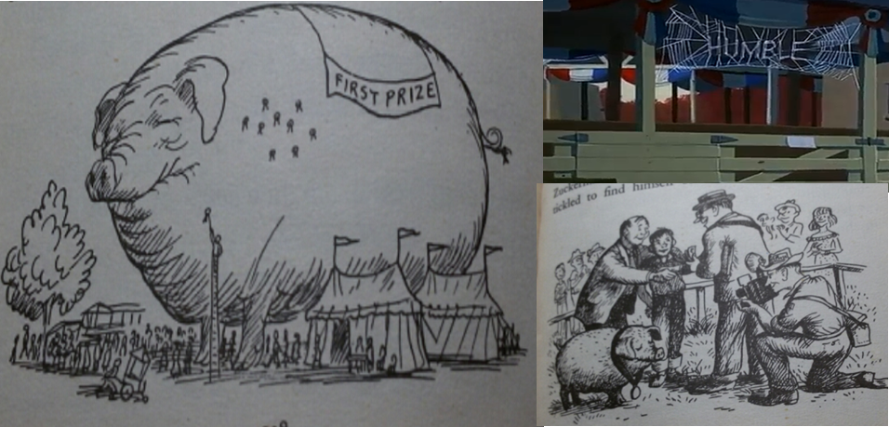

SCENE # 8
(Last Day )
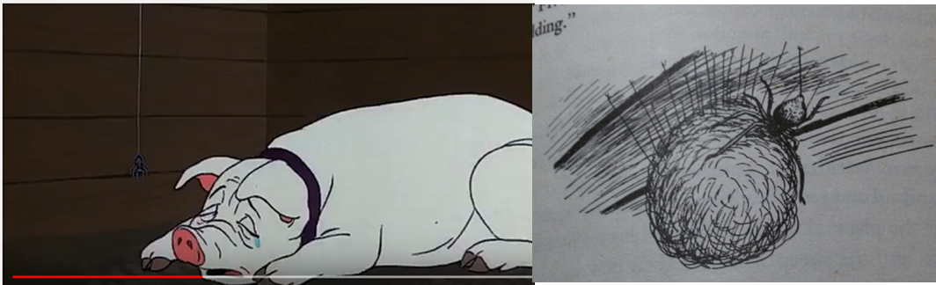

SCENE # 9
(New Beginning in Spring )
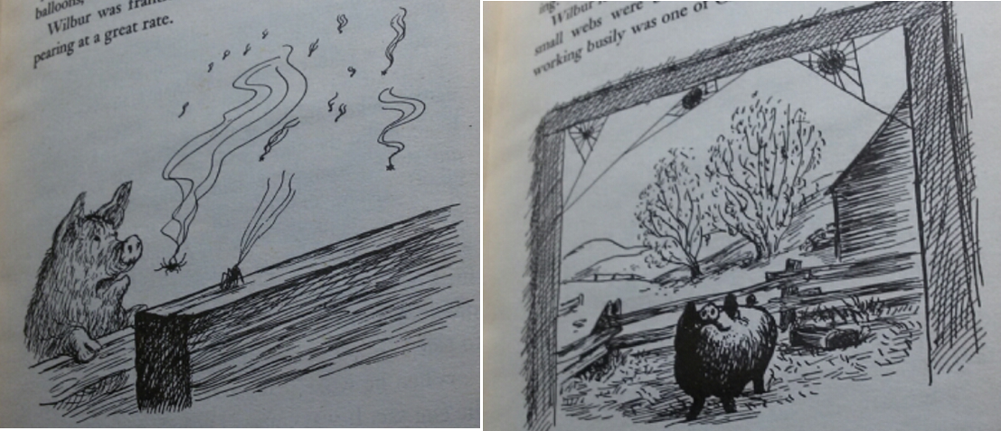

Wilbur
Charlotte
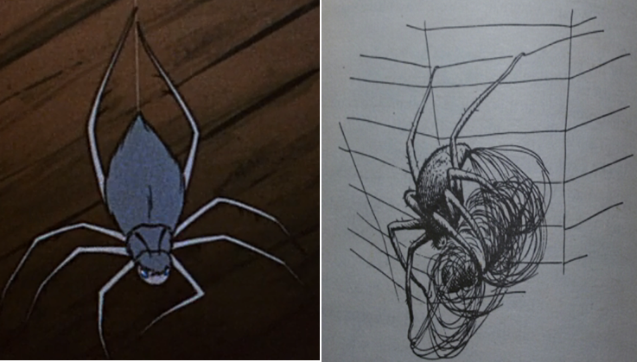

Fern
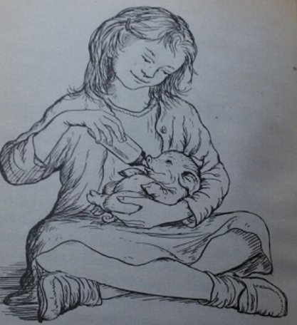

Templeton
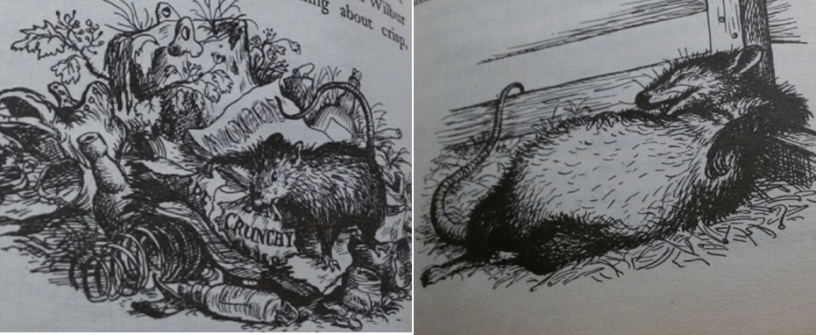
Barn Family
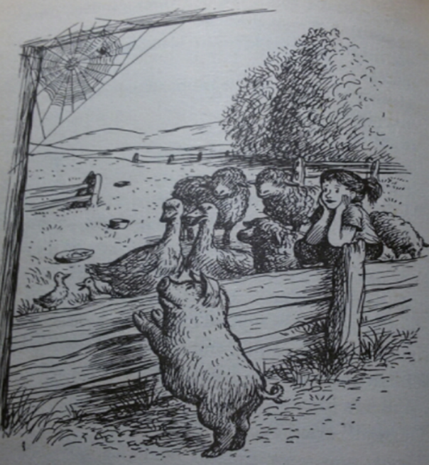
T’s Sample Story about Wilbur’s New Spring
Make a short story for Wilbur’s new spring, include the words, some, terrific, radiant and humble

Wilbur’s new spring

Wilbur befriends a lonely lamb named Cardigan. He is a handsome and smart lamb. Wilbur thinks that you’re some lamb, Cardigan! However, one radiant morning, Cardigan is sold to another farmer, so Wilbur goes on a journey to visit him, only to encounter trouble along the way.
Wilbur travels with three terrific and humble children of Charlotte. They do help Wilbur many times.
Book “Charlotte’s Web”
