□ Activity or Task Based Lesson □Language Based or Presentation, Practice, Production PPP Based Lesson
XXXStorytelling Lesson Plan □Puppet Play Presentation
Topic: The Golden Ax
Instructor:  Sally | Students Competency Level and Student ages  Elementary, 7-8 years old | Number of Students:  8 | Lesson Length:  50 min
Materials:(List the Names of all materials used in the lesson. Materials must be shown at the end of this document)
- The Golden Ax Storybook
- Masks
- A Mountain God
- A Honest Woodcutter
- A Greedy Woodcutter
- Stick Puppets
- A Mountain God
- A Honest Woodcutter
- A Greedy Woodcutter
- Small Stage
- Paper Axes
- The Gold Ax
- The Silver Ax
- The Iron Ax
- Word Cards For Role Play

Lesson Objectives (What do you want the students to know (new skill or knowledge that you want them to gain)? And What do you want them to be able to do?
Ss are glad to learn and enhance their ability to understand the story of the Golden Ax and get a good lesson from the story so that they can be more interested in reading books.
Aims:(What students will be able to achieve by participating in the activities of the lesson. (Ss gain or get by doing…)
Ss will be happy to know new things from the story showing a good lesson and new vocabulary.
Ss will improve listening and speaking skills by responding to teacher and sharing opinions in class
Ss will have more confidence for speaking and acting by doing role play.
Ss will recognise the honesty is the most important thing in life.
Language Skills:(Lists what activities language skills students will be using by participating in the activities of the lesson.)
- Reading: (Where did reading occur in the lesson?)
Word Cards
- Listening:(Where did listening occur in the lesson?)
Teacher’s Story Telling, Role Play From Other Students
- Speaking: (Where did speaking occur in the lesson?)
Answering Teacher, Role Play
- Writing: (Where did writing occur in the lesson?)
Word Cards
Assumptions:(What students must already be able to do and what concepts must already be mastered before the lesson in order to achieve the aims of the lesson.)
Ss are interested in focusing on the storytelling and learning a good lesson.
Ss like knowing new vocabulary from the story
Ss can be happy to do role play similar to The Golden Ax
Anticipated Errors and Solutions:(What things might go wrong in the lesson and what the solution will be. An SOS activity should also be included)
Teacher can give students more examples when they have difficulty understanding new vocabulary and preparing role play.
Teacher needs to encourage a student who is not confident to do role play.
References:

Lead-In or Pre-Task Part (Warm-Up Part to activate and create interest in the lesson.)
Materials: (List the Names of all materials used in the Lead-In or Pre-Task Part of the lesson. Materials must be shown at the end of this document)
- The Golden Ax Storybook
- Lylics

Time: | Classroom Set Up: | Student Activity and Goals: | Teacher Procedure &Instructions:
1min  3min  2min  1min  3min | Whole  Whole  Whole  Whole  Whole | Ss greet the teacher.  Listen the T’s story  Listen and respond  Listen  Listen and respond | Greeting.  Tell my story related to Honesty back in my elementary school days.  Ask Ss for what you think after listen to the T’s story.  Tell the Ss that what we talked about earlier is a lesson in The Golden Ax storybook.  Share The Golden Ax storybook covers.

Pre-Activity or Task Familiarization Part (Presentation Part for Presenting the language structure to be covered in the lesson. Prepares students for the communication activity.)
Materials: (List the Names of all materials used in the Pre-Activity or Task Familiarization Part of the lesson. Materials must be shown at the end of this document)
- Masks
- A Mountain God
- A Honest Woodcutter
- A Greedy Woodcutter
- Paper Axes
- The Gold Ax
- The Silver Ax
- The Iron Ax

Time: | Classroom Set Up: | Student Activity and Goals: | Teacher Procedure &Instructions:
7min  3min | Whole  Whole | Listen and look  Sing together | Introduce main characters with wearing masks and sing songs.  Sing together after T’s sing.

Main Activity or Task Realization Part (Practice to Production Part Teacher lead practice of the language presented and move to communication based more student-centered activity)
Materials: (List the Names of all materials used in the Main Activity or Task Realization Part of the lesson. Materials must be shown at the end of this document)
- Small Stage Box
- Stick Puppets
- A Mountain God
- A Honest Woodcutter
- A Greedy Woodcutter

Time: | Classroom Set Up: | Student Activity and Goals: |  | Teacher Procedure &Instructions:
12min  3min  2min | Whole  Whole  Whole |  | See a puppet show Respond  Resond  Listen | Storytelling with a puppet show and ask some questions during the show.  Ask Ss to have any feelings from the story  Share my opinion about the lesson.

Post Activity or Post Task Part (Wrap-Up Part to Close the Lesson on a high note to and consolidate language learned in a communication-based activity new situation.)
Materials: (List the Names of all materials used in the Post Activity or Post Task Part of the lesson. Materials must be shown at the end of this document)
- Masks
- A Mountain God
- A Honest Woodcutter
- A Greedy Woodcutter
- Paper Axes
- The Gold Ax
- The Silver Ax
- The Iron Ax
- Word Cards For Role Play

Time: | Classroom Set Up: | Student Activity and Goals: | Teacher Procedure &Instructions:
2min  10min  1min | Whole  Ss  Ss | Listen and fill out the cards  Role play and respond  Applaud | Introduce a post acitivity as role play and make groups.  Ask each group to do role play and facilitate class feedback to role play.  T expresses congratulations and thanks for the great effort for Ss.

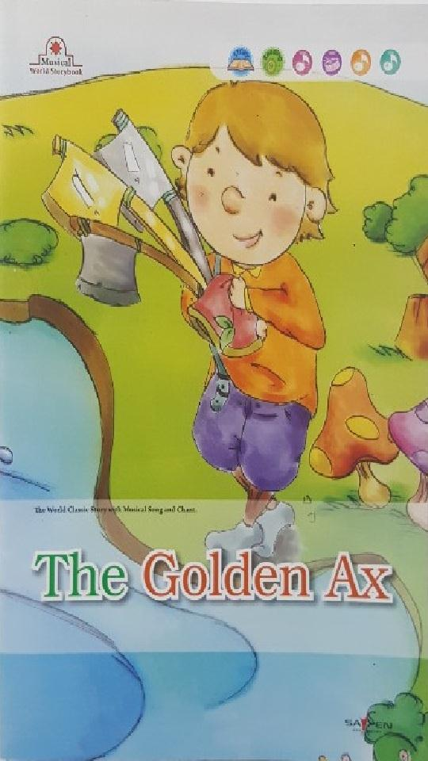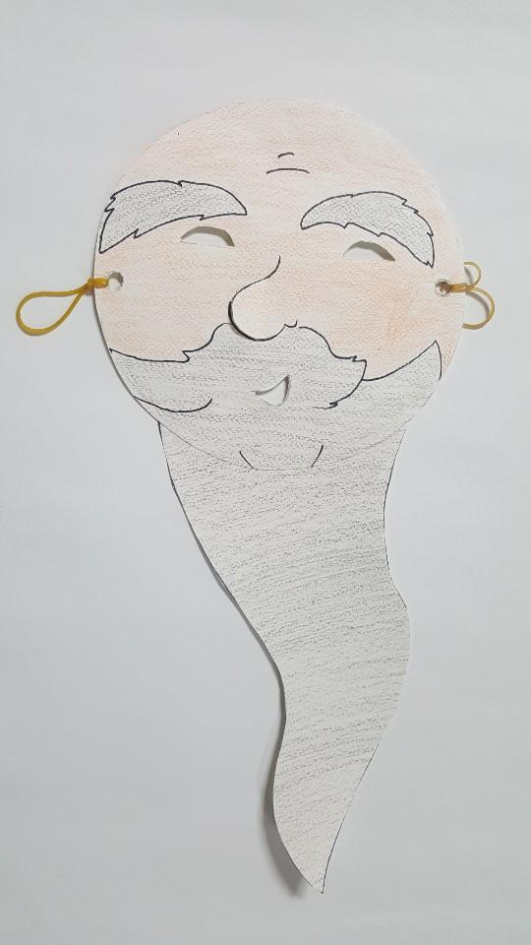
[Book Cover] [A Mountain God Mask]

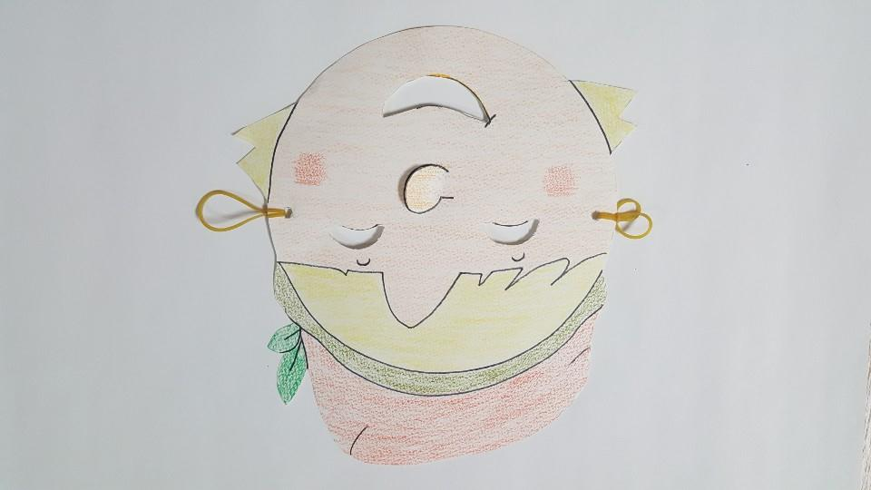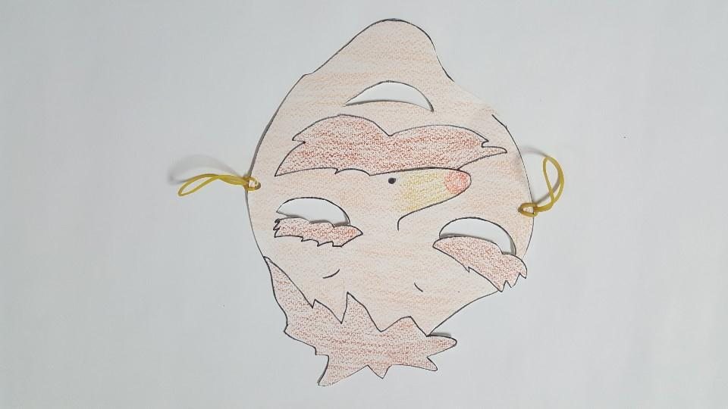
[A Honest Woodcutter Mask] [A Greedy Woodcutter Mask]

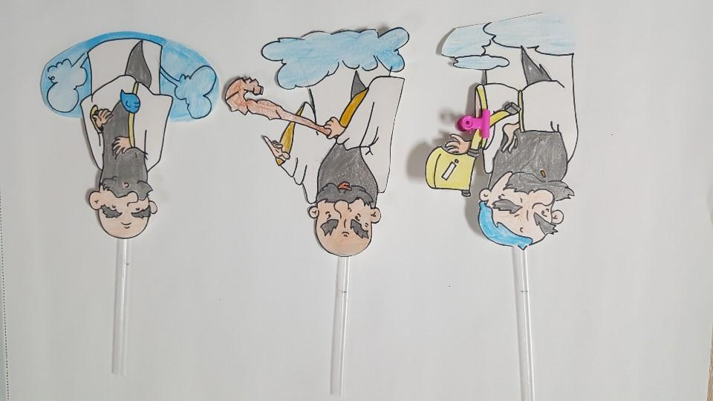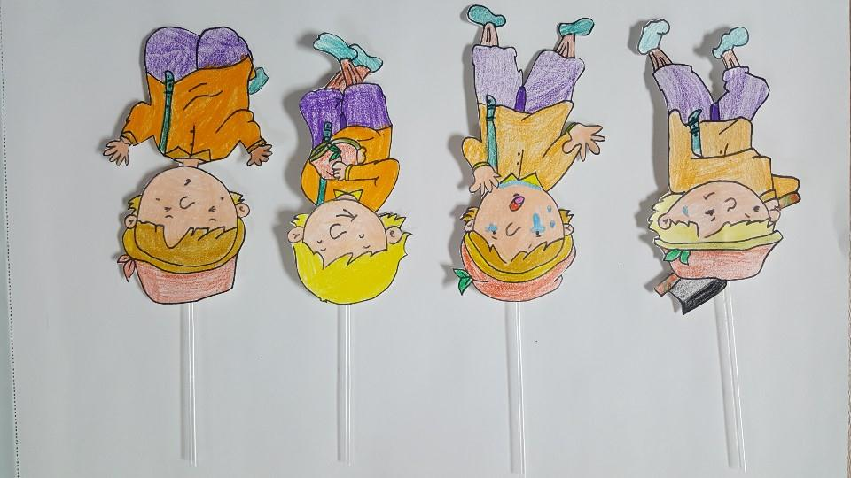
[A Mountain God Stick Puppets] [A Honest Woodcutter Stick Puppets]

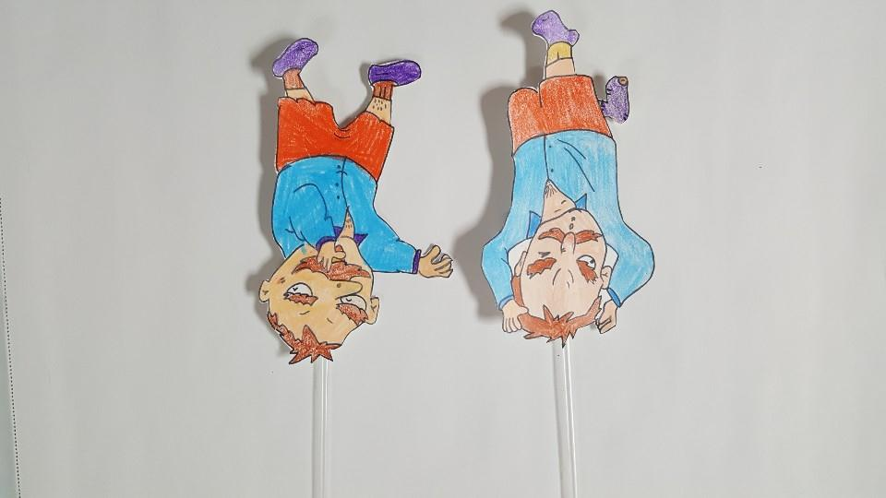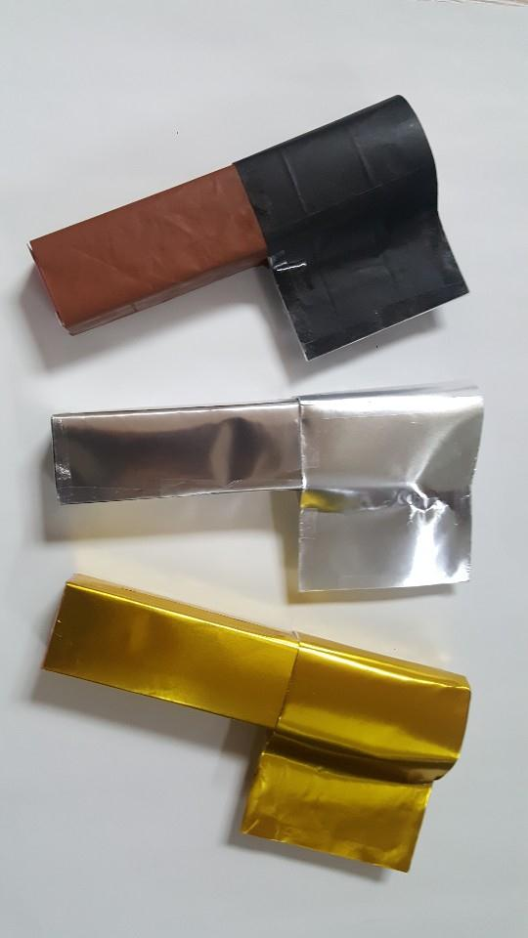
[A Greedy Woodcutter Stick Puppets] [Paper Axes]

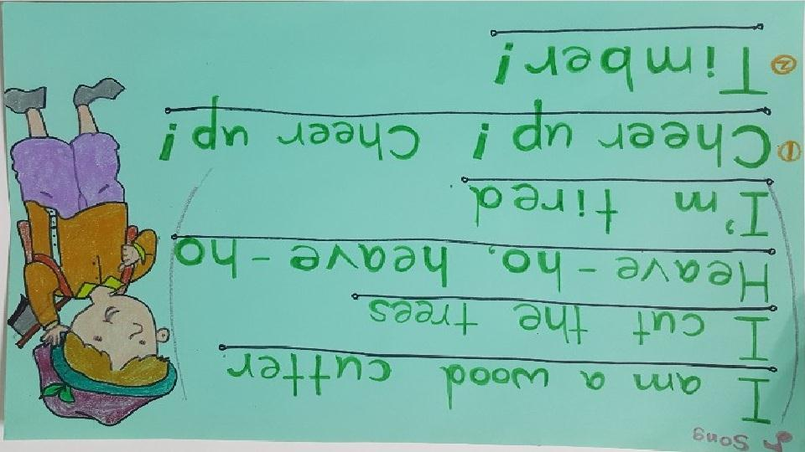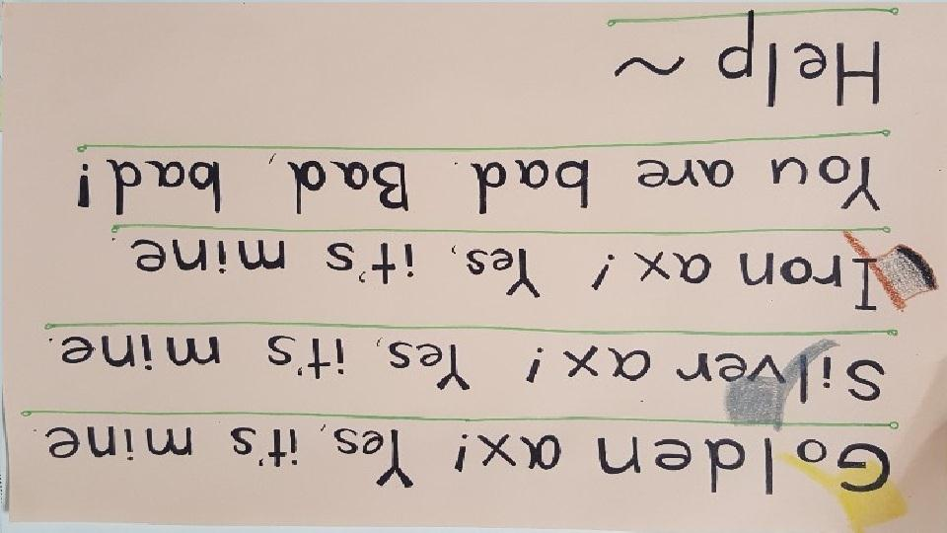
[Lylics 1] [Lylics 2]

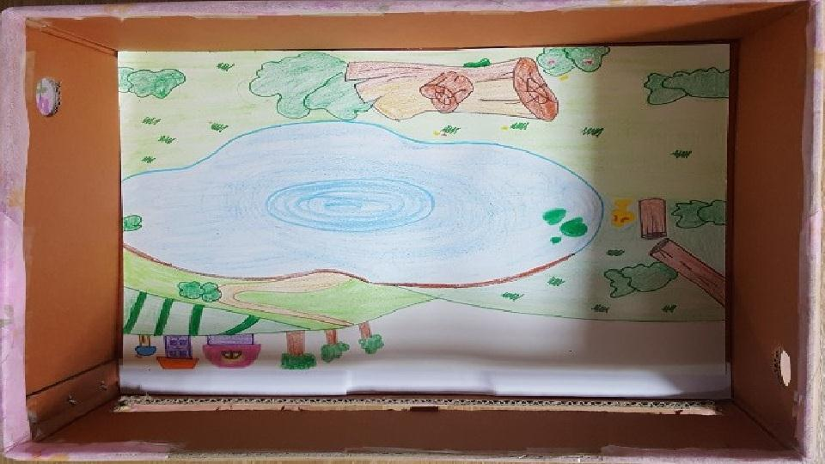
[Small Stage Box]

