Activity or Task Based Lesson Language Based or Presentation, Practice, Production PPP Based Lesson
Storytelling Lesson Plan Puppet Play Presentation

Topic: Seven Blind Mice

Instructor:  Sujin | Students Competency Level and Student ages  Elementary, 7-9 years old | Number of Students:  10 students | Lesson Length:  50 minutes
Materials: (List the Names of all materials used in the lesson. Materials must be shown at the end of this document)
- Whiteboard and Markers.
- Cell Phone
- Bluetooth Speaker
- “I Love Reading Song”
- The Lyrics of “I Love Reading Song”
- Story Summary Drawings on the Sketchbook.
- Teachers’ Guess Example
- “Seven Blind Mice” Story Book.
- 7 Different Shapes of Color Papers:
- A Pillar
- A Snake
- A Spear
- A Rope
- A Cliff
- A Fan
- A White Paper
- A4 White Papers

Lesson Objectives: The main objective of the lesson is to learn about the names of colors, days, orders and improve the ability to describe the object with the texture, shapes, pattern without saying the word.

Aims: (What students will be able to achieve by participating in the activities of the lesson. (Ss gain or get by doing…)
- Practice speaking skills by describing the object to other Ss.
- Improve writing skills by writing down the details of the animal in the flash card.
- Improve speaking skills by sharing your ideas with other Ss.
- Improve listening skills by listening to other S’s presentation.

Language Skills: (Lists what activities language skills students will be using by participating in the activities of the lesson.)
- Listening: (Where did listening occur in the lesson?)
When Ss listen to other S’s presentation.
When teacher talks about the story and the instruction.
- Speaking: (Where did speaking occur in the lesson?)
When T asks students questions about the story.
When Ss do presentation on their animals in the flash card.
- Writing: (Where did writing occur in the lesson?)
When Ss think and write down the details of the animal in the flash card.

Assumptions: (What students must already be able to do and what concepts must already be mastered before the lesson in order to achieve the aims of the lesson.)
- All Ss are aware of the names of animals.
- All Ss probably have enough vocabularies to describe the shapes of animals.
- All Ss will enjoy and also have fun.

Anticipated Errors and Solutions: (What things might go wrong in the lesson and what the solution will be. An SOS activity should also be included)
- If Ss may not have enough ideas. Inspire them by showing the example of the teacher.
- If the activity lasts too long Ss divide the class into group, and do group presentation.
- If the activity finished too soon Teacher suggests to read the vocabularies used in the class.
- If Ss may not understand the instruction: T helps them to explain more of examples.
- If certain Ss are shyT encourages them, give positive feedback, and change roles for them.

References:
www.google.com
www.naver.com
www.youtube.com

Lead-In or Pre-Task Part (Warm-Up Part to activate and create interest in the lesson.)
Materials: (List the Names of all materials used in the Lead-In or Pre-Task Part of the lesson. Materials must be shown at the end of this document)

- Whiteboard and Markers.
- Cell Phone
- Bluetooth Speaker
- I Love Reading Song MP3
- The Lyrics of “I Love Reading Song”
- Story Summary Drawings on the Sketchbook.

Time: | Classroom Set Up: | Student Activity and Goals: | Teacher Procedure &Instructions:
2min.  5min.  5min.  13min. | Whole  Whole  Whole  Whole | Ss listen and respond.  Ss listen to the song. Ss sing along.  Ss listen and guess.  Ss listen and try to figure out the storyline.  Ss guess. | T says greeting to Ss.  T asks Ss what they do at home when it’s cold.  T introduces what she does at home when it’s cold.  T plays “I Love Reading” song.  T hands in the lyrics of “I Love Reading” song to Ss.  T sings the song and suggests Ss to sing along.  T introduces story summary drawing on the sketchbook.  T asks students what is the object that seven blind mice have found.

Pre-Activity or Task Familiarization Part (Presentation Part for Presenting the language structure to be covered in the lesson. Prepares students for the communication activity.)
Materials: (List the Names of all materials used in the Pre-Activity or Task Familiarization Part of the lesson. Materials must be shown at the end of this document)
- Teachers’ Guess Example

Time: | Classroom Set Up: | Student Activity and Goals: | Teacher Procedure &Instructions:
5min. | Whole | Ss listen and try to guess what the object is. | T introduces teachers’ guess example to Ss.  T asks Ss to imagine what the object in the story is.

Main Activity or Task Realization Part(Practice to Production Part Teacher lead practice of the language presented and move to communication based more student centered activity)
Materials: (List the Names of all materials used in the Main Activity or Task Realization Part of the lesson. Materials must be shown at the end of this document)
- 7 Different Shapes of Color Papers:
- Pillar
- Snake
- Spear
- Rope
- Cliff
- Fan
- White Paper
- A4 White Papers.

Time: | Classroom Set Up: | Student Activity and Goals: | Teacher Procedure &Instructions:
1min.  9min.  5min. | Whole  Whole  Whole | Ss move the desk and sit down together.  Ss listen and guess.  Ss design their imagination.  Ss pastes color shapes on the paper.  Ss do presentation. | T changes the class into one table and sitting together.  T hands in 7 different shapes of color papers to Ss.  T asks to imagine and design the object of their guess first without pasting it on the paper.  T asks Ss to paste them on the paper.  T asks Ss to put the paper on the board and present their guess to Ss.

Post Activity or Post Task Part (Wrap-Up Part to Close the Lesson on a high note to and consolidate language learned in a communication based activity new situation.)
Materials: (List the Names of all materials used in the Post Activity or Post Task Part of the lesson. Materials must be shown at the end of this document)
- “Seven Blind Mice” Story Book.
- Cell Phone
- Bluetooth Speaker
- “I Love Reading” Song MP3

Time: | Classroom Set Up: | Student Activity and Goals: | Teacher Procedure &Instructions:
5min.  3min.  5min. | Whole  Whole  Whole | Ss listen and found out the answer by listening to the story.  Ss listen.  Ss sing along the song.  Clap hands together. | T shows Ss “Seven Blind Mice” story book and tells them what the object was.  T wraps up by telling the lesson on the book.  “Knowing in part may make a fine tale, but wisdom comes from seeing the whole”  T suggests to sing along “I Love Reading” Song.  Congratulate and T appreciates Ss participation.

- The Lyrics of “I Love Reading Song”
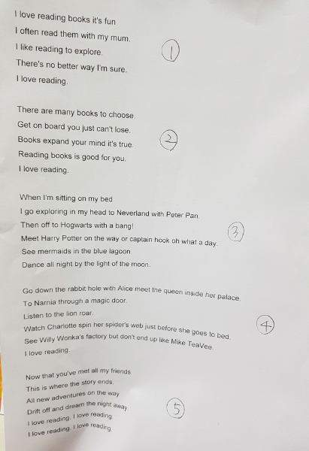

- Story Summary Drawings on the Sketchbook.
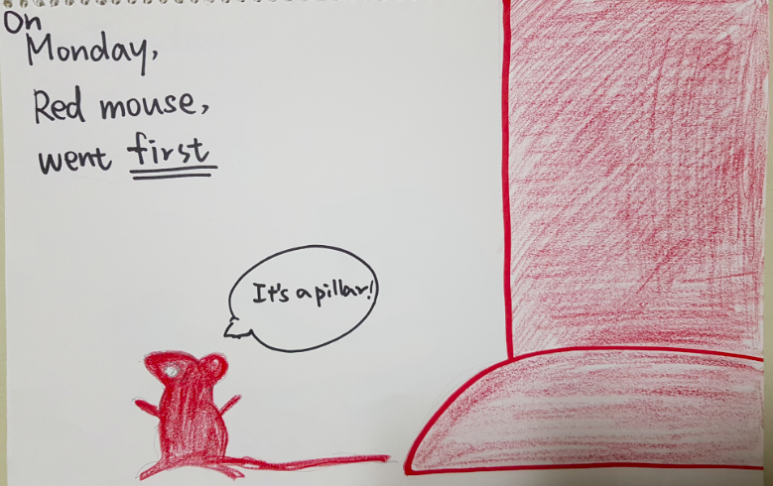

- Teachers’ Guess Example

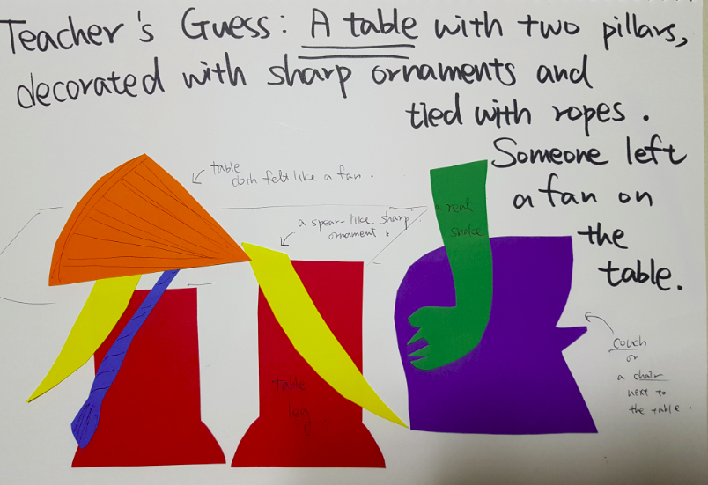
- “Seven Blind Mice” Story Book.
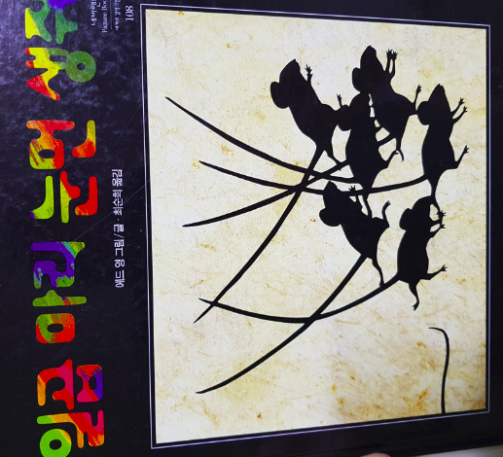
- 7 Different Shapes of Color Papers:
- A Pillar
- A Snake
- A Spear
- A Rope
- A Cliff
- A Fan
- A White Paper
