X Activity or Task Based Lesson Language Based or Presentation, Practice, Production PPP Based Lesson
Storytelling Lesson Plan Puppet Play Presentation

Topic: Recycle Cycle and Recycled Art

Instructor:  Penny | Students Competency Level and Student ages  7-8 years old, Elementary | Number of Students:  12 | Lesson Length:  60min
Materials:(List the Names of all materials used in the lesson. Materials must be shown at the end of this document)

- White Board and Markers
- Whale Pictures
* Warning Sculpture
* Whale Dies from Eating Plastic Bags
* Plastic Bags from a Whale’s Stomach
- Recycle Symbol
- Teacher’s Sample Ride The Recycle Cycle
- Recycled Art
* Elephant Picture
* Students’ Sample Recycled Art
- Recycled Waste
- Teacher’s Sample Recycled Art
- Cellphone
- Bluetooth Speaker
- Reduce Reuse Recycle Song
- Reduce Reuse Recycle Song Lyrics
- Color Paper
Lesson Objectives(What do you want the students to know (new skill or knowledge that you want them to gain)?AndWhat do you want them to be able to do?
Ss will understand what is the recycle cycle and be able to make recycled art by participating in activities of the lesson
Aims:(What students will be able to achieve by participating in the activities of the lesson. (Ss gain or get by doing…)
Ss will get interested in lesson by listening to T presentation about Ride The Recycle Cycle
Ss will improve listening and speaking skills by responding to T and sharing opinions in class
Ss will participate in fun in English communication activity by creating their own Recycled Art
Ss will improve interaction and communication skills by having a discussion during making a Ride The Recycle Cycle
Ss will gain writing skills by preparing a Ride The Recycle Cycle
Language Skills:(Lists what activities language skills students will be using by participating in the activities of the lesson.)
- Reading: (Where did reading occur in the lesson?)
Whiteboard, Ride The Recycle Cycle
- Listening:(Where did listening occur in the lesson?)
Teachers talk, discussion, presentation of other students
- Speaking: (Where did speaking occur in the lesson?)
Discussion, answering teacher, presentation
- Writing: (Where did writing occur in the lesson?)
Ride The Recycle Cycle
Assumptions:(What students must already be able to do and what concepts must already be mastered before the lesson in order to achieve the aims of the lesson.)
Ss have had a recycled waste before or seen by the media
Ss have an opinion about recycle cycle
Ss understand recycle cycle
Ss know general vocabulary and basic grammar of the lesson
Anticipated Errors and Solutions:(What things might go wrong in the lesson and what the solution will be. An SOS activity should also be included)
If Ss can not have many ideas, T gives them some hints or suggestions
If the first activity lasts too long, T gives the second activity for the next lesson
If all the activities are finished too soon, T asks Ss to present recycled art

References:
https://www.naver.com/
https://www.google.com/
- YouTube(Reduce Reuse Recycle Song)

Lead-In or Pre-Task Part (Warm-Up Part to activate and create interest in the lesson.)
Materials: (List the Names of all materials used in the Lead-Inor Pre-Task Partof the lesson. Materials must be shown at the end of this document)

- White Board and Markers
- Whale Pictures
* Warning Sculpture
* Whale Dies from Eating Plastic Bags
* Plastic Bags from a Whale’s Stomach
- Recycle Symbol
Time: | Classroom Set Up: | Student Activity and Goals: | Teacher Procedure &Instructions:
1  3  7 | Whole  Whole  Ss | Greet teacher  Respond and listen to the teacher  Respond and write on the whiteboard and understand vocabulary | Greeting  T share the story of whale  Show the whale pictures and waste pictures and then tell a story about them  Elicit the Recycle Cycle stories from Ss  Asks Ss to tell recycled waste and Ss write down the list on the whiteboard. Elicit and discuss vocabulary Reduce, Reuse, Recycle to ensure Ss understand

Pre-Activity or Task Familiarization Part (Presentation Partfor Presenting the language structure to be covered in the lesson. Prepares students for the communication activity.)
Materials: (List the Names of all materials used in the Pre-Activity or Task Familiarization Part of the lesson. Materials must be shown at the end of this document)
- White Board and Markers
- Teacher’s Sample Ride The Recycle Cycle
- Cellphone
- Bluetooth Speaker
- Reduce Reuse Recycle Song
- Reduce Reuse Recycle Song Lyrics
Time: | Classroom Set Up: | Student Activity and Goals: | Teacher Procedure &Instructions:
2  4  2  5 | Whole  Whole  Whole  Whole | Listen and what T says  Ss come out and write down Ride The Recycle Cycle  Ss listen to the song  Ss sing a song together | Introduce Ride The Recycle Cycle  T asks Ss to write down key words on the board  T gives Ss positive feedback and comments  Introduce Reduce Reuse Recycle Song  T sings a song first to Ss  And Ss sing a song together  T gives Ss positive feedback and comments

Main Activity or Task Realization Part(Practice to Production PartTeacher lead practice of the language presented and move to communication based more student-centered activity)
Materials: (List the Names of all materials used in the Main Activity or Task Realization Partof the lesson. Materials must be shown at the end of this document)
- White Board and Markers
- Recycled Art
* Elephant Picture
* Students’ Sample Recycled Art
- Recycled Waste
- Color Paper
Time: | Classroom Set Up: | Student Activity and Goals: | Teacher Procedure &Instructions:
2  10  8 | Whole  Ss  Whole | Listen and what T says  Ss get ready to make their own Recycled Art  Ss listen what Ss says and Ss applaud other Ss | Introduce Recycled Art  Gives instruction in Recycled Art. Give an example of T’s Recycled Art  T asks Ss to make their own Recycled Art and prepare presentations  T monitors making Ss’ Recycled Art . Give encouragement to each Ss and facilitates class feed back to Recycled Art  Each Ss comes out and present their Recycled Art to other Ss in the class  Gives Ss positive feedback and facilitate feedback from class and comments

Post Activity or Post Task Part (Wrap-Up Part to Close the Lesson on a high note to and consolidate language learned in a communication-based activity new situation.)
Materials: (List the Names of all materials used in the Post Activity or Post Task Part of the lesson. Materials must be shown at the end of this document)
- Recycled Art
* Elephant Picture
* Students’ Sample Recycled Art
- Recycled Waste
- Cellphone
- Bluetooth Speaker
- Reduce Reuse Recycle Song
- Reduce Reuse Recycle Song Lyrics
Time: | Classroom Set Up: | Student Activity and Goals: | Teacher Procedure &Instructions:
5  2 | Ss  Whole | Each Ss tells their opinion and others listen  Applaud  T&Ss sing a song together | T asks Ss to tell what was a good idea about other Ss’ Recycled Art  And what would you add more?  T encourages their opinions  T&Ss sings a song together  (Reduce Reuse Recycle Song)  Close by giving Ss feedback about their accomplishment.  Thanks Ss for participation.
-Whale Pictures
*Warning Sculpture
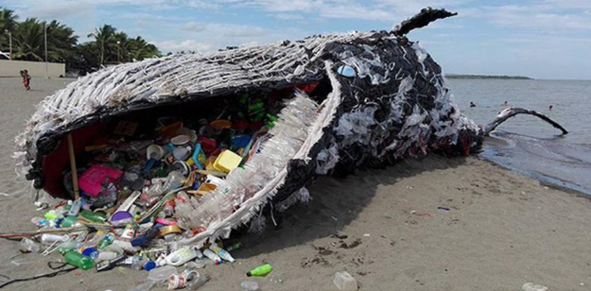
*Whale Dies from Eating Plastic Bags *Plastic Bags from a Whale’s Stomach
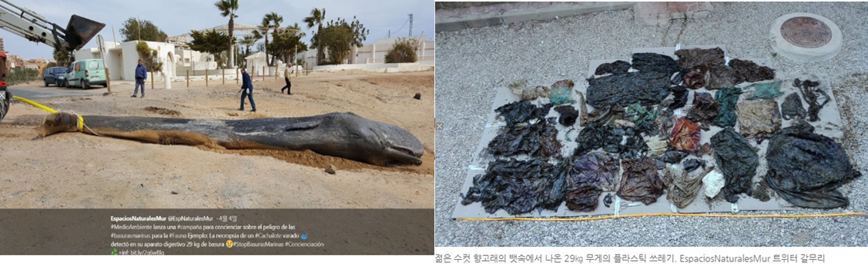

- Recycle Symbol
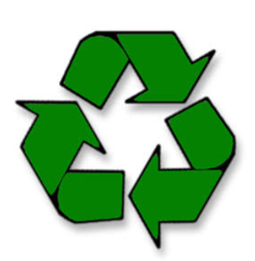
- Teacher’s Sample Ride The Recycle Cycle
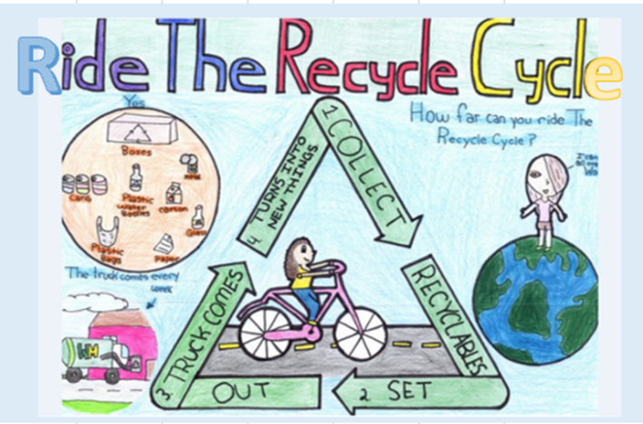

-Reduce Reuse Recycle Song Lyrics
Reduce, Reuse, Recycle
It's very easy to do
It's simple to remember
Recycle what you use!

Separate glass and paper
Separate plastic and tin
Then put them their places
In the recycling bin!

Plastic with plastic
Paper with paper
Tin with tin
And glass with glass

Reduce, Reuse, Recycle
It's very easy to do
It's simple to remember
Recycle what you use!

Separate glass and paper
Separate plastic and tin
Then put them their places
In the recycling bin!

Good for you !
-Recycled Art
* Elephant Picture
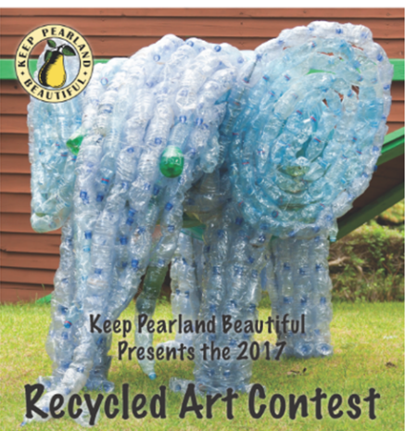

*Students’ Sample Recycled Art
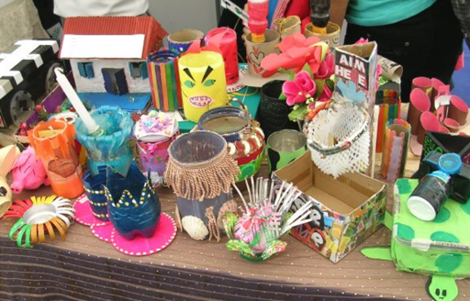
- Teacher’s Sample Recycled Art
