Activity or Task Based Lesson Language Based or Presentation, Practice, Production PPP Based Lesson
Storytelling Lesson Plan XXX Puppet Play Presentation

Topic: The Musicians of Bremen

Instructor:  Sally, Elin, Julia | Students Competency Level and Student ages  7-8 years old, Elementary | Number of Students:  10 | Lesson Length:  85min
Materials:(List the Names of all materials used in the lesson. Materials must be shown at the end of this document)
- Picture of the Statue of Bremen Musicians
- Bremen Town Musicians Word Search Worksheet
- Coloring Worksheet
- Writing Worksheet
- Musical Instruments Worksheet
- Puppet Play Script
- Play Stage
- Phone
- Bluetooth Speaker
- Puppets
- Rosy
- Bakki
- Pinkyfrog
- Donkey
- Dog
- Cat
- Hen
- Master
-Thief 1
-Thief 2
- Role Play Masks
- Donkey Mask
- Dog Mask
- Cat Mask
- Hen Mask
- Background Pictures
- Scene 1
- Scene 2
- Scene 3
- Scene 4
- Scene 5
- Scene 6
- Musical Songs MP3
- Donkey Song
- Dog Song
- Cat Song
- Hen Song
- A Beautiful Song
- Ending Song
- Instruments Sounds MP3
- Castanets
- Triangle
- Drum
- Trumpet
- Xylophone
- Flute
- Harmonica
- Piano
- Accordion
- Guitar
- Feliz Nvidad Song
- Instruments
- Hairbands

Lesson Objectives (What do you want the students to know (new skill or knowledge that you want them to gain)? And What do you want them to be able to do?
Ss will enjoy hearing a famous children’s story by puppet play and playing the musical instruments
Aims:(What students will be able to achieve by participating in the activities of the lesson. (Ss gain or get by doing…)
Ss will get interested in a story by watching puppets’ talk
Ss will improve listening skills by watching a puppet play
Ss will participate with fun in English communication activity by playing the musical instruments
Ss will improve interaction and communication skills by having discussion in a group
Ss will gain writing skills by writing their ideas
Language Skills:(Lists what activities language skills students will be using by participating in the activities of the lesson.)
- Reading: (Where did reading occur in the lesson?)
Worksheet
- Listening:(Where did listening occur in the lesson?)
Puppets’ talk, Puppet play, Musical songs, Students’ presentation
- Speaking: (Where did speaking occur in the lesson?)
Answering for puppets, Presentation, Singing
- Writing: (Where did writing occur in the lesson?)
Worksheet
Assumptions:(What students must already be able to do and what concepts must already be mastered before the lesson in order to achieve the aims of the lesson.)
Ss may have worries in their mind
Ss think playing musical instruments is fun
Ss like to watch musical play
Ss know general vocabulary and basic grammar of the lesson
Anticipated Errors and Solutions:(What things might go wrong in the lesson and what the solution will be. An SOS activity should also be included)
If Ss my not have many ideas on writing activity, T gives them some hints or suggestions
If the class lasts too long, T plays the carol once or gives the last activity for the next lesson
If the class finishes soon, T plays another song and play the instruments with new song
References:
https://www.youtube.com/watch?v=MyxCB-hLYMA
Donkey Song: https://www.youtube.com/watch?v=GQB5IJPRxgA
Dog Song: https://www.youtube.com/watch?v=lmfDR5z_1yw
Hen Song: https://www.youtube.com/watch?v=ZKMmb5tPKpw
Cat Song: https://www.youtube.com/watch?v=J3FiT4-zo-c
A Beautiful Song: https://www.youtube.com/watch?v=Fh3hKc5Enfc
Ending Song: https://www.youtube.com/watch?v=ekNIp0UT2uA

Lead-In or Pre-Task Part (Warm-Up Part to activate and create interest in the lesson.)
Materials: (List the Names of all materials used in the Lead-In or Pre-Task Part of the lesson. Materials must be shown at the end of this document)
- Picture of the Statue of Bremen Musicians
- Puppets
- Rosy
- Bakki
- Pinkyfrog

Time: | Classroom Set Up: | Student Activity and Goals: | Teacher Procedure &Instructions:
1  2  3  3 | Whole  Whole  Ss  Ss | Greet teachers  Greet puppets  Answer for Bakki  Listen to puppets | Greet students  Introduce puppets of Rosy, Bakki, and Pinkyfrog  Bakki asks Ss if they have worries  Rosy tells about her worry, Bakki and Pinkyfrog introduce Musicians of Bremen story with a Picture of the Statue of Bremen Musicians

Pre-Activity or Task Familiarization Part (Presentation Part for Presenting the language structure to be covered in the lesson. Prepares students for the communication activity.)
Materials: (List the Names of all materials used in the Pre-Activity or Task Familiarization Part of the lesson. Materials must be shown at the end of this document)
- Bremen Town Musicians Word Search Worksheet
- Coloring Worksheet
- Role Play Masks
- Donkey Mask
- Dog Mask
- Cat Mask
- Hen Mask
- Musical Songs MP3
- Donkey Song
- Dog Song
- Cat Song
- Hen Song
- Phone
- Bluetooth Speaker

Time: | Classroom Set Up: | Student Activity and Goals: | Teacher Procedure &Instructions:
1  8  5 | Ss  Ss  Ss | Get the worksheet  Find the words and color the drawing  Watch and listen to teachers | Hand out Bremen Town Musicians Word Search Worksheet and Coloring Worksheet  Ask Ss to find the main characters’ words and color the animals on the sheet  Wear Role Play Masks and introduce main characters by singing and dancing along the Musical Songs

Main Activity or Task Realization Part (Practice to Production Part Teacher lead practice of the language presented and move to communication based more student-centered activity)
Materials: (List the Names of all materials used in the Main Activity or Task Realization Part of the lesson. Materials must be shown at the end of this document)
- Play Stage
- Puppet Play Script
- Puppets
- Donkey
- Dog
- Cat
- Hen
- Master
-Thief 1
-Thief 2
- Background Pictures
- Scene 1
- Scene 2
- Scene 3
- Scene 4
- Scene 5
- Scene 6
- Musical Songs MP3
- Donkey Song
- Dog Song
- Cat Song
- Hen Song
- A Beautiful Song
- Ending Song
- Phone
- Bluetooth Speaker
- Writing Worksheet

Time: | Classroom Set Up: | Student Activity and Goals: | Teacher Procedure &Instructions:
20  3  1  1  1  6  5 | Ss  Ss  Ss  Groups  Groups  Groups  Groups | Watch the Puppet Play  Answer for T  Listen to T  Move into groups  Get the worksheet  Discuss in groups and write  down their ideas on the worksheet  Present their ideas | Play the puppet play by Puppet Play Script  Ask Ss what they liked about the story  Give instructions for writing activity  Divide into groups  Hand out Writing Worksheet  Ask Ss to discuss and write how they would trick the thieves if they were the animals from the story  Ask Ss to share their ideas

Post Activity or Post Task Part (Wrap-Up Part to Close the Lesson on a high note to and consolidate language learned in a communication-based activity new situation.)
Materials: (List the Names of all materials used in the Post Activity or Post Task Part of the lesson. Materials must be shown at the end of this document)
- Play Stage
- Musical Instruments Worksheet
- Instruments Sounds MP3
- Castanets
- Triangle
- Drum
- Trumpet
- Xylophone
- Flute
- Harmonica
- Piano
- Accordion
- Guitar
- Feliz Nvidad Song
- Phone
- Bluetooth Speaker
- Instruments
- Hairbands

Time: | Classroom Set Up: | Student Activity and Goals: | Teacher Procedure &Instructions:
2  1  3  5  3  2  2  3  3  1 | Whole  Ss  Ss  Ss  Ss  Ss  Ss  Ss  Ss  Ss | Listen to T  Answer for T  Listen to the sounds  Fill out the worksheet  Listen to T and answer  Pick one of the instruments and one of the hairbands  Try to make a sound of the instrument and practice  Play the instrument along the song  Play the instrument and dance  Applaud | Tell Ss the Bremen Town Musicians are going to perform a concert for Christmas and want Ss to join them  Ask Ss if they want to join the performance  Hand out Musical Instruments Worksheet and play Instruments Sounds  Ask Ss to write musical instruments’ name on the worksheet  Introduce Instruments and ask Ss what they are  Give Instruments and Hairbands to Ss  Ask Ss to pick one each they want to play and wear  Let each of Ss make the sound of their instrument and practice to make beats  Play Feliz Nvidad Song and ask Ss to play their instruments along the song  Play the song one more time and ask Ss to paly the instrument and dance  Congratulate and thank Ss for accomplishment

- Picture of the Statue of Bremen Musicians
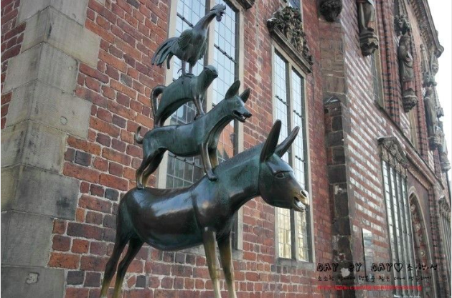
- Puppets
- Rosy - Pinkyfrog - Bakki
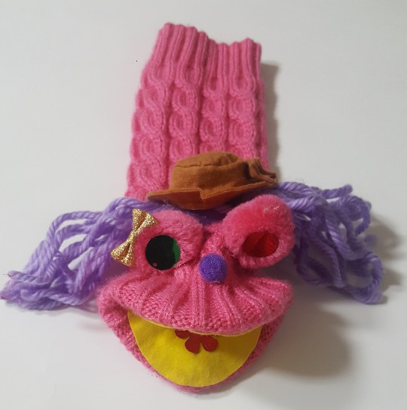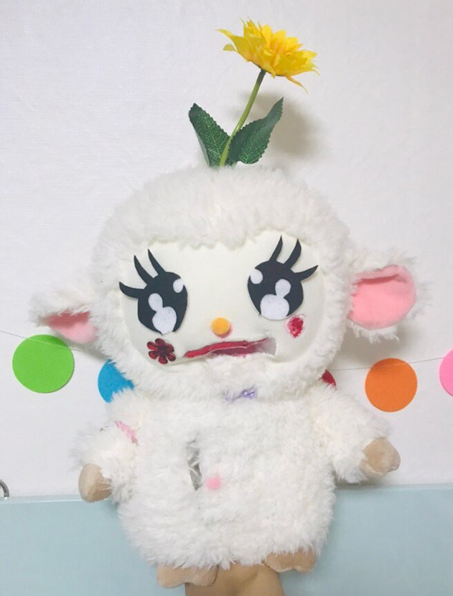
- Donkey - Dog - Cat
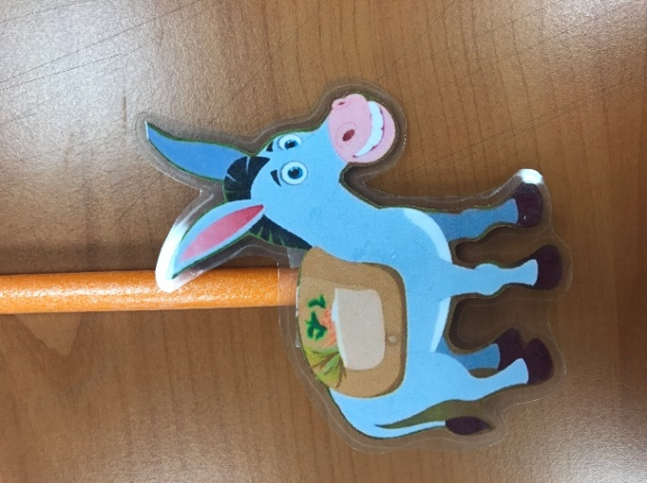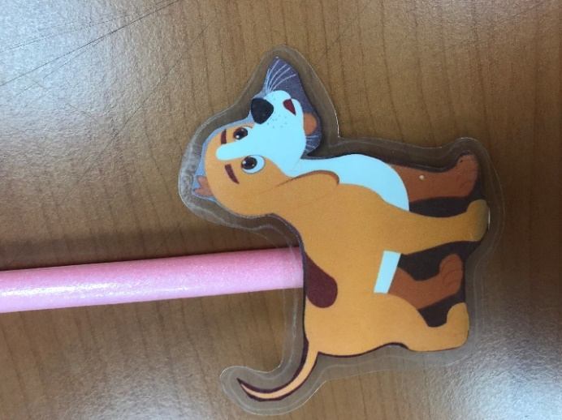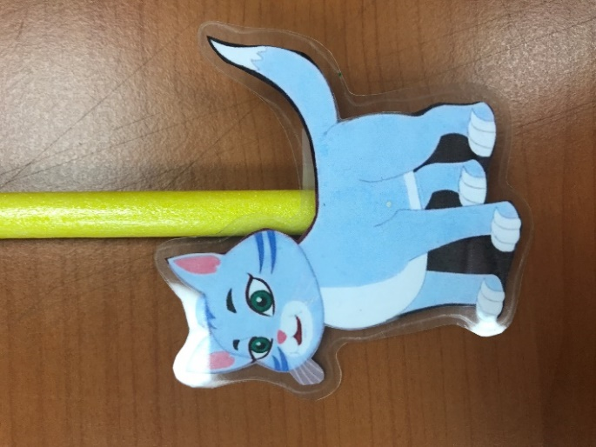
- Hen - Master
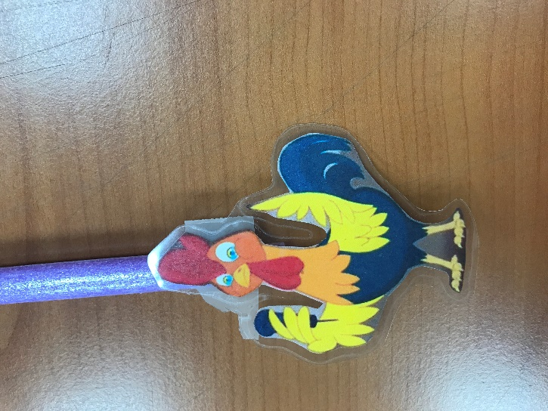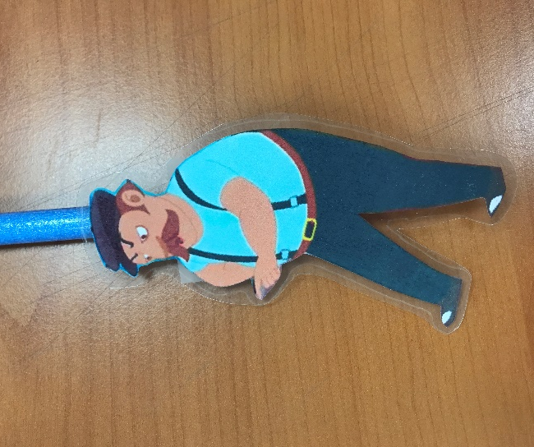
-Thief 1 - Thief 2
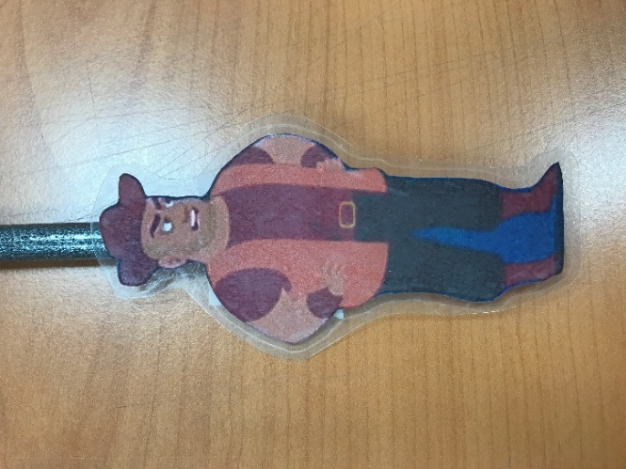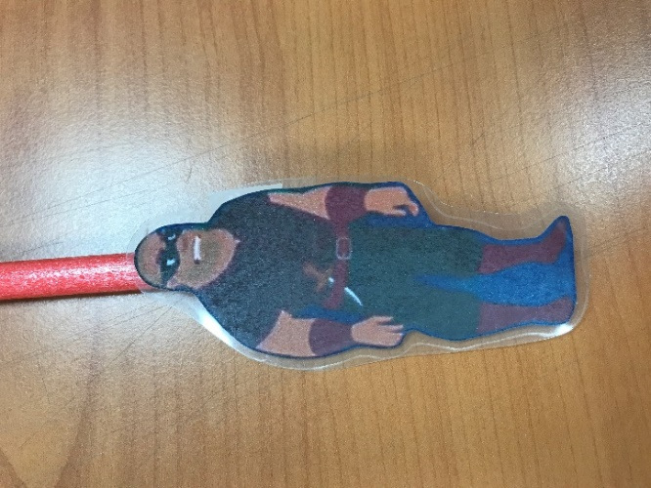
- Role Play Masks
- Donkey Mask - Dog Mask
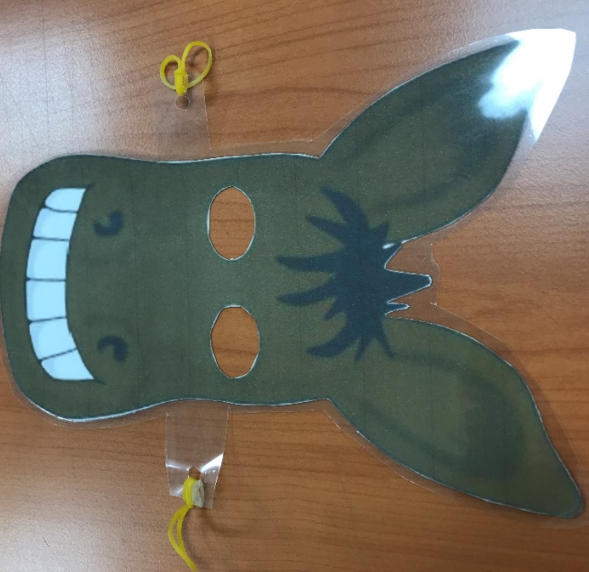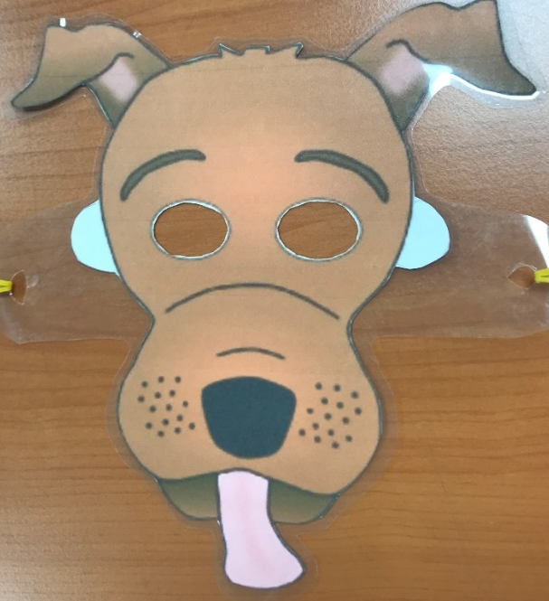
- Cat Mask - Hen Mask
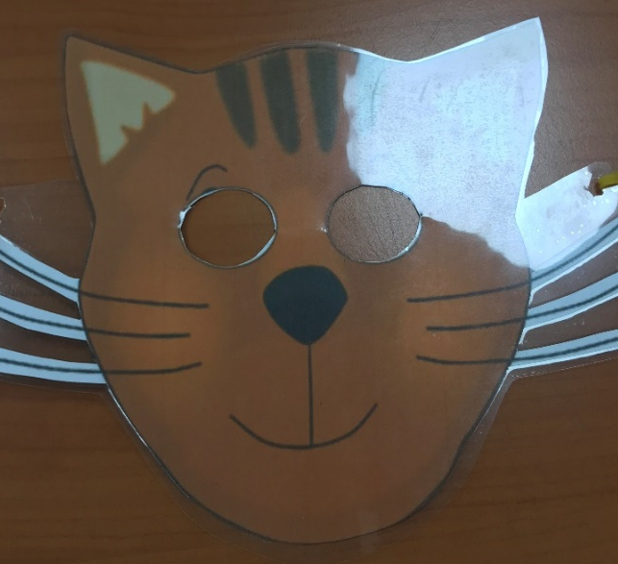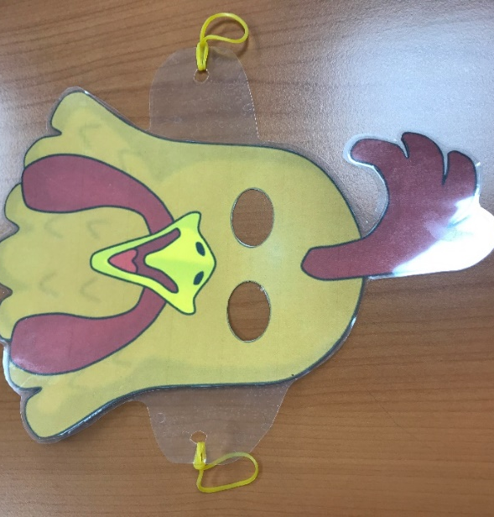
- Play Stage
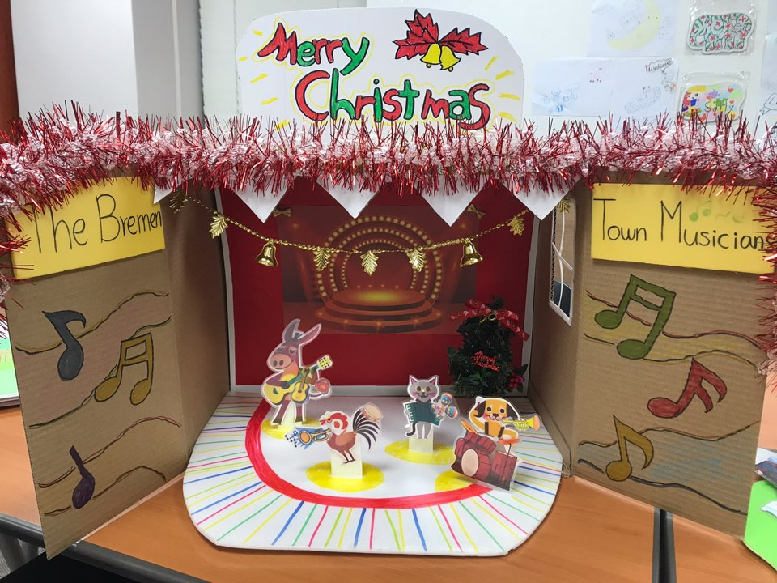
- Background Pictures
- Scene 1 -Scene 2
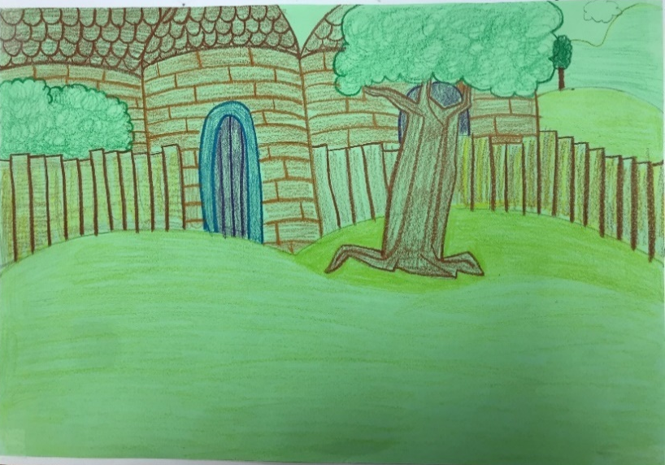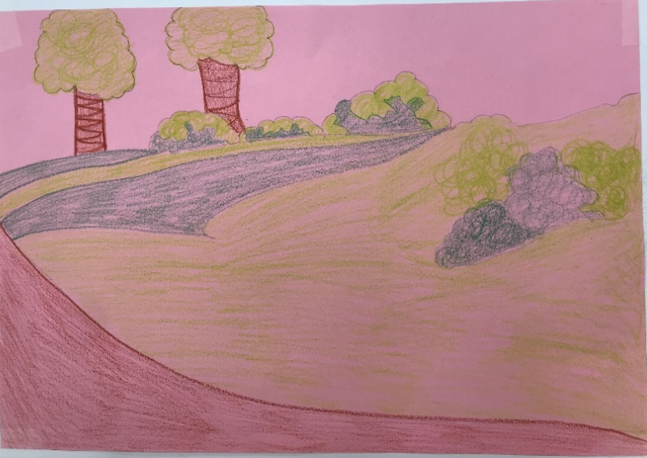

- Scene 3 -Scene 4
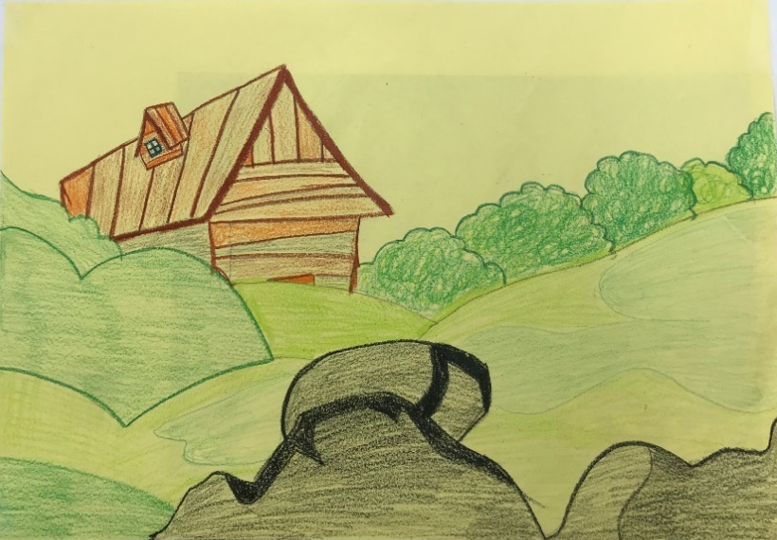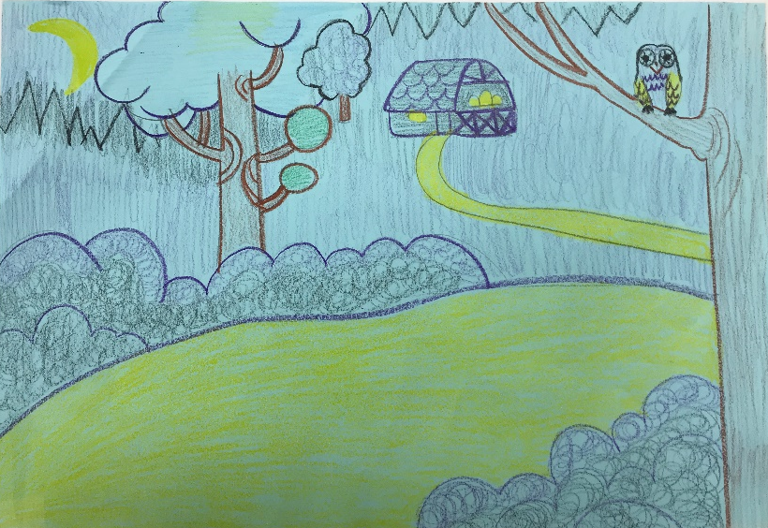

- Scene 5 - Scene 6
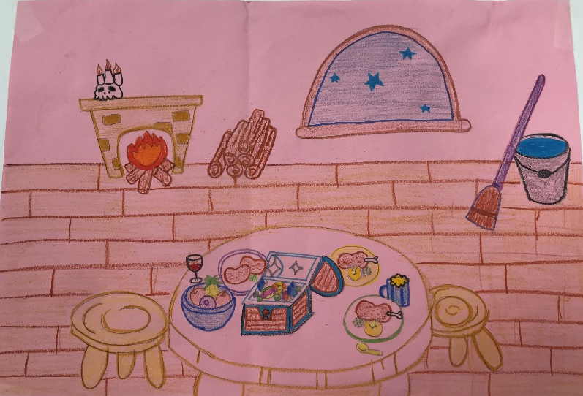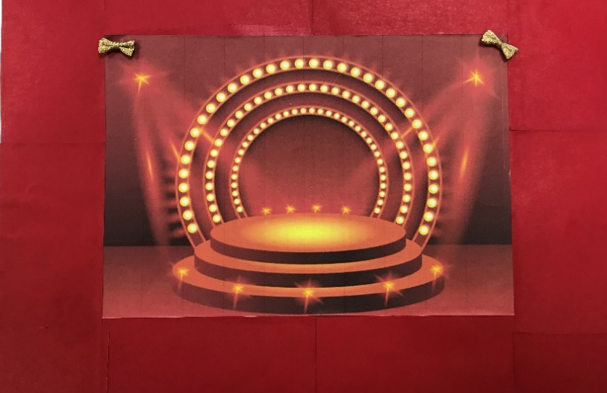

- Writing Worksheet - Coloring Worksheet
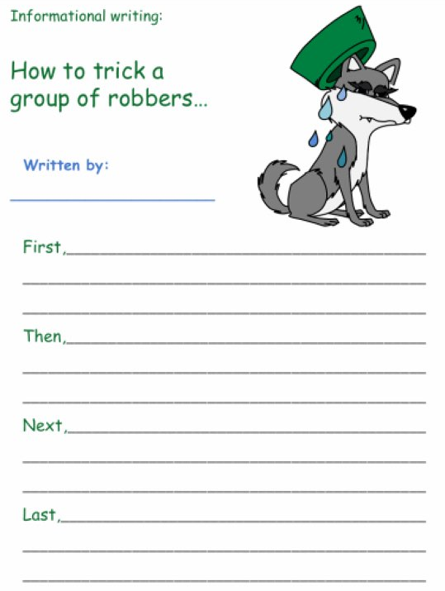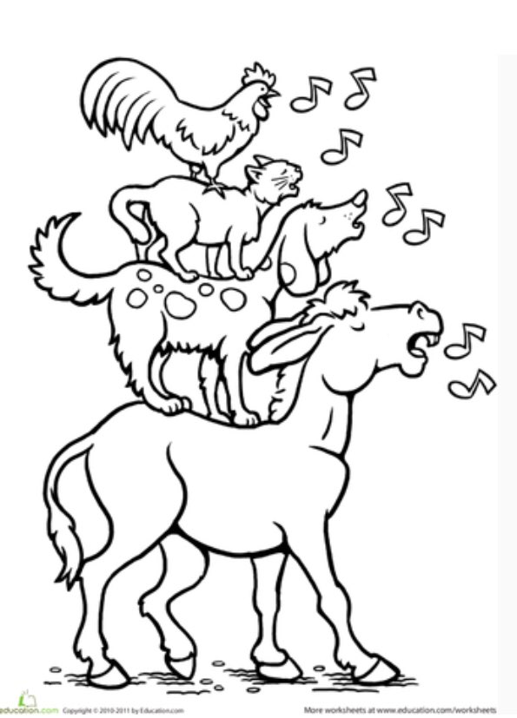
- Bremen Town Musicians Word Search Worksheet - Musical Instruments Worksheet
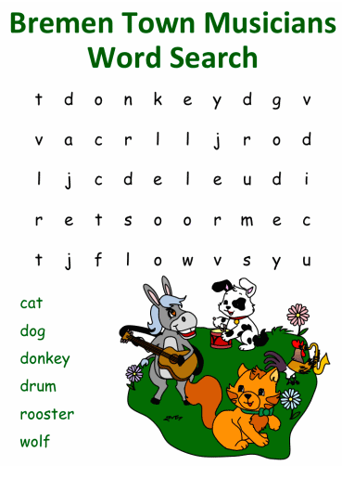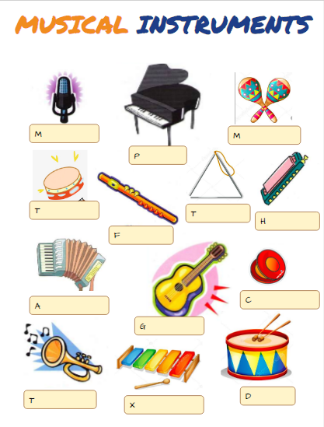
- Instruments - Hairbands
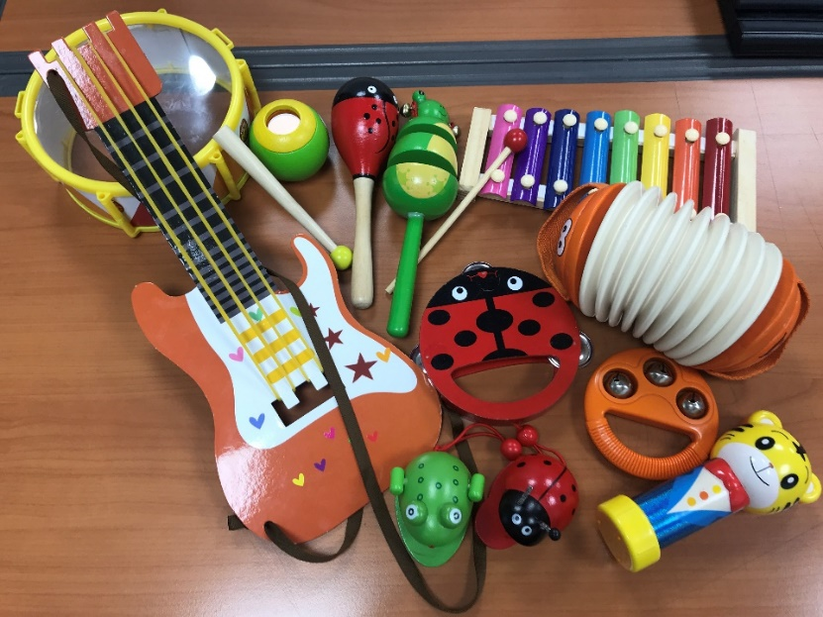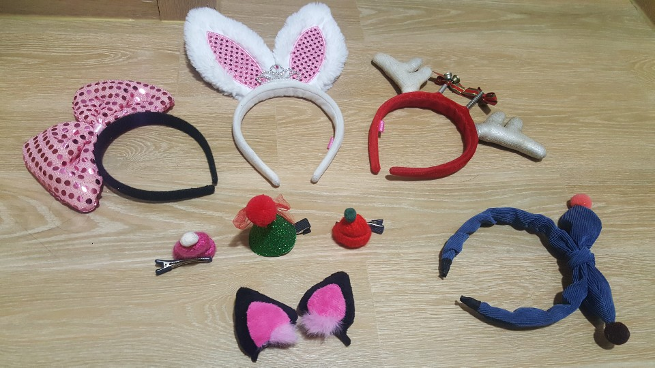

- Puppet Play Script

-The Bremen Town Musicians-
SCENE1
(Once upon a time, there was an old donkey.)
DONKEY: Oh my, I am now so old… I cannot do what my master asks.
Master: You old donkey! I will kill you and sell your skin to make drum!
DONKEY: Oh no!! I don’t want to die…What should I do? Right!
I will join the Bremen town musicians and play guitar which I love. It’s going to be so much fun!!
[SING] (The donkey understood his master’s plan and left for Bremen.)
SCENE2
(On his way, he saw an old dog lying in the grass.)
DOG: Woof, woof! Woof, woof!
DONKEY: What are you doing here, Mr.Dog? You look sad.
DOG: Well, I have become so old and my legs have become weak. I can no longer hunt rabbits and gather the sheep for my master anymore. My owner tried to shoot me with his rifle, so, I ran away!
DONKEY: Oh, no! Why don’t you come with me to Bremen? I’m joining the Bremen town musicians.
DOG: Woof, woof! That will be exciting! I will play the drum! We will be musicians!
(The dog agreed and the two new friends continued their journey.)
[SING] (In some time, they came upon a cat sitting by the road.
Looking like the skies were about to come down on him.)
CAT: Meow….
DOG: What’s wrong with you, Mr.Cat? Why do you look so sad?
CAT: I have grown old and my claws don’t grow anymore. I can no longer catch mice.
My mistress tried to throw me into the river, so I ran away!
DOG: Oh, that’s not nice. I have a n idea! The donkey and I are going to Bremen to become musicians. Why don’t you join us?
CAT: Meow! I can sing well and I can play the accordion!
(The cat liked the idea very much and made his escape with his two new friends.) [SING]
SCENE3
(They had only walked a while when they came upon a hen. She was singing without a stop.)
HEN: Cock-a-doodle-doo~!!
CAT: What’s the matter with you, Ms.Hen? You are singing like yelling.
HEN: Well, my master hates me because I am old. He is having a big dinner party over tonight and he is going to cook me for a soup. My head will be cut off this evening. So, I am singing until my neck and throat can sing.
DONKEY: That’s terrible. No worries. We are all going to Bremen to become musicians.
DOG: Come with us to Bremen. I think you will make a wonderful singer!
HEN: Yeah! I can sing very well!
[SING] (And so, the four went marching to Bremen…. which was still very far.)
[SING TIGETHER] A Beautiful Song
SCENE4
(As night fell, it was getting dark, they felt tired and hungry.)
CAT: We must find a place to eat and rest for the night.
DONKEY, DOG, HEN Yes!! I am hungry~~
Everybody agreed and they decided to look for a place to spend the night.
DOG: Everybody, look! There is a light over there!
DONKEY: It’s a house! We should stay there for the night.
(In some time, they came upon a lonely house. Its lights were lit and they could hear the sounds of a gathering from inside.
The cat climbed up a tree and peeped in from an open window.)
SCENE5
THIEVES: Wow, those people we stole from were really rich! We will never run out of food! Hahahaha!!
CAT: Look at them. They are thieves. There are delicious meats and drinks on the table.
DOG: I want to eat some of bones with meat right now.
HEN: I want to drink wine. I am thirsty!
DONKEY: Let’s teach them a lesson. I have a plan.
CAT, DOG, HEN: Let’s hear it! [WHISPER TOGETHER]
(The four friends came up with a plan to drive the robbers away.
The donkey put his front feet on the window. And the dog climbed over his back.
The cat jump onto the dog and the hen flew on to the top of the cat’s head.)
Once they were ready, they scared the thieves.
DONKEY: Ee-Ah!! / DOG: Woof! / CAT: Meow! / Hen: Cock-a-doodle-do!
TOGETHER: We will get you!
THIEVES: It’s a monster! Let’s get out of here!
(The robbers were scared by the animals’ big sound and quickly ran away from the house.)
DONKEY: We made it!
HEN: The thieves learned their lesson and will never steal again.
As soon as thieves were gone. They went into the house and ate delicious food on the dining table.)
CAT: Meow, the house is so warm.
DOG: Woof, I like this steak, it’s yummy!
HEN: We did a good job! I am so proud of us!
DONKEY: Yeah! Let’s have a party! Before we go to Bremen, let’s play our music together!
SCENE6
[SING TIGETHER] Ending song
The old animals wanted to live in this house. So, they did not go to Bremen., but they called themselves ‘The Bremen Town Musicians’
And so, the donkey, the dog, the cat, and the hen lived happily ever after in their new home full of delicious food and joyful music.

