☐ Activity or Task Based Lesson ☐ Language Based or Presentation, Practice, Production PPP Based Lesson
☐ Storytelling Lesson Plan XXX Puppet Play Presentation

Topic, Story Title, or Puppet Play Name:
Endangered Animals, Environment in Danger
Instructor:  Sujin  Seul | Students Competency Level and Student ages  7-8 years old, Elementary | Number of Students:  12 | Lesson Length:  80 minutes
Materials:(List the Names of all materials used in the lesson. Materials must be shown at the end of this document)
- Hand Puppet
  - Choco-saurus Puppet
  - Dragon-saurus Puppet
  - Angel and Devil Puppet
- Whiteboard and Markers
- Down by the Jungle Song Lyrics
- Down by the Bay (Original ver.) Song MP3
- Cell phone as Speaker
- Stages
  - Jungle
  - Under the Sea
  - Arctic Sea
  - City
- Lap-top
- Stages Sound effects
- Sketchbook Visual-aids
- Habitat
- Lyrics Blank Board
- Activity materials
- Tree memo (#Scene1)
- Plastic Straws & Silicon, Stainless Straws (#Scene2)
- Ice Bridge Foams (#Scene3)
- True/False Sticks
- Lyrics Words Card
- Endangered Animals Worksheet

Lesson Objectives(What do you want the students to know (new skill or knowledge that you want them to gain)? andWhat do you want them to be able to do?
- Ss will comprehend endangered animals and environment issue by watching the puppet play and participating in the activities.
Aims:(What students will be able to achieve by participating in the activities of the lesson. (Ss gain or get by doing…)
- Improve speaking skills by participating in the activities and responding to puppets.
- Improve listening skills by participating in an activity, responding to puppets.
- Improve reading skills by reading the worksheet instructions and singing with lyrics.
- Improve writing skills, interaction and communication skills by presenting their work.
- Activate, increase interest, and participate with fun in an English communication activity by presenting themselves to teacher and students.
Language Skills:(Lists what activities language skills students will be using by participating in the activities of the lesson.)
- Reading: (Where did reading occur in the lesson?)
Reading the post-activity worksheet, singing with lyrics
- Listening:(Where did listening occur in the lesson?)
Watching the puppet play
- Speaking: (Where did speaking occur in the lesson?)
Responding to puppets
- Writing: (Where did writing occur in the lesson?)
Conducting a poster in the post-activity
Assumptions:(What students must already be able to do and what concepts must already be mastered before the lesson in order to achieve the aims of the lesson.)
- All Ss probably has basic knowledge and interest in environment issues such as jungle destruction, plastic wastes, global warming and fine dust air pollution, endangered animals.
- All Ss probably enjoy guessing and taking quiz regarding endangered animals.
- All Ss probably enjoy drawing a poster with their own animal theme.
Anticipated Errors and Solutions:(What things might go wrong in the lesson and what the solution will be. An SOS activity should also be included)
- Ss think the quiz is too difficult. -> T give hint and facilitate communication openly.
- Ss don’t understand some words during puppet play. -> T explain what it is in easier way.
- Ss don’t concentrate well during puppet play. -> T make eye contact and ask questions in that direction.
- Ss have difficulty with matching the animals. -> T give hint during activity.
References:
- Tiger Who Am I : https://kids.nationalgeographic.com/videos/what-am-i/#wild_cat.mp4
- Turtle Who Am I: https://kids.nationalgeographic.com/videos/what-am-i/#epic_wave_rider.mp4
- Polar Bear Fact: https://wheredidthebearsgo.wordpress.com/2014/05/07/polar-bear-brochure/
- Global Warming: https://www.ducksters.com/science/environment/global_warming.php

Lead-Inor Pre-Task Part (Warm-Up Part to activate and create interest in the lesson.)
Materials: (List the Names of all materials used in the Lead-Inor Pre-Task Partof the lesson. Materials must be shown at the end of this document)
- Hand Puppet
  - Choco-saurus Puppet
  - Dragon-saurus Puppet
  - Angel and Devil Puppet
Time: | Classroom Set Up: | Student Activity and Goals: | Teacher Procedure &Instructions:
3  2 | Whole  Whole | Ss listen to Ts  Ss listen to Ts | Ts have a greeting and introduce the topic with small talk on their favorite animals. Some animals are in danger and have a few live in the wild, and there are many environmental issues compared to the old days our dinosaur friends used to play.  Ts introduce the three Puppets to Ss.

Pre-Activity or Task Familiarization Part (Presentation Partfor Presenting the language structure to be covered in the lesson. Prepares students for the communication activity.)
Materials: (List the Names of all materials used in the Pre-Activity or Task Familiarization Part of the lesson. Materials must be shown at the end of this document)
- Whiteboard and Markers
- Down by the Jungle Song Lyrics
- Down by the Bay (Original ver.) Song MP3
- Cell phone as Speaker
Time: | Classroom Set Up: | Student Activity and Goals: | Teacher Procedure &Instructions:
2  2  2  2 | Whole  Whole  Whole  Whole | Ss respond to Ts  Ss respond to Ts  Ss listen to music  Ss sing along with Ts | T Seul mentions the song ‘Down By The Bay’ from the previous lesson.  T Sujin introduce the new version of ‘Down By The Jungle’, which gives a hint of where we head to.  Ts plays the music on. Ts sing first with their puppets.  Ts sing again with some motions.

Main Activity or Task Realization Part(Practice to Production PartTeacher lead practice of the language presented and move to communication based more student centered activity)
Materials: (List the Names of all materials used in the Main Activity or Task Realization Partof the lesson. Materials must be shown at the end of this document)
- Stages
  - Jungle
  - Under the Sea
  - Arctic Sea
  - City
- Lap-top
- Stages Sound effects
- Sketchbook Visual-aids
- Habitat
- Lyrics Blank Board
- Activity materials
- Tree memo (#Scene1)
- Plastic Straws & Silicon, Stainless Straws (#Scene2)
- Ice Bridge Foams (#Scene3)
- True/False Sticks
- Lyrics Words Card
Time: | Classroom Set Up: | Student Activity and Goals: | Teacher Procedure &Instructions:
1  4  5  5  5  5  5 | Whole  Whole  Whole  Team  Team  Team  Whole | Ss watch and respond  Ss watch and respond  Ss watch and respond.  Ss write down their idea on Tree Memo and come up and put it on stage as instructed.  Ss watch and respond.  Ss do T/F activity, come up and remove straws on stage as instructed.  Ss watch and respond.  Ss do T/F activity, come up and put ice on stage as instructed.  Ss watch and respond.  Ss do T/F activity, come up and take off Dragon-saurus’ mask as instructed.  Ss match the blanks with Lyrics Cards and take turns to sing along. | Ts prepare and begin a puppet presentation on stage.  As a (opening), Angel and Devil ask help to Choco-saurus and Dragon-saurus.  (Scene1) They go to Jungle and meet Tiger.  Tiger wants his habitat back and ask to save the jungle. Small Activity of planting a tree in a jungle with How to Save Trees.  (Scene2) They go under the Sea and meet Turtle.  Turtle wants plastics out and ask to save the sea.  Small Activity of removing straws in sea after playing True or False game.  (Scene3) They go to the Arctic and meet Polar  Bear. Polar Bear is afraid of the ice melting due to global warming. Small Activity of putting ice bridge on the Arctic sea after playing True or False game.  (Scene4) They go to the city and meet children.  Children is sad they cannot go outside due to fine dust air pollution. Small Activity of taking of a mask after playing True or False game.  As a (Wrap up), give a Lyrics Card and let Ss put lyrics in order to make a new verse. After it’s completed, sing the theme song ‘Down by the Jungle’ to full verse.

Post Activity or Post Task Part (Wrap-Up Part to Close the Lesson on a high note to and consolidate language learned in a communication based activity new situation.)
Materials: (List the Names of all materials used in the Post Activity or Post Task Part of the lesson. Materials must be shown at the end of this document)
- Endangered Animals Worksheet
- Demonstrative Poster

Time: | Classroom Set Up: | Student Activity and Goals: | Teacher Procedure &Instructions:
2  10  10  2 | Whole  Whole  Whole | Ss watch and respond  Ss do activities  Ss make presentation  Ss respond to T | T show Demonstrative Poster and explain the activity that Ss match the endangered animals name and pick one for drawing a poster.  T walk around and facilitate Ss work.  T ask Ss to present their poster.  T give encouraging comments, facilitate in-class communication by asking peer feedbacks.

Materials :

- Down by the Jungle Song Lyrics

#1  Down by the jungle  Where the tigers growl  To save the animals  Let's do our best  For if we do  Animals would say  Did you ever see a tiger clapping his hand?  Down by the jungle. | #2  Down by the sea  Where the turtles swim  To save the animals  Let's do our best  For if we do  Animals would say  Did you ever see a turtle flapping his flipper?  Down by the sea. | #3  Down by the Arctic  Where the polar bears dream  To save the animals  Let's do our best  For if we do  Animals would say  Did you ever see a polar bear snoring at night?  Down by the Arctic. | #4  Down by the city  Where the children play  To save the Earth  Let's do our best  For if we do  Our friends would say  Did you ever see a friend wearing a mask?  Down by the city.

- Sketchbook Visual-aids
- Habitat
- Lyrics Blank Board
- 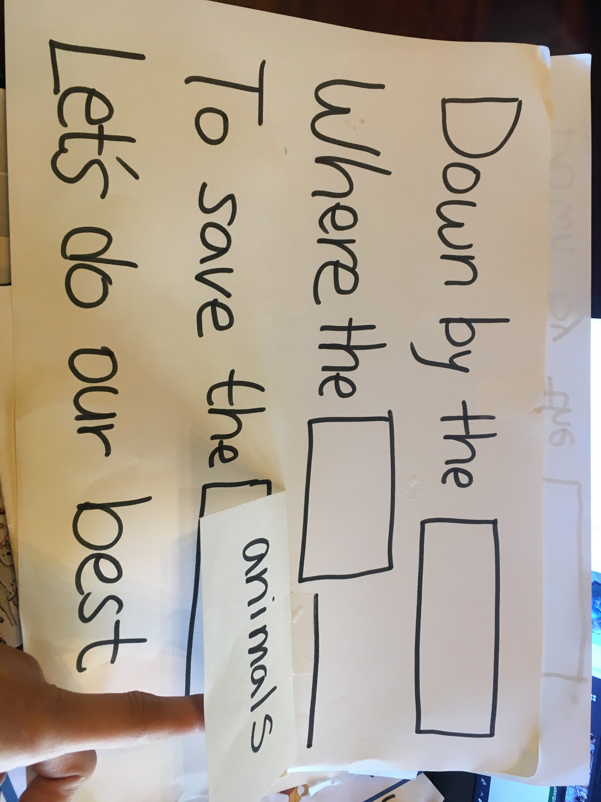
- Lyrics Words Card
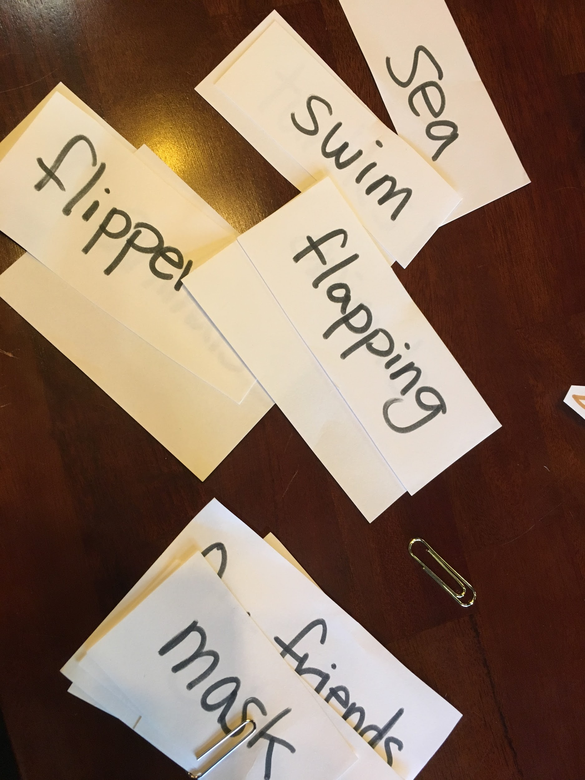
- Activity materials
- Tree memo (#Scene1)
- Plastic Straws & Silicon, Stainless Straws (#Scene2)
- Ice Bridge Foams (#Scene3)
- True/False Sticks
- 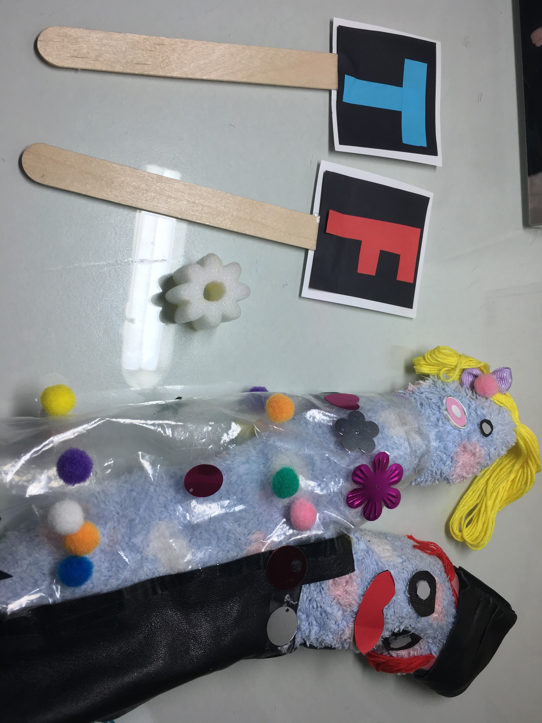

- Endangered Animals Worksheet
- Demo Poster

