Black Friday brings out bargain hunters
29th November, 2014
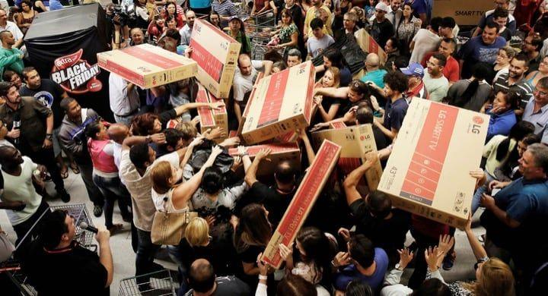
One of the biggest shopping days of the year has brought out millions of bargain hunters across the world. The day is called Black Friday. Real and online stores offer discounts of up to 70 per cent on thousands of items. It is traditionally a big shopping day in the USA, but four years ago it crossed the Atlantic and is now huge in the U.K. It has become so popular in Britain that police had to be called to four supermarkets just after midnight on Friday (the bargains went on sale at one minute past midnight). Police were worried about shoppers getting crushed in the crowds. A police spokesman said: "Officers have worked with store staff to ensure that sale-goers were able to enter and exit the stores safely." While shoppers in the U.K. were happy to head to the shops, many store workers in the USA were angry. Many stores decided to start Black Friday a day early, which was on the US celebration of Thanksgiving. Store employees and shoppers thought it was wrong for stores to ask employees to work on Thanksgiving, which is traditionally a time for people to spend with their family. A 'Boycott Black Thursday' Facebook page has more than 114,000 likes. Many big stores, such as Costco and IKEA did not open. CNN reports that there are over 60 petitions on the website Change.org trying to get stores and customers to change Black Friday. They want a bigger focus on family instead of profits.

Sources: DailyMail / BBC
Searching Words puzzles
c | a | s | d | f | g | h | j | k | l | l | k | j | n | m
e | t | r | a | d | i | t | i | o | n | a | l | l | y | r
l | q | w | e | r | t | y | u | i | o | p | l | k | j | h
e | z | x | c | v | b | n | s | h | o | p | p | i | n | g
b | a | s | d | f | g | h | j | k | l | k | o | h | g | f
r | q | w | e | r | b | t | r | e | w | s | p | f | g | h
a | e | m | p | l | o | y | e | e | s | q | u | e | r | t
t | x | v | e | c | y | m | n | b | v | c | l | z | a | s
i | i | a | t | q | c | w | e | r | d | f | a | y | h | n
o | t | m | i | b | o | n | v | c | x | z | r | s | d | f
n | q | w | t | r | t | t | y | u | i | o | f | l | k | j
a | s | d | i | f | t | g | h | j | k | l | n | m | b | v
q | p | r | o | f | i | t | s | w | e | r | f | d | s | a
z | x | c | n | v | b | n | m | h | g | d | f | s | r | t
a | s | d | s | f | g | h | j | k | l | i | h | u | g | e

shopping traditionally exit huge
celebration employees boycott petitions
profits popular

Synonym Match
1. offer a. set out for
2. items b. normally
3. huge c. products
4. crushed d. use
5. ensure e. squashed
6. head to f. concentrate
7. workers g. give
8. traditionally h. employees
9. spend i. enormous
10. focus j. make certain
True / False
a) One billion people went shopping on Black Friday. T / F
b) Stores offer discounts of up to 70% off thousands of products. T / F
c) Police went to supermarkets in England to stop people being crushed. T / F
d) Police said store staff refused to help them. T / F
e) Shoppers in England and staff in the USA were not happy. T / F
f) The US holiday of Thanksgiving is the day before Black Friday. T / F
g) An anti-Black Thursday Facebook page has over 100,000 likes. T / F
h) There are more than 600 online for Black Friday to change. T / F

Unscramble Words
1. It is llatdniiary to a big shopping day
2. the US btnaoeeicrl of Thanksgiving
3. ask seymopele to work
4. A 'otoBtyc Black Thursday' Facebook page
6. over 60 istoetpin
7. instead of tiporsf

Discussion
a) How important is shopping to you?
b) What do you think of discounts and sales?
c) What do you think of shopping days like Black Friday?
d) What are the good and bad things about shopping malls?
e) How long would you wait in line for a store to open?
Role Play
Role A

Furniture You think furniture is the best thing to buy in a sale. Tell the others three reasons why. Tell them why their things aren't so good. Also, tell the others which is the least useful of these (and why): jewellery, clothes or flowers.
Role B

Jewellery You think jewellery is the best thing to buy in a sale. Tell the others three reasons why. Tell them why their things aren't so good. Also, tell the others which is the least useful of these (and why): furniture, clothes or flowers.
Role C

Clothes You think clothes are the best thing to buy in a sale. Tell the others three reasons why. Tell them why their things aren't so good. Also, tell the others which is the least useful of these (and why): jewellery, furniture or flowers.
Role D

Flowers You think flowers are the best thing to buy in a sale. Tell the others three reasons why. Tell them why their things aren't so good. Also, tell the others which is the least useful of these (and why): jewellery, clothes or furniture

