Topic: Pollution is the world’s biggest killer
Instructor: | Level: | Age: | Number of Students: | Length:
Sunmi Kim(Cindy) | Intermediate | Adults | 3 | 30 minutes
Materials:
- Pictures#1 : presentation (eliciting)
- Pocket(with words) : practice
- Video#1 : practice
- Worksheet : practice
- Article : practice
- Pictures#2 : production (game)
- Video#2 : SOS
Aims:
- Students will be able to know the structure of superlative and use it properly.
- Students will be able to realize how pollution negatively affects people.
Language Skills:
- Listening : Students will listen the video about how superlative can be used.
- Reading : Students will read the article of pollution.
- Speaking : Students will have a discuss about worksheet and present an opinion about pollution.
- Writing : Students will fill the blanks of the worksheet.
Language Systems:
- Phonology : the + adjective + / -est /
- Lexis : adjective words in the article
- Grammar : superlative
- Function : expressing
- Discourse : discuss about pollution and compare the words
Assumptions:
- Students have thought about the pollution.
- Students know the vocabulary of the basic adjective words.
Anticipated Errors and Solutions:
- Students keep quiet for fear of making mistakes while speaking.
→ encourage them to speak with ease, not to correct their errors immediately
- Students may not be able to use the superlative exactly.
Ex) Air pollution was the bigger killer in the world.(X)
→ Air pollution was the biggest killer in the world.(O)
EX) She is the beautifulest.(X)
→ She is the most beautiful.(O)
References:
Video#1
Comparative Superlative Song - Rockin' English.(Rockin' English Lessons.2015.4.7.).In youtube. Retrieved January 8, 2019, from https://www.youtube.com/watch?v=872gqAJjc1g
Worksheet
SUPERLATIVE ADJECTIVES - Grammar Worksheet.(n.d.).In All Things Grammar. Retrieved January 10, 2019, form https://www.allthingsgrammar.com/superlatives.html
Article
Pollution is the world’s biggest killer.(Copyright Sean Banville.23rd October, 2017).In Breaking News English. Retrieved January 10, 2019, from https://breakingnewsenglish.com/1710/171023-pollution-2.pdf
Video#2
Superlatives︳Superlative Adjectives︳English for Kids︳Grammar for Kids.(Miss Puppi.2017.9.24).In youtube. Retrieved January 11, 2019, from https://www.youtube.com/watch?v=orLwiZBVoyA
Notes:

Presentation: Check the syllable to use the superlative and words
Aims: Students will learn how can use the superlative through the syllable. |  |  | Materials: Pictures#1
Time | Set Up | Student |  | Teacher
5 | Whole Class | - pollution  - bigger / biggest  - killer |  | - Greeting  Hello, everyone. Good morning. How’s the air outside today? Is there a lot of fine dust today? Fine dust is really bad for us.  Ok, Now let’s guess what the topic is today.  - Eliciting  What can you see in this picture?  How about this?  What does this painting mean?  Good. So today’s topic is ‘Pollution is the world’s biggest killer’(Write)  - Eliciting  Is pollution good? Of course not.  What kind of pollution do we have?  (Write the Ss’ answer)  Good try. So It’s ‘the biggest’ that we’re going to focus on.  Before we start, we can check something together. How many syllables are there in our name? Let’s check by clapping our hands.  (Clap) We’re clapping hands as many as the number of vowels.  How many vowels does ‘big’ have?  Yes, so you can make the superlative by putting ‘-est’ behind it.  But, if you have more than 2 syllables, you should put a ‘most’ in front.  For example, let’s think about ‘important’. How many vowels does it have?  Right. So you have to put ‘the most’ in front of the word like ‘the most important ~’. (attach the sign picture)
Notes:
Practice: Main activity
Aims: Students will be able to use the superlatives properly. |  |  | Materials: Pocket(with words) / Video#1 / Worksheet / Article
Time | Set Up | Student |  | Teacher
5  5  5 | Whole Class | (Take turn)  - air pollution  - water pollution  - workplace pollution  (underline) |  | - Drilling  Let’s play game together.  (Write sample sentence - He is the ____man)  Here’s a sentence, and let’s take a piece of paper out of the pocket and change the form to fill the blanks.  I’ll do it first ; demonstrate  In fact, there’s some exception to the superlatives. Watch the video please.  (Video)  Can you find the exception? What is it? Right. Good and Bad.  This time I’ll give you a worksheet and fill in the blanks sharing your ideas.  - ICQ  Are you working alone?  Did you check the meaning of the words before you write?  Can you clap for how many vowels?  - Error correction  I’ll give you an article which is related to our topic. Let’s read it together.  (Read)  What is the biggest pollution in the world?  What’s the second?  What’s the next?  Find all the superlatives and underline.  How can the pollution negatively affect to people? For example breath hard and ~?
Notes: The definition of workplace pollution is the presence of hazardous materials or noises within a workplace that may affect people while performing their job.
Production: Play a game
Aims: Students will think about the pollution and be able to express using superlatives. |  |  | Materials: pictures#2
Time | Set Up | Student |  | Teacher
5 | Whole Class |  |  | How can we reduce pollution?  I prepare some pictures of them and you can attach it to the right place.  <cue; good/bad/healthful/efficient>  - It is ______________.  Ok. Now let’s read with cue words. I’ll read it first, just follow me. (Echo)
Notes:
Post Production: Feedback
Aims: Students review what they learned today and expect to learn next time. |  |  | Materials: -
Time | Set Up | Student |  | Teacher
2 | Whole Class | - best  - worst |  | - Asking about the lesson  What is the highest quality of good?  How about bad?  Next time, let's look at more exceptions.  Our time is finished. Thank you for participating.
Notes:

SOS Activity
Aims: Students will enjoy the video while reviewing the usage. |  |  | Materials: Video#2
Time | Set Up | Student |  | Teacher
3 | Whole Class |  |  | We have a little time left, so let’s review again looking at the other video.  - turn on the video  (Review)
Notes:

* Worksheet #1
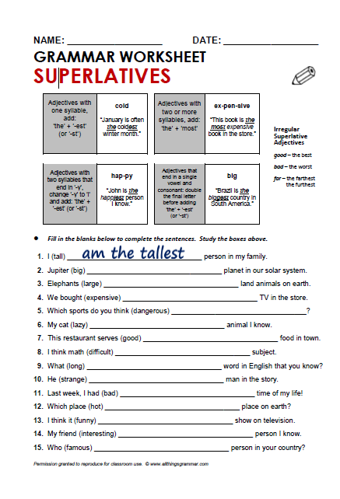
1. am the tallest | 9. is the longest
2. is the biggest | 10. is/was the strangest
3. are the largest | 11. the worst
4. the most expensive | 12. is the hottest
5. are the most dangerous | 13. is the funniest
6. is the laziest | 14. is the most interesting
7. the best | 15. is the most famous
8. is the most difficult

