Presentation, Practice, Production Listening Lesson Plan
Topic: Snow leopard under threat from climate change
Instructor: | Level: | Age: | Number of Students: | Length:
Sohyun Kim | Upper Intermediate | Adults | 15 | 50 Mins
Materials:
- White board and marker
- 15 copies of worksheets
- Computer with sound (For audio listening)
- Visual aids : Pictures, YouTube video clips (For eliciting the topic: Climate change, snow leopard)
Aims:
- Students will be able to discuss about the main topic; the Climate Change and endangered species
- Students will be able to utilize the question about the weather and season
- Students will be able to distinguish the vocabulary; danger and derivatives / inhabit and derivative
Language Skills:
- Listening: Listening to the provided audio materials, teacher’s elicitations, background information about the main idea and other students’ opinions in discussion
- Reading: The quiz from the worksheet
- Speaking: Participating in an activity, sharing ideas in a group and discussion
- Writing: Filling in the quiz from the worksheet and preparing the presentation
Language Systems:
- Phonology: Reading the text, distinguish the different vocabulary from the lexis (Inhabit, habitat…)
- Lexis: Learning new words; inhabit and its derivatives (inhabit, habitat, habitable, uninhabitable)
- Grammar: The usage of ‘danger’ and ‘endanger’
- Function: Acquiring information about the weather and how to express it
- Discourse: Learning the expressions about the weather with Wh~ Questions
Assumptions:
- Some students are familiar with the phenomenon; ‘Climate Change’
- Some students already know some species are endangered
- Students are interested in the topic of the environmental protection
- Students are at intermediate level and mostly active
Anticipated Errors and Solutions:
- Students may not know the ‘Climate Change’ or the term ‘endangered species’
- Using extra visual aids to explain what is the climate change and extinction species
- Students may not interested in the topics; climate change, endangered species, protecting the Earth
- Trying to encourage students to engage within a group and discuss about the topic
- Some students take longer time to finish their discussion/presentation
- Giving students signals to do a time-management
References:
Snow leopard under threat from climate change. (n.d). Retrieved from
https://breakingnewsenglish.com/1510/151026-snow-leopard-4.html
Snow leopards face 'new climate change threat'. (2015, October 23). Retrieved from
http://www.bbc.com/news/world-asia-34616494
Notes:

Presentation
Aims:  Students will be able to grasp the Climate Change and the meaning of the words ‘endanger’ |  |  | Materials:  Worksheet with visual aids, white board and marker
Time | Set Up | Student |  | Teacher
1 min  7 min | Whole class | (Greeting)  (Various answers)  (Fire, fireman, dry-land, hurricane, the eye of a typhoon and etc)  (Temperature of the earth goes up, sea-level goes up, the iceberg from the arctic melt, more drought and substantial weather changes etc)  (Various answers to explain about the ‘danger and endanger’ from students)  (Students answer the names of animals which endangered these days including those from the picture #3) |  | Good morning, everyone!  How are you today?  How was your weekend?  Great!  <Preparation of the task>  Today, we are going to discuss about the interesting topic.  (Handing out the worksheets)  (Eliciting and CCQ)  1. What can you see in the picture?  (The picture #1)  2. Have you heard about the Climate Change? Who can explain what the Climate Change is?  What you were talking about the climate change are good example.  (ICQ)  3. Are you familiar with the word ‘danger’, what is that mean? Then do you know the word ‘endanger’?  4. Do you know Snow Leopard? If you do not know, please refer to the picture from the worksheet.  (The picture #2 & 3)  Then shall we talk about the endangered species other than Snow Leopard? What else do you know?  Those key words and concepts are all familiar with you by now, any further question about the vocabulary?
Notes:
Practice
Aims:  Students will be able to explain the basic concept of the climate change and the endangered animal.  Students will practice English discussion and group working. |  |  | Materials:  Computer with sound (For audio listening), white board and marker  Four sheets of octavo paper, colored pens and markers
Time | Set Up | Student |  | Teacher
2 min  3 min  15 min | Whole class  Groups  (3) | (Students will listen to the audio clip and guess the main idea)  (Various answers related with the topic)  (Each group will discuss the topic and prepare the presentation)  (Each group will composed with five students and work together.)  (As a group, students are supposed to prepare the visual/text-based material)  (During the 15 mins, teacher will check the preparation status with students and ask them to rehearse, and actively correct the mistakes) |  | <listening for the main topic>  Now, we are going to listen to the news article, after you finish listening please tell me what the main idea is.  (Playing the audio)  (Guiding questions)  1. What was the main idea?  2. Why do you think so?  Right, everybody gave me very good ideas.  <Group Work>  OK, Let’s work together as a group and some brainstorming!  3. Each of your three group will discuss each topics as follows;  - What causes the Climate change?  - How it affects our daily life?  - In order to mitigate the Climate Change, what should we do?  - In order to protect those endangered species, what can we do?  Now you will be given 15 min for group discussion as well as presentation. With regard to the presentation, please prepare the suitable material. At the backside of the classroom, there are some octavo paper, colored pens and markers ready.  Teacher will actively monitor the students’ group work and correct their mistakes on time. Also answering students’ questions. Give time warning and allow more time if students need. (Checking the progress of the group work, preparation and give them time warning)
Notes:
Production
Aims:  Students will be able to extend their ideas about the main topic; the Climate Change including causes and effects, and how to prevent it. |  |  | Materials:  White board and marker, and sticky tapes
Time | Set Up | Student |  | Teacher
16 min | Groups  Group 1  Group 2  Group 3 | (A representative of each group will deliver the presentation to the class, and 5 mins each) |  | <Conducting a presentation>  Teacher will monitor and note the feedback for each group and lead the students to conduct a presentation in order.  (Some groups may not cover all of four topics, then just proceed to presentation as it is)  Well done, everyone. You did a great job. Do you have any other questions for each groups?
Notes:
Post Production:
Aims:  Students will be able to discuss & provide relevant feedback in English. |  |  | Materials:  White board and marker
Time | Set Up | Student |  | Teacher
6 min | Whole class | (Various ideas from the presentation, and briefed/summarized conclusions can be suggested)  (The feedback and comments from the teachers and students can be communicated freely) |  | <Review & feedback>  (Eliciting and CCQ)  1. What was the common ideas to cause the Climate Change? And how does it affect our life?  2. According to your discussion, how can we prevent the Climate Change in daily life? And protecting the endangered animals can be executed by which actions?  And let’s discuss about the good things and comments for each presentation! I think all of you did a great job!  For your assignment, please fill in the blanks to complete the listening contents. And make a conversation asking about the weather and answers with Wh~ questions.  Well done guys and class dismissed!
Notes:

Listening Lesson Plan worksheet / Visual Aids
#1. What can you imagine with the Climate change?
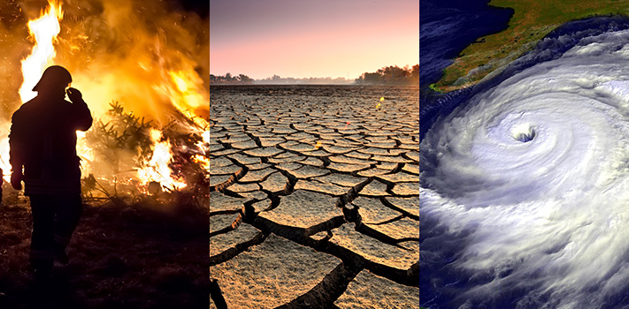

#2. Do you know Snow Leopard?
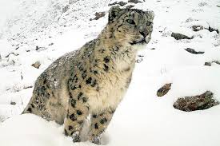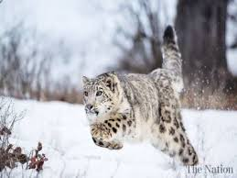
#.3 What are the endangered species?
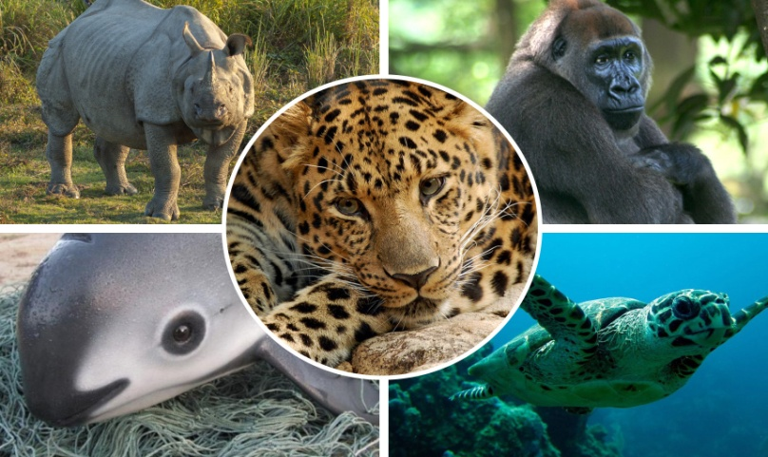
References:
How climate is changing. (n.d). in Nasa. Retrieved January 25, 2019, from https://climate.nasa.gov/effects/
A New Snow Leopard Population Estimate Has Scientists on Edge. (2016, July 12). Retrieved from
http://www.takepart.com/article/2016/07/12/new-snow-leopard-population-estimate-has-scientists-on-edge

Five of the world's most endangered animals. (2015, December 9). Retrieved from
https://www.telegraph.co.uk/news/earth/wildlife/12040047/Five-of-the-worlds-most-endangered-animals.html

Listening Lesson Plan worksheet / Transcript
Filling in the blanks: Completing the listening context

The World Wildlife Fund (WWF) has warned that climate change is threatening the snow leopard. It says rising temperatures are reducing the animals' natural habitat to the point where they could become extinct. Up to a third of the areas where the leopards live could become uninhabitable. The WWF said: "The Himalayas region will face a major crisis if we choose to ignore climate change…We risk losing…species such as the snow leopard."
Humans are also a big threat to the snow leopard. The big cats are hunted for their fur and body parts. Many poachers are joining this profitable, illegal trade. Farmers also kill the leopards. The natural prey of the snow leopards is decreasing, so the animals are going onto farms and killing farm animals. The result is the farmers shoot the leopards. The WWF released its report on Friday. This was the first ever International Snow Leopard Day.
Material for the brainstorming for the climate change:

The potential effects of the Climate Change…
(Hint)

Temperature
- Seasons
- Drought/Rain/Snow

Sea level

Arctic

(Answer)

Temperatures will continue to rise

Frost-free season (and growing season) will lengthen

Changes in precipitation patterns

More droughts and heat waves

Hurricanes will become stronger and more intense

Sea level will rise 1-4 feet by 2100

Arctic likely to become ice-free
Ideas where we can try to protect the Earth as well as endangered species:

Protecting the Earth…
1.
2.
3.
Protecting the endangered species
1.
2.
3.
Making a conversation asking about the weather with Wh~ questions:

Various conditions of the weather: Rainy, Sunny, Gloomy, Windy, Hot, Snowy etc
1.
2.
3.

