Topic: Sexual Harassment
Instructor: | Level: | Ages: | The number of students: | Length:
KIM EUNJAE(Lia) | Pre-intermediate | Adults | 15 | 50 minutes
Materials:
* Computer and speaker (to access breaking news)
* white board and markers ( Discussion question)
* 15 copies of the text "Sexual Harassment"
* 15 copies of the vocabulary and fill and blank work sheet
* The picture of Holly wood actresses
* 5slips of papers with Hollywood actresses name
Aims:
Main aim: Student will be able to speak about sexual harassment by discussing
Secondary aim: Students will be able to acquire the movement in America
Language Skills:
Reading: Reading and understanding key vocabulary
Writing: writing sentences with key vocabulary
Speaking: Sharing opinion of this topic
Listening: Comprehension question
Language Systems: Phonology
-Pronunciation of new vocabulary, Equally [ ‘i:kwali ] ,acknowledge [ak’na:l-]
Lexis- Sexual harassment, Racial, Inequality
Function-Explaining dealing with sexual harassment
Discourse-Discussion and sharing ideas
Grammar-Present perfect
Assumptions:
Students are pre-intermediate levels.
Students have experience in group discussion
Most students are currently used to this kind of issue.
Anticipated Errors and Solutions:
-The “time’s up movement started on October. X
-The “time’s up movement started in October. O
-The women are famous actress. X
-The women are famous actresses. O
References:
Sexual harassment (January 04, 2018). In Breaking News English. Retrieved from
https://breakingnewsenglish.com/1801/180104-sexual-harassment-l.html

Notes:

Presentation: Lead-in
Aims:  students will be able to  build rapport  with their class mates |  |  | Materials:  White board, markers, The picture of Hollywood actresses, 5slips of papers with Hollywood actresses name
Time | Set Up | Student |  | Teacher
10min. | Whole  Whole | Greeting& Answering  Prediction  looking at the picture  Listening instructions  Acting or guessing |  | (Greeting)  Good morning everyone!  How are you today?  Did you have great weekend?  (Eliciting&Prediction) What do you see in this picture? (Answering)  Do you like Hollywood movies?  Who’s your favorite actress?  (write down the name of them)  (Instructions)  Ok, class! We are going to do something fun Before starting our class.  I have 5 slips of papers and there are some famous Holly wood actresses name in it. What we are going to do is acting like them in movies without sounds, then the rest of students will guess who.  (Demonstration)  I need 5 Volunteers for it.  Anyone?  Yea, let’s get started
Notes:
Practice: pre-activity
Aims:  1.Students will be acquainted with  Key words by doing filling in the blank. |  |  | Materials:  White board, makers, computer,  15 copies of worksheet
Time | Set Up | Student |  | Teacher
5min.  5min.  3min. | Individual  Individual  Individual | Listening article,  Filling in the blank  Listening |  | (Instructions)  Today We are going to discuss Sexual harassment.  Did everyone get two papers? Look at the worksheet 1.  Before discussing it, We are going to listen some article twice,  then Fill in the blank.  After it, we are going to look up some vocabulary.  Are you all ready with it?  Have you guys done it?  (If no, giving them 2min.)  Alright, let’s look up a couple  new vocabulary.  (checking and explaining)  Everyone is all clear of the vocabulary, now?  Ok, let’s move to next  (Anticipated Error)  #The “Time’s up movement started on  October  #The women are famous actress
Notes:
Production: Main-activity
Aims:  Students will be able to speak about  the Issue of Sexual harassment |  |  | Materials:  white board and markers  15 copies of the text
Time | Set Up | Student |  | Teacher
20min...  . | 3groups | Discussing topic  Making 3groups |  | (Writing discussion topic on the board)  1.What do you think of “Time’s up” movement?  2.What advice do you have for the women?  3.When will women be treated fairly and equally?  We are going to discuss a couple of things for 20min. sharing what you think about it, what you support and any ideas of them.  Ok, Let’s make groups of 3,  and get started.  (ICQ) how much time do you have?  Did you make groups of 3?  (Monitoring with note)
Notes:
Post Production: Post-Activity
Aims:  Students will be able to  Share expressions about  sexual harassment |  |  | Materials:  Board and markers
Time | Set Up | Student |  | Teacher
7min. | 3groups | Presentation  Listening |  | Did you fun with this topic?  I heard many interesting ideas from you, and I want you to share it with all class mates.  What do you think of “time’s up” movement?  Is anyone to share the idea from group A?  Ok, great!  Next, What advice do you have for the women? Group B?  Last, when do you think will women be treated equitably? Group C?  Alright.  Everyone one did really good job today.  I liked all your great opinions.  (CCQ)  Did you guys also share all your ideas of sexual harassment?  Great!  Let’s call it a day  See you next class !
Notes:

Sexual Harassment
Over 300 women in Hollywood have joined together to fight sexual harassment. They have started a movement called 'Time's Up'. They want men to know that time is up for women not being treated fairly and equally. They are angry about the inequality in the movie industry and the amount of harassment working-class women face around the USA. The women are famous actresses, as well as female agents, directors, executives and producers. The group paid for a letter to be printed in newspapers. It said: "The struggle for women to break in, to rise up the ranks and to simply be heard and acknowledged in male-dominated workplaces must end". It added that "time's up" for men controlling everything. The Time's Up movement started in October, soon after many top actresses reported that movie producer Harvey Weinstein had sexually harassed them. Its leaders have asked actresses to wear black when they walk along the red carpet of The Golden Globes awards ceremony on Sunday. They want women to use the red carpet to speak out against gender and racial inequality. Actress Eva Longoria said: "For years, we've sold these awards shows as women, with our gowns and colors and our beautiful faces and our glamour." She added that: "This time, the industry cannot expect us to go up and twirl around. That's not what this moment is about."
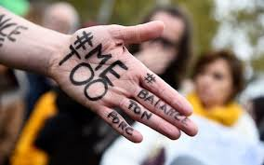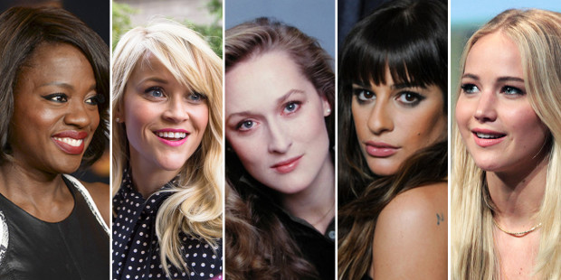

Listening — Listen and fill in the gaps

Over 300 women in Hollywood have (1) ___________________ fight sexual harassment. They have started a movement called 'Time's Up'. They want men to know that (2) ___________________ for women not being treated fairly and equally. They are angry about (3) ___________________ the movie industry and the amount of harassment working-class women face around the USA. The women (4) ___________________, as well as female agents, directors, executives and producers. The group paid for a letter to be printed in newspapers. It said: "The (5) ___________________ to break in, to rise up the ranks and to simply be heard and acknowledged in male-dominated (6) ___________________". It added that "time's up" for men controlling everything.

The Time's Up movement started in October, soon (7) __________________ actresses reported that movie producer Harvey Weinstein had sexually harassed them. Its (8) ___________________ actresses to wear black when they walk along the red carpet of The Golden Globes (9) ________________ Sunday. They want women to use the red carpet to speak out against gender (10) ___________________. Actress Eva Longoria said: "For years, we've sold these awards shows as women, with our (11) ___________________ and our beautiful faces and our glamour." She added that: "This time, the industry cannot expect us to go up and twirl around. That's not what this (12) ___________________."

